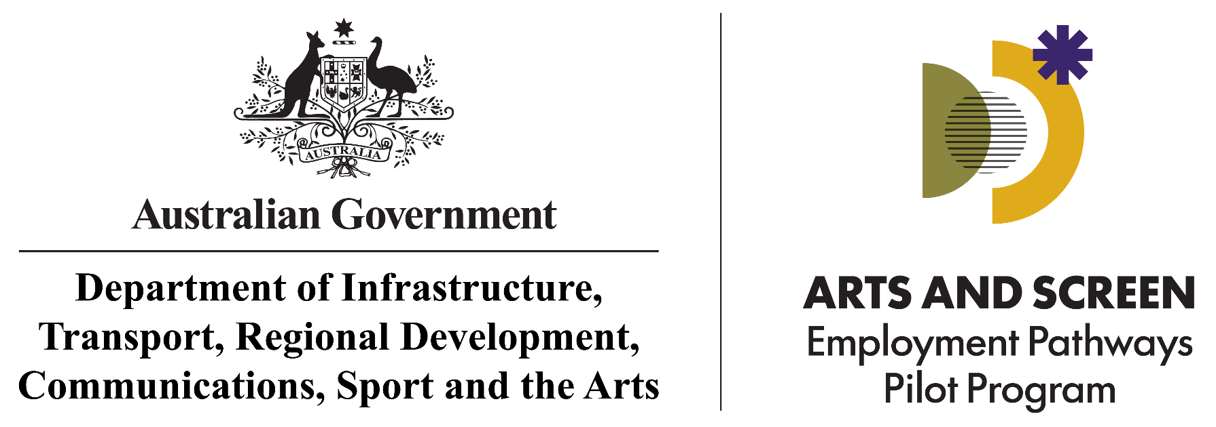
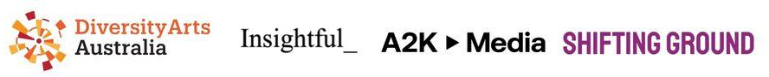
Arts Screen Employment Program Coordinator
Arts and Screen Employment Pathways Pilot Program | Diversity Arts Australia Consortium
Position description — 28 September 2026
About the Position
The Program Coordinator will coordinate the day-to-day running of the Program, shaping its delivery in collaboration with the Consortium and supported by its members. The role will help lead and embed Disability-led practice across the Program, and coordinate training delivery (Disability Justice, Creative Equity and First Nations Cultural Safety training) and access facilitation.
This is an identified position for d/Deaf and/or Disabled people (see Definitions). Direct lived experience of Disability is essential. We encourage applications from First Nations people and people from Culturally and Linguistically Diverse and/or Culturally and Racially Marginalised backgrounds who identify as d/Deaf and/or Disabled.

About the Arts and Screen Employment Pathways Pilot Program
The $2.2 million Arts and Screen Employment Pathways Pilot Program (the Program) runs over three years (2025–26 to 2027–28). It is funded through Equity: the Arts and Disability Associated Plan, the Australian Government's four-year, $8.1 million plan to build equity for artists, arts workers and audiences with disability across Australia.
The Program will connect early to mid-career d/Deaf and Disabled artists and arts workers (see Definitions), including those facing multiple and intersecting barriers, with arts, cultural, screen and digital games organisations through a supported matching process. Around 20 participants will take up paid placements of up to 12 months across Australia, in two cohorts commencing March and June 2027.

The objectives of the Program are:
- to support d/Deaf and Disabled artists and workers in the arts, cultural, screen and digital games sectors to build professional skills and networks to advance their careers
- to support arts, cultural, screen and digital games host organisations to become more accessible, equitable, and culturally safe
- to collect feedback on the impact of temporary job placements in the arts, cultural, screen and digital games sectors for d/Deaf and Disabled people, and for the host organisations.
- to provide an evidence base for future Australian Government policy development.
About the Consortium
Following a competitive grant process, a Consortium led by Diversity Arts Australia (DARTS) was selected to deliver the Program. DARTS is the national voice for ethno-cultural and racial equity in the arts, cultural and creative industries, working intersectionally and in partnership to deliver research, training, resources, events, creative projects and professional development.
The Consortium brings expertise in Disability-led, First Nations and culturally diverse creative practice, workplace access facilitation, cultural safety, training and mentoring, arts and anti-discrimination policy, equitable employment and organisational change. Collectively, we have decades of experience working with d/Deaf and Disabled, First Nations, Culturally and Linguistically Diverse, Culturally and Racially Marginalised, Queer, Trans and Intersex, Black, Indigenous and People of Colour communities and organisations.
In consultation with the Office for the Arts, the Consortium oversees the Program and supports the Program Coordinator, participants and host organisations across recruitment, selection, placement planning, delivery, data collection, grant reporting and evaluation, with a shared focus on culturally safer and more accessible placements.

Key responsibilities and delivery timeline:
Area | What it involves | Expected timing
Project coordination | Maintain project actions, milestones, records and key documentation; coordinate relevant Consortium activity; and support delivery against agreed timelines. | Ongoing
Host organisation recruitment | Coordinate national recruitment and selection of around 20 diverse host organisations, including in regional and remote areas, with targeted outreach to Disability-led, First Nations-led and culturally and racially marginalised/Culturally and Linguistically Diverse-led organisations. Recruitment will already be underway when the Program Coordinator commences. | October - December 2026
Accessibility and cultural safety audits | Coordinate accessibility and cultural safety audit processes for selected host organisations using designated tools provided by the Consortium. | December 2026-February 2027
Training coordination | Coordinate Disability Justice, Creative Equity and First Nations Cultural Safety training for host organisation teams and participants, delivered largely by Consortium members. | By February 2027
Host organisation induction | Coordinate host organisation agreements, onboarding and induction before placements commence. | By February 2027
Participant recruitment | Coordinate an accessible national recruitment and selection process for around 20 participants, including accessible application formats, arranging Disability-led interviews and coordinating panels that include Consortium members with direct lived experience of Disability. | By March 2027
Placement planning | Work with participants, host organisations and Consortium members to shape and arrange meaningful placements that reflect participants' career goals, interests and access requirements, and the opportunities each host organisation can offer. | By March 2027
Placement support | Provide ongoing access support and advocacy throughout placements, including check-ins, cluster mentoring and a confidential, accessible process for raising concerns. Act as the first point of contact for access issues and complaints, escalating to the DARTS CEO where needed | Throughout placements
Accessibility facilitation | Work with participants and host organisations to identify access requirements and disabling barriers, and coordinate supports, including participant inductions and access riders with Insightful. Liaise with JobAccess, participants and host organisations to plan and implement Employment Assistance Fund (EAF) provisions. | From March 2027
Communities of Practice | Coordinate the Participant Community of Practice every two months and the host organisation Community of Practice quarterly. | From April 2027
Payments coordination | Oversee quarterly wage payments to host organisations, administered by DARTS finance. | Quarterly from March 2027
Data and reporting | Collect placement and outcomes feedback, support monitoring and evaluation, and contribute to reporting to the Office for the Arts. Create accessible ways for participants to give feedback that shapes continuous improvement and future Program design. | Ongoing

Selection criteria
Essential
- You identify as d/Deaf and/or Disabled. This is an identified position for people with direct lived experience of Disability.
- Coordination or project management experience in the arts, cultural, screen or digital games sectors, including managing multiple workstreams and deadlines using appropriate systems, supports and workplace adjustments as needed.
- Experience working with d/Deaf and Disabled artists, arts workers or communities, or within Disability-led practice.
- Effective, respectful and responsive communication skills, with the ability to build collaborative relationships with participants, host organisations, Consortium partners and government stakeholders, using a diverse range of appropriate communication methods and supports.
- Demonstrated experience in identifying and addressing disabling barriers and facilitating access for people with diverse access requirements across different workplace contexts, including practical understanding of accessibility and workplace adjustments.
- Ability to work in culturally safer and respectful ways with First Nations and culturally and racially marginalised participants.
- Ability to maintain records, collate placement and outcomes feedback, and contribute to monitoring, evaluation and reporting to the Office for the Arts.
- Sound judgement and ethical practice, including handling sensitive and confidential information (such as access requirements, workplace adjustments, complaints and participant wellbeing) and identifying, responding to and escalating access, placement, wellbeing or stakeholder issues in a timely and appropriate way.
Desirable
- Experience with employment, placement or traineeship programs, particularly for d/Deaf and Disabled people.
- Experience and understanding of working in intersectional contexts, including where Disability intersects with race, culture, gender, sexuality, age, religion and other identities.
- Mentoring or training coordination experience.
- Experience with government grant reporting.
- Experience accessing the Australian Government Job Access Employment Assistance Fund.
Pre-employment requirements: The successful applicant must obtain a National Police Records Check, Working with Vulnerable People Check, and a Working with Children Check.
Terms
Title | Program Coordinator, Arts and Screen Employment Pathways Pilot Program
Hours | 3 days per week (0.6 FTE)
Contract Length | 18 month contract
Key dates | Advertising period: 28 September–19 October 2026  Applications close: Monday 19 October 2026, 5pm  Shortlisting: 20–23 October 2026  Expected interviews: Week commencing 26 October 2026  Expected commencement: From 9 November 2026
Salary | Based on 3 days per week: $54,000 salary plus $6,480 superannuation ($60,480 total package). This is based on a full-time equivalent salary of $90,000 plus 12% superannuation. We offer Portable Long Service Leave for employees.
Reports to | Chief Executive Officer, Diversity Arts Australia
Location | Diversity Arts Australia is based in Parramatta, and the Program operates nationally. Some interstate travel is required. Where travel creates access barriers, alternative arrangements will be put in place.
Job share | Job share arrangements will be considered, including where this supports an applicant’s access requirements.
Support | Onboarding and mentoring support will be provided to the successful applicant. We will also support any required workplace adjustments, including through the Employment Assistance Fund.

How to apply
Please send us:
- your CV; and
- a cover letter (no more than 3 pages) or equivalent* addressing the essential selection criteria and telling us why the role interests you and what you would bring to it.
*Applications are welcome in written, video, audio or other accessible formats. If applying by video or audio, please keep your response to around 5 minutes.
You do not need to respond to each criterion in a separate section, but your application should give us enough information to understand how your experience, skills and lived experience relate to the role.
If you would like an adjustment at any stage of the application or interview process (such as to the format, timing, communication method or access support), or need support to submit your application, please contact Madlen at jobs@diversityarts.org.au or on 0404 389 581. This is also the contact for any questions about the role.
To talk with us through the National Relay Service (NRS), email or call and we will contact you via the NRS.
The Arts and Screen Employment Pathways Pilot Program is an Australian Government initiative funded through Equity: the Arts and Disability Associated Plan.

DEFINITIONS:
Early to mid-career refers to people who are ready to apply for and develop their skills through a paid placement, including those entering, re-entering or rebuilding a career in the creative industries, in any art form or creative practice area and at any position level. Career stage is not defined by age, years of experience or traditional milestones, recognising that disability and other structural barriers can affect people’s career pathways and progression.
d/Deaf and Disabled people and People with Disability include (but are not restricted to) those who have long-term physical, mental, intellectual or sensory impairments which, in interaction with various barriers, may hinder their full and effective participation in society on an equal basis with others. This can include psychosocial disability, neurodivergence and chronic health conditions that result in significant physical, social and economic participation barriers. The term ‘d/Deaf’ includes all people with hearing loss or who are hard of hearing. They may or may not identify as Disabled. Members of the ‘uppercase D’ Deaf community often identify as having a distinct language (Auslan) and culture. Disability can also be visible or non-visible.
Disability-led practice means work shaped, led, and informed by d/Deaf and Disabled people, with meaningful decision-making power over the design, delivery, and evaluation of a piece of work. It goes beyond consultation by ensuring that people with lived experience have genuine leadership and influence throughout a process.
Culturally and Racially Marginalised (CaRM) refers to people and communities who are negatively racialised and experience systemic barriers because of their race and culture.
Intersectionality recognises that people may experience multiple and overlapping barriers or forms of discrimination based on different aspects of their identity, and that these can interact to deepen inequity. For example, a d/Deaf or Disabled person may also experience racism, sexism, homophobia, ageism or discrimination related to culture, language or religion.

