About SUFY

Speaking Up For You Inc. (SUFY) is an independent Individual Social Advocacy Organisation for people with a disability who live in the Brisbane and Moreton Bay regions. SUFY advocates to ensure people with disability who have been marginalised and made vulnerable by societal systems and discrimination, enjoy the same human rights and autonomy as other community members. ts key principles are:
- Human rights: SUFY will promote and defend the human rights, lives and autonomy of people with disability whom we support through an advocacy relationship.
- Social Justice: SUFY will operate in ways that support the achievement of rights, equity, access, belonging, and participation in our advocacy work with each person.
- Inclusion in Community Life: SUFY will operate in ways that value and support the inclusion of people with disability to live the life they choose in their diverse communities.
- Priority of the most vulnerable and marginalised: In all its work SUFY will aspire to prioritise those who are most at risk, ignored and least able to speak up for themselves.

SUFY is a small special-purpose organisation – although its income and staff numbers fluctuate over time, it generally has a financial turnover of $2m and a staff team of 10-15.

We are an Equal Employment Opportunity workplace and we encourage people with disability and people of diverse backgrounds to apply.

The Role

The main role of the NDIS Appeals Advocate is funded by the Federal Department of Social Services and provides support to individuals who wish to appeal their NDIS plan. The NDIS Appeals Advocate will report to the Manager with day-to day supervision provided by the Senior NDIS Appeals Advocate.

The following diagram shows this role within SUFY’s overall accountability structure.

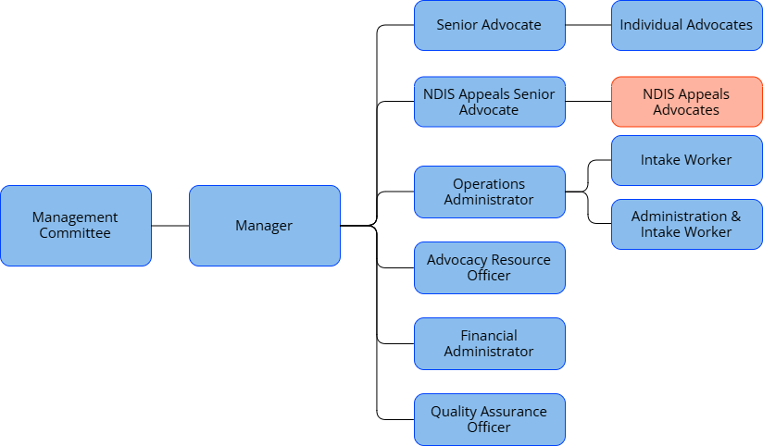

The key elements of the role are shown in the following diagram.

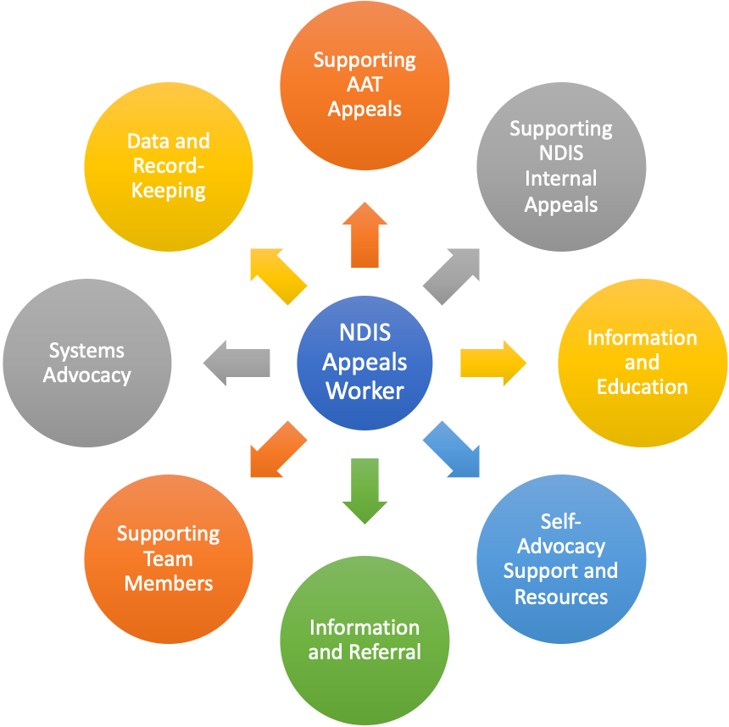

The following are details of these duties.

Supporting NDIS Appeals to the Administrative Review Tribunal (ART)
The NDIS Appeals Advocate will analyse, plan and provide support and assistance to individuals with disability whilst they navigate the process of seeking an ART review of NDIS decisions. This includes:
- Supporting people with disability including children and young people to self-advocate where this is appropriate.
- Working with other NDIS Appeals team members to prioritise referrals and determine which referrals can be accepted and which need to be declined or referred elsewhere.
- In partnership with the person with disability including children and young people, develop and implement a plan which will provide effective support.
- Assist the person to navigate the process of ART review of decisions – this could include attending ARAT conferences and hearings with applicants and fostering self-advocacy for applicants to put their own cases before the ART.
- Assist the person to apply for funding (including completing a referral to the Central Assessment Provider (CAP)) where legal issues are highlighted and an application has been made to the ART (for complex or novel legal cases).
people with disability including children and young people with disability including children and young people

Information and Education
The NDIS Appeals Advocate will engage in providing information sessions, education and skills development for individuals with disability and their support networks. This can include:
- Developing information resources
- Attending and speaking at information sessions or meetings

Self-Advocacy Support and Resources
As SUFY does not have the resources to directly advocate on behalf of everyone who seeks assistance, it also seeks to support people with disability including children and young people to advocate on their own behalf. The NDIS Appeals Advocate will support self-advocacy in NDIS appeal processes by:
- Providing information and advice to people with disability including children and young people and their support networks about their rights and about advocacy strategies.
- Assisting with the development and review of written self-advocacy resources around the NDIS.

Information and Referral
Part of the role of the NDIS Appeals Advocate is to link people with disability including children and young people with other supports that can help them achieve their goals. This is the case where the situation is outside the professional competence of the Advocate, or where the support required is not within the advocacy role. This can include, but is not limited to:
- Referral to support services such as supports coordination or direct support provision.
- Referral to Advocates with specialised knowledge or skills.
- Referral to qualified legal practitioners where legal representation is required.

This aspect of the role also requires the NDIS Appeals Advocate to contribute to the knowledge within the SUFY team of potential referral agencies and their roles and capabilities. This includes engaging in Child Safe Organisations principles and practices.

Supporting Team Members
The NDIS Appeals Advocates and other staff work as a team and support one another. While each NDIS Appeals Advocate will carry primary responsibility for a number of active cases, they will also support one another in various ways, such as (but not limited to):
- Attending meetings or appointments to support fellow team members in situations where this will make advocacy more effective or where there are concerns about the safety of staff or individuals with disability.
- Attending meetings or responding to a person’s needs in place of a team member where that team member is not available for some reason (e.g. sickness, leave, competing priorities etc.).
- Assisting colleagues by reviewing their work, providing feedback or otherwise assisting them with complex issues.

Systems Advocacy
Systems Advocacy is focussed on influencing and changing systems—including the legislative, policy and practice aspects of systems – to improve the way these systems relate to people with disability. This work arises out of and complements SUFY’s individual advocacy. The Manager is responsible for leading SUFY’s Systems Advocacy work. The NDIS Appeals Advocate will support this work by:
- Assisting the Manager and team to identify systems advocacy priorities arising from their individual advocacy work, in particular systemic issues with the NDIS.
- Assisting with the preparation of written documents such as submissions and policy papers.
- Where appropriate, representing SUFY in public forums on NDIS systems advocacy issues.
- Contributing to wider sector campaigns and actions around the NDIS.

Data and Record-keeping
NDIS Appeals Advocates are responsible to maintaining up-to-date records of individual advocacy activities and data about advocacy work. This assists with formal funding accountability and also with continuity and legal and insurance protection where SUFY’s work is shared by more than one team member or is called into question via a complaint.

Selection Criteria
Values
The NDIS Appeals Advocate is expected to have a strong values base including:
- An unswerving commitment to a vision for people with disability including children and young people that they achieve valued inclusive lives within their communities.
- Commitment to SUFY's principles, including the principle of independent advocacy.

Qualifications and Experience
A qualification in law whilst not essential will be advantageous.
Qualifications in social sciences, human services, advocacy and/or a minimum three years equivalent combination of relevant experience, education and/or training in the community services or advocacy sector would be an advantage.

Advocacy Knowledge and Skills
The NDIS Appeals Advocate is expected to have a high level of advocacy skills and knowledge gained either in the disability field or in other related fields, including:
- An ability to quickly gain an understanding of the legislation and policy around the NDIS and the appeals processes offered in that system.
- An ability to negotiate with people in positions of power and to professionally and appropriately present a case.
- Experience working in formal tribunal settings such as the Administrative Appeals Tribunal or similar environments.
- An ability to present coherent and persuasive written documents presenting the case of the person on whose behalf they are advocating.
- An understanding of Child Safe Organisations principles and practices.
- High-level problem solving and negotiation skills.

Communication Skills
The NDIS Appeals Advocate is expected to have high level and highly versatile communication skills. These include:
- The ability to communicate well with people from all walks of life and with varying levels of education, including those whose disability may involve communication challenges.
- The ability to produce high quality written work aimed at a variety of audiences.
- The ability to communicate confidently with people in positions of authority and to cogently and appropriately present the case of the individual on whose behalf they are advocating.
- An ability to speak to groups of people and present education and information materials professionally and clearly.

Teamwork Skills
The NDIS Appeals Advocate is expected to work well within a team context including:
- Good relationship skills and a willingness to both support and learn from fellow team members.
- An ability to manage their own time and priorities within the context of team decisions.
- An ability to contribute to the overall efficiency and effectiveness of the organisation through the development of systems and processes that contribute to high quality work.
- Capacity to contribute to the creation of an open, collaborative team environment that values and celebrates diversity, especially the full inclusion of people with disability including children and young people.

Knowledge of Disability
A detailed knowledge of the NDIS would be an advantage in entering this role. Candidates who have limited knowledge of the NDIS are expected to have an understanding of the capabilities and challenges faced by people with disability including children and young people and the way these can impact on their human rights, and demonstrate the capacity to quickly acquire an understanding of the NDIS.

Clearance Checks
The Disability Services Act 2006 requires clearance checks for all people engaged by a funded non‐government service provider. All staff are required to complete and achieve the Disability Worker Screening (Yellow Card) & Working With Children Check (Blue Card). Ongoing employment is dependent upon the person’s ability to renew the Blue Card and the Yellow Card.

Terms and Conditions
SUFY employees are employed under the conditions of an Enterprise Bargaining Agreement. The NDIS Appeals Advocate role is [full-time/part-time], [X days per week/fortnight]. Job-share options may be considered if appropriate and compatible with organisational requirements. This position is a fixed-term contract until [DATE] with a high likelihood of extension. All SUFY positions have a funding contingent continuing employment provision that employment will continue only if funding for the position is available. Pay and conditions are equivalent to Level X of the Social, Community, Home Care and Disability Services (SCHADS) Industry Award.

