POSITION DESCRIPTION  Community Recovery Coordinator  Harcourt & District Community Recovery Association (HADCRA) | 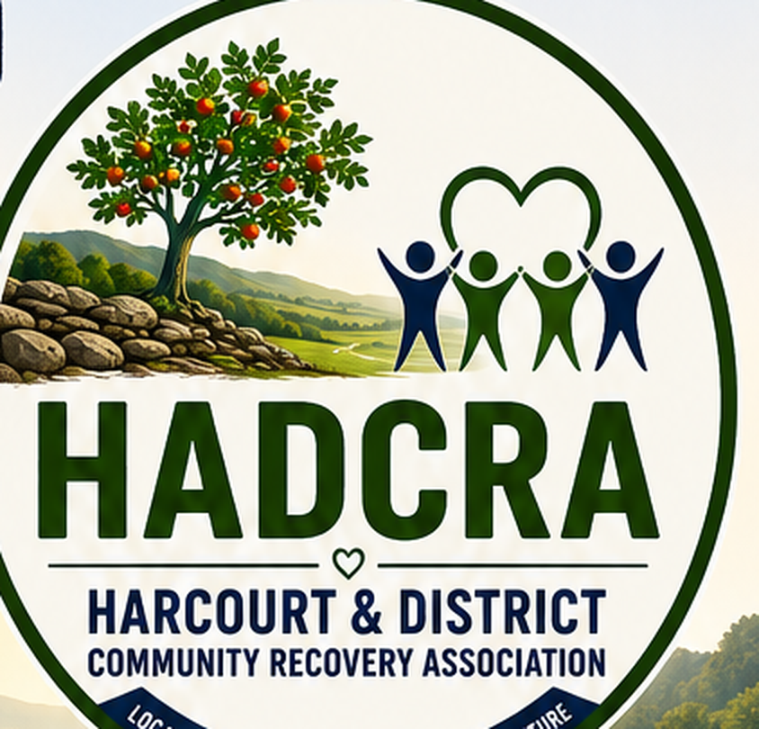

Role at a glance
Role | Community Recovery Coordinator
Engagement | Employee or contractor engagment
Funding | State & Commonwealth Govt – through AGRN1242 CRO & Hubs
Value | $97k - $102k + super
Basis | 1 x FTE – 38 hours per week
Term | One year from commencement date in Spring 2026, with possibility of extension for a second year and beyond.
Reports to | The HADCRA Committee, through a nominated office-bearer
Location | Local, alongside the MASC Recovery Hub in Castlemaine or Harcourt or at the Harcourt Valley Community House. Flexible working available by arrangement
About HADCRA
HADCRA is a community-led recovery association for Harcourt and district. It was formed after the fires of 9 January 2026. It is run by a volunteer committee, and it is built to run for three years then reviewed against community needs. Its work spans three lenses: recovery, resilience and progress. That work is delivered through a set of working groups that any member or volunteer can join. HADCRA leads the community’s own recovery, alongside Council and other agencies.
Purpose of the role
The Community Recovery Coordinator is the principal employee of HADCRA and is responsible for turning community priorities into funded recovery outcomes.
Working under the direction of the Committee, the Coordinator leads the planning, coordination and delivery of community-led recovery initiatives, builds partnerships, secures funding and supports volunteers to achieve agreed outcomes.
Because HADCRA is a volunteer-led organisation, the Coordinator also undertakes practical governance, secretariat and administrative tasks that ensure the organisation remains effective, compliant and well run.
The role therefore combines community development leadership with hands-on operational support.
Key result areas
The role has four key result areas, listed in order of priority.
KRA 1 Community Recovery Leadership and Project Delivery Primary
Outcome. Community priorities are translated into practical, funded and measurable recovery outcomes.
Responsibilities
- Coordinate the implementation of HADCRA's recovery, resilience and progress priorities.
- Work with the Committee, working groups and community members to identify and develop recovery initiatives.
- Support the design, planning and delivery of community-led recovery projects.
- Build and maintain productive relationships with Council, Recovery Hub partners, government agencies, funders and community organisations.
- Identify emerging recovery needs and opportunities and provide advice to the Committee.
- Support community consultation, listening and engagement activities.
- Monitor project progress and report on outcomes.
What success looks like: Recovery projects progress from ideas to implementation. Strong partnerships are built and maintained. Community priorities are reflected in funded activities. Recovery outcomes are visible and measurable.
KRA 2 Funding, Grants and Resource Development Primary
Outcome. HADCRA maintains the resources required to deliver its recovery priorities.
Responsibilities
- Keep watch on the funding environment. Maintain a grants pipeline that reflects member and committee conversations and maps funding opportunities to HADCRA’s plans and to the three lenses of recovery, resilience and progress.
- Identify funding opportunities aligned to community priorities.
- Prepare high-quality grant applications and funding submissions.
- Develop relationships with philanthropic, government and community funders.
- Coordinate grant administration, reporting and acquittals.
- Work with the Finance Lead to monitor project budgets and funding commitments.
- Assist the Committee to identify longer-term funding and sustainability opportunities.

What success looks like: A live and prioritised funding pipeline. Grant opportunities actively pursued. Funding targets met. Reporting obligations met.
KRA 3 Volunteers, Working Group and Community Capacity Building Core
Outcome. Volunteers and community groups have the support they need to contribute to recovery.
Responsibilities
- Coordinate volunteer participation across HADCRA activities.
- Maintain volunteer systems and records.
- Support working group leaders to plan and deliver initiatives.
- Connect volunteers and community groups with opportunities, resources and partners.
- Encourage participation from across the community.
- Build capability within volunteer leaders and working groups.

What success looks like: Volunteers remain engaged. Working groups deliver tangible outcomes. Local capacity and leadership continue to grow.
KRA 4 Governance, Administration and Organisational Support Supporting
Outcome. HADCRA remains compliant, organised and well governed.
Responsibilities
- Provide secretariat support to the Committee, including agendas, papers, minutes and action tracking.
- Maintain organisational records, registers and document management systems.
- Support office bearers to meet statutory and reporting obligations.
- Coordinate preparation of reports for members, funders and stakeholders.
- Support privacy, records management and compliance activities.
- Manage enquiries and act as a central coordination point for organisational communications.
- Undertake other administrative and operational duties required to support a small community organisation.

What success looks like: Governance obligations are met. Committee processes run efficiently. Records are accurate and current. Administrative systems support effective organisational decision-making.
What we are looking for
Essential
- Demonstrated experience coordinating community development, recovery, resilience or community-led initiatives.
- Experience planning, coordinating and delivering projects involving multiple stakeholders.
- Demonstrated success in grant writing, fundraising or resource development.
- Strong relationship-building and stakeholder engagement skills.
- Experience supporting volunteers, community groups, committees or boards.
- Strong written communication, reporting and organisational skills.
- Ability to work independently, use initiative and manage competing priorities.
- Demonstrated administrative and governance capability, including meeting coordination, record management and reporting.
Desirable
- Local knowledge and relationships with existing groups and community.
- Experience in disaster recovery.
- An understanding of government and DRFA recovery funding requirements.
- Experience with not-for-profits or incorporated associations.
- Existing relationships with regional and philanthropic funders.
Personal attributes
- Enthusiastic, energetic and positive about recovery, resilience and progress.
- Discreet, reliable and well-organised.
- Comfortable working to a volunteer committee that makes decisions together.
- Trauma-aware, and sensitive to a community recovering from disaster.
Working relationships
The Coordinator works with the HADCRA Committee, through a nominated office-bearer for day-to-day matters. The role works closely with:
- The Secretary and the Finance Lead.
- HADCRA’s working group leaders.
- The Mount Alexander Shire Council Recovery team and the Recovery Hub.
- Funders, and partner and government agencies.
- Existing community groups and members of the community.
Engagement terms
- Funding. Provided by State & Commonwealth Governments via AGRN 1242 CRO & Hubs.
- Value. $97k - $102k
- Basis. Full time, Fixed term. 38 hours per week
- Term. Twelve months initial term, with possibilities for extension. This is indicative and depends on continued funding. Progress and the arrangement will be reviewed along the way.
How to apply
To apply, please send an expression of interest that includes the following.
- A short statement, of up to two pages, telling us how you meet the things we are looking for.
- A summary of your relevant experience, or a current CV/resume.
- The names and contact details of two referees.
Send your expression of interest by email to harcourtrecovery@cch.org.au.
Closing date. 5th of October 2026
Questions. Contact the HADCRA committee at HADCRA.ADMIN@Gmail.com, Jon MacKenzie at 0468 765 063, or Bonnie Sowman at 0425 170 190

We warmly encourage local people to apply. Knowledge of Harcourt and district, and the trust of the community, are a real strength in this role.

A strong voice. A strong community. A stronger future.

