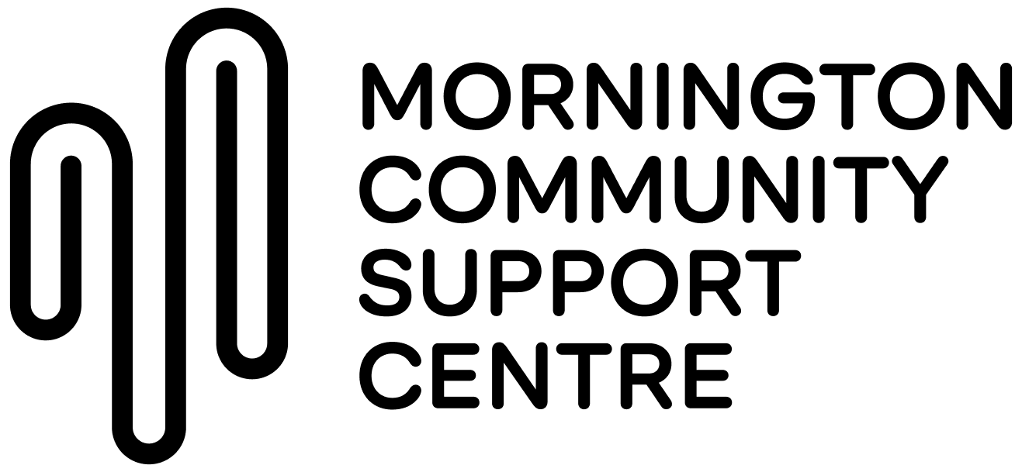
POSITION DESCRIPTION
Relationships and Fundraising Lead
Classification: SCHADS Level 5
Employment Type: Part-time 0.8FTE (0.6FTE negotiable)
Reports to: CEO
Organisational purpose and summary:
Mornington Community Support Centre (MCSC) exists to build a fair, connected, and caring Mornington Peninsula community where everyone can thrive. Guided by our vision of connection, support and compassion for all, we are a vibrant local hub offering safety, practical help and advocacy for people facing hardship. Our purpose is to meet real local needs through emergency relief, food security, shared meals, crisis accommodation, volunteering, and pathways to financial wellbeing, while working alongside other services to strengthen community resilience. We live our values every day: humility as we listen and learn; respect for each person’s story and culture; compassion as the heartbeat of our response; support that walks beside people; and dignity that upholds everyone’s inherent worth. Together, these commitments drive our service, our partnerships, and our leadership for lasting change

- Position Summary
The Relationships & Fundraising Lead will be instrumental in the development, implementation, and management of MCSC’s fundraising and donor engagement strategy. This includes building and stewarding donor relationships, grant writing, coordinating fundraising events, and supporting communications initiatives to raise MCSC’s profile in the community.
The role reports to the CEO, exercising autonomy, initiative, and professional judgment in delivering fundraising and donor engagement programs that align with organisational goals.

- Position Context and Objectives
This is an exciting opportunity for a person passionate about fundraising and community engagement to join a highly skilled and dedicated team working to support some of the most vulnerable people on the Mornington Peninsula.
MCSC is growing. In the past 3 years we have doubled our volunteer team (from 120 to 270 people) and increased our fundraising ten-fold. Our programs have expanded, and now include crisis accommodation in Mornington. To support this growth, we are looking for an experienced, talented individual with a track record in fundraising, income generation, or marketing who is ready to step into a leadership role. You will have demonstrated success in achieving growth targets and managing relationships with a diverse range of stakeholders.
The Relationship & Fundraising Lead will deliver MCSC’s fundraising programs—currently focused primarily on major gifts and donor appeals - as well as support the organisation’s donor engagement strategy. Reporting to the CEO, this role forms part of our leadership team within a growing organisation that is highly respected within the community. The role has the support of a Board that is invested in supporting fundraising success.

- About you
The successful candidate will:
- Have excellent interpersonal skills and be able to form and maintain strong relationships.
- Take accountability for outcomes and be proactive in achieving fundraising goals.
- Be self-motivated, energetic, and able to work independently and collaboratively.
- Have experience in fundraising, donor stewardship, and marketing/communications in a community or nonprofit context.
- Be committed to the mission and values of MCSC and understand the needs of the community it serves.

- Responsibilities
4.1 Fundraising & Donor Management
- Contribute to the development of annual operational plans for all fundraising programs and assist the CEO with strategy.
- Build and steward relationships with individual donors, community groups, trusts, and foundations.
- Coordinate fundraising events (2–3 per year) with the support of internal teams and volunteers.
- Prepare grant applications, acquittals, and impact reports for philanthropic and government funding.
- Analyse program performance and provide recommendations to improve income generation.
- Coordinate donor communications, including thank-you letters, donor packs, and bequest communications.
- Supervise volunteers associated with fundraising programs where required.
4.2 Marketing & Communications
- Assist in developing and implementing MCSC’s communications strategy.
- Support content creation for online campaigns, social media, newsletters, and donor engagement materials.
- Work collaboratively with staff and volunteers to promote fundraising campaigns and organisational programs.
- Ensure messaging aligns with MCSC’s brand, mission, and values.
- Manage MCSC’s ad campaigns via Google, Meta, and other opportunities.
4.3 Service System Development
- Manage the fundraising database (Raisely) to ensure accurate supporter records and program reporting.
- Develop operational plans, briefs, and reporting tools to support fundraising and marketing activities.
- Participate in supervision, training, and team-building activities to maintain professional standards.
- Engage comprehensively with MCSC programs and staff to align fundraising and communications activities with organisational priorities.

5. Organisational Relationships
- Reports to: CEO
Supervises: Volunteers involved in events and fundraising activities
Internal relationships: CEO, Leadership Team (CEO, CSSL, COL, and MFL), program staff, operations staff, volunteers, Board.
External relationships: Donors, community and corporate partners, local media, local networks, stakeholders

6. Key Selection Criteria
Essential:
- Minimum of three years’ experience in income generation, fundraising, or marketing roles.
- Demonstrated experience in soliciting significant gifts from donors, trusts, private ancillary funds, and community groups.
- Self-motivated, energetic, and able to manage competing priorities.
- Flexibility to attend community events or donor functions outside standard business hours.
- Excellent communication, writing, and organisational skills.
- Strong skills in relationship management and stakeholder engagement.
- Strong understanding of advertising platforms on Meta and Google, including application of Google Ad grants.
Desirable:
- Experience coordinating direct marketing appeals and donor recruitment programs (both mail and digital).
- Experience in grant writing, reporting, and donor stewardship.
- Ability to analyse program performance and implement improvements.
- Competence in Microsoft Word, Excel, and fundraising databases.

7. Other Requirements
- Current Working with Children Check.
- Current Police Check (or willingness to obtain).
- Current driver’s licence.
- Commitment to social justice, community wellbeing, and organisational values.

Acceptance
Employee Name: ______________________________
Signature: ___________________________________
Date: ________________________________________
CEO Signature: _______________________________
Date: ________________________________________

