Position description

Position title | : | Manager, Policy and Advocacy
Reports to | : | Director, Policy & Advocacy
Employment type | : | Maximum-Term/Full-time
Location | : | Melbourne or Sydney
No. of direct reports | : | None
Date | : | August 2026
Approved by | : | Chief Executive Officer

The operating environment

SVA overview
Social Ventures Australia (SVA) is a not-for-profit organisation that works with partners to alleviate disadvantage – towards an Australia where all people and communities thrive.
We influence systems to deliver better social outcomes for people by learning about what works in communities, helping organisations be more effective, sharing our perspectives and advocating for change.

SVA Values
As a purpose-driven organisation, our values guide who we are, how we work and the decisions we make.

 | People at  the centre |  | Difference gives  us strength |  | Open and ready  to learn |  | Real change  takes time

Learn more about SVA’s values here.
First Nations Practice Principles
SVA is committed to providing a culturally safe workplace for all our First Nations employees, partners and clients. We commit that our work with First Nations peoples is aligned with our First Nations Practice Principles set out below.
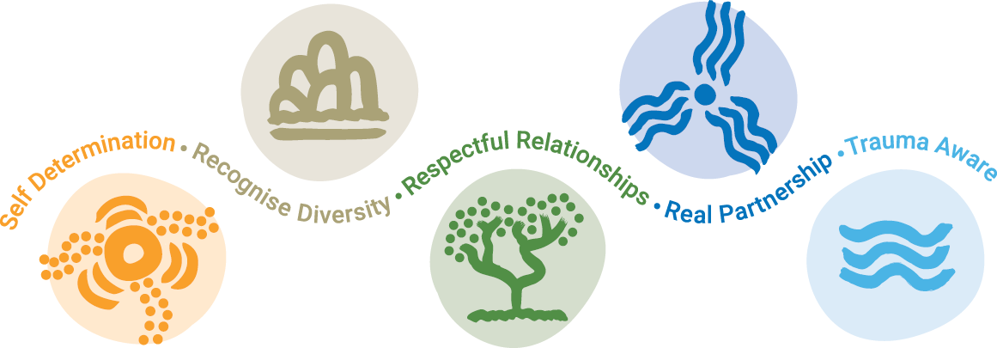

Learn more about SVA’s First Nations Practice Principles here.

Team overview
SVA’s Policy and Advocacy team helps drive SVA’s systems change agenda by taking SVA’s perspectives and using them to influence government policy and sector practice to become more effective and reduce disadvantage. The team works across all areas of social policy including people excluded from education, employment and housing, as well as addressing issues affecting children experiencing vulnerabilities, people with disability and First Nations peoples. The Manager, Policy and Advocacy, sits within the Policy and Advocacy team and reports to the Director, Policy and Advocacy.

Position purpose
The Manager Policy & Advocacy oversees SVA’s policy and advocacy activity in selected policy areas, as part of the team’s policy, government engagement and advocacy activity. The position contributes to the development of policy positions and implementation of advocacy strategies to drive change in Australia’s policy landscape linked to SVA’s overarching policy and advocacy agenda. This requires close engagement with a range of internal and external stakeholders, policy research and analysis, as well as understanding the external evidence of what works and codifying the learning from SVA’s work with partners to advocate for system change.

Position responsibilities
Specific responsibilities include:
- Plan, manage and deliver policy research and analysis to support development of policy solutions and advocacy strategies on selected issues, aligned to SVA’s strategy.
- Contribute to SVA’s Policy & Advocacy strategy and business plan including input on opportunities for SVA to provide a distinct perspective or role to support systems change.
- Ongoing monitoring of evolving social policy debates including identifying opportunities for SVA to participate in formal and informal policy processes and discussions.
- Prepare high quality written and verbal advice in the form of policy briefs, papers, presentations, proposals and other communications to support SVA’s engagement with stakeholders including government and contribute to public policy debate.
- Provide strategic policy advice across teams and assist in building SVA’s policy capability to improve the effectiveness and influence of SVA’s work.
- Provide input on current policy-relevant research and evidence as part of the planning of new innovations and concepts that SVA could develop or work with partners to develop.

Special requirements
Some interstate travel will be required.

Person requirements
To effectively perform this position, the person will require the following:

Knowledge
- Demonstrated knowledge, passion and commitment to working in the social sector and on society’s most important challenges.
- Knowledge of Australia’s policy settings, social issues and an understanding of the levers employed by Government in economic and social policy. This includes the processes by which social policy is developed and implemented, the key actors, and preferably the relevant legislation.
- IT literate (Word, Excel, PowerPoint).

Experience
- Consolidated experience in public policy development, ideally across social and economic policy domains.
- Experience developing policy advice and positions either within government or on behalf of an organisation seeking to influence government policy (including coalition building, advocacy campaigns, or communications for policy impact).

- Demonstrated ability to undertake policy research and development, including stakeholder consultation with diverse stakeholders (particularly in cross-cultural and disadvantaged communities), to support the identification of policy solutions and/or advocacy objectives.

Qualifications
- Degree qualifications in a relevant field, such as Public Policy, Law, Social Sciences, or relevant field; or equivalent experience

Skills and Abilities
- Ability to analyse, understand and navigate complex social and economic policy issues
- Consolidated written and oral communication skills; persuasive strategic communication skills and ability to effectively build consensus among multiple stakeholders
- Project management skills
- Demonstrated ability to prioritise use of time and limited resources toward meeting ambitious, measurable goals
- Capacity to work effectively independently, without support staff, including providing advice to senior managers.
- Relationship-building skills to manage multiple relationships across a broad set of external organisations that relate to specific existing projects or are prospects for future work
- Ability to work collaboratively and consultatively within team unit and broader organisation
- Ability to be adaptable and proactive in an entrepreneurial, outcomes-focused culture
- Ability to work effectively and problem solve in multi-disciplinary teams with diverse professional experience
- Ability and willingness to embrace new ideas and to be challenged
- Ability to work in cross-cultural settings and to situate the voice of people with lived experience in all program design thinking and decision making.
- Alignment with SVA values and First Nations Practice Principles

