ADRA Australia
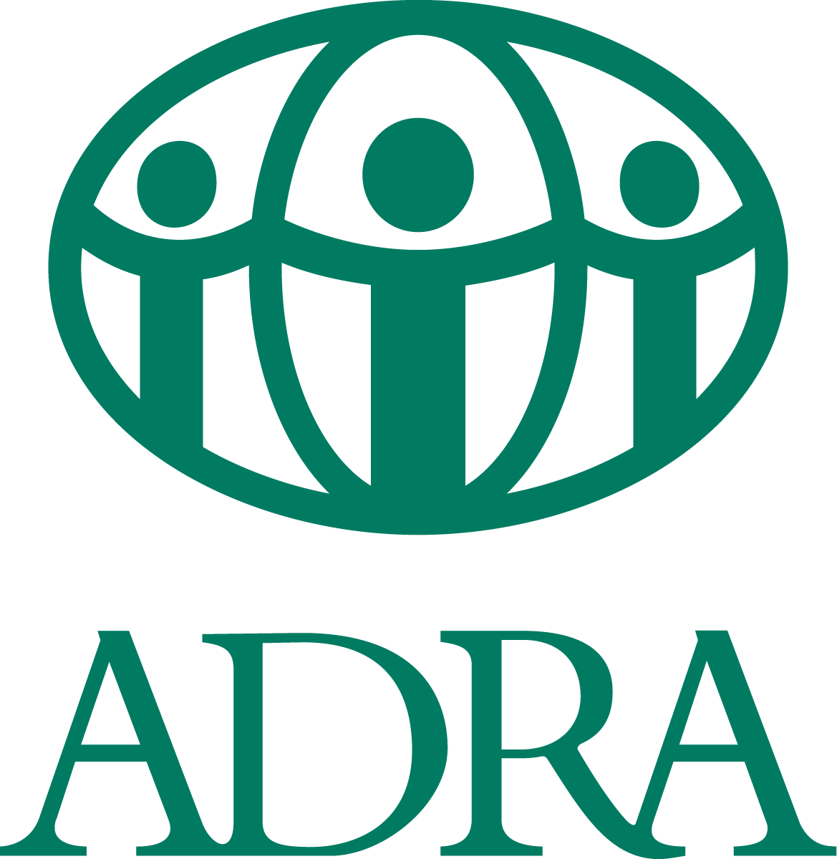
Op Shop Development Manager
Commitment: Full-time (maximum term two-years)
Location: Wahroonga, Australia base

About the role

ADRA Australia is seeking a Connected, Courageous and Compassionate Op Shop Development Manager to lead the strategic growth and operational excellence of ADRA Op Shops across Australia. This is a key leadership role that combines national-level strategy with hands-on operational oversight of a multi-site op shop network.

This Op Shop Development Manager is responsible for ensuring that each Op Shop operates as a financially profitable and well-managed social enterprise, delivering meaningful benefits for customers, volunteers, donors, and the wider community. The role focuses on building capacity, strengthening governance and operational systems, and fostering a culture of continuous improvement and innovation across the network.

By leveraging data-driven insights, proactive management, and collaborative relationships, the Op Shop Development Manager will enhance efficiency, expand opportunities for growth, and amplify the social, economic, and environmental impact of Op Shops.

With a strong focus on aligning with ADRA’s values and mission, this role transforms second-hand retail into a powerful avenue for community engagement and positive change.

The successful applicant must have the legal right to live and work in Australia at the time of application.

The Job Description for the role and the Employment Application Form are included at the end of this document.

About ADRA Australia

The Adventist Development and Relief Agency (ADRA) is the official humanitarian agency of the Seventh-day Adventist Church. As part of the global ADRA network which reaches into more than 120 countries, we are motivated by our faith, to enable people and communities in Australia, New Zealand, the South Pacific, Asia and Africa to improve their health and livelihoods and assist people to prepare for and recover from disasters around the world.

ADRA Australia holds full accreditation with the Australian Government Department of Foreign Affairs and Trade (DFAT) and is a member of the Australian Council for International Development (ACFID) and the Australian Council for Social Services (ACOSS).

Our Values - We conduct our work by being:
Connected - working collaboratively for the best outcome for those living in poverty or distress.
Courageous - persevering through challenging situations.
Compassionate – empathising with the communities we work with and with each other.

About the National Programs Team

The Op Shop Growth & Operations Manager is appointed by the ADRA Australia ADCOM and reports to the Director of National Programs.

The National Programs team works collaboratively with the following teams:
- Emergency Management
- Finance/IT
- International Programs
- People and Culture
- Supporter Engagement

Selection Criteria

Essential
- Leading the strategic establishment of new ADRA Op Shops, including site identification, feasibility
assessment, set-up, and successful operational launch.
- Developing and owning a multi-year national Op Shop growth strategy, including expansion targets,
prioritised geographies and supporting operational models.
- Providing overall management and leadership of the national Op Shop network, with accountability for performance, culture, standards, and continuous improvement across Australia.
- Directly supervising Op Shop Operations staff and ensuring effective support to site-based managers
and volunteers.
- Overseeing financial accountability, data-informed decision-making, compliance implementation, and network-wide systems relating to WHS, safeguarding, risk, and operational best practice.
- Leading the development of monitoring, evaluation and learning frameworks to measure social,
environmental and financial impact.
- Using data, monitoring and evaluation to inform decision making, improve performance and guide future growth.

Desirable
- Demonstrated experience establishing or scaling retail or social enterprise operations, including site identification, set-up and performance improvement.
- Proven ability to lead dispersed teams of paid staff and volunteers, including direct management of operational coordinators and indirect leadership of site-based managers.
- Strong commercial and financial acumen, including experience with budgets, business analytics and driving profitability across multiple sites.
- Excellent communication, influencing and relationship-building skills, with the ability to inspire volunteers, donors, customers and internal stakeholders around a compelling Op Shop vision.
- Willingness and ability to travel regularly across Australia to support existing shops and establish new ones.

Key Competencies

- Applying Expertise and Technology
Applies specialist and detailed technical expertise; uses technology to achieve work objectives; develops job knowledge and expertise (theoretical and practical) through continual professional development; demonstrates an understanding of different ADRA departments and functions.

- Formulating Strategies and Concepts
Works strategically to realise organisational goals; Sets and develops strategies; Identifies and develops positive and compelling visions of the organisation’s future potential; Takes account of a wide range of issues across, and related to, the organisation.

- Delivering Results and Meeting Individual’s Expectations
Focuses on individual’s needs and satisfaction; sets high standards for quality and quantity; monitors and maintains quality and productivity; works in a systematic, methodical and orderly way; consistently achieves project goals.

- Coping with Pressure and Setbacks
Maintains a positive outlook at work; works productively in a pressurized environment; keeps emotions under control during difficult situations; handles criticism well and learns from it; balances the demands of a work life and a personal life.
- Entrepreneurial and Commercial Thinking
Keeps up to date with industry information and market trends; Identifies business opportunities for the organisation; Demonstrates financial awareness; Controls costs and thinks in terms of profit, loss and added value

Other Requirements

Commitment to abide by the ADRA Australia Code of Conduct and organisational policies and procedures. Copies of relevant policies are available on request.

ADRA takes the prevention of sexual misconduct, harassment and child protection seriously and screens applicants for suitability. The successful applicant will be required to obtain a police check for each country in which the individual has lived for 12 months or longer over the last five years, and for the individual’s country of citizenship (including dual citizenship holders). The successful applicant will need to provide their consent to a criminal record check. ADRA recognises that in limited instances it may prove impossible to obtain a reliable criminal record check. In such circumstances a statutory declaration outlining efforts made to obtain a foreign police check and disclosing any charges and spent convictions may be accepted.

Applicants will be requested to disclose whether or not they have had a substantiated Sexual Exploitation Abuse or Harassment claim of any nature made against them in Australia or overseas. This is included in the Job Application Form.

As part of ADRA Australia, you will be expected to model ADRA’s values of being Connected, Courageous and Compassionate, and to uphold the ADRA Code of Conduct and related policies.

Eligibility and compliance

The successful applicant will be required to:

- Undergo and maintain a satisfactory national criminal history check and any other background checks as required.
- Be eligible to work in Australia.
- Comply with ADRA Australia’s Code of Conduct, safeguarding and WHS policies, and participate in required training.
- ADRA is a child-safe and equal opportunity employer and is committed to creating a diverse and inclusive workplace. We encourage applications from suitably qualified people of all backgrounds who are aligned with ADRA’s ethos and values.

Final applicants will be screened against the ADSAFE* database as well. ADSAFE’s check is to ensure no substantiated or outstanding investigations or allegations are attributed to an applicant within the Seventh-day Adventist Church system in the South Pacific.

How to Apply

To apply, candidates should address the selection criteria in their application letter providing examples of past experiences and qualifications. There is no closing date, however we will be interviewing suitable candidates as they apply.

Please submit:
- A current resume;
- A cover letter addressing the key competencies and experience outlined above;
- The Employment Application form found at the end of this document, along with the names of three work related referees to: HR@adra.org.au

If you have questions or need further information, please contact:

Kuren Galant - Human Resources Manager for ADRA Australia
Phone +61 2 9473 9525 or
email: HR@adra.org.au

ADRA Australia is an inclusive and Equal Employment Opportunity (EEO) employer.

The appointing body reserves the right to fill this position at its discretion and to close applications early.

See Job Description and Employment application forms following.
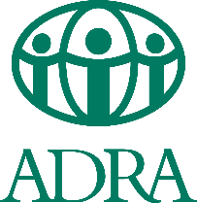 |  | Position Title: | Op Shop Development Manager |  | Full / Part Time: | Full Time
 | Connected | Department: | National Programs |  | Revised Date: | August 2026
 | Courageous | Reports To: | National Programs Director
 | Compassionate | Team Supervision: | Op Shop Operations Staff

Purpose of Position: A basic statement that describes the intent of the position.
The Op Shop Growth & Operations Manager leads both the strategic growth and the overall management of ADRA Op Shops across Australia. The role drives the
establishment of new Op Shops and the improvement of existing ones, while carrying day-to-day accountability for the performance, compliance, and culture of the Op Shop network. This is a dual-mandate position: building the future of ADRA Op Shops as thriving social enterprises that maximise their social, economic and environmental impact, while ensuring the current network is well-led, financially sustainable, and operating to a consistently high standard. Supported by Op Shop Operations and National Programs staff, this role transforms ADRA Op Shops into a connected, growing network that exemplifies ADRA’s values and meaningfully contributes to ADRA’s purpose.
Behavioural Expectations: Our code of Conduct - How we do things in our organisation that underpins our values.

ADRA Australia Code of Conduct and related policies.
Key Competencies: The competencies, qualifications, skills and experience the person needs to do the role successfully.
ADRA Competency Framework: 4.2 Applying Expertise and Technology, 5.3 Formulating Strategies and Concepts, 6.2 Delivering Results and Meeting Customer Expectations, 7.2 Coping with Pressure & Setbacks, 8.2 Entrepreneurial and Commercial Thinking
Key Competencies: A related diploma/degree and 5+ years of significant experience combining strategic development with hands-on operational leadership, ideally across retail, social enterprise or multi-site management in the Not-for-Profit sector. Proven track record of establishing or scaling retail or social enterprise operations, including site identification, set-up, and operational stabilisation. Demonstrated ability to lead and supervise dispersed teams of paid staff and volunteers, including direct management of operational coordinators and indirect leadership of site-based managers. Strong commercial and financial acumen, with the ability to interpret business analytics, manage budgets, and drive profitability across multiple sites. Excellent communication, persuasion and influencing skills, able to articulate a compelling vision and build engagement across volunteers, donors, customers, and internal stakeholders. Willingness and ability to travel regularly across Australia to support existing shops and establish new ones.

Key Responsibilities: The things that the person needs to be responsible for to successfully fulfil the obligations of this position.
Area of Responsibility  Groupings or areas of responsibility | Actions / Tasks / Objectives  What has to get done in this area | Measures of Success / KPI’s  How job performance will be measured
STRATEGIC GROWTH & EXPANSION | - Lead the strategic establishment of new ADRA Op Shops,  including site identification, feasibility assessment, set-up, and successful operational launch in alignment with the National Program strategy.  - Develop and own a multi-year national Op Shop growth strategy that defines expansion targets, prioritised geographies, and the operational model that underpins sustainable growth.  - Conduct market research and business analysis to identify new opportunities for Op Shops, including sustainable operational models, partnerships, and circular economy opportunities.  - Develop and articulate a compelling Op Shop narrative  and brand identity that resonates with donors, volunteers, and customers, strengthening brand consistency across the network while preserving local uniqueness.  - Develop, refresh and roll out an Op Shop “franchising  package” (basket of goods) that provides standardised guidance, tools, resources, and services to streamline  processes and alleviate administrative burdens for new and existing shops.  Collaborate with the Volunteer Coordinator to develop a national volunteer recruitment and engagement strategy, attracting a diverse range of volunteers across demographics and ages and supporting local Op Shops to grow their volunteer base. | - Op Shop growth plan developed within 6 months of  commencement, with annual expansion targets agreed and  tracked quarterly.  - At least [X] new Op Shop established per year in line with the  agreed growth plan, achieving operational break-even within agreed timeframes.  - Op Shop market analysis and benchmarking refreshed annually.  - Op Shop Manual and branding guidelines reviewed and updated annually.  - Op Shop franchise package (basket of goods) rolled out within  first year of commencement and updated annually.  - Engagement in development and implementation of the volunteer recruitment and engagement strategy annually reviewed.
NETWORK MANAGEMENT & OPERATIONAL LEADERSHIP | - Provide overall management and leadership of the ADRA Op Shop network, carrying direct accountability for the performance, culture, and standards of Op Shops across Australia.  - Directly supervise the Op Shop Operations staff, setting priorities, agreeing work plans, and ensuring effective field support to Op Shop managers and volunteers.  - Provide calm, reflective, intentional, and supportive leadership to the Op Shop network, fostering proactive management and a continuous improvement mindset.  - Engage regularly with Op Shop Volunteer Managers and Treasurers, through periodic site visits, scheduled hub operations catch ups, ensuring they have the tools, equipment, training and confidence to manage their Op Shops well.  - Drive operational efficiency across the supply chain, including sorting, pricing, inventory management, and display  practices, and promote the sharing of best practice and innovation across the network.  - Oversee the implementation of ADRA policies and best  practices across all Op Shop including Work Health and Safety (WHS), Safeguarding, Code of Conduct, and Risk Register requirements.  - Lead network-wide events and training, building connection  between Op Shops and a strong sense of belonging to the wider ADRA community. | - Op Shop Operations staff are well-supported, with clear  priorities, regular 1:1s, and periodic performance appraisals  and plan in place.  - Op Shop supply chain management (inventory, sorting, pricing, disposal) and WHS compliance system reviewed, monitored, and annually updated across the network.  - Evidence of increased horizontal linkages and knowledge  sharing between Op Shops and through the Op Shop Hub  Operations Catch ups.  - Op Shop visit schedule (jointly with Operations staff) executed as agreed, with insights informing strategic decisions.  - Op Shop Volunteer Managers' annual evaluation of ADRA's support to Op Shops is positive.  - 100% of Op Shop Volunteer managers and volunteers fully screened before commencing work with ADRA.
FINANCIAL IMPACT & MAXIMISATION | - Actively maximise Op Shop surpluses, balancing financial  sustainability, adequate reserves, and effective investment into local, national, and international programmatic needs aligned with ADRA's purpose.  - Champion the social, economic, and environmental impact of ADRA Op Shops, developing mechanisms to measure and articulate these benefits, and ensuring the "Accountability and Compliance Fee" is understood as a contribution to core mission support and collective impact.  - Oversee asset ownership and management structures across the network, including vehicles, equipment and leases.  - Establish environmental impact reporting mechanism to capture data on diverted tonnage from landfill and associated environmental benefits.  - Ensure financial accountability at site level, working with  the Operations staff, Op Shop Treasurers, and the ADRA  Finance department to maintain correct coding in Xero and  timely reconciliation. | - Monthly financial tracking table developed and maintained, measuring Op Shop Network profitability, expenses, and sustainability.  - 10% annual increase in Op Shop Network Net Operating Profit (profitability after Core Mission Support and Operating Expenses).  - 10% annual increase in Op Shop Network Net Surplus for Programs (NP + IP).  - Quarterly Op Shop Network environmental tracking table maintained (e.g., landfill diversion rate, carbon emissions avoided, water and energy savings).  - Each new Op Shop reaches an agreed financial milestone within the first 12–18 months of opening.
DATA, MONITORING & LEARNING | - Develop and implement an Op Shop MEL Framework measuring social, environmental and financial impact aligning with Op Shop Strategic Objectives and National Programs Strategic Priorities.  - Use data to inform growth decisions, including site selection  for new shops, performance interventions for underperforming shops, and replication of what is working well.  - Improve data collection methods, integration across systems, and analysis to provide actionable insights and knowledge products to decision-makers, supporting continuous  improvement and evidence-based decision making. | - MEL Framework and tracking dashboards produced within 6 months of commencement measuring social, environmental and financial impact.  - Data-informed quarterly report to the National Programs Director on network performance and growth.  - Constantly looking for ways to improve the Op Shop systems for a better customer and volunteer experience while ensuring necessary compliance is met and achievement of the Op Shop Strategic Objectives.
OTHER DUTIES AS ASSIGNED BY SUPERVISOR | - Other duties as assigned by National Programs Director as needed/applicable. | - Other duties performed within given timeframe

Employee Signature: |  |  |  | Supervisor(s) Signature(s): |  |  |  | Date: / /
Print Employee Name: |  |  |  | Print Supervisor Name:

Employment Application Form | Adventist Development  and Relief Agency  ABN 85 109 435 618 | 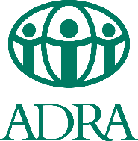
Title |  | First Name |  |  |  |  |  | Last Name
Address (include Country, State and Post/Zip Code)
Phone Nos. |  |  | Home |  |  | Mobile |  |  | Work
Email |  |  |  |  |  |  |  |  | Gender
Position applying for:

GENERAL | Type in “Yes” or “No” or the appropriate answer
- Are you ALREADY legally entitled to work in Australia? If you are not an Australian citizen, please provide your visa details.
If the response to Question 1 is No, we are unable to consider your application and there is no need to proceed any further.
- What prompted you to apply for this role? Why would you like to work for ADRA?
- Do you have any illnesses or injuries which would affect your ability to perform the inherent requirements of the job for which you have applied? If yes, please provide details below:
SAFEGUARDING

- ADRA Australia’s strict safeguarding policies aim to help protect children, young people and vulnerable adults. In line with these policies are you willing to undergo a police check, a working with children check and be screened through Adsafe*?
- Do you have any convictions or charges related to child abuse? If yes, please provide details below:
- ADRA Australia has a zero tolerance to Sexual Exploitation and Harassment. Do you have any convictions or charges related to sexual abuse or harassment of any nature made against you in Australia or overseas? If you have responded “Yes”, please provide details below:
ADRA AS PART OF THE SEVENTH-DAY ADVENTIST CHURCH

- Have you ever worked for ADRA or any other entity of the Seventh-day Adventist Church in Australia or overseas under your current name or another name? If yes, please provide details of your last position below:
- Do you have any relatives currently employed by the Seventh-day Adventist Church? (We need to check any conflicts of interest.)
If the answer is Yes, please list their names and places of employment below.
- Are you a practising Seventh-day Adventist? (If you are not an SDA, this does not exclude you from applying for the position.)
Being employed by the Seventh-day Adventist Church involves understanding, representing and being committed to the Church’s mission and lifestyle in your professional life. (Our code of conduct policy is available on request.) Please respond to the next two questions.
- Do you understand the Church’s lifestyle values? (these include abstinence from tobacco, alcohol, recreational drug use, immoral, illegal conduct, etc.)
- If you are employed by the Church, are you happy to reflect its mission in your work and adhere to its lifestyle values in your professional life?

I understand, agree and declare that:
- If required by ADRA, I will undertake a pre-employment medical screening by an ADRA designated practitioner who shall pass completed details of the examination to ADRA. (Refer Point 3)

- If required by ADRA, I will produce documentary evidence relevant to this application e.g. identification, work visa, evidence of my qualifications, etc.

- Any statement made by me in this document which is found to be deliberately misleading shall render me, if employed, liable to dismissal.

- The Terms and Conditions of my employment shall be in accordance with:
- Any applicable State or Federal Laws.
- The appropriate Industrial Award and/or church policy.

Signature | Date

*Adsafe has been established as a service and resource to assist local Churches and Denominational Entities to protect children and vulnerable adults, to comply with applicable legislation and to develop denominational policy.

