Position description

Position title | : | Manager, Consulting
Reports to | : | Principal or Director, Consulting
Employment type | : | Permanent, Part-time/Full-time
Location | : | Darwin
No. of direct reports | : | Nil
Date | : | August 2026
Approved by | : | Executive Director, Consulting

SVA Consulting is hiring a senior team member in Darwin for our Northern Australia consulting team. The person will manage teams and deliver impactful client projects across SVA’s core offerings of strategy development, outcomes management and evaluation.
This role offers high autonomy and a "start-up" local feel with national backing, suited for someone with strong local networks, deep cultural competency, and a passion for contributing to social impact.

About SVA
SVA Consulting is Australia’s leading social impact consulting team. We provide consulting services to not-for-profits, social enterprises, governments, philanthropic organisations and corporates to help achieve lasting social change.
Our Consulting team of around 50 people is spread across our larger Sydney and Melbourne offices, and our smaller Brisbane, Perth, and Darwin locations. We provide high-quality consulting services focused on strategy and organisational effectiveness (helping organisations work better), outcomes management (evaluations, SROI, and outcomes frameworks), and policy and program development.
We currently have four NT-based staff (three in Darwin, one in Alice Springs). We work closely together, and with our colleagues across our national offices, to bring the best of SVA's resources and expertise to Northern Australia.
Who we work with sets our Northern Territory practice apart. Most of our work in the Territory is delivered in direct partnership with Aboriginal-led organisations and ACCOs. We are incredibly proud to support the foundational capacity of partners like Aboriginal Housing NT (AHNT), Danila Dilba Health Service, Katherine West Health Board, Warnumamalya Health Services Aboriginal Corporation, the Central and Anindilyakwa Land Councils, Aboriginal Investment NT, and with the Australian Government primarily in areas related to Indigenous Affairs.
At Social Ventures Australia (SVA), we put our extensive know-how to work supporting these complex systems—and the organisations within them—to drive greater impact. We help institutions and local organisations navigate this fragmentation, providing the extra hands needed to build foundational capacity and drive real, sustainable change rather than just delivering isolated programs.

SVA Values
As a purpose-driven organisation, our values guide who we are, how we work and the decisions we make.

 | People at the centre |  | Difference gives us strength |  | Open and ready to learn | 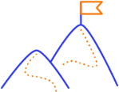 | Real change  takes time

Learn more about SVA’s values here.

First Nations Practice Principles
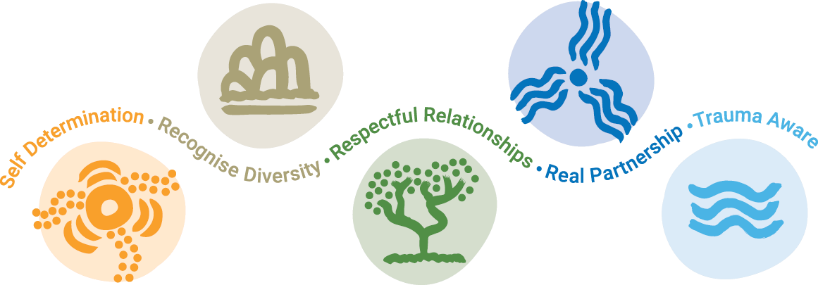SVA is committed to providing a culturally safe workplace for all our First Nations employees, partners and clients. We commit that our work with First Nations peoples is aligned with our First Nations Practice Principles set out below.

Learn more about SVA’s First Nations Practice Principles here.

The Role
We are looking to add a new senior team member at the Manager level (5+ years’ experience in strategic management consulting or a comparable problem-solving role) to contribute to SVA’s impact across Northern Australia. We would welcome conversations with people with more experience too. As a senior member of the team, this role focuses on identifying and developing impactful client work, leading project teams, and building trusted sector relationships.
While no two client projects are the same, Managers are typically responsible for leading and/or contributing to problem-solving, analysis, project and client management work as part of a broader project team, either under direct supervision of a Director or Principal, or working independently with guidance from more senior team members as required. Many projects will require the Manager to provide oversight of the work of Analysts and Consultants.
Typical projects last between three to six months. Managers generally work across multiple projects at a time and may take on different roles in each depending on the project and composition of the team.
Outside of client projects, Managers contribute to business development and thought leadership, developing proposals for potential clients, and sharing knowledge and expertise with the team and external stakeholders.

This role will suit you if:
- You want to shape strategy from scratch: You enjoy untangling complex, messy challenges and defining the problem early rather than just executing a pre-packaged checklist or building slide decks.
- You want high autonomy in a small team: You will work in lean, agile project teams of 2 to 3 people directly alongside Directors, giving you immediate influence and ownership over projects.
- You value a "start-up" dynamic with national backing: You get the close culture, speed, and growth potential of a 3-person Darwin team, paired with the resources of a 50+ person national consulting practice and a 100+ person organisation.
- You want genuine workplace flexibility: You need a schedule that respects family or caring commitments, with a hybrid office/home split (2–3 days in office) and trust-based working hours.
- You are motivated by long-term systems change: You understand that tackling entrenched social inequality in the Top End is a marathon, not a sprint, and you care more about lasting impact than quick commercial wins.

What you’ll be doing:
- Relationship and client development: You will build trust-based relationships by being out, active, and seen in the community. By deeply understanding what is happening within the complex system of the NT, you will identify how SVA can best support partners and secure impactful projects aligned with our purpose.
- Project delivery: You will deliver project engagements across northern Australia, managing geographically dispersed teams and external First Nations project-delivery partners. Importantly, you will also roll up your sleeves and directly contribute to delivering the work to ensure high-quality outcomes for our clients.
- People development: You will work collaboratively with other team members, both locally and across SVA’s offices, including coaching, model SVA's values, and actively contribute to a safe, mentally healthy workplace.
- Thought leadership: You will develop and share insights from our advisory work to build capability within the social sector.

Who are we looking for:
We know the Northern Territory is home to amazing people with incredibly diverse and interesting experiences, and we are eager to bring those unique perspectives into our team. While there is no single path to success here, we are looking for a person with:
- Substantial experience in strategic management consulting (5+ years), or a comparable problem-solving role in government, law, finance, or the social sector.
- A deep understanding of the complexity of the systems in the NT, backed by strong local networks. Experience working with or within the Northern Territory government is highly desirable.
- Demonstrated cultural competency, with the proven ability to work effectively, sensitively, and in real partnership with Aboriginal people, organisations, and communities across both urban and remote settings.
- A proven track record in successful project delivery, client development, and trusted relationship management.
- A willingness to travel across northern Australia to support our clients and communities where they are.

