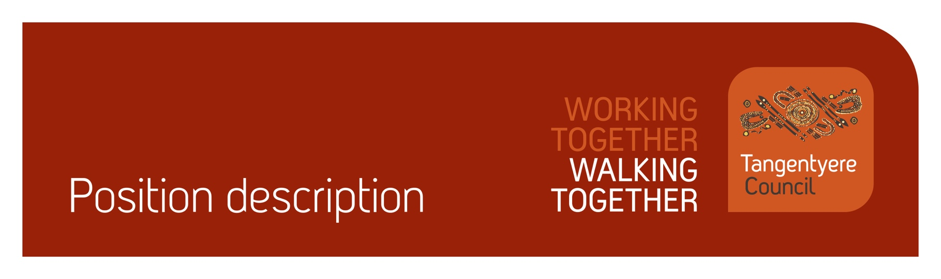

Position title | CAYLUS Community Development Worker
Division | CAYLUS
Classification | 5.1
Prepared by | Liam Campbell
Date | 19 June 2026
Staff reporting to position | Nil

Position Summary
Tangentyere Council Aboriginal Corporation (TCAC) is a community controlled Public Benevolent Institution delivering human services and social enterprise activities for the benefit of Aboriginal people from the Alice Springs Town Camps, urban Alice Springs, and Central Australia.
CAYLUS services remote communities across Central Australia to reduce the supply, demand and harm caused by volatile substance use.
This position will work with community stakeholders in remote communities in the CAYLUS service area supporting them in developing and implementing strategies to prevent and reduce the impact of substance misuse on young people and families, including delivery of youth programs and activities outside of school hours and on weekends.
The position will be required to work proactively and independently to identify emerging issues and possible actions to address them and bring them to management for discussion of possible implementation.
The successful candidate may be based in Alice Springs or reside in a remote community. The position involves frequent travel to remote communities and may require overnight or extended stays to support program delivery and community engagement.
As part of your role, you will be working with children, people with a disability and people who are vulnerable. It is your obligation to always ensure their safety and report any concerns in line with our duty of care obligations. We have zero tolerance when it comes to abuse of any kind and will take disciplinary action, including and up to termination of employment, should we determine that abuse has taken place or there has been a failure to report any suspected or alleged abuse.

Responsibilities
- Supporting the delivery of a sustainable remote community youth program, including direct delivery of activities for young people.
- Supporting audits and upgrades to CAYLUS computer rooms, houses and other facilities and assets.
- Assisting communities to develop and implement other local initiatives for youth and families.
- Promoting linkages between communities and other relevant programs and services.
- Supporting clients to access to rehab and detox facilities, with support from other CAYLUS staff and Managers.
- Developing and maintaining a work plan to document planned actions/activities and the achievement of these.
- Supporting supply, demand, and harm reduction strategies by working with retailers and other stakeholders.
- Assisting CAYLUS to provide advocacy to government and services on behalf of remote communities, partner services and clients.
- Representing CAYLUS in our work with community and agency stakeholders.
- Contributing to maintenance and improvement of the CAYLUS assets and CAYLUS administrative systems.
- Working in compliance with relevant policies and procedures.
- Providing written and verbal reports.
- Assist with achieving quality management objectives across the organisation.
- Assist with achieving safeguarding objectives across the organisation.
- Assist with achieving compliance objectives across the organisation.
- Other tasks as requested.

Major Accountabilities
Accountabilities | Performance indicators
- Supporting the delivery of a sustainable remote community youth program, including direct delivery of activities for young people. | - Shows genuine interest in engaging with community members, community leaders and young people, as well as relevant local and regional agency stakeholders.  - Works collaboratively to develop sustainable and appropriate youth activities and programs. Able to co-deliver activities with local program staff as a part of this.  - Able to reside in communities for extended periods – one week or more.
- Supporting audits and upgrades to CAYLUS computer rooms, houses and other facilities and assets. | - Provides reports on the status of CAYLUS assets across the region.
- Assisting communities to develop and implement other local initiatives for youth and families. | - Supports local ideas and initiatives that are achievable and fall within CAYLUS objectives.
- Promoting linkages between communities and other relevant programs and services. | - Links communities to relevant programs, supports and services.
- Supporting clients to access to rehab and detox facilities, with support from other CAYLUS staff and Managers. | - Identifies at-risk young people – working with them and their families to access rehabilitation services locally and outside remote communities.  - Escorts young people into Alice Springs, Darwin and interstate when required, ensuring they can safely access support services.
- Developing and maintaining a work plan to document planned actions/activities and the achievement of these. | - A clear work plan in an agreed format is established and kept up to date at all times. Plan shows future actions, timelines, and status.  - Positively and proactively seeks and accepts feedback from Managers
- Supporting supply, demand, and harm reduction strategies by working with retailers and other stakeholders. | - Works collaboratively with stakeholders to develop sustainable and appropriate harm reduction strategies.
- Assisting CAYLUS to provide advocacy to government and services on behalf of remote communities, partner services and clients. | - Appropriately seeks and takes advice from CAYLUS managers in relation to such advocacy.
- Representing CAYLUS in our work with community and agency stakeholders. | - Presents professionally and respectfully when meeting with stakeholders.  - Appropriately seeks and takes advice from CAYLUS managers in relation to such engagement.  - Supports retailer visits across Alice Springs and remote communities.
- Contributing to maintenance and improvement of the CAYLUS assets and CAYLUS administrative systems. | - Coordinates with other staff and take actions to ensure the program is operative during business hours.  - Coordinates with other CAYLUS and school staff and take actions to ensure workplace is kept in a tidy and organised condition and complies with OHS requirements.
- Working in compliance with relevant policies and procedures. | - Is able to understand and adhere to relevant policies and procedures and works within the bounds of these.
- Providing written and verbal reports. | - Reports are completed to an appropriate standard within the required timeframe.  - Provide social media updates with images across all social media platforms.  - Provides reports on the status of CAYLUS assets across the region.
- Assist with achieving quality management objectives across the organisation.  - Commitment to the Tangentyere Council Quality Management Objectives. | - All work-related actions and behaviours are aligned with the organisations mission and values.  - Actively participate in and promote a continuous improvement culture across the organisation.  - Understand and comply with organisation policies and procedures.  - Maintain organisation and client records in accordance with legislative and organisational policy requirements.  - Ensure all decisions made in the course of your duties are transparent and align with organisational policy and procedures.  - Assist clients to provide feedback when required.  - Contribute to QMS area audits as required in a timely manner.  - Contribute to implementing change when identified through the QMS as required.  - Provide feedback on the QMS as required.
- Assist with achieving safeguarding objectives across the organisation. | - Report any concerns or suspicions of abuse of children, people with a disability or vulnerable peoples in line with duty of care and mandatory reporting obligations.
- Assist with achieving compliance objectives across the organisation. | - Maintain own records and manage Employment Hero compliance for staff, where applicable.  - Maintain current certifications (Driver’s Licence, Working with Children (Ochre Card), Police Check, and where relevant, RN Registration, White Card, and First Aid Certificate etc.) and upload evidence in Employment Hero.  - Complete probation reviews (6, 12 and 22 weeks) within the approved timeframe.  - Read and acknowledge all relevant policies in Employment Hero.
- Other tasks as requested. | - Additional tasks that may arise from time to time are completed within the required timeframe and to a suitable standard.

Relationships
Internal
- CAYLUS Managers | - CAYLUS Staff
- Tangentyere Finance | - Tangentyere Human Resource Team
- Tangentyere Office of the Chief Executive | - Tangentyere Fleet
- Tangentyere IT | - Tangentyere WHS
External
- Community members, particularly youth and community leaders | - Community based staff
- Youth Service Providers | - Aboriginal Corporations
- Regional Councils | - Government and Non-Government Agencies
- Dept Health | - Rehabilitation Services

Competencies
Tangentyere core competencies
- Commitment
- Teamwork
- Communication
- WHS
- Cultural Awareness

Qualifications and Selection Criteria
Required
- A demonstrated interest in working with young people and other stakeholders in remote communities.
- Able to work and reside in remote communities.
- Able to work during the NT summer and winter school holiday periods.
- Demonstrated ability to work proactively, seeking input from managers at appropriate junctures.
- Able to gather information and prepare reports.
- Basic understanding of the issues affecting young people across the region.
- Current NT Drivers Licence, NT Working with Children (Ochre) Card, satisfactory Police Check.
Desired
- Qualifications in Community Development, Social Work, Youth Work, AOD, Public Health or similar are desirable.
- Experience traveling to or living in a remote community.
- An understanding of Aboriginal culture as well as a broad range of contemporary issues affecting Central Australian Aboriginal people.
- Local Indigenous language skills.

Verification
This section verifies that the position holder and the manager have read the attached position description and are satisfied that it accurately describes the position.
Position holder
Name
Date effective
Signature
Manager
Name
Date effective
Signature

