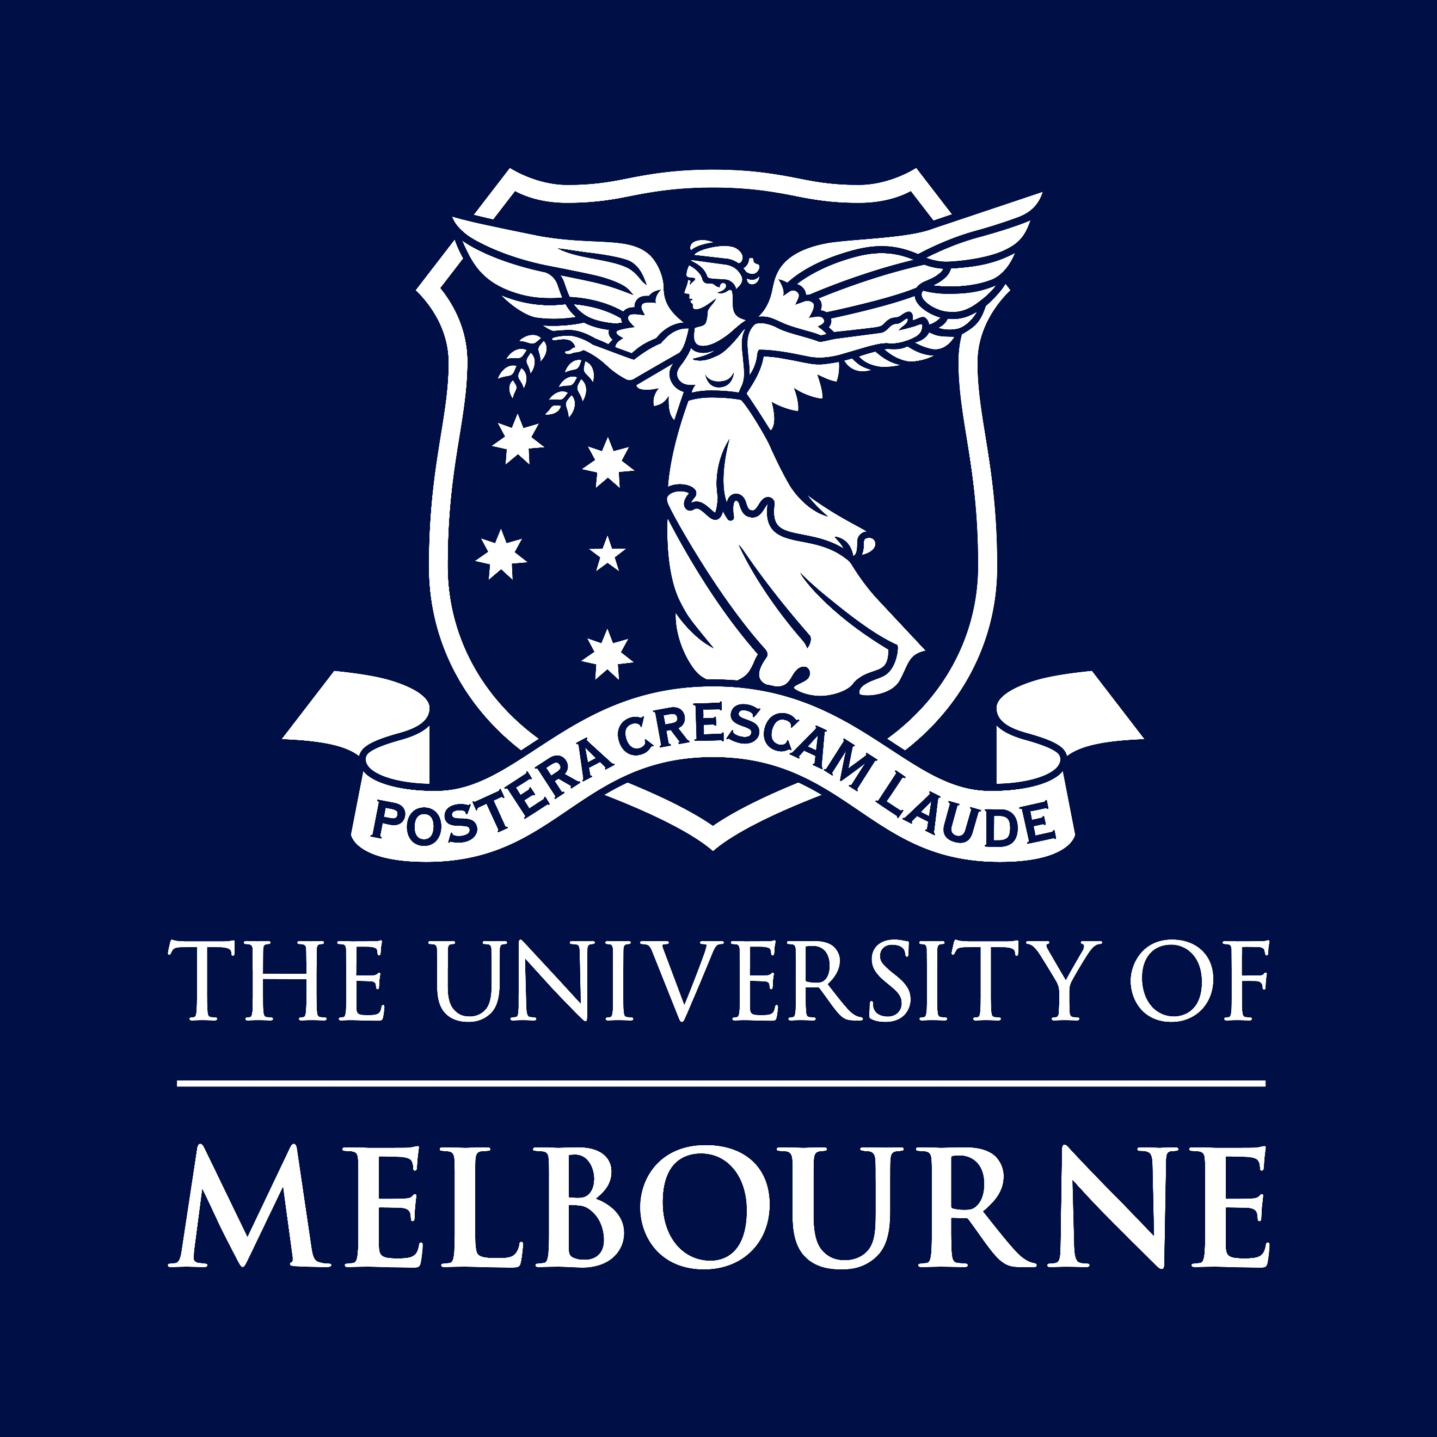

POSITION DESCRIPTION

Chancellery (DVC Indigenous)
Indigenous Program Manager
This position is open only to Indigenous Australians.

Only Indigenous Australians are eligible to apply as this position is exempt under the Special Measure Provision, Section 12(1) of the Equal Opportunity Act 2010 (VIC).

Position No | 3548363
Classification | UOM 8
Salary | UOM 8 - $125,191 - $135,504 per annum (pro rata for part-time)
Superannuation | Employer contribution of 17%
WORKING HOURS | Full time
BASIS OF EMPLOYMENT | Continuing
Other Benefits | https://about.unimelb.edu.au/careers/staff-benefits
How to Apply | Online applications are preferred. Go to http://about.unimelb.edu.au/careers, select the relevant option (‘Current Opportunities’ or ‘Jobs available to current staff’), then find the position by title or number.
contact  For enquiries only | Ebony Henderson  ebony.henderson@unimelb.edu.au  Please do not send your application to this contact
For information about working for the University of Melbourne, visit our website:
about.unimelb.edu.au/careers
Acknowledgement of Country
The University of Melbourne acknowledges the Traditional Owners of the unceded land on which we work, learn and live: the Wurundjeri Woi Wurrung and Bunurong peoples (Burnley, Fishermans Bend, Parkville, Southbank and Werribee campuses), the Yorta Yorta Nation (Dookie and Shepparton campuses), and the Dja Dja Wurrung people (Creswick campus).
The University also acknowledges and is grateful to the Traditional Owners, Elders and Knowledge Holders of all Indigenous nations and clans who have been instrumental in our reconciliation journey.
We recognise the unique place held by Aboriginal and Torres Strait Islander peoples as the original owners and custodians of the lands and waterways across the Australian continent, with histories of continuous connection dating back more than 60,000 years. We also acknowledge their enduring cultural practices of caring for Country.
We pay respect to Elders past, present and future, and acknowledge the importance of Indigenous knowledge in the Academy. As a community of researchers, teachers, professional staff and students we are privileged to work and learn every day with Indigenous colleagues and partners.

The University of Melbourne
Established in 1853, the University of Melbourne is a leading international university with a tradition of excellence in teaching and research. The main campus in Parkville is recognised as the hub of Australia’s premier knowledge precinct comprising eight hospitals, many leading research institutes and a wide-range of knowledge-based industries. With outstanding performance in international rankings, the University is at the forefront of higher education in the Asia-Pacific region and the world.
The University of Melbourne employs people of outstanding calibre and offers a unique environment where staff are valued and rewarded.
Further information about working at The University of Melbourne is available at http://about.unimelb.edu.au/careers

Strategy 2030: Resilience
As set out in the University of Melbourne's Strategy 2030, our purpose is to benefit society through the transformative impact of our education and research. This can only be achieved by building a resilient institution, empowering our people, and working toward shared ambitions.
Our aspiration for 2030 is to be a world-leading, globally connected Australia university with students at the heart of everything we do. Strategy 2030 provides a sharp focus to advance our shared ambitions and guide us through to 2030.
It elevates three core ambitions:
- Exceptional Education: Educating our outstanding students to thrive in complexity
- Transformational Research: Creating knowledge, fostering innovation and transforming lives
- Our Resilient University: Serving and connecting Country, people and community
The strategy identifies our University’s distinctive capabilities including Indigenous scholarship, world-class curriculum, our diverse community and our global research networks and precincts.

Four focus areas for action guide decision-making and ensure the University is equipped for challenges ahead. These are: Empowering people and performance, Improving student experience, Partnering for impact and Leading with a future-focus.
For more information, visit https://about.unimelb.edu.au/strategy/strategy-2030
Chancellery

ORGANISATION UNIT

INDIGENOUS PORTFOLIO
Led by the Deputy Vice-Chancellor (Indigenous), the Indigenous Portfolio provides strategic leadership and coordination to advance the University’s Indigenous priorities across the organisation. Guided by Murmuk Djerring: The University of Melbourne Indigenous Strategy 2023–2027, the portfolio works to embed 2 Indigenous perspectives, strengthen outcomes for Indigenous staff and students, and support meaningful engagement with Indigenous communities.
The Indigenous Portfolio operates across the University, working in partnership with faculties, Chancellery and professional services to drive strategic alignment, policy development and the delivery of initiatives that support Indigenous leadership, participation and success. The portfolio balances long-term strategic direction with implementation and operational delivery, ensuring Indigenous priorities are integrated into the University’s planning, programs and performance.
The Indigenous Portfolio is comprised of the following teams:
- Indigenous Strategy
- Indigenous Partnerships
- Korin Korin
- Murrup Barak
- The Academy of Sport, Health and Education (ASHE)

KORIN KORIN
Korin Korin leads Indigenous employment initiatives at the University of Melbourne. They focus on attracting and recruiting Aboriginal and Torres Strait Islander staff, supporting retention and career development, fostering culturally safe and inclusive workplaces, and driving strategic change to increase Indigenous leadership and representation.

BUDGET DIVISION
The Chancellery is led by the Vice-Chancellor and has a University-wide focus on:
- Delivering strategic leadership
- allocating capital according to strategic priorities
- developing and overseeing a business framework that includes appropriate financial and other organisational planning and controls
- ensuring identity or brand is consistent with strategic intent and purpose, and
- overseeing policies and initiatives that develop the academic and professional expertise of University staff members.

Position Summary
Reporting to the Associate Director, Korin Korin, the Indigenous Programs Manager is accountable for leading and delivering key initiatives under the University’s Indigenous Employment Framework 2023–2027, along with related strategies, policies, and programs. The role is responsible for driving outcomes across Indigenous staff recruitment, retention, professional development, and the strengthening of connections and networks.
The position will also have accountability to build strong relationships with HR support services across the University, ensuring consistent, culturally informed advice and practice. The role also leads Indigenous Employment Programs across the university, with accountability for program growth, end-to-end delivery, stakeholder engagement, participant outcomes,compliance and reporting. Through this work, the position ensures measurable impact and continuous improvement in Indigenous employment outcomes and culturally safe practices across the University.
- Task level: Significant
- Organisational knowledge: Significant
- Judgement: Significant
- Reporting line: Direct report to Associate Director Indigenous Employment and Development
- No. of direct reports: Nil
- No. of indirect reports: Nil
- Direct budget accountability: As directed

KEY RESPONSIBILITIES
- Support the implementation of initiatives within Murmuk Djerring and the Indigenous Employment Framework 2023–2027, ensuring alignment with University priorities.
- Coordinate and deliver Indigenous Employment Programs, including program design, delivery, and continuous improvement.
- Develop and design new Indigenous Employment Programs initiatives university-wide, for mentorships, academics, and others.
- Design and deliver programs that support recruitment, retention, and career development outcomes for Aboriginal and Torres Strait Islander staff.
- Actively work to build building capability across HR and leadership teams to embed culturally safe and inclusive practices.
- Drive program growth and sustainability, ensuring clear pathways and opportunities for Indigenous participants.
- Establish and maintain strong stakeholder relationships across faculties, departments, and external partners.
- Monitor and evaluate program performance, ensuring achievement of targets and measurable outcomes.
- Ensure compliance with relevant policies, frameworks, and reporting requirements.
- Prepare high-quality reports, briefings, and insights to inform decision-making and strategy.
- Identify risks and opportunities, and implement improvements to strengthen program effectiveness and impact.
- Other tasks as directed.

Selection Criteria

ESSENTIAL
- Demonstrated experience leading complex programs or initiatives, ideally in HR, employment, or workforce development.
- Proven ability to deliver measurable outcomes in recruitment, retention, and development programs.
- Strong understanding of issues impacting Aboriginal and Torres Strait Islander employment and career progression.
- Experience providing high-level advice and building capability across HR or organisational stakeholders.
- Demonstrated ability to lead and manage end-to-end program delivery, including planning, implementation, evaluation, and reporting.
- Strong stakeholder engagement skills, with the ability to influence and build trusted relationships at all levels.
- Experience managing competing priorities and delivering results in a complex organisational environment.
- High-level communication skills, including the ability to prepare clear reports, briefings, and presentations.
- Demonstrated commitment to fostering culturally safe, inclusive, and respectful workplaces.

DESIRABLE
- Knowledge of relevant policies, frameworks, and compliance requirements within large organisations or the higher education sector (desirable).

OTHER JOB-RELATED INFORMATION
- Occasional work out of ordinary hours, travel, etc.
- This position requires the incumbent hold a current and valid Working with Children Check. The University of Melbourne is dedicated to safeguarding the welfare of all community members, especially those most vulnerable. As part of our commitment to child safety and in line with the Victorian Child Safe Standards, this position will be required to hold a valid Employee WWCC, regardless of where in the University an employee may work or what work they do.

Equal Opportunity, Diversity and Inclusion
The University is an equal opportunity employer and is committed to providing a workplace free from all forms of unlawful discrimination, harassment, bullying, vilification and victimisation. The University makes decisions on employment, promotion, and reward on the basis of merit.
The University is committed to all aspects of equal opportunity, diversity and inclusion in the workplace and to providing all staff, students, contractors, honorary appointees, volunteers and visitors with a safe, respectful and rewarding environment free from all forms of unlawful discrimination, harassment, vilification and victimisation. This commitment is set out in our Diversity and Inclusion Strategy 2030 that addresses diversity and inclusion, equal employment opportunity, discrimination, sexual harassment, bullying and appropriate workplace behaviour. All staff are required to comply with all University policies.
The University values diversity because we recognise that the differences in our people’s age, race, ethnicity, culture, gender, nationality, sexual orientation, physical ability and background bring richness to our work environment. Consequently, the People Strategy sets out the strategic aim to drive diversity and inclusion across the University to create an environment where the compounding benefits of a diverse workforce are recognised as vital in our continuous desire to strive for excellence and reach our strategic targets.

Occupational Health and Safety (OHS)
All staff are required to take reasonable care for their own health and safety and that of other personnel who may be affected by their conduct.
OHS responsibilities applicable to positions are published at:
https://safety.unimelb.edu.au/people/community/responsibilities-of-personnel
These include general staff responsibilities and those additional responsibilities that apply for Managers and Supervisors and other Personnel..

Governance
The Vice-Chancellor is the Chief Executive Officer of the University and responsible to Council for the good management of the University.
Comprehensive information about the University of Melbourne and its governance structure is available at https://about.unimelb.edu.au/strategy/governance

