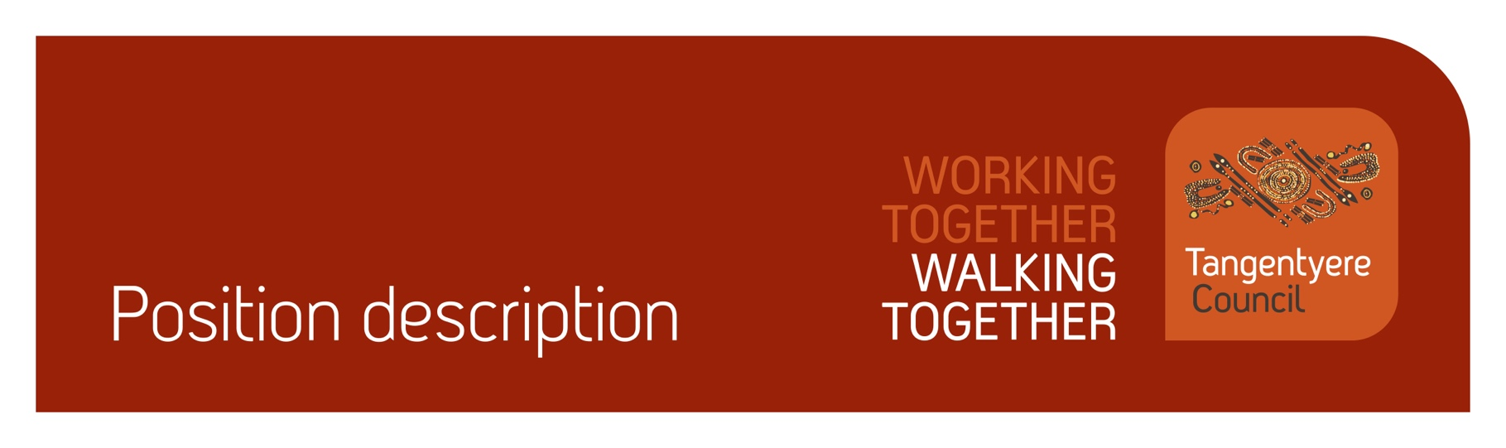

Position title | Senior Architect & Manager
Division | Tangentyere Designs
Classification | 8.1
Prepared by | Patrick McDonald
Date | 01/04/2026
Staff reporting to position | 2-4

Position Summary
Tangentyere Council Aboriginal Corporation (TCAC) is a community controlled Public Benevolent Institution delivering human services and social enterprise activities for the benefit of Aboriginal people from the Alice Springs Town Camps, urban Alice Springs, and Central Australia.
Tangentyere Design, a subsidiary of TCAC, is an Aboriginal-owned architectural practice based in Alice Springs. For three decades Tangentyere Design has been providing architectural and project management services to Aboriginal Australians throughout the Northern Territory, as well as to Commonwealth and Territory Government Agencies, and to a range of commercial and private clients.
Design has professional experience and expertise in a range of project types including health and housing, childcare and education, art and culture, recreation, and administration. Tangentyere Design is a Public Benevolent Institution that emphasizes the use of design and participatory development approaches to deliver appropriate housing and infrastructure to promote safety and wellness.
The Senior Architect and Manager of Tangentyere Design is responsible for the day-to-day management of Tangentyere Council’s social enterprise. The position is responsible for managing architectural projects, staff supervision and general office administration. The position reports to a board of directors, providing advice and reporting on strategic direction and financial performance.
As part of your role, you will be working with children, people with a disability and people who are vulnerable. It is your obligation to always ensure their safety and report any concerns in line with our duty of care obligations. We have zero tolerance when it comes to abuse of any kind and will take disciplinary action, including and up to termination of employment, should we determine that abuse has taken place or there has been a failure to report any suspected or alleged abuse.

Responsibilities
- Support Tangentyere Council and its strategic objectives by advancing Tangentyere Design’s charitable trust mission, including support of Town Camp residents and their aspirations for a healthy, safe and secure built environment.
- Plan and implement strategies for a sustainable social enterprise, balancing the commercial imperative to remain financially viable while also delivering a social outcome.
- Prepare fee proposals and tender submissions and manage architectural projects across a range of building types, budgets, and client groups.
- Manage architectural projects through all phases of delivery.
- Manage staff and foster a positive work culture.
- Prepare project accounts, maintain budgets, develop work plans and resourcing strategies; and liaise with Tangentyere Finance, Payroll, HR, and other Tangentyere Council support personnel.
- Prepare annual reports, attend, and report at Town Camp meetings and Tangentyere Council AGMs.
- Assist with achieving quality management objectives across the organisation.
- Assist with achieving safeguarding objectives across the organisation.
- Assist with achieving compliance objectives across the organisation.
- Other reasonable duties as required.

Major Accountabilities
Accountabilities | Performance indicators
- Support Tangentyere Council and its strategic objectives by advancing Tangentyere Design’s charitable trust mission, including support of Town Camp residents and their aspirations for a healthy, safe, and secure built environment. | - Strategic plan developed with Design Board.  - Strategic plan complements TCAC’s Strategic Plan.  - Performance against strategic plan is monitored annually.
- Plan and implement strategies for a sustainable social enterprise, balancing the commercial imperative to remain financially viable while also delivering a social outcome. | - Business plan prepared and presented to Design Board.  - Performance against business plan is monitored quarterly.
- Prepare fee proposals and tender submissions and manage architectural projects across a range of building types, budgets, and client groups. | - Fee proposals and tender submissions prepared and lodged to generate future income streams.
- Manage architectural projects through all phases of delivery. | - Projects are delivered on schedule and according to budget.  - All contractual requirements are met.  - Projects meet the needs and expectations of clients.
- Manage staff and foster a positive work culture. | - Qualified and experienced staff who share the enterprise’s values and vision are recruited and inducted.  - Staff roles and responsibilities are defined and communicated through written position descriptions.  - Monthly supervision is provided and recorded  - Channels for team interaction are implemented and maintained.
- Prepare project accounts, maintain budgets, develop work plans and resourcing strategies; and liaise with Tangentyere Finance, Payroll, HR, and other Tangentyere Council support personnel. | - Project accounts are prepared monthly.  - An annual budget is prepared for approval by Design Board and monitored monthly.  - Each project has a work plan with staff allocated.  - Billing, payments, payroll and HR matters are addressed in a timely manner in conjunction with Tangentyere Council support personnel.
- Prepare annual reports, attend and report at Town Camp meetings and Tangentyere Council AGMs. | - Annual report prepared.  - Report delivered at TCAC AGM.  - Town Camp meetings attended as required.
- Assist with achieving quality management objectives across the organisation.  - Commitment to the Tangentyere Council Quality Management Objectives. | - All work-related actions and behaviours are aligned with the organisations mission and values.  - Actively participate in and promote a continuous improvement culture across the organisation.  - Understand and comply with organisation policies and procedures.  - Maintain organisation and client records in accordance with legislative and organisational policy requirements.  - Ensure all decisions made in the course of your duties are transparent and align with organisational policy and procedures.  - Assist clients to provide feedback when required.  - Contribute to QMS area audits as required in a timely manner.  - Contribute to implementing change when identified through the QMS as required.  - Provide feedback on the QMS as required.
- Assist with achieving safeguarding objectives across the organisation. | - Report any concerns or suspicions of abuse of children, people with a disability or vulnerable peoples in line with duty of care and mandatory reporting obligations.
- Assist with achieving compliance objectives across the organisation. | - Maintain own records and manage Employment Hero compliance for staff, where applicable.  - Maintain current certifications (Driver’s Licence, Working with Children (Ochre Card), Police Check, and where relevant, RN Registration, White Card and First Aid Certificate etc.) and upload evidence in Employment Hero.  - Complete probation reviews (6, 12 and 22 weeks) within the approved timeframe.  - Read and acknowledge all relevant policies in Employment Hero.
- Other reasonable duties as required. | - Additional tasks that may arise from time to time are completed within the required timeframe and to a suitable standard.

Relationships
Internal
- Tangentyere Council Corporate Members | - Tangentyere Design Board
- Office of the Chief Executive | - Town Camp Associations
- Youth & Community Safety Services Division | - Community Centre Division
- Family Safety & Social Services Division | - Tangentyere Employment Services
External
- Department of Infrastructure, Planning & Logistics | - Territory Families, Housing & Communities
- Alice Springs Town Council | - Power and Water Corporation

Competencies
Tangentyere core competencies
- Commitment
- Teamwork
- Communication
- WHS
- Cultural Awareness

Qualifications and Selection Criteria
Required
- Relevant academic qualification in architecture.
- Architectural registration within Australia transferable to the NT.
- An understanding of issues facing Aboriginal people in Central Australia and the capacity of architecture to assist with these challenges.
- An ability to communicate and work effectively with Aboriginal people.
- A strong commitment to improving the lives of Aboriginal people through design quality in the built environment.
- An understanding of environmental health principles and its role in fostering healthy living opportunities.
- Proven ability to develop and maintain high level relationships with clients and stakeholders.
- Strong leadership, interpersonal and supervisory skills.
- Strong administration and business development skills.
- Sound oral and written communication skills.
- Current NT Drivers Licence, NT Working with Children (Ochre) Card, satisfactory Police Check.
Desired
- 8+ years experience post registration.
- Current First Aid Certificate, or ability and willingness to attain.
- An understanding of Aboriginal culture as well as a broad range of contemporary issues affecting Central Australian Aboriginal people.

Verification
This section verifies that the position holder and the manager have read the attached position description and are satisfied that it accurately describes the position.
Position holder
Name
Date effective
Signature
Manager
Name
Date effective
Signature

