

Position Description

National Program Manager
Position No: | NEW
Business Unit: | Provost
Division: | School of Psychology and Public Health
Research Centre:  Classification Level: | ARCSHS  HEO8
Employment Type: | Full-time, Fixed Term (2 years)
Campus Location: | Campus Independent
Other Benefits: | http://www.latrobe.edu.au/jobs/working/benefits
Further information about: La Trobe University - http://www.latrobe.edu.au/about

Position setting

The Australian Research Centre in Sex, Health and Society (ARCSHS) is a leading research and knowledge translation centre housed in the School of Psychology and Public Health at La Trobe University. Founded in 1993, the Centre has expertise in the areas of sex and sexual health, gender and sexuality, family violence, and alcohol and other drug consumption, as well as numerous other aligned topics. ARCSHS also has extensive experience developing the capability of health and human services to integrate evidence into practice. The Centre’s purpose is to create and translate knowledge that enables inclusion, equity, health and wellbeing, particularly as they relate to sex, gender, sexuality and relationships. Through research and knowledge translation work, ARCSHS supports better understandings of, and solutions for, social problems facing communities in Australia and the world today.

ARCSHS includes an innovative knowledge translation program called Rainbow Health Australia. Rainbow Health Australia supports lesbian, gay, bisexual, trans and gender diverse, intersex and queer (LGBTIQA+) health and wellbeing through training, resources, policy advice and service accreditation through the Rainbow Tick.

Position context

The role holder will manage delivery of a federally funded initiative designed to improve the safety, inclusivity, and quality of primary care for LGBTIQA+ people across Australia. Led by Rainbow Health Australia at ARCSHS, La Trobe University, in partnership with primary care and LGBTIQA sectors, the program integrates accreditation, workforce training, and relationship management to embed lasting, evidence-based change in primary care organisations. The program will support primary care providers, including ACCHOs, and health NGOs to achieve LGBTIQA+ accreditation, deliver training to primary care practitioners, and produce publicly accessible consumer information to help LGBTIQA+ people find safe, affirming care.

The National Project Manager will provide operational leadership and oversight for the project, supervising staff and coordinating activity across a diverse consortium of national partners to ensure delivery is on time, within budget, and aligned with program objectives. The role is responsible for supporting the delivery of the project’s workstreams, governance processes, risk and quality frameworks, and stakeholder relationships.

Duties at this level will include:

- Program Delivery and Coordination
- Develop and maintain the program plan and support the coordination of workstream plans, ensuring milestones, deliverables, and reporting obligations are met across all consortium partners.
- Oversee project implementation including, lead day-to-day coordination of project and support the work of project partners

2. Consortium and Stakeholder Management
- Serve as the primary operational liaison between ARCSHS and consortium partners
- Maintain and implement the RACI framework, partnership agreements, and inter-organisational accountability mechanisms

3. Governance, Risk, and Quality
- Lead program governance processes, including preparation for steering committee meetings, reporting against KPIs, and oversight of financial compliance in line with La Trobe University's financial control systems
- Maintain a comprehensive risk and quality framework, actively monitoring risks across recruitment, timelines, data security, stakeholder engagement, and program quality
- Embed continuous improvement processes, using monitoring data, stakeholder feedback, and evaluation findings to refine and strengthen delivery

4. Evaluation and Reporting
- Work closely with the internal and independent evaluation teams to ensure robust data collection, feedback loops, and alignment between process and outcome measures
- Prepare regular progress reports for the funding body, governance bodies, and consortium leadership
- Support the development of knowledge translation outputs

5. Communications

- Support stakeholder communications, program branding, and public-facing materials consistent with program values and consortium guidelines

6. Culture and Strategy

- Work collaboratively to identify and implement strategies to improve processes, create a positive work culture
- Lead activities that align to and help to progress ARCSHS strategic plan

Selection Criteria
Essential
- Demonstrated experience managing complex, multi-partner programs or projects at a national scale, including in health, community services, or social policy contexts.
- Strong understanding of primary care systems in Australia, including the roles of general practice, ACCHOs, PHNs, and relevant accreditation bodies.
- Proven ability to manage competing priorities, project budgets, and reporting obligations across multiple stakeholders and workstreams.
- Experience working in meaningful partnership with community organisations and other stakeholders.
- Knowledge of and commitment to LGBTIQA+ health equity, inclusion, and the specific health needs of LGBTIQA+ communities, including First Nations LGBTIQA+ people.
- Excellent communication, relationship management, and facilitation skills, with demonstrated ability to work across diverse organisations, sectors, and communities.
- Experience developing and implementing governance, risk management, and quality assurance frameworks.
- High-level organisational skills and attention to detail, with the ability to maintain program momentum across geographically dispersed partners.
- Experience in conducting, analysing, and summarising research/consultation and/or knowledge translation processes, including the ability to synthesise findings into clear, actionable recommendations for diverse stakeholders.

Desirable
- Understanding of workforce capability frameworks and digital-first learning delivery.
- Experience working with First Nations community-controlled health organisations and applying culturally safe, self-determination principles.
- Postgraduate qualifications in public health, project management, social sciences, or a related field (or equivalent experience)

Capabilities required to be successful in the position
- Knowledge of own strengths, weaknesses and biases – modifying behaviour, based on self-reflection and feedback, to respond to others with empathy and act on feedback to improve knowledge, skills and behaviour.
- Ability to work collaboratively, demonstrate inclusivity and tailor communication in a way that is meaningful to the audience – consistently modelling accountability, connectedness, innovation and care.
- Demonstrated creative and critical thinking, ability to generate ideas to solve local problems and recommend improvements to current work practices.
- Ability to make sense of data to inform decision making – implementing ideas to improve local practices.
- Ability to cultivate and create space for creativity and innovation, enabling staff members to solve local problems and identify improvements to current work practices.

Essential Compliance Requirements

To hold this La Trobe University position the occupant must:

- hold, or be willing to undertake and pass, a Victorian Working With Children Check; AND
- take personal accountability to comply with all University policies, procedures and legislative or regulatory obligations; including but not limited to TEQSA and the Higher Education Threshold Standards.

Other Information

The position description is indicative of the initial expectation of the role and subject to changes to University goals and priorities, activities or focus of the job.

Position Flexibility

We offer flexible work arrangements that can assist you in balancing your work and other responsibilities.

ARCSHS Values


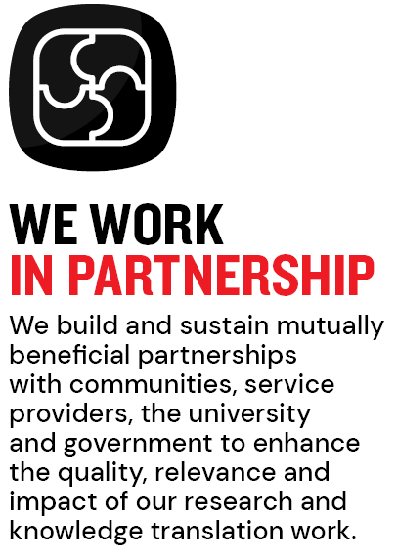

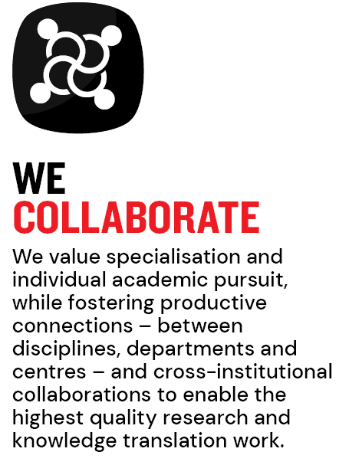

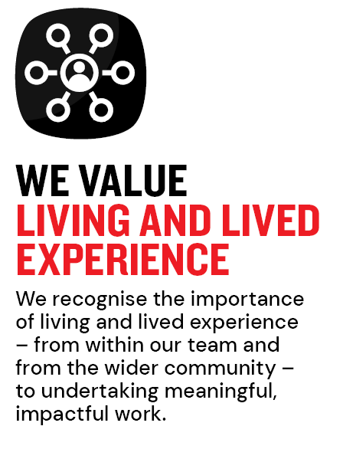
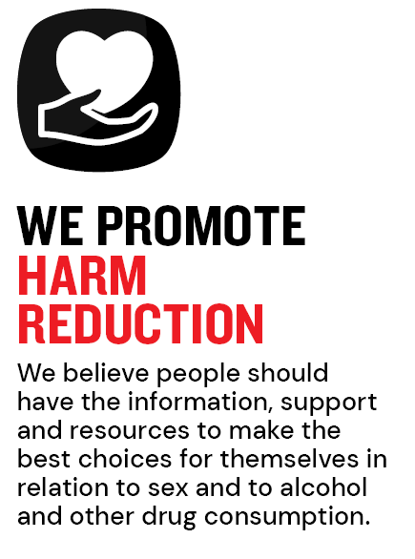
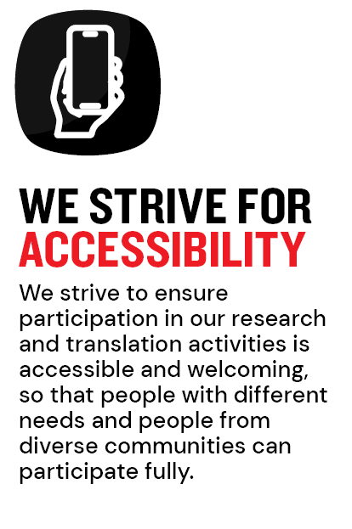

Why La Trobe:

- Develop your career at an innovative, global university where you’ll collaborate with community and industry to create impact.
- Enjoy working on our inspiring and stunning campuses – the perfect hub for industry, students and academics
- Help transform the lives of students, partners and communities now and in the future

This is more than just a job. Working at La Trobe offers opportunities to demonstrate excellence and transform lives.

Here, you’ll join exceptional people, partners and communities, who power our operations with ambition and purpose.

Our success can be attributed to its strong sense of community. We have a long-standing commitment to diversity, inclusion and social justice; we are committed to providing a workplace where all staff feel valued, respected and supported to achieve their full potential. We strive to build a workplace where all employees of diverse backgrounds, abilities, experiences, sexuality, gender, religion and age are welcome, valued, respected and one that is representative of our community. We demonstrate our cultural qualities by holding ourselves accountable and creating a culture of trust and innovation while genuinely caring for one another.

La Trobe’s Cultural Qualities:

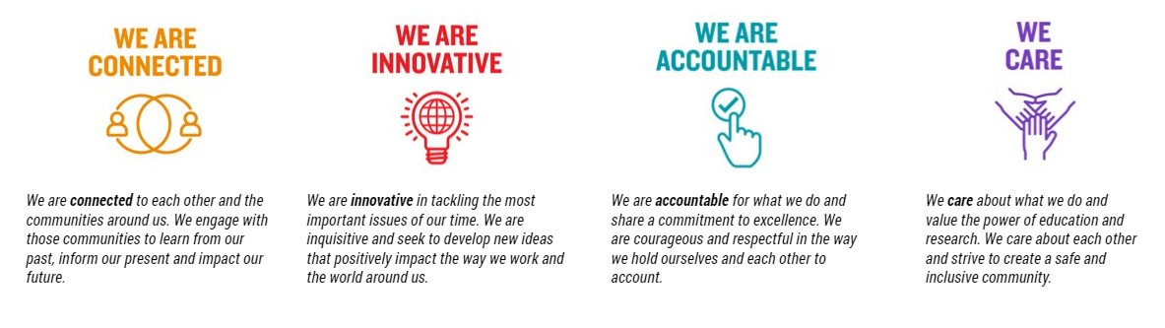

For People & Culture Use Only
Initials: Date:

