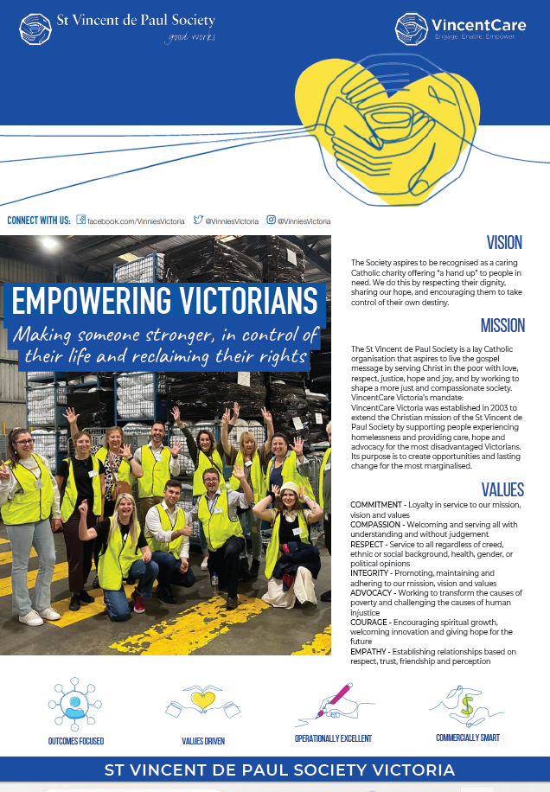
Position Description
Job Title | Project Lead – Membership Projects
Reports to | Head of Projects & Reporting
Department | Strategy, Technology & Impact
Direct/Indirect Reports | TBC
Date Revised | June 2026

Position Summary
The Project Lead is responsible for the implementation of a number of strategic initiatives and projects in our membership space. This role will lead the foundation and establishment of our referrals, partnership and case management capability across the society as well as leading projects to optimise the support structures provided to our membership to optimise efficiency and meaningful support for our Members.
This role requires excellent stakeholder management skills, working closely with our Membership & Special Works team and our Member Governance structures to implement projects that have lasting change and support the Society in meeting its strategic objectives. This role requires navigating community and social service systems to support design and implementation of these practices in a member led organisation.
This is a 2 year fixed term contract.

Position Key Responsibilities
Project Management | - Define project scope, objectives, deliverables and success criteria in line with the SVDPV strategic objectives and the SVDPV project delivery framework.  - Plan and manage project timelines, budget, resources and dependencies to ensure efficient delivery.  - Establishing governance frameworks, providing regular updates, reporting and project controls.  - Lead a small cross-functional team including planning, assigning tasks and monitoring progress against milestones.
Stakeholder Management | - Identify and understand the motivations/interest of key stakeholders including in membership  - Facilitate engagement through workshops, meetings & feedback sessions  - Ensure that member needs and value proposition are reflect in project outcomes and service delivery  - Manage communications across member bases, including updates, consultation and feedback loops.  - Monitor member satisfaction, participation & retention, adjusting approaches to enhance member value.
Change Management | - Working closely with the Membership & Special Works team as well as Change Managers to plan, prepare and deliver lasting changes to membership  - Work with change managers to define and implement change management strategies aligned to organisational objectives.  - Assess change impacts across people, processes & systems to inform planning  - Engage stakeholders to build support, address resistance and drive adoption.
Contribute to the organisational culture | - Demonstrate understanding and empathy with the mission and ethos of the St Vincent de Paul Society and ensure the Society’s values are incorporated into all aspects of the performance of the role  - Respect the values inherent within the organisation and encourage reflective practice in the workplace  - Engage, inspire and influence organisational culture  - Actively participate in activities that develop your personal and professional skills, knowledge and experience  - Regularly attend and actively participate in all team / divisional and organisational meetings  - Contribute to developing a culture of continuous improvement and respond positively to change
Safety | - Take reasonable care for your own safety and that of others in line with policy and procedures  - Identify and report hazards within 24 hours of them occurring on the incident reporting system  - Manage day to day risks in line with policy and procedures

THE LIST OF RESPONSIBILITIES HEREIN IS NOT INTENDED TO BE ALL-INCLUSIVE, AND MAY INCLUDE ADDITIONAL RESPONSIBILITIES AS REQUIRED AND ASSIGNED. IT MAY BECOME NECESSARY TO MODIFY/CHANGE THESE POSITION RESPONSIBILITIES FROM TIME TO TIME.
Key Selection Criteria
Qualifications
- Tertiary qualification in Business, Project Management or related field (or equivalent previous experience)
- Project Management certification (highly regarded)
- Degree in social work or community development certificate (highly regarded)
Experience
- Leading end to end project delivery across complex or multi-stakeholder environments
- Managing cross-functional teams & coordinating multiple workstreams/projects.
- Working with membership-based organisations (favourable)
- Designing or implementing service delivery models involving triage, assessment & referral pathways.
- Service design for people accessing a range of community services (navigating different support services)
- Working with community services, health, NFP, membership or regulated environments
Skills/Knowledge
- Basic understanding of case management desirable
- Highly developed communication skills, including reporting & presentations
- Understanding of end-to-end lifecycle management (intake > assessment > referral > outcome tracking)
- Experience coordinating between multiple service providers or internal teams to deliver outcomes.
- Ability to influence at all levels of the organisation
- Strategic thinking and ability to translate objectives into actionable plans.
- Referral pathways and reporting obligations and requirements and ability to translate this into a framework/guidelines/tools.

Wellbeing, Health and Safety
Child Safety Statement
St Vincent de Paul Society is committed to the safety and wellbeing of all children and young people. Our members, volunteers and employees understand that child safety is everyone’s responsibility and is at the centre of all that we do and every decision we make.
We have zero tolerance for child abuse or neglect of child safety
We are committed to providing a child safe environment where children and young people are safe and feel safe, and their voices are heard about decisions that affect them. This includes but is not limited to the cultural safety of Aboriginal & Torres Strait Islander children, children from diverse cultural, linguistic, and/or religious backgrounds, children who identify as LGBTQI+, and children with a disability.
Whilst all St Vincent de Paul programs and activities may not involve regular contact with children by SVDP Representatives, it is the decision of St Vincent de Paul State Council that all St Vincent de Paul programs and activities will be subject to the Child Safety Policy
Diversity and Inclusion
We are committed to the principles of social justice and aim to ensure every individual is treated with dignity and respect regardless of their cultural background, ability, ethnicity, gender identity, sexual orientation or religion.


