POSITION DESCRIPTION
Sparkways Non-Executive Director & Chair – Finance, Audit and Risk Management Committee (FARM)
(Voluntary Appointment)

1. Organisation Overview
Sparkways is a not-for-profit provider of early childhood education and care services operating within a highly regulated environment. The organisation is committed to delivering high-quality outcomes for children and families through the provision of accessible, inclusive and innovative early childhood education and care programs, underpinned by strong governance, financial stewardship and effective risk management.
https://sparkways.org.au/

The Board is skills-based and accountable for strategic oversight, financial sustainability and regulatory compliance.

2. Organisation Purpose
Sparkways purpose is to provide inclusive, high-quality early childhood education and care that breaks the cycle of disadvantage and enables every child to thrive.
Sparkways is committed to:
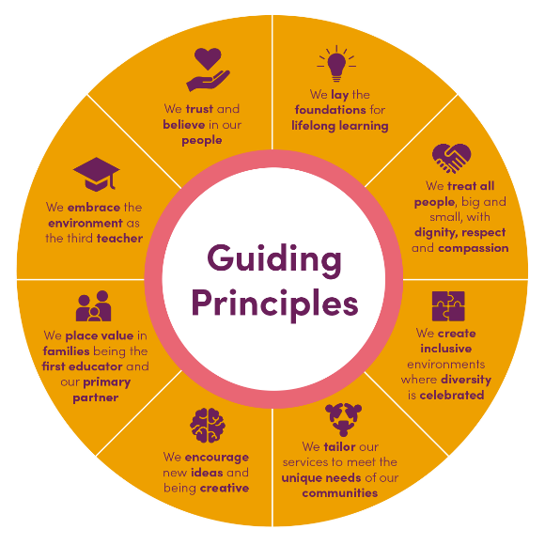
Sparkways works alongside children, families and communities to support building capacity, resilience, and independence. Sparkways prides itself on being a trusted and collaborative partner with a passion for discovering new ways of doing things, which are responsive to social need.

Child safety
Sparkways is a child safe organisation. Child safety is a critical aspect of all roles and responsibilities in the organisation. All Non-Executive Directors (NEDs) must fully understand their obligations in relation to child safety regulation and oversight.
Sparkways promotes the rights of all children to participate, have purpose, and be protected from harm. Sparkways has a zero tolerance of any behaviours or attitudes that might cause harm to children.
3. Position Purpose
The Non-Executive Director (NED) will serve as a member of the Board and Chair of the Finance, Audit and Risk Management Committee (FARM).
This is a critical governance appointment. The Board seeks a senior finance and risk leader with the expertise, judgement and presence to provide independent oversight and constructive challenge in relation to financial performance, audit integrity and enterprise risk.
The Non-Executive Director is expected to contribute constructively to Board deliberations, provide independent oversight and support effective decision making and contribute to the effective governance, strategic directions and long-term sustainability of the organisation.
The role is strictly governance-focused and carries no operational responsibilities.

4. Key Responsibilities
4.1 Board Responsibilities
As a director, the appointee will:
Strategic Leadership
- Contribute to the development and oversight of the organisation's strategic direction
- Support the achievement of the organisation's vision, mission and objectives
- Consider emerging opportunities, challenges and risks affecting the organisation and the early childhood sector
- Promote long-term organisational sustainability

Governance and Oversight
• Fulfil directors' duties with due care, diligence and independence
• Act in the best interests of the organisation at all times
• Ensure appropriate governance frameworks, policies and systems are maintained
• Monitor organisational performance against strategic and operational objectives
• Oversee organisational compliance with legal, regulatory and funding obligations
• Uphold the highest standards of ethical conduct and accountability
Financial Stewardship
• Review and approve annual budgets and financial plans
• Monitor financial performance and organisational sustainability
• Ensure appropriate financial controls and risk management processes are in place
• Contribute to Board discussions regarding investments, capital expenditure and financial strategy
Risk and Compliance
• Oversee strategic, operational, financial and reputational risks
• Support the maintenance of an effective enterprise risk management framework
• Provide oversight of emerging risks on compliance, governance and child safety obligations, including cyber security, digital transformation, workforce sustainability, regulatory reform and child safety
Board Contribution
• Prepare for and actively participate in Board meetings and strategic discussions
• Contribute professional expertise and independent judgement
• Work collaboratively with fellow Directors, the CEO and senior leadership
• Serve on Board committees as required
• Declare and appropriately manage conflicts of interest

4.2 Chair – Finance, Audit and Risk Management Committee
The Chair will lead the Committee in providing rigorous oversight across financial reporting, audit and risk.
- Financial Governance
  - Oversee the integrity and accuracy of financial reporting
  - Review budgets, forecasts and financial performance
  - Monitor liquidity, reserves and capital management
  - Ensure appropriate internal controls and financial delegations are in place
- Audit and Assurance
  - Oversee the appointment, independence and performance of external auditors
  - Review annual financial statements and audit findings
  - Monitor implementation of audit recommendations
  - Ensure compliance with applicable accounting standards and regulatory reporting obligations
- Risk Oversight
  - Oversee the enterprise risk management framework
  - Review and monitor known and emerging strategic, operational, financial and regulatory risks
  - Ensure risk registers and mitigation strategies are robust and current
  - Provide assurance to the Board regarding the effectiveness of risk governance systems
- Committee Leadership
  - Set agendas in consultation with the Board Chair and CEO
  - Facilitate disciplined and evidence-based discussion
  - Report clearly and succinctly to the Board
  - Drive continuous improvement in Committee effectiveness

5. Candidate Profile
The successful candidate will bring deep financial and risk management expertise and demonstrated governance capability.

5.1 Qualifications
- Relevant tertiary qualification in finance, accounting or related discipline
- CPA or CA qualified
- GAICD (Graduate of the Australian Institute of Company Directors) or other applicable NED governance qualification highly desirable, though not mandatory
5.2 Experience
- Current or former senior finance executive (e.g. CFO or equivalent) ideally with experience managing government funded programs
- Experience overseeing complex financial operations and financial strategy
- Board experience, preferably including service on or chairing a Finance, Audit or Risk committee
- Extensive experience working with external auditors
- Strong understanding of audit and assurance processes, including oversight of annual financial statements
- Demonstrated experience overseeing risk management frameworks and governance reporting

5.3 Personal Capability
- High levels of integrity, independence and professional judgement
- Gravitas to operate credibly at Board level
- Independent judgement and sound decision-making capability
- Commitment to the organisation’s purpose and values
- Capacity to provide constructive challenge while maintaining collegiality
- Strong communication skills, with the ability to translate complex financial matters for a diverse Board
- Ability to work effectively with both established and newly appointed Non-Executive Directors
5.4 Desirable
- Experience within the not-for-profit sector
- Understanding of the early childhood education and care sector
- Familiarity with government-funded service environments

6. Time Commitment
- 8 Board meetings per annum
- 4 Finance, Audit and Risk Committee meetings per annum
- Estimated total hours for Board and Committee Meetings including preparation time is 44 hrs per annum
- Participation in annual strategy and governance review sessions (estimated 3 hrs per annum)
7. Remuneration
This is a voluntary, non-remunerated appointment.

8. Term of Appointment
- Initial term of 3 years
- Eligible for reappointment in accordance with the Constitution

9. Governance Obligations
The Director will:
- Comply with all statutory and fiduciary duties
- Maintain confidentiality
- Declare and manage conflicts of interest
- Uphold the organisation’s child safety and governance standards including obtaining a National Police Check, Working with Children Check and completion of child safe training
- Maintain ongoing professional development appropriate to the role
- Be required to become a registered Person of Management Control (PMC) for the organisation
- Hold, or are eligible to obtain, a Director Identification Number

Why Join the Board?
This is an opportunity to contribute to an organisation that makes a meaningful difference in the lives of children, families and communities. As a Non-Executive Director, you will help shape the strategic direction of a respected not-for-profit organisation while applying your skills and experience to support strong governance and long-term impact.

