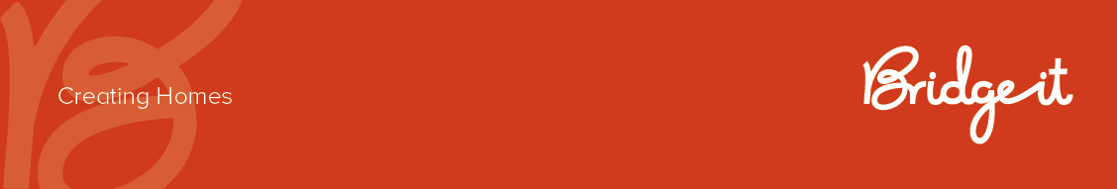

Expression of Interest

POSITION TITLE: | Community Cooking Volunteer
REPORTS TO: | Team Leader/Wellbeing Coordinator
REMUNERATION CLASSIFICATION: | Volunteer (Unpaid)
LOCATION: | St Kilda Cocoon
HOURS: | 7.5 per month minimum
TERM: | 6 month commitment
SUPERVISES: | Nil

ORGANISATION OVERVIEW

Bridge It was founded in June 2021 with the vision of creating a high-impact, supportive housing program for young women and gender-diverse people who have been impacted by the out-of-home care system or homelessness.
Bridge It’s Cocoon provides high-quality, affordable, and self-contained homes for 12-18 months. Beyond housing, The Cocoon offers a comprehensive range of supports, including:
- Lived experience mentoring
- Life and living skills development
- Therapies and community-building activities
- Support with resident’s daily life

Bridge It innovates, collaborates, and challenge the status quo, and is an organisation that meets the needs of the young people we support. At Bridge It, we believe in the potential of young people and are committed to supporting them to thrive.

OUR MISSION & VALUES

Our Mission
To end youth homelessness by providing homes, community, and high-quality support.

Our Vision
- Micro Vision: A Cocoon in every state of Australia.
- Macro Vision: Inspiring new ways of thinking so that homelessness support is life-changing
- and long-lasting.
- Mega Vision: We play a role in ending youth homelessness in Australia
Our Values

- Community: Building meaningful connections and relationships.
- Fun: Creating joyful, supportive environments.
- Aspiration: Encouraging dreams and ambitions.
- Safety: Ensuring secure, stable, and nurturing spaces.
- Connection: Fostering a sense of belonging and collaboration.

ROLE PURPOSE

The Community Cooking Volunteer will support resident wellbeing, connection, and life-skills development through the preparation of shared meals and inclusive cooking activities at The Cocoon.
This role is ideal for someone who enjoys cooking, sharing food, and creating welcoming environments where young people can develop confidence in meal planning, food preparation, and cooking skills. Volunteers will work alongside residents where appropriate, encouraging participation in a flexible, supportive, and trauma-informed way.
The role is designed to work around your availability, with a minimum commitment of one day per month, ideally on a Monday evening until 7pm (however this is flexible). We welcome volunteers who can offer regular sessions and are also open to discussing low bono arrangements where specialised expertise is being provided.
Bridge It will cover the cost of all approved ingredients, food, and program materials.
We are particularly interested in people who have experience or interest in:
- Home cooking and meal preparation
- Community kitchens or shared meal programs
- Teaching practical cooking and food preparation skills
- Nutrition and healthy eating
- Culturally diverse cooking practices
- Working with young people and/or vulnerable communities
- Creating inclusive and welcoming community spaces

KEY DUTIES
- Plan and prepare nutritious, enjoyable meals for residents of The Cocoon
- Facilitate opportunities for residents to participate in meal planning, shopping (where applicable), food preparation, and cooking
- Promote confidence and independence in practical cooking and kitchen skills
- Create a safe, inclusive, and welcoming environment that encourages social connection and community building
- Adapt activities to residents' varying interests, abilities, and comfort levels
- Maintain safe food handling, hygiene, and kitchen practices
- Work collaboratively with Cocoon staff to support resident wellbeing and engagement
- Maintain appropriate professional boundaries and ethical practice
- Complete brief session notes or feedback as required
- Comply with Bridge It policies, including safeguarding, food safety, and confidentiality

PERSONAL QUALITIES & BEHAVIOURAL CAPABILITIES
- Warm, empathetic, and trauma-informed approach
- Strong active listening and communication skills
- Ability to work flexibly and adaptively with young people with complex needs
- Culturally safe and inclusive practice
- Collaborative and professional in team environments
- Ability and confidence to identify, respond and report risks to Bridge It

QUALIFICATIONS / EDUCATION
*Desirable but not essential
- Demonstrated experience in cooking, food preparation, catering, hospitality, community kitchens, or meal-based community programs
- Confidence preparing meals for small groups (*approx. 8 people) and adapting meals to a range of dietary requirements where needed
- Experience engaging, teaching, or mentoring others in practical cooking and food preparation skills
- Understanding of safe food handling and kitchen hygiene practices
- Knowledge of trauma-informed, strengths-based, and inclusive approaches to working with young people (or willingness to learn)
- Ability to create welcoming, culturally safe, and inclusive environments that encourage participation and connection
- Current Food Safety Handler Certificate or equivalent (desirable)
- Current Police Check and Working with Children Check (mandatory – Bridge It can fund this for successful applicants)
- Australian Driver's Licence preferred

EMPLOYEE ACKNOWLEDGEMENT
I, ____________________________, acknowledge that I have read and understood the role requirements for my position. I am committed to fulfilling these responsibilities to the best of my abilities.
......................................................... ....................................................
Signature Date

