ADRA Australia
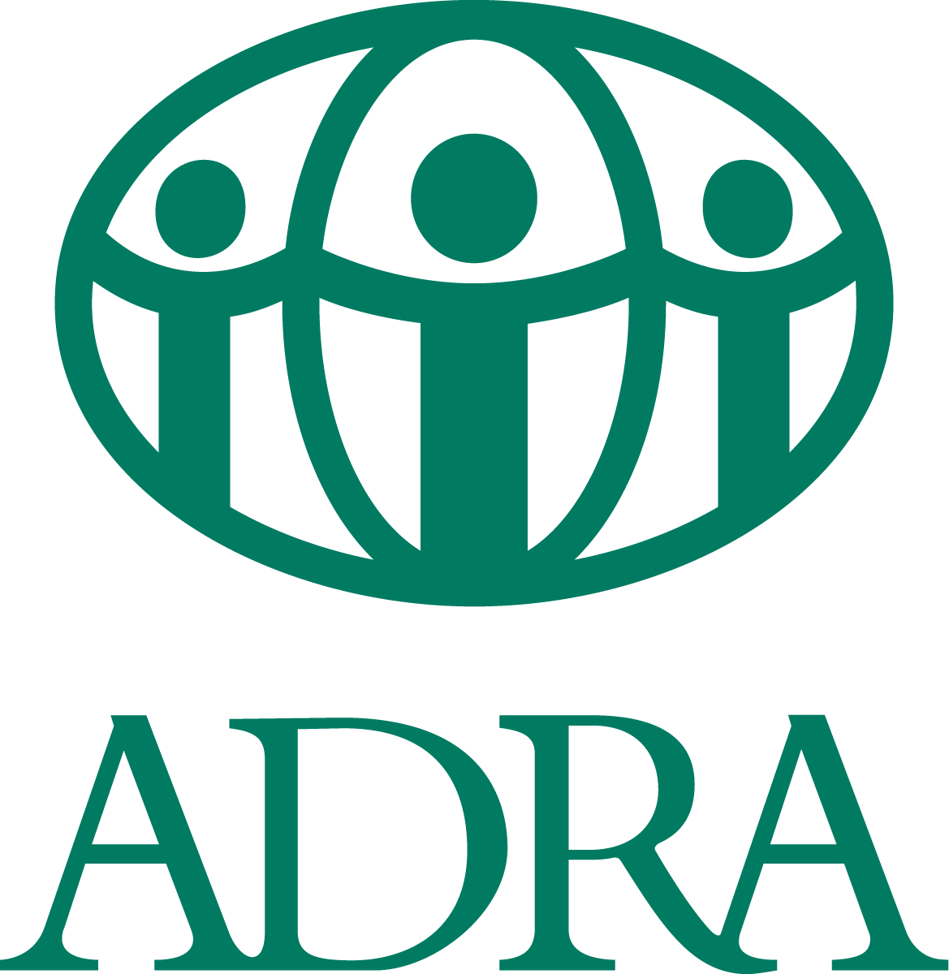
Op Shop Manager
Commitment: Part-time, Fixed Term Contract (24 hours per week)
Location: ADRA Op Shop Ballina, NSW

About the role
ADRA Australia is seeking an organised Op Shop Manager who will enjoy the opportunity to use their superior administrative skills to work with and support the National Programs team.

As the Op Shop Manager, you will oversee the daily operations of the Op Shop, fostering a welcoming and positive environment for volunteers and the local community while upholding ADRA’s vision, mission, and policies as outlined in the National Programs Operations Manual. Your responsibilities will include recruiting, onboarding, and managing volunteers, maintaining shop presentation, and building relationships within the community. You will also ensure compliance with Safeguarding policies, maintain accurate records, provide regular reports, and manage expenditures within the approved budget. This role requires strong leadership and organizational skills to ensure the shop operates smoothly, ethically, and effectively.

As the successful applicant you are a servant-leader who is passionate about ADRA’s purpose, “to serve humanity so all may live as God intended” and are committed to meeting the challenges of this diverse role with enthusiasm, collaboration, and teamwork.
You must have the legal right to live and work in Australia at time of application.
The Job Description for the role and the Employment Application Form are included at the end of this document.
About ADRA Australia
The Adventist Development and Relief Agency (ADRA) is the official humanitarian agency of the Seventh-day Adventist Church. As part of the global ADRA network which reaches into more than 118 countries, we are motivated by our faith, to enable people and communities in Australia, New Zealand, the South Pacific, Asia and Africa to improve their health and livelihoods and assist people to prepare for and recover from disasters around the world.

ADRA Australia holds full accreditation with the Australian Government Department of Foreign Affairs and Trade (DFAT) and is a member of the Australian Council for International Development (ACFID) and the Australian Council for Social Services (ACOSS).

Our Values - We conduct our work by being:
Connected - working collaboratively for the best outcome for those living in poverty or distress.
Courageous - persevering through challenging situations.
Compassionate – empathising with the communities we work with and with each other.

About the National Programs Teams
The Op Shop Manager is appointed by ADRA Australia ADCOM and reports to the Regional Manager for NSW.

The National Programs team works collaboratively with the following ADRA Australia teams:
- Emergency Management
- Finance/IT
- International Programs
- People and Culture
- Supporter Engagement

Selection Criteria
Essential
- Commitment to the purpose of ADRA, and to the achievement of our overall strategy and priorities with demonstration of our ADRA values and desired team culture lived out in all aspects of work practice.
- Willingness to work within a Christian ethos with conduct that is respectful of the beliefs and practices of the Seventh-day Adventist Church when in the workplace or otherwise representing ADRA Australia.
- Leadership & Volunteer Management – Proven ability to recruit, train, and manage volunteers, fostering a positive and inclusive work environment.
- Organisational & Administrative Skills – Strong record-keeping, reporting, and financial management skills, ensuring compliance with budgeting and ADRA policies.
- Customer Service & Community Engagement – Excellent interpersonal and communication skills to engage with volunteers, customers, donors, of various backgrounds and ages.
- Business & Retail Acumen – Experience in retail operations, including shop presentation, stock management, and sales strategies to enhance store performance.
- Commitment to ADRA’s Mission & Compliance – Understanding of Workplace Health & Safety (WHS), Safeguarding policies, and ethical retail practices, ensuring alignment with ADRA’s values.
- Attention to Detail - Demonstrated ability to accurately manage and maintain records, documents, and processes.
- Demonstrated ability to work well in a team, facilitate administrative processes.
- Technical Proficiency - Strong skills in data management and proficiency in Microsoft Office, particularly Excel and Word, with the ability to quickly learn, adapt to, and navigate new systems and technologies.

Desirable
- Proven ability to contribute to the continuous improvement of processes and procedures that are fit-for-purpose, and compliance with overarching protocols.
- Experience with Xero and Salesforce.
- Experience in working in the not for profit/NGOs.

Key Competencies
- Leading and Supervising
Provides others with a clear direction; Sets appropriate standards of behaviour; Delegates work appropriately and fairly; Motivates and empowers others; Provides staff with development opportunities and coaching; Recruits staff of a high calibre.
- Working with People
Demonstrates an interest in and understanding of others; Adapts to the team and builds team spirit; Recognises and rewards the contribution of others; Listens, consults others and communicates proactively; Supports and cares for others; Develops and openly communicates self-insight.

- Relating and Networking
Establishes good relationships with colleagues; Builds wide and effective networks of contacts inside and outside the organisation; Relates well to people at all levels; Uses humour appropriately to enhance relationships with others.

- Planning and Organising
Sets clearly defined objectives; Plans activities and projects well in advance and takes account of possible changing circumstances; Manages time effectively; Identifies and organises resources needed to accomplish tasks; Monitors performance against deadlines and milestone.
Other Requirements
- At the time of application, the successful applicant will already have the legal right to live and work in Australia.
- Commitment to abide by the ADRA Australia Code of Conduct and organisational policies and procedures. A copy of relevant policies is available on request.
- ADRA Australia takes the prevention of sexual misconduct, harassment and child safeguarding seriously and screens applicants for suitability. The successful applicant will be required to obtain a police check for each country in which the individual has lived for 12 months or longer over the last five years, and for the individual’s country of citizenship (including dual citizenship holders). The successful applicant will need to provide their consent to a criminal record check. ADRA Australia recognises that in limited instances it may prove impossible to obtain a reliable criminal record check. In such circumstances a statutory declaration outlining efforts made to obtain a foreign police check, and disclosing any charges and spent convictions may be accepted.
- Applicants will be requested to disclose whether or not they have had a substantiated Sexual Exploitation Abuse or Harassment claim of any nature made against them in Australia or overseas. This is included in the Job Application Form.

How to Apply
To apply, candidates should address the selection criteria in their application letter providing examples of past experiences and qualifications. There is no closing date, however we will be interviewing suitable candidates as they apply. Please forward your application letter, resume and the Employment Application form found at the end of this document, along with the names of three work related referees to: HR@adra.org.au

If you have questions or need further information, please contact:

Gianina Coutts – Human Resources Officer for ADRA Australia,
Phone +61 2 9473 9525 or email: HR@adra.org.au

ADRA Australia is an inclusive and Equal Employment Opportunity (EEO) employer.

The appointing body reserves the right to fill this position at its discretion and to close applications early.

See Job Description and Employment application forms following.

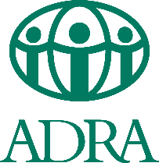 |  | Position Title: | Op Shop Manager – ADRA Op Shop Ballina |  | Part Time: | 5 Months Fixed Term - 24 Hours Per Week
 | Connected | Department: | National Programs |  | Revised Date: | May 2026
 | Courageous | Reports To: | ADRA Regional Manager NSW
 | Compassionate | Team Supervision: | Team Leaders and Volunteers

Purpose of Position: A basic statement that describes the intent of the position.
The role of the ADRA Op Shop Manager (hereafter called the Manager) is to manage the day-to-day operations of the Op Shop, promote a healthy, positive environment for volunteers and the local community.
The Manager is employed by ADRA Australia to manage volunteers, complete administrative requirements necessary whilst maintaining and promoting the vision and mission statement of ADRA Australia.
The Manager is responsible for a wide range of tasks e.g. recruitment and onboarding of volunteers, shop presentation, networking in the community, record keeping and reporting to the Local Management Committee (LMC) as required, WHS, Safeguarding and ensuring that expenditure does not exceed the approved budget.
The Manager is to adhere to all codes, policies, procedures and guidelines set out by ADRA Australia in the National Programs Operations Manual.
Behavioural Expectations: Our code of Conduct - How we do things in our organisation that underpins our values.

Compliance with ADRA Australia’s Code of Conduct including Work Health and Safety. The Manager will demonstrate, promote and maintain a safe work environment that values confidentiality, punctuality, humanity, justice, independence, compassion, transparency, collaboration and commitment.
Key Competencies: The competencies, qualifications, skills and experience the person needs to do the role successfully.
Leadership, collaboration, initiative, problem solving, flexibility, interpersonal and organisational skills, visioning, innovation, research, analysis and communication,
ADRA Competency Framework: 1.2 Leading and Supervising, 2.1 Working with People, 3.1 Relating & Networking, 6.1 Planning and Organising.

Key Responsibilities: The things that the person needs to be responsible for to successfully fulfil the obligations of this position.

Area of Responsibility  Groupings or areas of responsibility | Actions / Tasks / Objectives  What has to get done in this area | Measures of Success / KPI’s  How job performance will be measured
OPERATION AND FINANCIAL MANAGEMENT | - Manage the Op Shop on sound established business principles.  - Operate the shop in accordance with all applicable legislation set by the Australian Charities and Not-for-profit- Commission regarding financial and operational compliance and reporting. Follow all policy and procedures set by ADRA Australia.  - Attend all relevant ADRA training events, where practicable.  - Use ADRA’s branding guidelines for all advertising, signage, social media and promotions.  - Work closely with the National Retail Manager (NRM) and ADRA Regional Manager (RM) as required.  - Schedule, attend and report at Local Management Committee (LMC) Meetings.  - To work with the ADRA RM to achieve ADRA objectives, such as the delivery of emergency relief services and Disaster Response.  - Work with the treasurer to ensure appropriate cash-handling and that banking procedures are followed, and expenditure does not exceed the LMC-approved budget. | - Ensure 100% compliance with ADRA policies and financial budgets.  - Complete all financial and operational reports accurately and submit them on time  - 80% training attendance rate  - 100% compliance to branding guidelines  - Frequency and quality of communications  - Minimum of once-a-month check-ins with the RM and NRM  - 90% attendance rate at LMC meetings  - Quarterly manager’s report submitted to every LMC meeting  - Ensure zero breaches in cash-handling procedure
VOLUNTEERS AND STAKEHOLDER MANAGEMENT | - Appoints relevant team leaders and supervisors to create a sustainable framework for the Op Shop (in case the Manager is sick/on leave) if required.  - Responsible for the recruitment, resourcing and management of Op Shop volunteers (recruitment, orientation, training, performance reviews, dismissal etc).  - Managing volunteers to ensure that the Op Shop is a safe workplace for all, that everyone is treated fair and equally, and adverse behaviour addressed appropriately.  - Conduct weekly meetings with the volunteers as a minimum. (E.g Daily or weekly Toolbox)  - Create a welcoming and safe environment for the community to shop at. Ensure that the Op Shop is kept clean and maintained.  - To provide/arrange referrals for both clients and staff where required and provide appropriate assistance and support to people in need. | - Number of volunteers recruited and retained  - Conduct onboarding for 100% of new volunteers within two weeks of joining.  - Hold at least one volunteer meeting per week, and one monthly staff meeting.  - Positive feedback from volunteers, clients and staff on assistance and support provided
WORKPLACE HEALTH & SAFETY (WHS) | - Monitor and maintain health and safety aspects of the Op Shop environment and staff, including training, WHS on the agenda of all meetings as well as appropriate use of the WHS platform.  - Undertaking relevant training provided in relation to WHS.  - Correctly use any information, training personal protective equipment and safety devices provided.  - Refrain from intentionally misusing or recklessly interfering with anything that has been provided for health and safety reasons.  - Undertaking only those tasks for which they have authorisation and/or the necessary training, and for which all necessary safety arrangements are in place.  - Report any WHS incidents on Salesforce as soon as possible | - WHS discussions included in 100% of staff and volunteer meetings, with documented minutes and action items.  - 100% of volunteers complete mandatory WHS training within their first two weeks of joining.  - Positive staff feedback on the usefulness of WHS training  - Staff awareness and adherence to health and safety guidelines  - 100% of Incidents have report submitted on Salesforce.  - Percentage of tasks performed with proper authorization and training

Employee Signature: |  |  |  | Supervisor(s) Signature(s): |  |  |  | Date: / /
Print Employee Name: |  |  |  | Print Supervisor Name:

Adventist Development and Relief Agency Limited  ACN 85 109 435 618  Employment Application Form | 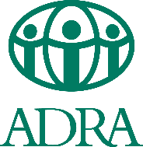

Title |  | First Name |  |  |  |  | Last Name
Current Address: (Street, Town, State, Post Code, Country)
Phone No. |  | Home |  |  |  | Mobile |  | Work
Email |  |  |  |  |  |  |  | Gender
Position applying for:
GENERAL |  |  |  |  |  |  |  | Type in “Yes” or “No” or an appropriate comment
- Are you ALREADY legally entitled to live and work in Australia? If you are not an Australian citizen, please provide your visa details.
If the response to Question 1 is No, we are unable to consider your application and there is no need to proceed any further.
- What prompted you to apply for this role? Why would you like to work for ADRA?
- Do you have any illnesses or injuries which may affect your ability to perform the essential requirements of the job for which you have applied? If yes, please provide details below:
SAFEGUARDING
- ADRA Australia’s strict safeguarding policies aim to help protect children, young people and vulnerable adults. In line with these policies are you willing to undergo a police check, a working with children check and be screened through Adsafe*?
- Do you have any convictions or charges related to child abuse? If yes, please provide details below:
- ADRA Australia has a zero tolerance to Sexual Exploitation and Harassment. Do you have any convictions or charges related to sexual abuse or harassment of any nature made against you in Australia or overseas? If you have responded “Yes”, please provide details below:
ADRA AS PART OF THE SEVENTH-DAY ADVENTIST CHURCH
- Have you ever worked for ADRA or any other entity of the Seventh-day Adventist Church in Australia or overseas under your current name or another name? If yes, please provide details of your last position below:
- Do you have any relatives currently employed by the Seventh-day Adventist Church? (We need to check any conflicts of interest.)
If the answer is Yes, please list their names and places of employment below.
Name |  |  |  |  | Place of Work
- Are you a practising Seventh-day Adventist? (If you are not an SDA, this does not exclude you from applying for the position).

Being employed by ADRA Australia, which is part of the Seventh-day Adventist Church, involves understanding, representing and being committed to the Church’s mission and lifestyle in your professional life. (Our code of conduct policy is available on request.) Please respond to the following two questions.
- Do you understand the Church’s lifestyle values? (These include abstinence from tobacco, alcohol, recreational drug use, immoral, illegal conduct, etc.)
- If you are employed by ADRA Australia, are you happy to reflect its purpose and values in your work and adhere to its lifestyle values in your professional life?

I understand, agree and declare that:
- If required by ADRA Australia I will undertake a pre-employment medical screening by an ADRA designated practitioner who shall pass completed details of the examination to ADRA (Refer Point 3).

- If required by ADRA, I will produce documentary evidence relevant to this application e.g. identification, work visa, evidence of my qualifications, etc.

- Any statement made by me in this document which is found to be deliberately misleading shall render me, if employed, liable to dismissal.

- The Terms and Conditions of my employment shall be in accordance with:
- Any applicable State or Federal Laws.
- The appropriate Industrial Award and/or church policy.

Signature | Date

*Adsafe has been established by the Seventh-day Adventist Church as a service and resource to assist local Churches and Denominational Entities to protect children and vulnerable adults, to comply with applicable legislation and to develop denominational policy.

