Physiotherapist

Department: | Allied Health
Reports To: | Allied Health Manager
Direct Reports: | None
Salary Classification: | Depending on Qualification and experience
Enterprise Agreement: | Allied Health Professionals (Victorian Public Sector) (Single Interest  Employers) Enterprise Agreement 2021-2026
Effective Date: | October 2025

Position Objective/Purpose
To provide evidence- based physiotherapy services in accordance with the code of Professional Conduct as set down by the Australian Physiotherapy Association.

Selection Criteria

Essential:
- Tertiary qualification in Physiotherapy and registered as a Physiotherapist with the Australian Health Practitioner Regulation Authority.
- Demonstrated effective and highly developed interpersonal and communication skills and be able to work within an interdisciplinary team.
- Demonstrated understanding and ability to provide client focused and evidence -based care in a range of clinical settings including inpatient and outpatients, residential aged care and the community.
- Ability to provide direction and supervision to support staff.
- Possess competent computer skills and the ability to provide relevant reports and statistics.

Desirable:
- Two years post graduate experience in a rural setting with an understanding of rural health issues.
- Understanding of the National Health priorities.
- Understanding of NDIS and be able to demonstrate how to work effectively within the NDIS framework.
- Working in a large and complex healthcare system (desirable)
- Proven understanding of the role and value of healthcare organisations in a rural environment
- Experience with paediatric clients
- Valid Victorian or NSW Driver's License

Role and Responsibilities
Key Responsibility  Area | Tasks
Clinical Care | - Acute care inpatient services working in a multidisciplinary team to provide patient centered care and support discharge planning

- Outpatients provide assessments, plan and implement evidence- based treatments for patients referred or self-referred to physiotherapy using a patient centered approach
- Residential Aged care providing assessments and interventions and working with care staff to optimize residents' physical functioning
- Provide Fall risk assessments to individuals in acute and residential aged care and for the community and design and support individual or group interventions to improve balance, coordination, strength and mobility to reduce falls risk and maximize physical function.
- Assess and treat patients with acute and chronic health conditions including but not limited to musculoskeletal conditions and injuries, neurological, cardiovascular and pulmonary disorders
- To completely and effectively use a range of physical and electrical modalities in patient interventions
- To assessing and evaluating programs and treatments using relevant outcome measures and patient goals
- To participate in the Continuum of Care program with other health professionals in the provision of coordinated care to complex clients
- To work with patients and their families to implement effective home programs.
- Complete accurate clinical documentation to record assessment findings, patient responses to treatment and progress in accordance with relevant legislative requirements
- developing and implementing screening and preventative health promotion programs
Efficient, Effective, Safe Service Delivery | - Continuous Quality Improvement aligned with National Safety and Quality Health Service Standards, Australian Aged Care Accreditation Standards, National Disability Insurance Scheme and Australian General Practice Accreditation Limited  - Timely and accurate completion of data relating to service delivery  - Reporting of outcomes/ deliverables in line with funding agreements
Professional Conduct | - The interchange and management of communication with internal and external stakeholders.  - Compliance with relevant codes of conduct and policies and  procedures, including infection control and confidentiality.

- Compliance with relevant legislation such as work health and safety, equal opportunity and anti-discrimination.
- Behaving in a professionally responsible and accountable manner at all times.
- Compliance with Agency mandatory training Policy.
- Flexibility in working role related to changing job requirements
Work Health and Safety | - Take reasonable care for their own health and safety and comply and cooperate with reasonable instructions, policies and procedures regarding the safety and health of other persons and workplaces  - Incidents and hazards reported within the required notification timeframe  - Follow safe practices/procedures to perform your duties in a manner, so as affect the health and safety of yourself or others  - Participate in development of safe work procedures and risk assessments with your Supervisor when required  - Actively participate in WHS inductions and training when required,  - Wear and use Personal Protective Equipment (PPE) in the prescribed manner and when specified  - Participate in workplace inspections if required  - Use and maintain plant or equipment of any kind, including computer and other telecommunication devices in accordance with instructions and procedures  - Participate in code and emergency preparedness training  - Report all hazards, near misses and damage as per agency reporting procedure  - Participate in accident and incident investigations as required  - Not discriminate, harass or bully any work colleague.

About Corryong Health
Corryong Health (CH) is a public sector agency and one of six multi-purpose services in Victoria. CH is funded by Commonwealth and Victorian State Government funding, and provides a broad range of hospital (Acute and Urgent Care), residential aged care, medical and primary health and community support services. We provide services to the Corryong community and operate a Medical Clinic, Health and Fitness Centre and Retirement Village.
Corryong Health is committed to continuous quality improvement aligned with National Safety and Quality Health Services Standards, Australian Aged Care Accreditation Standards, National Disability Insurance Scheme and Australian General Practice Accreditation Limited.

Our Values
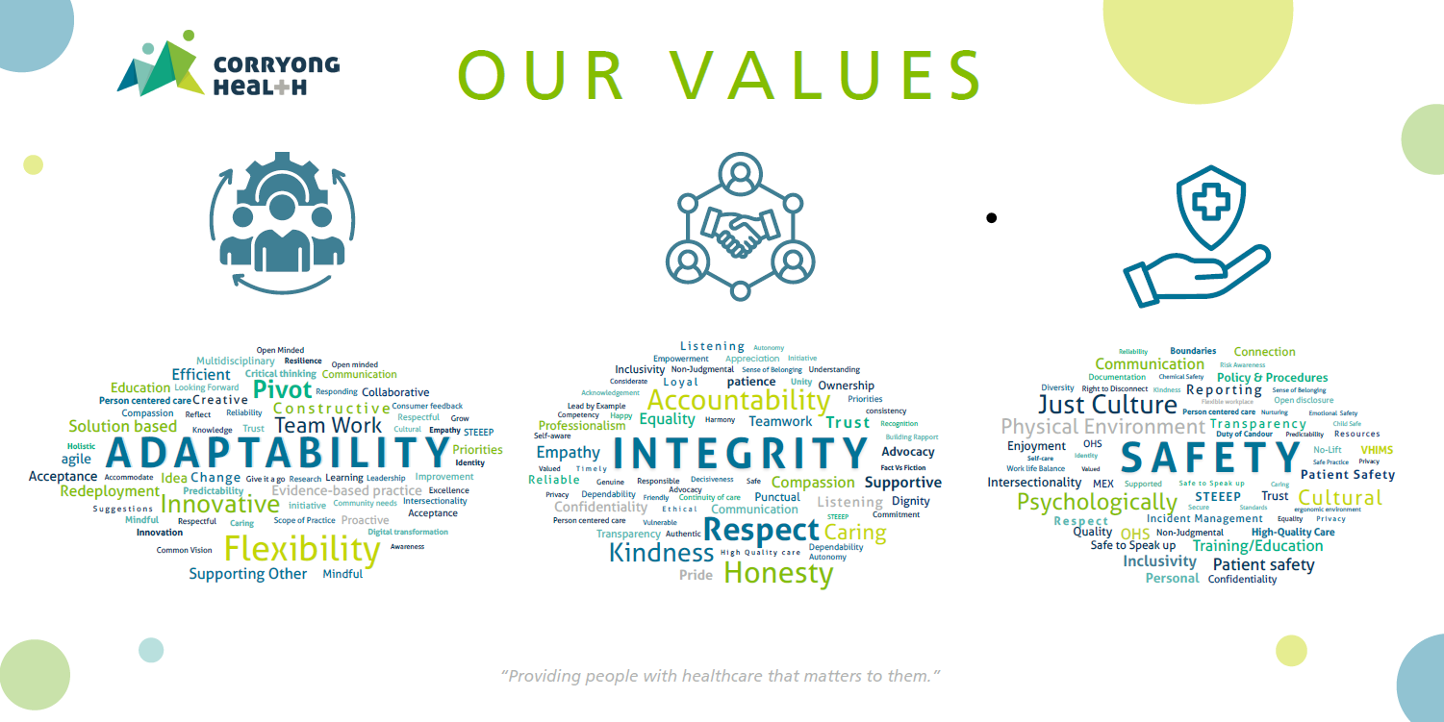
Our values are a core element at Corryong Health. All employees are required to uphold our values and to comply with the behaviours in relation to them. Our values provide guidelines on how employees at Corryong Health must behave.
Corryong Health is an equal opportunity employer and is committed to providing a diverse and inclusive workforce, free from bullying, harassment and discrimination.

Other Information
Pre-employment Checks | The following pre-employment checks are mandatory before commencing this position:  - NDIS worker screening check  - Working with Children's Check
ANZSCO Classification

This position description is a true reflection of the current requirements of the role. Corryong Health will regularly review position descriptions and appropriately update them during the performance review process to ensure that they relate to the job being performed, or to incorporate whatever changes are being proposed. Where appropriate, employees will be consulted on the changes and employees are expected to participate in consultation.
I have read, understood and accepted the responsibilities as outlined in this position description.

Signature Date

Employees Name (Printed please)

