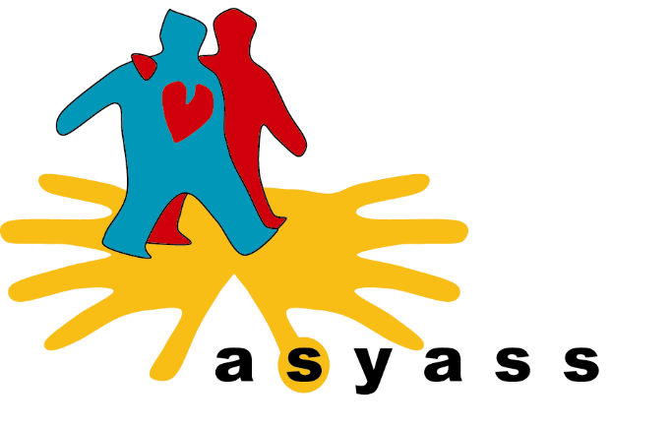
Position Description
Position title: Quality Assurance Officer – 38 hours per week
Date: 9 March 2026
Reports to: Chief Executive Officer
Salary and conditions commensurate with the SCHCaDSI Award. Significant salary sacrifice is available.
Duties Specific to Role
- Ensuring compliance with industry regulations such as ISO and QIP requirements.
- Provide high level support to the CEO/Quality Assurance Manager for the continual improvement of the Quality Assurance Systems that exceeds the needs of ASYASS and its key stakeholder groups.
- Assist in completion of internal audits to ensure compliance with contractual obligations and continuous improvement opportunities are identified and actioned.
- Assist in developing policies, procedures, work instructions and standard operating procedures within the work area consistent with Quality Assurance, Work, Health and Safety and relevant guidelines.
- Maintain documents in the Quality Assurance System and records relating to internal audit, surveys.
- Maintain the Share Point management system, Track and ensure ‘Non-conformance Reports’ and ‘Corrective Actions’ are actioned and verified in the appropriate timeframe.
Education, Qualifications and Requirements [Mandatory]
- Success in this role will demand an understanding of the causes and impact of homelessness and other presenting issues such as disability, mental health and an empathic approach to those in our community who may find themselves homeless and disadvantaged.
- A minimum Diploma in either Youth work, social work, Community development, Psychology, Social Sciences, Disability Services or Mental Health with a minimum of 3 years’ experience working in housing, a residential setting, or Community Services
- Internal Auditor – Quality Management Systems or willingness to obtain

Skills & Experience:
A sound understanding of and ability to research relevant legislation, standards, and guidelines relating to the Human Services/Community sector and exposure to human services auditing processes
- Well-developed interpersonal skills that foster trust and collaboration
- Attention to detail with excellent analytical and problem-solving skills
- Well-developed skills and knowledge of MS Office software including Excel, Word, PowerPoint, Outlook and the ability to learn new ICT systems
- Knowledge of ISO 9001 Quality Management System, QIP system and WHS Legislation.
- Ability to actively participate in coaching and mentoring sessions to improve standards of service provision.
- Support the development, implementation, and administration of the ASYASS QMS, including user management, document control, incident reporting, and ongoing maintenance of the system to reflect organisational change
- Produce training resources and answer inquiries relating to QMS functionality
- Contribute to the development and implementation of policies, procedures, and standards to enhance the quality, accuracy, efficiency, and timeliness of continuous quality improvement cycles at ASYASS
- Coordinate timely responses to Requests for Information (RFI) in close collaboration with involved programs and the CEO where required
- Monitor and coordinate organisational processes relating to the regular review, creation and approval of policies and procedures including maintenance of the SharePoint Document Library and associated QMS document register
- Support implementation and compliance with new and existing quality frameworks e.g. Child Safe Organisations, external audit preparation e.g. QIP standards.
- Administer the annual Safeguarding Children and Young People survey, including producing resources and training to support staff understanding of and compliance to the Child Safe.
- Previous experience in a quality assurance or administrative role requiring high attention to detail.
- Developing and maintaining ASYASS quality management systems (QMS) and documentation i.e., registers including QMS Risk and Opportunities, Documents and SIRs.
- Conducting internal audits and inspections to verify compliance
- Investigating and reporting on deviations, corrective, and preventive actions (CAPA).
- High level MS Office Products including excel, designing complex documents, databases and spreadsheets.
- Ability to actively participate in coaching and mentoring sessions to improve standards of service provision.
- Ability to coordinate daily tasks around unplanned activities that become priority.
Administration
Collect and maintain accurate, timely client data and contribute to program-specific and organisation-wide monitoring, evaluation and learning activities.
At ASYASS, we actively promote diversity and inclusion and provide a supportive team environment for everyone. We do not discriminate based on ethnicity, colour, religion, sex, sexual orientation, gender identity or expression, national origin, age, disability or marital status.

Employee Position Declaration
I have read and understand the requirements and expectations of the above Position Description. I agree that I have the physical ability to fulfil the inherent requirements of the position and accept my role in fulfilling the Key Accountabilities. I understand that the information and statements in this position description are intended to reflect a general overview of the responsibilities and are not to be interpreted as being all-inclusive.

Employee Signature:
Employee Name:
Date:

Witness Signature:
Witness Name:
Date:

Employer Rep Signature:
Employer Rep Name:
Date:

