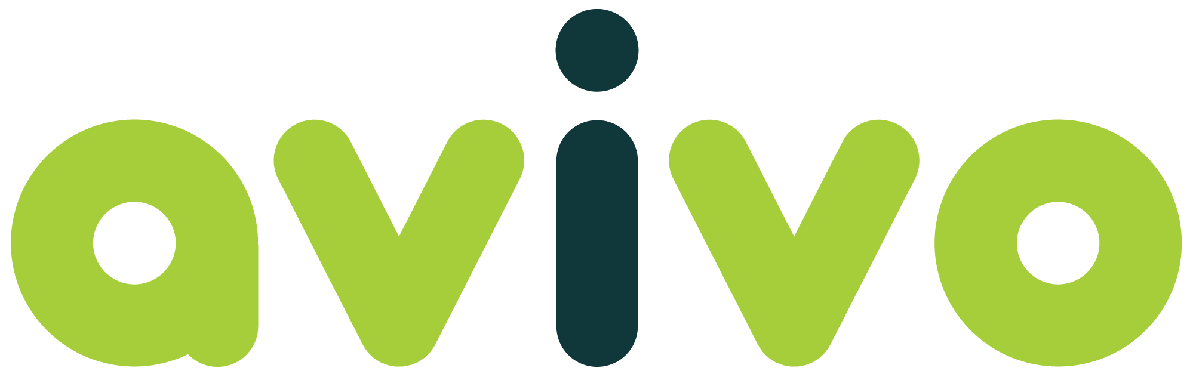
Position Description – Automation Solutions Software Developer
Team | Technology Team | Salary Band | TBA
Reports To | Technology Lead | Direct Reports | No
Location | Osborne Park and Remote | Date | January 2026

Who Avivo is
Avivo is a not-for-profit community organisation supporting people with disability, mental ill-health, and older people across Western Australia.
We exist to empower individuals and strengthen communities.
Our vision is a world where every person is connected, fully supported, and able to thrive.
Our mission is to provide practical, individualised support that enables people to live a good life in a community that values and includes them.

We collaborate to deliver:
• Individualised support tailored to each person’s goals and circumstances.
• Empowered teams who work collaboratively and with purpose.
• Meaningful community engagement that fosters belonging and inclusion.

At the heart of everything we do is our commitment to our people - both customers and colleagues.
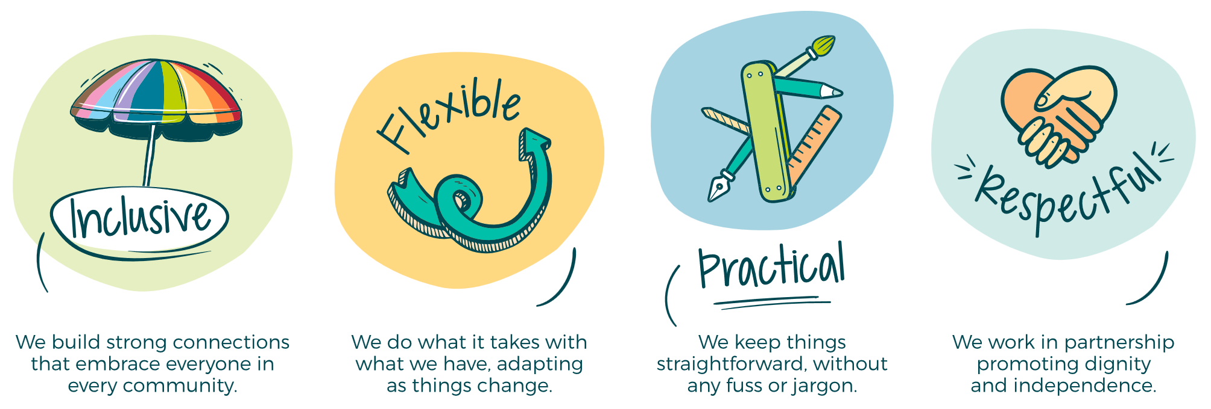

Primary purpose of role
This Automation Solution Software Developer is accountable to design and implement the AI platform and automation solutions leveraging Artificial Intelligence (AI) and Machine Learning (ML) techniques and tools to improve efficiency, scalability, and innovation across business processes and technology platforms.

Key responsibilities
Safety & Risk Management
- Work safely and follow Avivo’s Work Health and Safety policies and procedures.
- Be responsible for the effective identification, management and reporting of risks, incidents, and hazards.

- Professional Conduct
- Understand and work in accordance with the Avivo Code of Conduct Policy and the NDIS Code of Conduct as provided in the NDIS Worker Orientation training module.
- Solution Development
  - Design and build the AI foundation framework and platform
  - Research, recommend and implement automation and ML tools
  - Design and develop automation scripts, and frameworks to streamline workflows, reduce manual effort and improve data quality.
  - Develop AI/ML models for predictive analytics, anomaly detection, and intelligent decision-making.
  - Integrate solutions with existing systems and platforms.
- AI/ML Implementation
  - Work closely with the Data Engineer to collect, preprocess, and analyse data for model training and validation.
  - Deploy and monitor ML models in production environments.
  - Continuously improve models based on performance metrics and feedback.
- Collaboration & Stakeholder Engagement
  - Work closely with business units to identify automation opportunities.
  - Work within the Avivo Technology Development team and collaborate closely with the Systems and Operations teams to deliver end-to-end solutions and to build capability within the team.
  - Communicate technical concepts to non-technical stakeholders.
- Quality & Compliance
  - Ensure solutions adhere to security, compliance, and data governance standards.
  - Follow development guidelines for standardised and high-quality software development methods, including design patterns, release management, documentation, testing and validation to maintain reliability and accuracy.
- Continuous Improvement
  - Stay current with emerging AI/ML technologies and automation trends.
  - Recommend innovative approaches to enhance business processes.

Key Measures
- Reduction in manual effort through automation.
- Accuracy and performance of AI/ML models.
- Timeliness and quality of delivered solutions.
- Stakeholder satisfaction and adoption rates.

Direct Reports:
- N/A

Selection Criteria
- Tertiary qualifications in Computer Science, IT, Engineering, or Business Analytics or similar
- Demonstrated proficiency in programming languages (Python, Scala, or similar).
- Demonstrated experience with AI/ML frameworks (AI Foundry or similar)
- Demonstrated experience with automation tools (e.g., Power Platform, Copilot Studio).
- Knowledge of Azure cloud platform
- Experience with DevOps deployment
- Excellent problem-solving and analytical skills.
- Excellent communicator with strong business engagement skills

Employee Name ________________________

Employee Signature ________________________ Date ___/___/______

