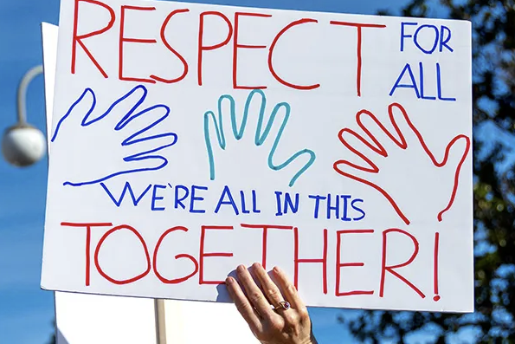

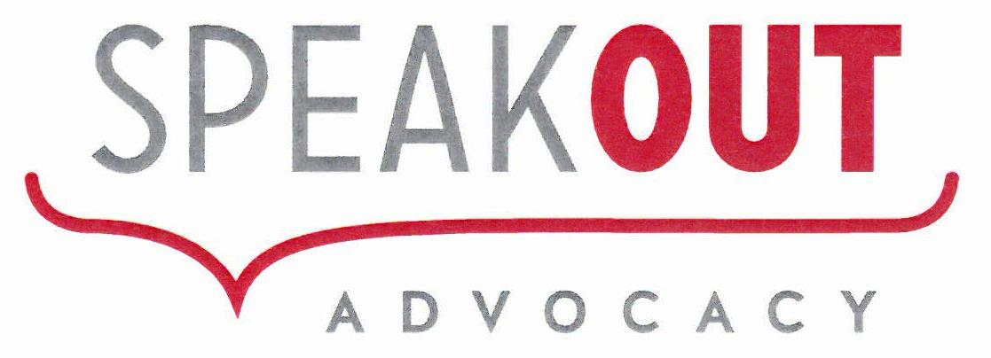

Board Information Pack

“Our vision is a respectful and inclusive community where people
living with disability are heard, respected and valued.”

Acknowledgement of Self Advocates
Speak Out Advocacy acknowledges and pay our respect to the contribution made by self-advocates, past, present and emerging in their fight for equality and the advocates that stand beside them.

February 2026

The Speak Out Association of Tasmania Inc.
Authored by: Mark Mason

ABN: 83 857 653 481
Level 3, 168 Collins St - HOBART TAS 7000

Board Information Pack - 2026

Acknowledgement of Country
Speak Out Advocacy acknowledge with deep respect the resilience and knowledge of the Tasmanian Aboriginal community, the traditional custodians of lutruwita, Tasmania. We acknowledge the wisdom, resilience and knowledge of the Tasmanian Aboriginal community and we stand for a future that profoundly respects their perspectives, culture, language and history.
Contents
About Speak Out Advocacy 4
Who are we? 4
Our History 4
Who do we support? 4
What kind of organisation is Speak Out? 5
Self-Advocacy Groups and Conferences 5
Working with others 5
What we do 6
1. Individual Advocacy 6
2. Self Advocacy 7
3. Systemic Advocacy 7
4. Fee for Service – Accessible Information and User Testing 8
5. Project Work 8
What does the Board do? 9
About the Role 9
What will you do as a Board Member? 10
Who can apply? 10
Board Member Position Description 11
Funding 14
Australian Government 14
Tasmanian Government 14
Inclusion Australia 14
Disability Advocacy Network of Australia (DANA) 15
Fee for Service Work 15
Why Funding Matters 15
Organisational Chart 16
Want to know more? 17

About Speak Out Advocacy

Who are we?
Speak Out helps people with disability.
We help people:
- Speak up
- Be treated fairly
- Have their rights respected
We help people across Tasmania.

Our History
- Speak Out started in 1982
- It began with a big conference
- The conference helped people learn to speak up
Later:
- Speak Out started giving advocacy support to members
- Speak Out became a strong voice for people with disability

Who do we support?
Speak Out:
- Is a membership organisation for people with intellectual disability
- But we provide advocacy to people with other disabilities

Our advocacy is:
- Free
- Private
- Independent

What kind of organisation is Speak Out?
Speak Out is a Disabled Persons Organisation (DPO).
This means:
- It is run by people with disability
- It is for people with disability

Self-Advocacy Groups and Conferences
We run:
- Self Advocacy groups every month
  - Hobart
  - Launceston
  - Burnie
We also run:
- The Speak Out Conference every year
This conference is:
- For people with intellectual disability
- The longest-running one in Australia

Working with others
Speak Out works with other organisations like:
Inclusion Australia - The national voice of people with an intellectual disability and their families.
Disability Advocacy Network of Australia (DANA) - The national voice of independent disability advocacy.
This helps us:
- Share ideas
- Learn from others
- Make change across Australia
Our Mission
We support people with disability to speak out.
We promote and defend the rights of people with disability,
- through our advocacy work;
- good governance that includes people with intellectual disability; and
- building the capacity of communities.

What we do
Speak Out operates across five main areas:

Individual Advocacy
Individual advocacy is one-on-one support. It helps a person with disability be treated fairly and get what they need in education, healthcare, work, and daily life.
​​
Why Individual Advocacy Matters
- It helps people deal with urgent or serious issues, especially if they don’t have support.
- It gives people a stronger voice when they need help most—like facing discrimination or abuse.
- Advocates work on your side, helping you speak clearly, explore your choices, and make decisions with respect and care.
​

Self Advocacy
Self-advocacy means speaking up for yourself. It’s about knowing what supports and rights you need—and sharing that with others. Self-Advocacy gives you more control over your life.
​
Why Self-Advocacy Matters
- It gives you voice and control over your life.
- It builds your confidence and independence.
- It supports equal access in education, work, and community life.
​

Systemic Advocacy
Systemic Advocacy is working to change whole laws, systems, or services instead of focusing on one person. It aims to benefit many people with disability at once, not just individuals.
​
Why Systemic Advocacy Matters
- It targets big, ongoing problems that affect many people.
- It is stronger and lasts longer than acting alone on individual cases.
- Real lived experiences from people with disability guide and shape these changes.

Fee for Service – Accessible Information and User Testing
User Testing
User testing means checking if something works well for the people who will use it.
​We ask real people to try something – like easy read information, a website, form, apps, or a service – and tell us what they think.
​Easy Read & Plain English
Speak Out has made lots of easy read resources
to help people with intellectual disability.
​These resources help people:
- Understand hard information
- To read important information easily
​Animations
We use animations (videos) to share information that is easy to understand.
​​People with intellectual disability help Speak Out to make these things.

Project Work
Speak Out regularly delivers projects, some of these projects are delivered with us as the lead, other projects we partner with organisations like Inclusion Australia. Below is a list of the current projects that we are delivering (individually or in partnership):

What does the Board do?
The Board helps lead Speak Out with our Members Executive Committee.
The Board:
- Helps make big decisions
- Makes sure Speak Out follows the law
- Looks after money
- Helps plan for the future

About the Role
- The Board meet 6 times a year
- Some meetings are online
- Some meetings are in person
Time needed:
- About 3–4 hours each month
- Plus 2 days each year
Term (How long can I be on the Board?):
- 4 years
- You can stay longer if you want and are voted on by our Members.

What will you do as a Board Member?
You will:
- Go to Board meetings
- Share your ideas
- Help with committees
- Support Speak Out’s values
- Help plan for the future

Who can apply?
You do not need Board experience.
You just need:
- Interest
- Commitment
- Willingness to learn
Everyone is welcome to apply, especially people with disability.
We value different experiences and voices.

Board Member Position Description
What is this role?
A Board Member helps make big and important decisions for Speak Out.
Board Members work together to:
- Make sure Speak Out is run well
- Make sure Speak Out follows the law
- Support the rights of people with disability

Who can be a Board Member?
This role is for:
- People who are elected to the Board
- People who want to help Speak Out do its best work

What does a Board Member do?
Go to meetings
- Go to Board meetings
- Read papers before the meeting
- Be ready to join in and share ideas

Help make plans and decisions
- Help plan for the future of Speak Out
- Help make big and important decisions
- Think about what is best for people with disability

Be on committees
- Join Board committees if needed
- Help with specific areas like:
  - Finance
  - Governance
  - Strategy

Support Speak Out
- Talk positively about Speak Out
- Be a good role model
- Follow Speak Out’s values

Do the right thing
- Be honest and fair
- Put Speak Out first
- Tell the Board if there is a conflict of interest
(This means when something could affect your decision)

What support will I get?
- Clear information
- Help to understand Board papers
- Support to do your role well

Why this role matters
Board Members help:
- Keep Speak Out strong and safe
- Make sure people with disability are heard
- Build a better future

Funding
Speak Out gets money to do our work.
This money helps us:
- Support people with disability
- Run advocacy services
- Create projects and information

Australian Government
Some funding comes from the Australian Government.
This funding helps us:
- Give advocacy support
- Support First Nations advocacy work
- Run projects that build skills and respect

Tasmanian Government
Some funding comes from the Tasmanian Government.
This funding helps us:
- Provide individual advocacy
- Run the Speak Out Conference
- Do systemic advocacy work

Inclusion Australia
Some funding comes from Inclusion Australia.
This supports projects like:
- Speaking Up in the Bush
- Disability Employment Advocacy
- National self-advocacy work

Disability Advocacy Network of Australia (DANA)
Some funding comes from DANA.
This supports projects like:
- State Employment Advocacy
- National First Nations Employment Advocacy

Fee for Service Work
Speak Out also earns money by doing work for others.
This includes:
- Easy Read translation
- Making animations
- Other accessible information work
This work helps support Speak Out’s services.

Why Funding Matters
Funding helps Speak Out:
- Stay strong
- Support people with disability
- Keep advocacy free and independent

Organisational Chart
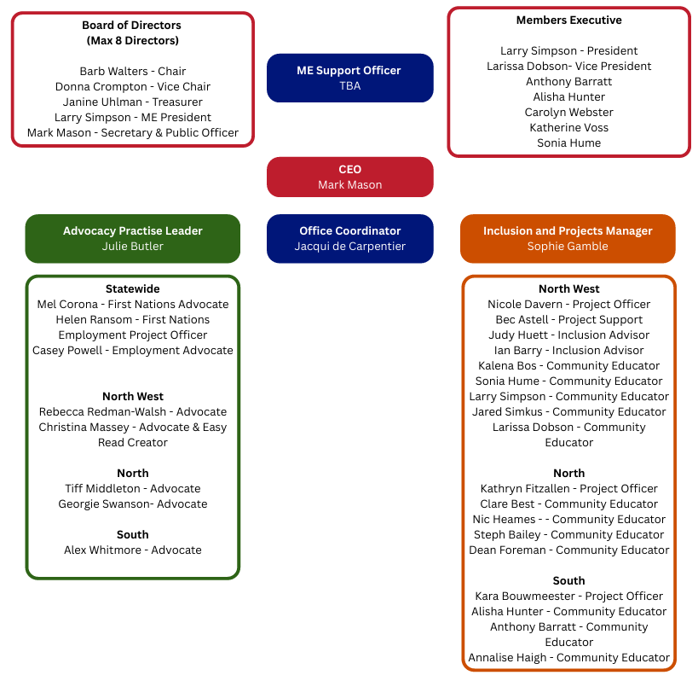

Page 16 of 18

Want to know more?
If you would like to know more, contact our Chairperson:
Barb Walters
📞 0447 409 444
📧 chair@speakoutadvocacy.org

Page 17 of 18

Page 17 of 18

