Position details

Division: Community and City Services
Branch: Community Development
Reports to title: Director Community Development
Position No: XXXX
Classification: Exec 1
Financial management $3 million per annum (Expenditure);
Total people: 4 (FTE)

Positions directly reporting into the Head of Homelessness

- Homelessness Partnership Lead
- Principal Project Lead
- Senior Project Officer Service Coordination x 2

Primary skill pool: Leadership and People Management
Secondary skill pool: Strategy, stakeholder management and delivery

Team context

The purpose of the Homelessness Team is to improve housing outcomes across the housing spectrum in the City of Melbourne. This will involve partnering with the homelessness sector, including with the Victorian Government through Homes Victoria, the not-for-profit sector including Community Housing Organisations and homelessness service providers. The Homelessness Team will strive to ensure people have access to safe, high-quality housing, close to jobs and services to ensure Melbourne is safe and inclusive, accessible and affordable, and economically prosperous into the future.

The team will deliver Council’s endorsed Homelessness Strategy to lead a creative and visible program to reduce homelessness in the city. The team will work with neighbouring inner-metro Councils to upscale service co-ordination and strategy development, advocate to the Victorian Government to enable sustained investment into social and affordable housing and essential services to support people who are experiencing homelessness.

Culture and Values

CoM aspires to a culture which is humanistic and encouraging, self-actualising, affiliative and achievement focused. We focus on culture because we know that a constructive culture is good for our wellbeing as well as our ability to deliver high quality outcomes.

We measure our performance against the desired culture using the Human Synergistics tool, the “Organisational Culture Inventory” (OCI).

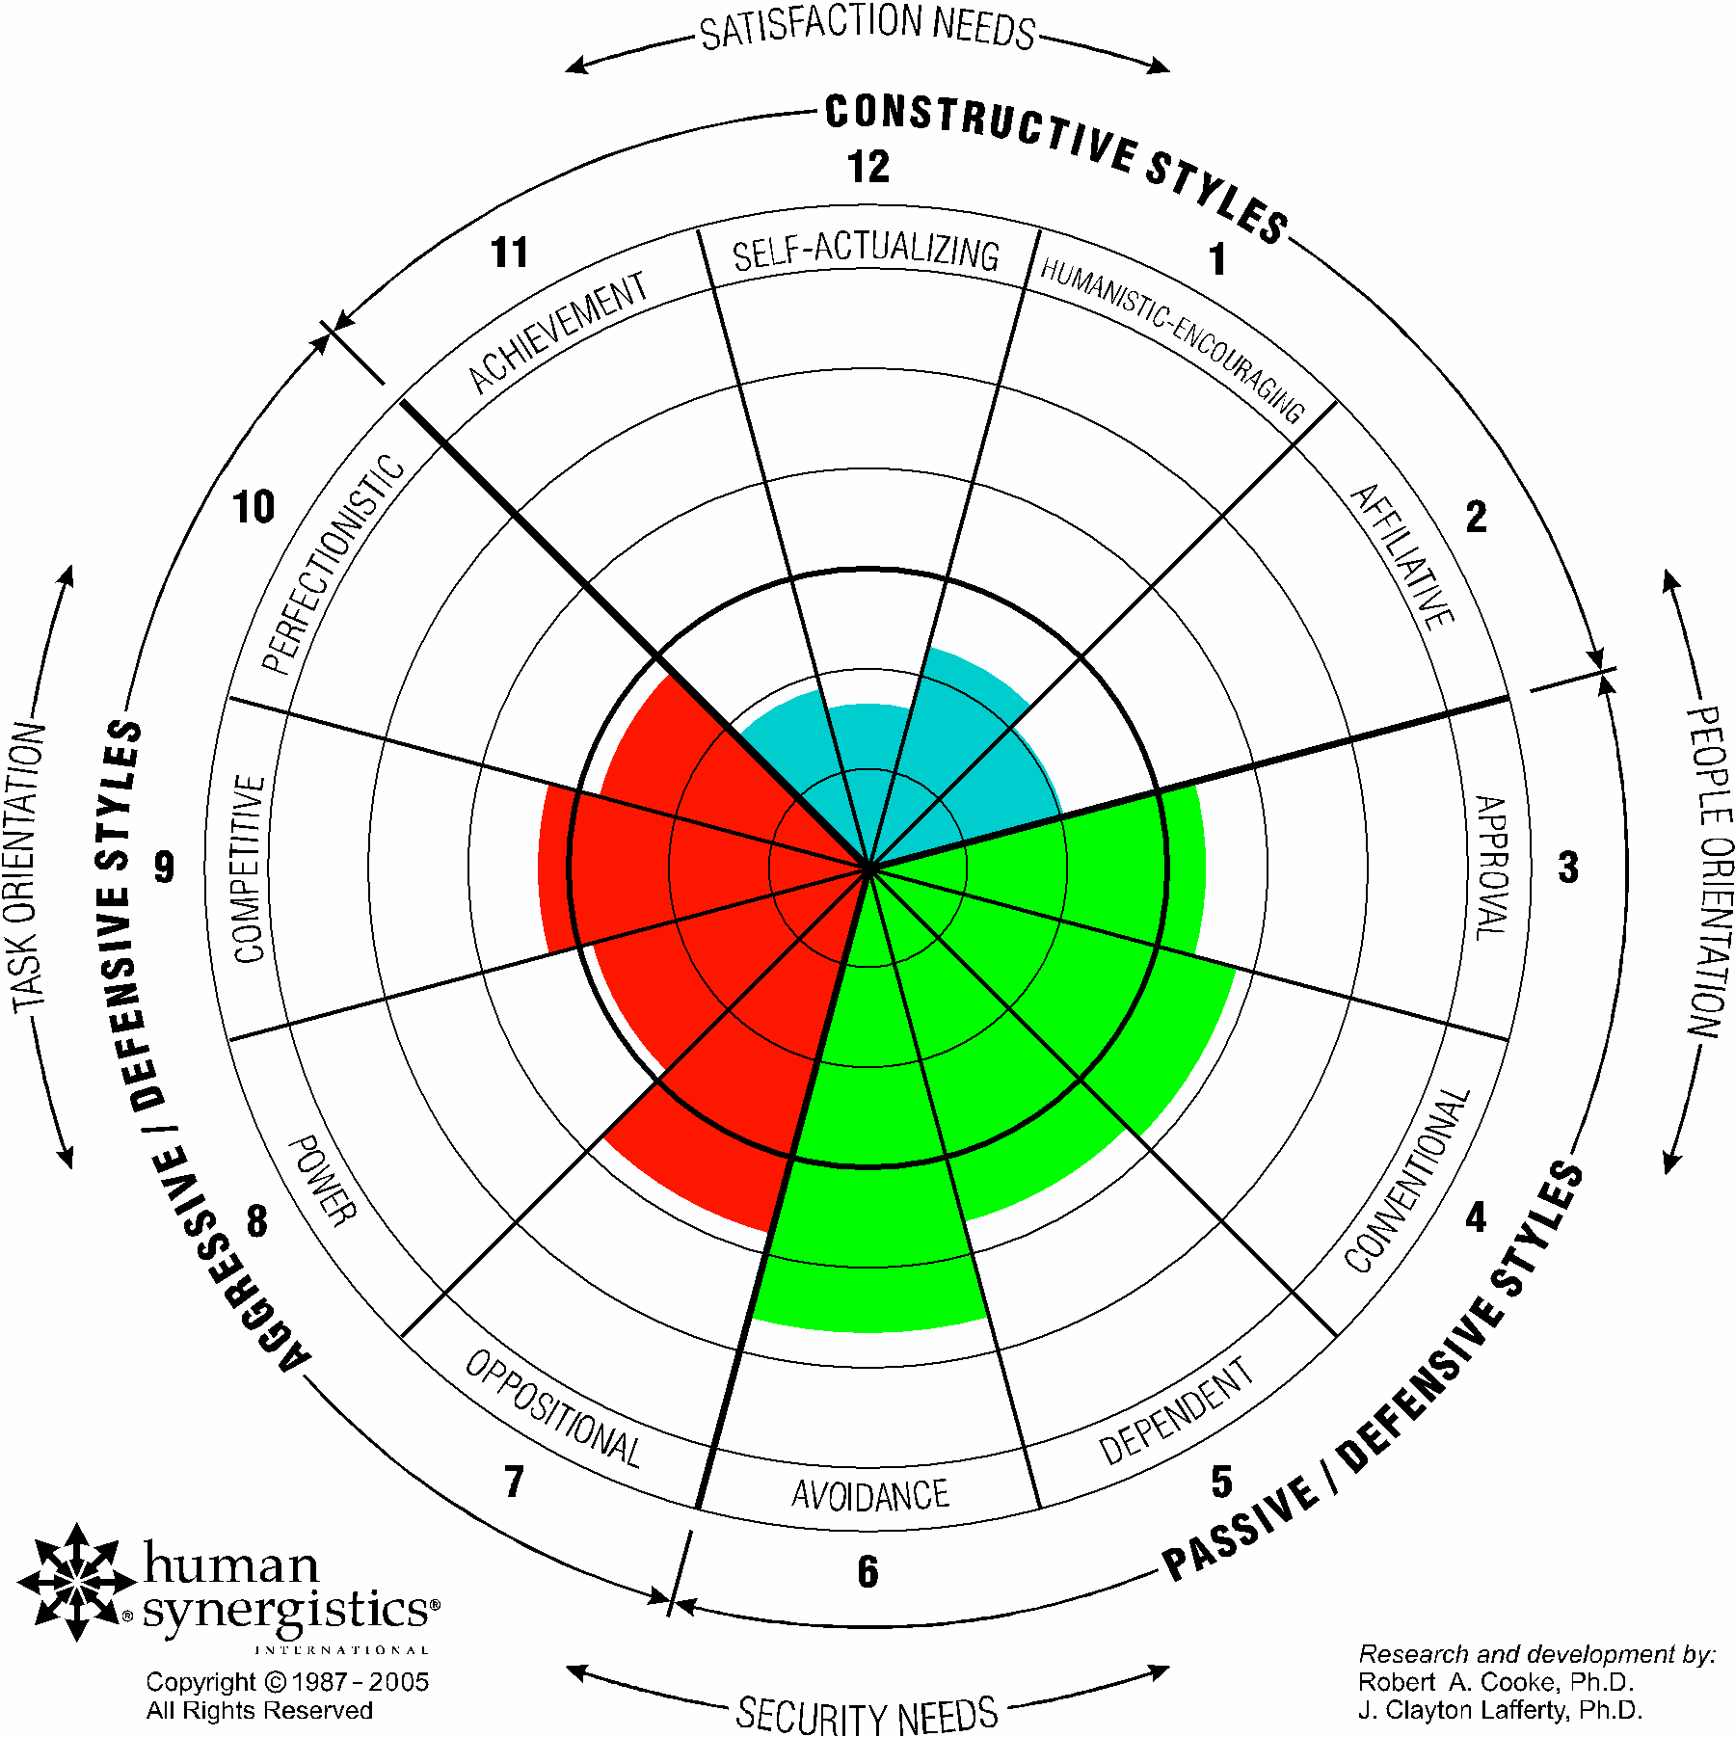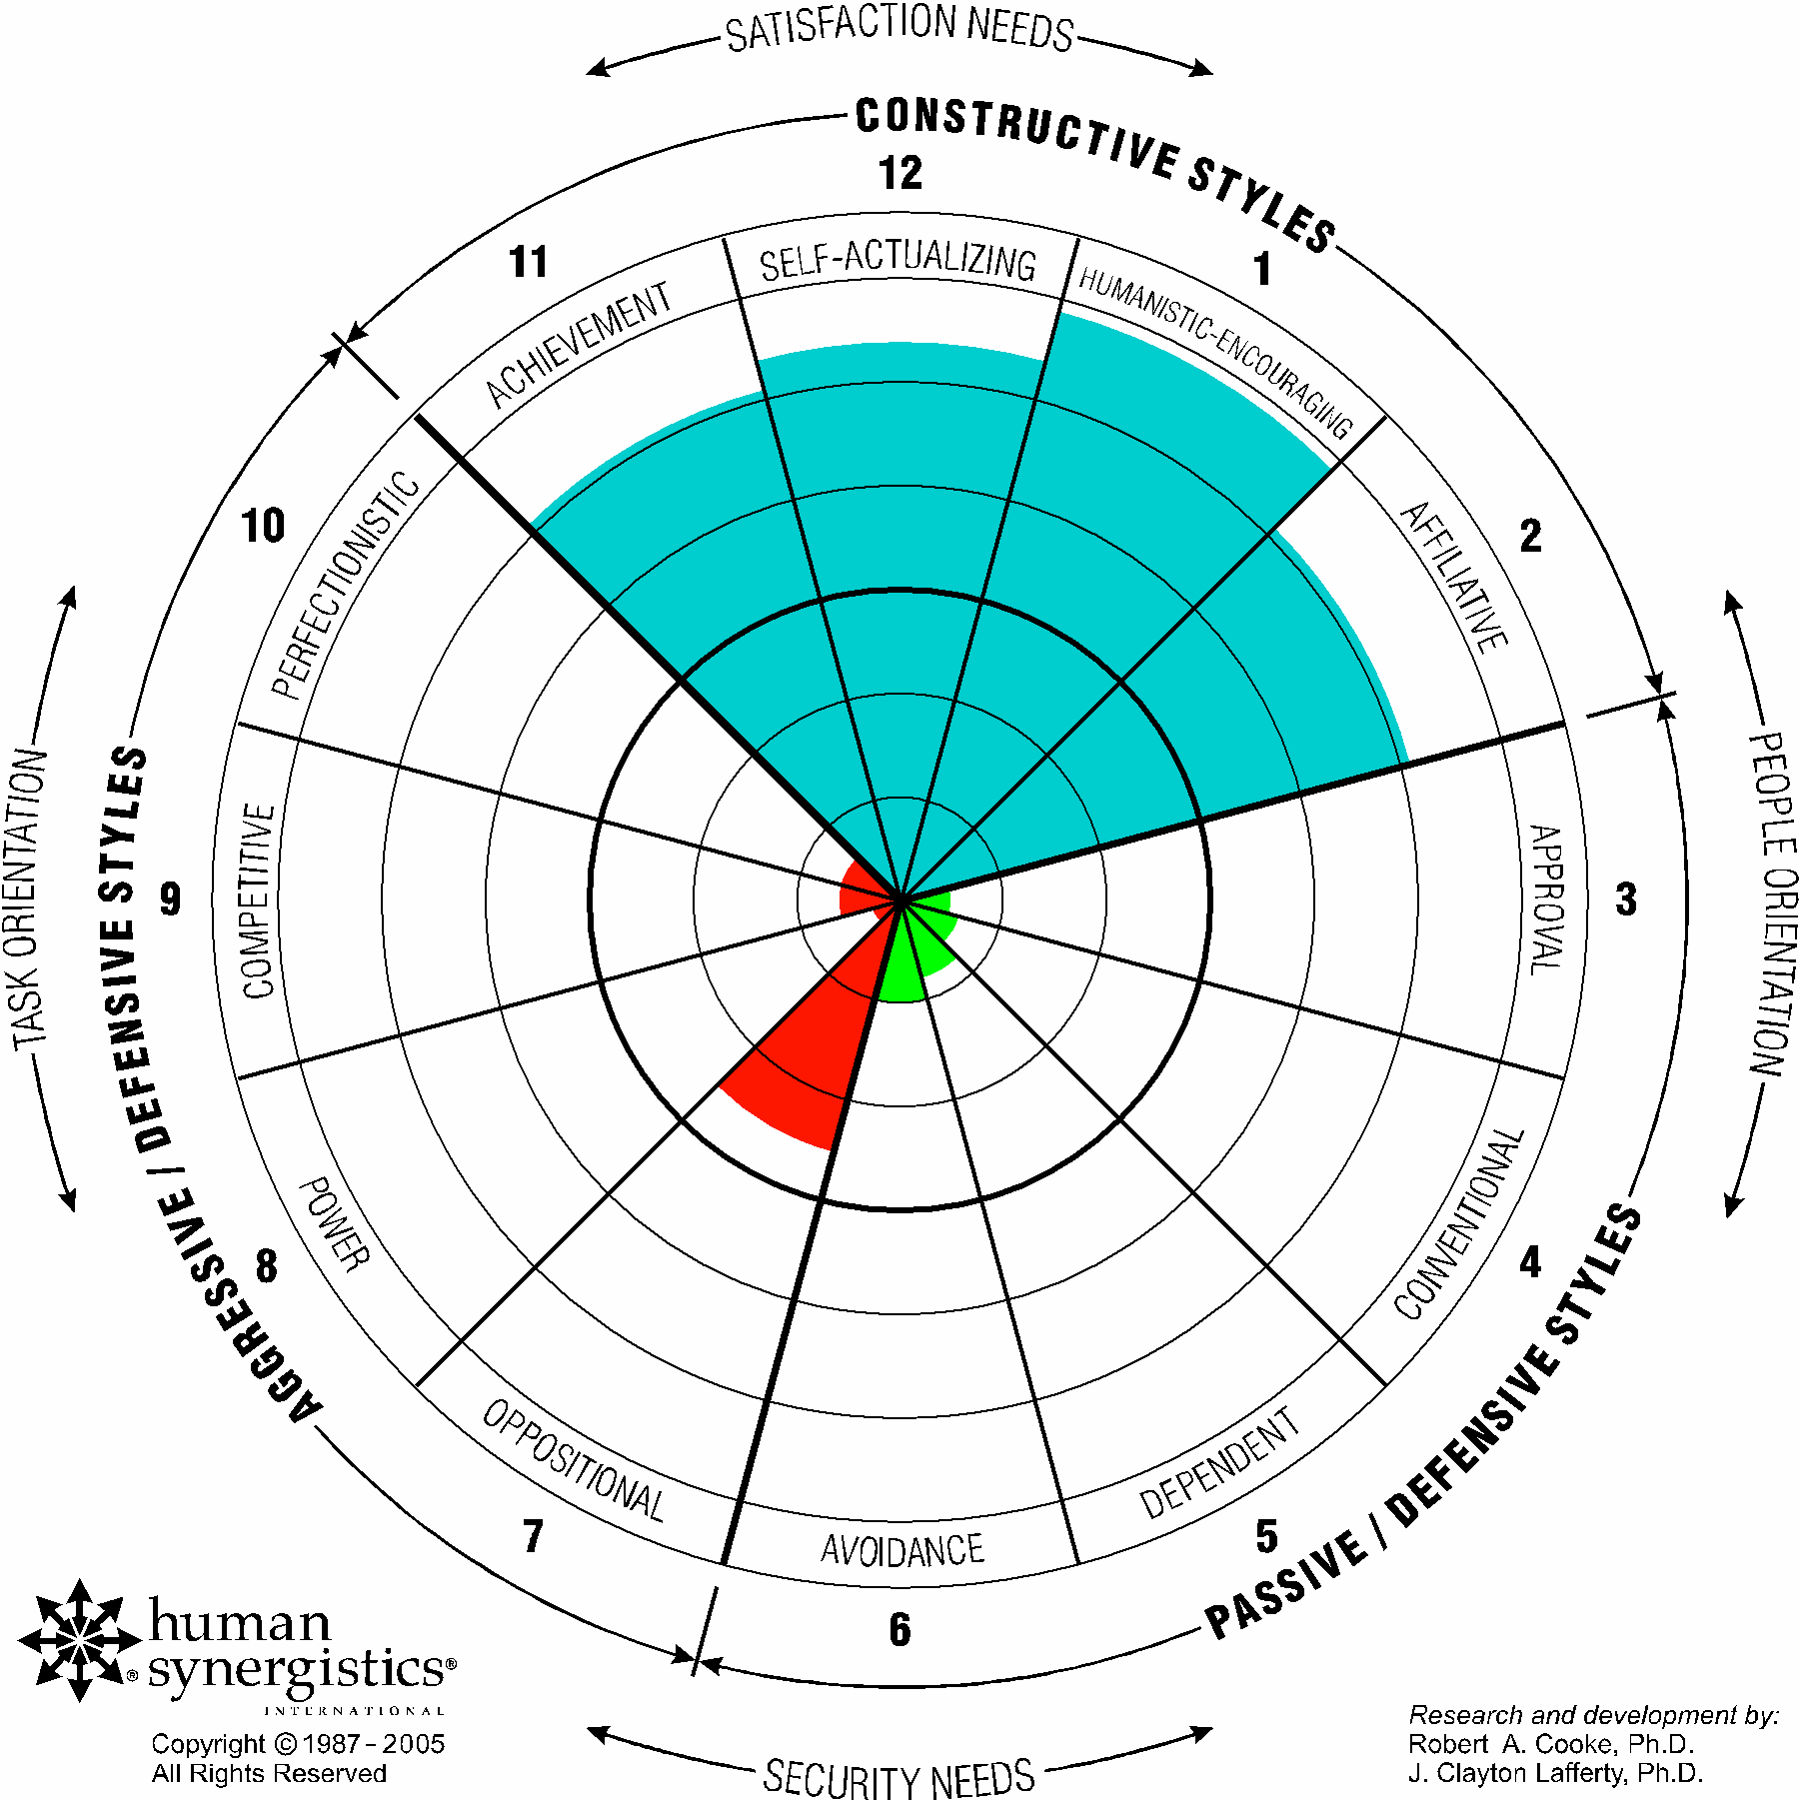

Our ICARE values (integrity, courage, accountability, respect and excellence) are the foundation for our behaviour for ourselves and our teams.

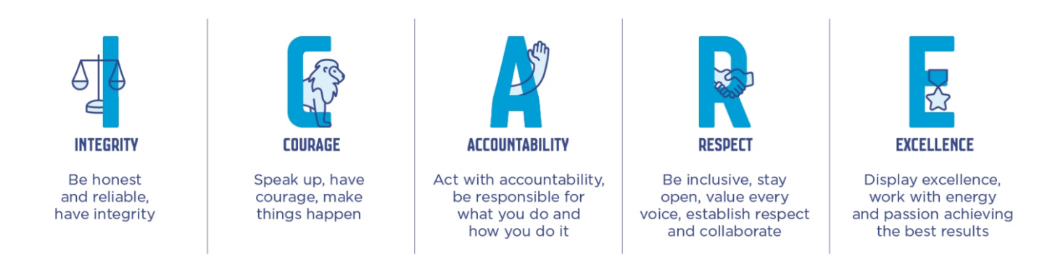
Position purpose

The Head of Homelessness will drive the strategic direction of the Homelessness Team and ensure effective governance, organisational, and financial management by instilling effective strategy and business planning with high standards of financial and people management.

The Head of Homelessness will establish and enhance key internal and external relationships through productive stakeholder engagement and inspire and lead a high performing team to deliver the key priorities of the Council’s Homelessness Strategy and wider Council Plan 2025 - 2029.

The Head of Homelessness will ensure major homelessness contracted services deliver outcomes to achieve the Council’s Homelessness Strategy, provide key information to understand data and trends and are managed efficiently.

The Head of Homelessness will also build internal capacity and understanding of the organisation around the issues of homelessness, and create strong advocacy positions to influence key stakeholders and communicate key issues and opportunities to increase the supply of crisis, social and affordable housing across the municipality.

Position accountabilities

All CoM People Leaders will be influential leaders accountable for:

- Leading your people with the values at the centre of everything you do.
- Creating and maintaining a constructive culture where you personally and your Branch display the styles of achievement, self-actualising, humanistic, encouraging and affiliative behaviours.
- Attracting, developing and retaining outstanding employees who share our values and ambitions to be a leading organisation for a leading city.
- Leading, guiding and managing the team to foster a performance based culture and drive accountability and excellence in outcomes through coaching, mentoring and empowering team members and direct reports to develop and perform at a high level, and as an effective team.
- Efficiently and effectively manage the work area budget and optimise financial resources for maximum return on investment.
- Being a strong team player, working collaboratively and constructively across the organisation and externally to deliver shared outcomes.
- Building and sustaining strategic relationships with influential stakeholders and partners that deliver significant benefits for the City of Melbourne.
- Providing strategic advice to the Director of Community Development influencing, educating and supporting them in their roles.
- Respecting the values of the community and appreciating the diverse skills, values and backgrounds of employees.
- Delivering high quality policy, strategies programs and services to the community safely and within budget.
- Manage and monitor continuous improvement activities within the team.

In addition, the Head of Homelessness will be accountable for:

- Delivering on Councils aspirations as outlined in the Homelessness Strategy 2024 – 2030 and related outcomes in the Council Plan 2025 - 2029.
- Providing strong leadership, strategic planning and oversight to deliver key initiatives the Melbourne Service Coordination Project and major homelessness service contracts.
- Developing and maintaining the delivery of the teams contributions to the Community Development branch plan and associated budgetary and financial management.
- Enhancing and extending key external stakeholder relationships, including with the Victorian and Commonwealth Governments, Homes Victoria, industry/private sector corporations, and not for profit organisations, by developing a long-term stakeholder engagement strategy that responds to opportunities, impediments, and shared strategic policy directions.
- Working collaboratively across City of Melbourne, establishing strong internal relationships and building organisational capability to negotiate, develop, initiate solutions and effectively response to homelessness.
- Managing and leading a highly effective team to deliver key projects and produce high quality and complex written reports, briefs, policies and procedures.

Selection criteria

All CoM People Leaders will demonstrate:

- Ability to articulate and demonstrate benefits of positive culture and values.
- Demonstrated experience in leading a team to achieve high performance outcomes with strong coaching skills to develop team capabilities, team cohesion and the ability to effectively manage conflict and under performance.
- Highly developed analytical and lateral thinking skills and the ability to take the initiative, drive change and implement innovations.
- Excellent inter-personal, negotiation and persuasion skills with the ability to use discretion and judgement in a complex business and political environment.
- Demonstrated ability to develop, manage and maintain business plans and associated budgetary and financial management requirements.
- Proven experience effectively managing complex issues within a highly political and complex environment.

In addition, the Head of Homelessness will require:

- Proven leadership capability and experience, including leading by example and consistently working towards a constructive culture.
- Significant experience and proven achievement in developing, operationalising and embedding strategy both internally and external facing, within a complex environment.
- Excellent problem solving abilities, with a demonstrated capacity to think strategically and conceptually to identify obstacles, consider multiple perspectives and distil complex information to create viable options that address the organisation’s current and future requirements.
- Proven capacity to manage and cultivate productive working relationships with high profile and diverse stakeholders including State Government, public and private sector business associates, suppliers, partners, joint ventures and strategic alliances.
- Proven ability to formulate strategic direction, deliver operational and business outcomes and lead change within a complex, political and high-profile organisation.
- Demonstrated experience in leading a team to achieve high performance outcomes with coaching skills to develop team capabilities, team cohesion and the ability to effectively manage conflict and under performance.
- Strong team player with the ability to work collaboratively across the organisation and externally to deliver shared outcomes.

Inherent Physical Requirements

The reference to the Inherent Physical Requirements for this position is DM#9329597.

The Way We Work

Commitment to Child Safety

The City of Melbourne (CoM) is committed to being a child safe organisation and has zero tolerance for child abuse. All children and young people are valued members of our community and have the right to be and feel safe. We are committed to embedding child safety into the everyday thinking and practice of all employees, agency staff, contractors and volunteers. We require all CoM employees, agency staff, volunteers and contractors to understand and act to prevent, detect, respond and report any suspicion of child abuse and maintain a culture of child safety and any further responsibilities as required by the role.

CoM’s vision is to be a leading organisation for a leading city. CoM fosters a workplace that is stimulating, constructive, flexible, diverse and inclusive and that achieves high quality outcomes for the Council, customers and our community. We recognise that a constructive culture brings out the best in our people. We strive to meet the demands of our employees’ professional lives while they can accomplish their priorities outside of work and have a positive work life balance.

We strive to make our organisation agile, with the ability for our work teams to adapt and change based on the evolving needs of CoM. To keep pace with our customers and our changing city, we need a resilient, adaptable, accountable, diverse and inclusive workforce that reflects our community and is committed to excellence.

We establish challenging but realistic goals, develop plans to reach those goals, pursue them with enthusiasm, and are accountable for their achievement. We want our employees to get enjoyment from their work, develop themselves, and take on new and interesting activities whether they are within CoM or outside of CoM. We want our workforce to be supportive, helpful and open in their dealings with each other, through open communication, cooperation, and the effective coordination of activities.

