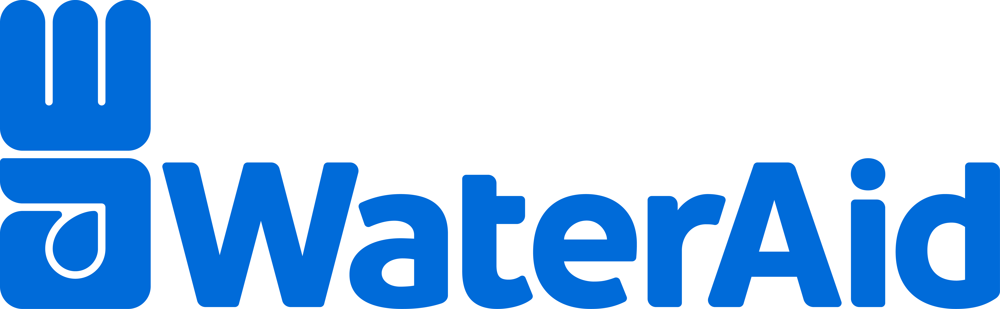
POSITION DESCRIPTION
TITLE | Technical Lead – Health
RESPONSIBLE TO | Head of Strategy
LOCATION | Flexible working arrangements, must hold right to work in Australia, Cambodia, or Timor-Leste
EMPLOYMENT BASIS | Fulltime 2 year fixed-term (subject to a 6 month probationary period)
SALARY | WA Australia Salary Grade 3, between $73,000 and $128,000 plus super and salary sacrificing

Introduction

WaterAid is an international not-for-profit organisation. Our vision is a world where everyone everywhere has access to safe water, sanitation and hygiene (WASH). Our mission is to change lives by improving access to safe water, sanitation and hygiene.

WaterAid works through supporting local organisations and government authorities to design and demonstrate appropriate and sustainable WASH programs. WaterAid also seeks to influence policy change through governments and other key sector actors to secure and protect the right of poor people, to safe, affordable, water and sanitation services.

Everything we do is shaped by six values: Integrity, Respect, Collaboration, Courage, Accountability, and Innovation. These values define our culture and unite us globally across the many countries in which we work. The values and standards we uphold are highlighted in our Global Code of Conduct available at www.wateraid.org/uk/publications/global-code-of-conduct. All roles within WaterAid are required to comply with our Global Code of Conduct.

WaterAid is a child-safe organisation and we are committed to protection from sexual exploitation and abuse in everything we do. We recognise that we must meet community expectations and the trust placed in our personnel to maintain the highest standards of conduct with children. Therefore, all roles within WaterAid are required to comply with our Child Safeguarding Policy and Code of Conduct.

Successful candidates will also be asked to undergo police and other integrity checks.

Position Summary

The Technical Lead – Health leads WaterAid’s portfolio of health projects, advocacy, and technical advice in Southeast Asia and the Pacific. This includes technical support to Country Program teams and the development of tools and approaches to support effective and quality health focused program delivery. The position is also responsible for leading our regional WASH in Healthcare Facilities Strategy and supporting teams to deliver behaviour change best practice. The role also supports the design of new health programming initiatives, including approaches to building new evidence. Leveraging WaterAid regional and global networks and expertise the position will work alongside other WaterAid Australia and regional colleagues to integrate health considerations into WaterAid’s business plans. This role also represents WaterAid externally to the Australian government and regional health related agencies, research institutions and other key stakeholders.

Key Performance Areas/Accountabilities
- Lead technical area of health within WaterAid Australia, including working collaboratively with country programs on the design and implementation of their health programs, with a strong focus on climate-resilience and gender equality.
- Lead the implementation of WaterAid’s Health Strategy for the Southeast Asia and Pacific region, building on and supporting the capacities and priorities of country programs
- Support Country Programs to deisgn and deliver quality behaviour change initiatives relevant to water, sanitation and hygiene
- Build networks, relationship and partnership with Australian and regional health actors to position WASH as a critical issue for health system strengthening and outcomes
- Lead or support research initiatives related to health and support documentation and communication of WaterAid’s experiences, lessons and findings with targeted stakeholders
- Maintain strategic relationships with WaterAid health colleagues across the Federation
- Contribute to business development at a regional and country program level relating to WASH and health
- Support grant management, program operations, safeguarding and learning and development processes as required

Qualification, Skills & Attributes (Key Capabilities/Selection Criteria)

Knowledge, Skills and Experience | - Substantial experience in health programming in a development context, including in one or more of the following areas: strengthening health systems, behaviour change, infection prevention and control, women’s health and maternal, newborn and child health  - Experience in providing capacity strengthening and/or technical program support, including distance relationships management and the development of staff networks  - Excellent facilitation skills and ability to make clear public presentations in English  - Good networker adept at establishing and maintaining relationships with colleagues and collaborators. Familiarity with the top health sector actors (agencies, donors, researchers) and global and country specific health strategies, desirable.  - Experience in developing, overseeing and coordinating complex agency level policy and practice, including fostering internal linkages within an organisation  - Understanding of the intersections of health and gender equality and social inclusion and experience with addressing gender inequality within development programming  - Understanding of key health trends and current research relevant to WASH with some understanding of water, sanitation and hygiene in Southeast Asia and Pacific contexts  - Strong research, writing and analytical skills to produce technical reports or scientific papers
Education | - Post graduate qualification related to global public health
Personal qualities | - Commitment to WaterAid’ values and standards of safety of children and protection from sexual exploitation and abuse in all our activities  - Demonstrate an understanding of and commitment to gender equality and women’s empowerment, equality inclusion and human rights, including ethnic diversity and cultural sensitivity  - Self-motivation and independent worker, adaptable to work with remote communication between teams  - Excellent interpersonal skills, collaborative style and ability to forge new relationships and partnerships  - Being open to learn, experiment and take risks  - Commitment to Child Safeguarding and to the WaterAid values of integrity, respect, collaboration, courage, accountability and innovation  - Ability to travel to Cambodia, Timor Leste, Papua New Guinea, Fiji, Australia and Europe.

Physical Environment and Demands

Remote, flexible working arrangement in Australia, Cambodia, Timor-Leste or Papua New Guinea. with relevant equipment supplied as required, approximately 10 weeks overseas travel required per year when safety and security conditions permit.

Level of contact with children
During project site visits, office family days.

To Apply
Please submit an application to recruitment@wateraid.org.au by Sunday 22nd June, with the subject line Application – Technical Lead – Health .

Applications for this position must include a resume and a cover letter (max 2 pages) addressing the above Qualification, Skills and Selection Criteria.

For any queries not answered in this document please email recruitment@wateraid.org.au.

Only shortlisted candidates will be contacted.

