Position Description
Data and Evidence Officer
Yoorrook Justice Commission
The Yoorrook Justice Commission (Yoorrook) is the first formal truth-telling process into historical and ongoing injustices experienced by First Peoples in Victoria since colonisation. Guided by its values and principles, Yoorrook will:
- Establish an official record of the impact of colonisation on First Peoples in Victoria.
- Develop a shared understanding among all Victorians of the impact of colonisation, as well as the diversity, strength and resilience of First Peoples' cultures.
- Make recommendations for healing, system reform and practical changes to laws, policy and education, as well as to matters to be included in future treaties.
Yoorrook is independent of government and the First Peoples’ Assembly of Victoria. It has been established as an independent Royal Commission under the Inquiries Act 2014. See here the Letters Patent that set out Yoorrook’s mandate.
Yoorrook is unique among Royal Commissions because, while it is for the benefit of all Victorians, First Peoples drove its design and remain at its centre.
Strategic Goals and Values
Yoorrook seeks to achieve truth, understanding and transformation. Yoorrook’s values guide the way it works.

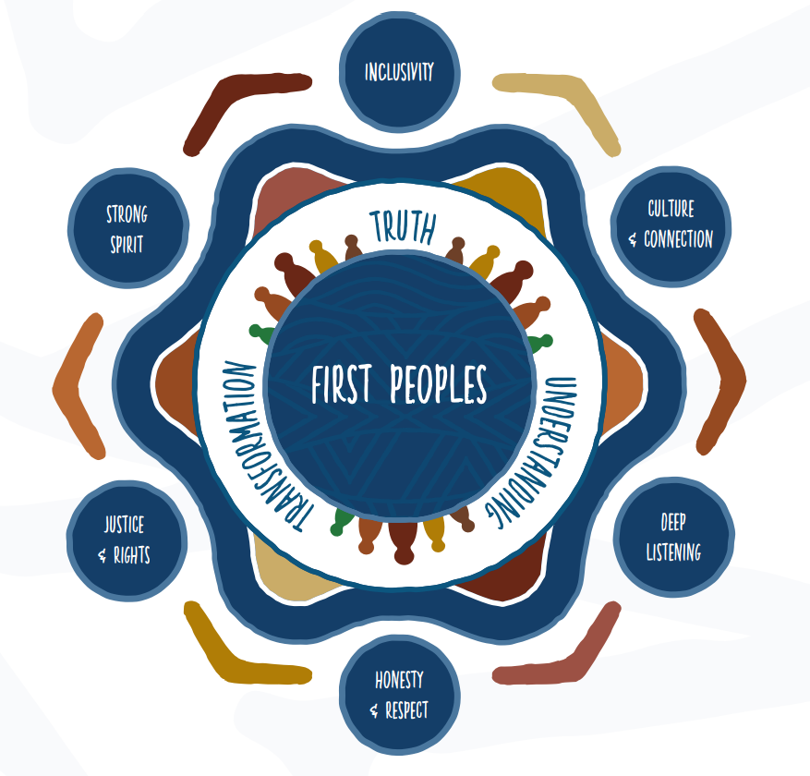
Position Summary
The Data and Evidence Officer supports the management of Yoorrook’s data and evidence material as per its mandate and duties as a First People’s Royal Commission.
Reporting to the Data and Information Manager, the position plays an active role in the day-to-day management of evidence material including submissions, transcriptions, and other hearings material. This involves logging, tracking, and monitoring data workflows and its progress across multiple systems and with various stakeholders.
Yoorrook’s mandate requires it to complete its work by 30 June 2024. Yoorrook has recommended to the Victorian Government that it extend this timeframe by two years to 30 June 2026.
Yoorrook’s Letters Patent requires it to prioritise the employment of First Peoples. First Peoples are strongly encouraged to apply for all roles at Yoorrook.
Classification | VPS 4
Term | Fixed term till 28 June 2024 (with possibility of extension)
Salary Range | $91,418 - $103,725 p.a. plus 10.5% employer superannuation contribution
Reports to | Marlyn Assad, Data and Information Manager
Location | 54 Wellington St, Collingwood VIC 3066

Key Accountabilities
- Under the direction of the Data and Information Manager, support Yoorrook’s data and information workflow including the receipt, processing, and management of evidence material across Yoorrook’s Information Management System.
- Responsible for the day-to-day processing of individual and organisational submissions received by the Yoorrook Justice Commission through logging, verifying and tracking submission workflow processes.
- Serve as a primary liaison for evidence material during Hearings periods by engaging with Yoorrook’s Solicitor’s Assisting team and other stakeholders to track and report on key activities, timeframes, and issues.
- Responsible for the receipt, scanning, and management of physical submissions received as part of the supported submissions process.
- Responsible for actioning transcription requests, including tracking and monitoring of Yoorrook’s transcription and submissions logs.
- Engage with participants and organisations to verify their information and selections on Yoorrook’s submission form as needed.
- Actively contribute to a positive, collaborative, innovative and culturally safe workplace culture that supports strong connections across the organisation and lives up to Yoorrook’s values and mandate.
- Other related tasks and duties as determined by the Data and Information Manager, Director, Operations and CEO that are consistent with a position of this grade and skills requirement.
Key Selection Criteria
- Demonstrated professional experience in areas of data and information management.
- The role requires great accuracy, attention to detail and experience working with tight timeframes.
- Advanced computer skills, including excellent proficiency in Microsoft Office’s suite of software applications and SharePoint.
- Proven relationship management skills, with an ability to bring internal and external stakeholders along in support of positive organisational outcomes.
- Demonstrated willingness to be flexible and adaptable to changing priorities within a work environment.

Desired requirements
- Experience working with Aboriginal communities and organisations, and/or understanding and awareness of Aboriginal self-determination and cultural safety.
- Experience managing sensitive records and awareness of Indigenous Data Sovereignty protocols.
Additional information
Please note that as the work of Yoorrook is unprecedented, the focus of roles may be subject to change to ensure Yoorrook can be responsive to First Peoples’ needs and deliver on its mandate.

Yoorrook Commitment
Diversity and Equal Employment Opportunity
We welcome applicants from a diverse range of backgrounds and experiences, including Aboriginal and Torres Strait Islander peoples, people from culturally and linguistically diverse (CALD) backgrounds, people who identify as LGBTIQA+, people with disability, as diversity and inclusion drives our success.
It is important to us that candidates with disability can participate equitably in the recruitment process. If you need assistance or adjustments to fully participate in the application or interview process or if you have any enquiries about diversity and inclusion at Yoorrook, please contact Lisa Tricarico, HR Manager at 0412 597 791.
Supporting our employees balance their work and life commitments.
The nature and scope of flexible options available will depend on the nature of the position. Applicants are encouraged to discuss flexible arrangements with the hiring manager during the recruitment process.
Occupational health and safety responsibilities
In the context of OHS policies, procedures, training and instruction, as detailed in Section 25 of the Occupational Health and Safety Act 2004, employees are responsible for ensuring they:
- Follow reasonable instruction
- Cooperate with their employer
- At all times, take reasonable care for the safety of others in the workplace.

Security requirements and professional obligations
- Pre-employment screening may apply to all appointments
- Preferred applicants may be asked to provide evidence of their qualifications
- All preferred applicants will be required to produce sufficient proof of their identity prior to commencing employment with the department
- Employment of successful candidates may be subject to a National Police Check

To receive this publication in an accessible format, please contact 0412 597 791, using the National Relay Service 13 36 77 if required (for more information visit www.relayservice.gov.au).

