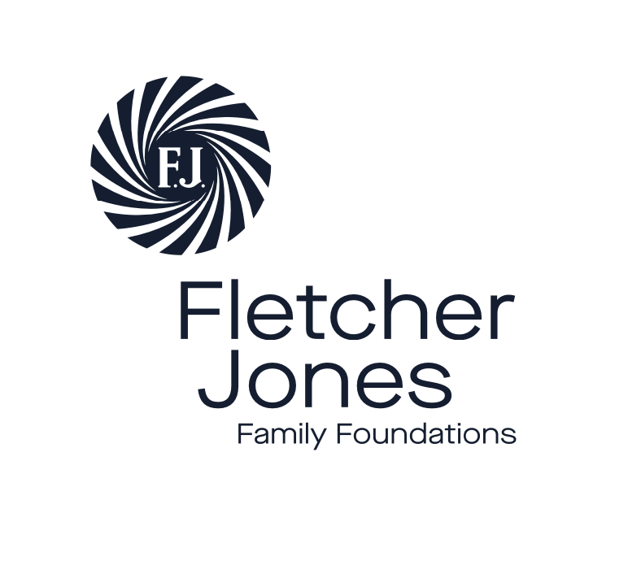
Fletcher Jones Family Foundations Executive Officer

Position Description

Reports to - Trustees of Foundations
Contract term - three years
Hours per week - eight
Probation period - six months
Performance planning - six monthly review
Location - Warrnambool

About us
The Fletcher Jones Family Foundations fund and facilitate social-impact initiatives that seek to drive positive change in the greater Warrnambool region.

Our philanthropic investments aim to benefit the people and communities of the region, by building strong local connections and collaborating with other organisations who share our goals.

The legacy of Fletcher Jones’ social ethos and care for the communities that he was a part of governs all we do today. He was a pioneer and an innovator and built a successful company by placing emphasis on people rather than profit, focusing across employees, their families, customers and community organisations.

Warrnambool was his chosen home and the place he established his business base in the 1930s. Over the four decades since his death in 1977, the foundations have been steered by his descendants who are committed to continuing a focus on the Warrnambool region.

We aim to:
- Honour the legacy of FJ and his focus on people by creating opportunities for people to thrive and find true connection to their community.
- Encourage and enable innovation to facilitate positive social change and develop the region’s creative capacity.

The Executive Officer will provide leadership and oversight of the following with support of the Trustees:

Strategic planning
- In collaboration with the Trustees, create a strategic plan for 2022/2023
- Develop 5-year plan

External relationships
- Foster, develop and maintain strong relationships with local foundations, co-funders, donors, public, business, local state and federal govt, community service organisations and sector colleagues
- Develop database (CRM) to track key and ongoing relationships
- Focus on building strong connections with local foundations

Communications
- Create and maintain website
- Produce regular newsletter
- Manage individual communications with donors, peers – build individual relationships
- Build CRM database through ongoing work
- Use brand assets consistently through all communications
- Use social media to build awareness of activity

Grants
- Pro-actively find new grant partners
- Field grant enquiries
- Assess applications and do due diligence
- Draw up agreements
- Draw up evaluation frameworks and track outcomes
- Monitor grants and manage acquittals
- Manage partner relationships

Impact measurement
- Develop methodology and database to record project outcomes and grant transactions
- Record reporting timelines
- Develop means of recording non-financial outcomes
- Develop means of aggregating data
- Provide assistance to local grant making community on progress and impact of programs

Leadership
- Represent FJF at sector events
- Take a lead in the sector through the extension of place-based work
- Increase profile of our work through engagement with sector events and communications
- Keep abreast of national/international developments

Events
Oversee management of events, eg partner workshops, celebrations

Governance
- Prepare background papers, manage minutes + monitor actions
- Ensure ASIC requirements are met
- Manage strategic planning workshops

Reporting
- Develop a reporting process for status updates of activity undertaken
- Regular phone conferences with Trustees
- Develop an annual work plan based on meeting key priorities of the strategic plan

Preferred attributes
Self-motivated, dedicated, detail-oriented, strong administrator, critical thinker, able to work comfortably at senior levels and on the ‘front line’, engaged member of the local community

Time commitment
Permanent part time, 1 day per week (potential to increase time commitment in future)

