Job Description
The Ability Links Recovery coaches will provide support to people with psychosocial disability to live a full and contributing life. People will be assisted to take more control of their lives and to better manage complex challenges of day to day living.
Through recovery-enabling relationships and skilled coaching, people will be supported to build capacity, including strengths and resilience. Recovery coaches will work collaboratively with people, their families, carers, and other services to design, plan, implement and adjust a recovery plan

The Recovery coach reports to the Community Services Manager.

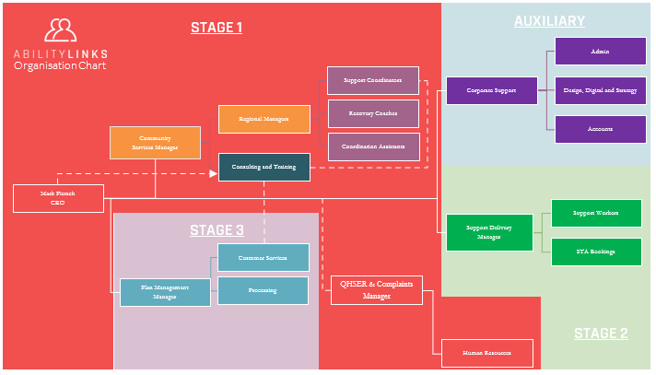

Specific job duties of the Recovery Coach includes the following:
Provide Quality Service

- Data management utilising CSM.
- Provide regular feedback to the CS Manager on current processes and practices as well as identifying continuous improvement opportunities.
- Developing a recovery-enabling relationship
- Supporting the person with their recovery planning

Recovery Coaching supports people to articulate and own what a contributing life means for them and their families, and carers and to then make decisions for themselves.

The Recovery Coach role is centred on:

- Contributing lived or learned experience of recovery perspectives – alongside the broader system of supports, including by collaborating with other NDIS funded providers to ensure those supports are recovery-oriented.

- Supporting linkages and continued engagement with the broader service system - Assistance and practical support to build the capacity of the person with psychosocial disability to access, engage, maintain engagement and optimise the use of different service systems, particularly health housing, education, employment, finances, family supports and physical health care services.

- Supporting connections with peer support groups and mutual self-help networks- Isolation is one of the biggest challenges experienced by people with psychosocial disability and these resources introduce a person to a community to build social and support networks.

- Facilitating a coordinated response between services - With or at the direction of the person, facilitate and participate in shared planning including case conferencing to ensure a coordinated response between services, e.g. mental health, physical health, justice and housing. This may involve the recovery coach working collaboratively with the person’s clinical mental health team and other services to develop a shared recovery plan. Monitoring and regular review and adjustment of the recovery plan should be undertaken in partnership with the person, their family and carers and other key support services the person may be receiving, including clinical services.

- Shared planning at transition points - It is particularly important that shared planning is undertaken at key transition points. These may include when a person experiences fluctuating needs and during life transitions such as moving home and changes to their support network. This may also include support with handover, facilitating the delivery of NDIS concurrent supports and discharge planning with input from clinical services.

Recovery coaches will be responsible for:
- supporting the person, their families and carers to ensure informed and timely NDIS plan development and ongoing review
- supporting the person to understand and make the best use of the funded supports in their NDIS plan
- providing support to the person to negotiate with providers on what they offer
- ensuring that service agreements and service bookings are completed
- working with the person (and if available, their Plan Manager) to monitor the use of funded supports
- working with the person to adjust their NDIS plan budget and supports where there is a change in support needs, this may include initiating a NDIS plan review

Legal Obligation: Documentation and reporting

The purpose of documentation and reporting is to demonstrate that supports are meeting the person’s expectations and needs. Only the person can confirm if supports are meeting their needs and expectations. Therefore, it is essential/critical that the person actively engages in the reporting process and wherever possible co-authors documentation and reports.

Recovery coaches will be expected to provide progress reports to the person and NDIA one month after accepting the request for service and prior to plan review. Progress reports will outline how NDIS funds and other resources are being effectively utilised to progress goals identified in the recovery plan.

Recovery coaches will keep timely and accurate documentation on interactions when providing support. This will include both in-person interactions and activities undertaken to coordinate and support the person with psychosocial disability.

Knowledge, Skills and Abilities Required:

- Excellent interpersonal relationship.
- Lived experience with mental health issues is highly regarded
- Ability to work within a team and with other organisations.
- Must be willing to travel when required.
- Knowledge of office management systems and procedures.
- Excellent time management skills and ability to multi-task and prioritize work.
- Attention to detail and problem-solving skills.
- Excellent written and verbal communication skills.
- Strong organizational and planning skills.
- Proficient in MS Office Computer MS (word, excel, power point, etc.).
Coaching abilities required include:
- Understanding by asking questions, listening, clarifying
- Agreeing on identified goals
- Developing a shared understanding of actions and roles and responsibility
- Building skills for self-direction and taking control
- Following up on actions
- Reflecting, evaluating and learning.
- Willingness to engage with professional supervision and development (20 hours per year).

Recovery coaches, where helpful, will use manualised programs and other tools and resources to assist the coaching relationship e.g. WRAP, Active8, Optimal Recovery, Collaborative Recovery Coaching Protocols, My Mental Health Recovery Measure (RAS:DS), Beyond Now and PTSD Coach etc.

Education and Experience:

- computer skills and knowledge of relevant software
- knowledge of operation of standard office equipment.
- knowledge of clerical and administrative procedures and systems such as filing and record keeping
- knowledge of principles and practices of basic office management
- Open Drivers Licence.
- Current Police check.
- Working with Children Clearance
- Cert IV level or above in Community Services, Disability Services, Mental Health or equivalent.

I acknowledge that I have read, understood and accept the roles and responsibilities as laid out in the above Job Description.

I understand that the terms and condition of employment is that I must fulfill all roles and responsibilities as laid out in the Job Description above.

Name |  | Signature |  | Date

Witness

Name |  | Signature |  | Date

Bora R, Leaning S, Moores A, Roberts G. Life coaching for mental health recovery: the emerging practice of recovery coaching. Advances in Psychiatric Treatment 2010; 16:459–467
Bird V, Leamy M, Le Boutillier C, Williams J, Slade M (2014) REFOCUS (2nd edition): Promoting recovery in mental health services, London: Rethink Mental Illness. https://www.researchintorecovery.com/files/REFOCUS%20Manual%202nd%20edition_4.pdf
Collaborative Recovery Model Coaching Resources https://www.uow.edu.au/socialsciences/research/iimh/collaborativerecoverymodel/

