
Position Description
Title: Youth Program Development Officer (Aboriginal and/or
Torres Strait Islander Identified Role)
Position No: F67015
Classification: Band 5
Status: Maximum Ter, Part-time
Hours: 21 hours per week
Division: Youth Services
Department: Families Youth and Children
Location: The Hub, Northland Shopping Centre, EX01, 2 – 50 Murray Road, Preston
Enquiries: Patrick Buchanan, T: 8470 8013 E: Patrick.buchanan@darebin.vic.gov.au

About Darebin

Located in the northern suburbs of Melbourne, covering an area of around 53 square kilometres of land and encompassing the areas of Bundoora, Kingsbury and Macleod, Fairfield and Alphington, Northcote, Preston, Reservoir, Coburg and Thornbury, the City of Darebin has a population of 161,609 (2018 ERP). The city has one of the largest populations of Aboriginal and Torres Strait Islander residents in metropolitan Melbourne and is home to one of the largest, most diverse communities anywhere in the State in terms of cultures (close to 33 per cent were born overseas), language (138 languages are spoken), religions, gender, age, abilities, socio-economic background, employment status, occupation, and housing needs. One in five Darebin residents is affected by a disability, and almost one-third of these residents require assistance with daily living. About 6 per cent of the population 16 years and over, identify as bisexual, gay or lesbian.

Council has a clear commitment to equity, diversity and inclusion in all that it does. We acknowledge the role that a workforce reflective of the community plays in delivering services and programs; we recognise that in order to meet the needs of the diverse community we serve, we need a diverse workforce with special knowledge and skills. This means that a high quality workforce, skilled in diversity, equity and inclusion principles and practice, is central for Council to deliver responsive, accessible, equitable and inclusive services across the municipality.

We are an Equal Opportunity Employer and do not discriminate in our selection and employment practices on the basis of race, colour, religion, sex, national origin, political affiliation, sexual orientation, gender identity, marital status, disability, genetic information, age, membership in an employee organisation, or other non-merit factors. We are committed to providing a safe working environment that embraces and values child safety, and thorough ‘Safety Screening’ processes apply. For all other information regarding the City of Darebin, including our Profile, our Diverse Community, our Values, the Council Plan 2017-2021, Equal Opportunity Employment, Disability Access and Inclusion, the Victorian Charter of Human Rights, and Risk Management, visit our website: www.darebin.vic.gov.au

Our Values

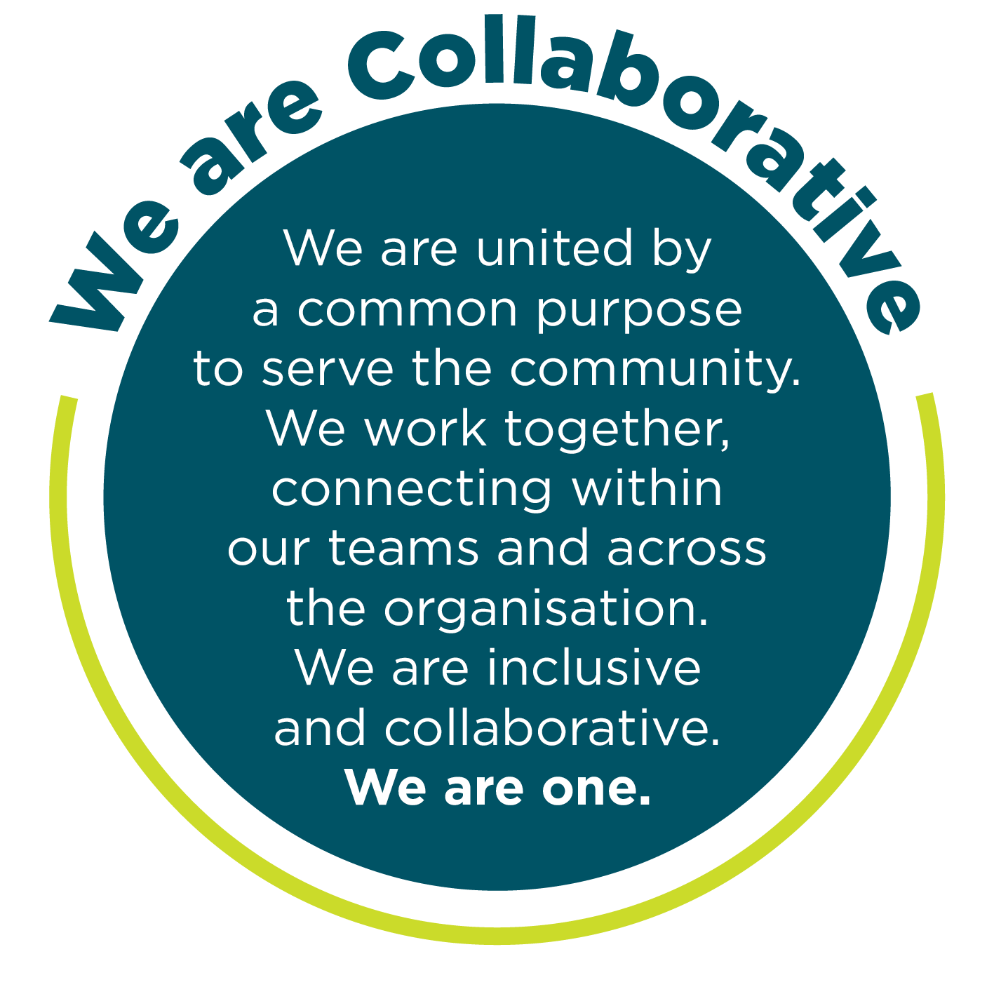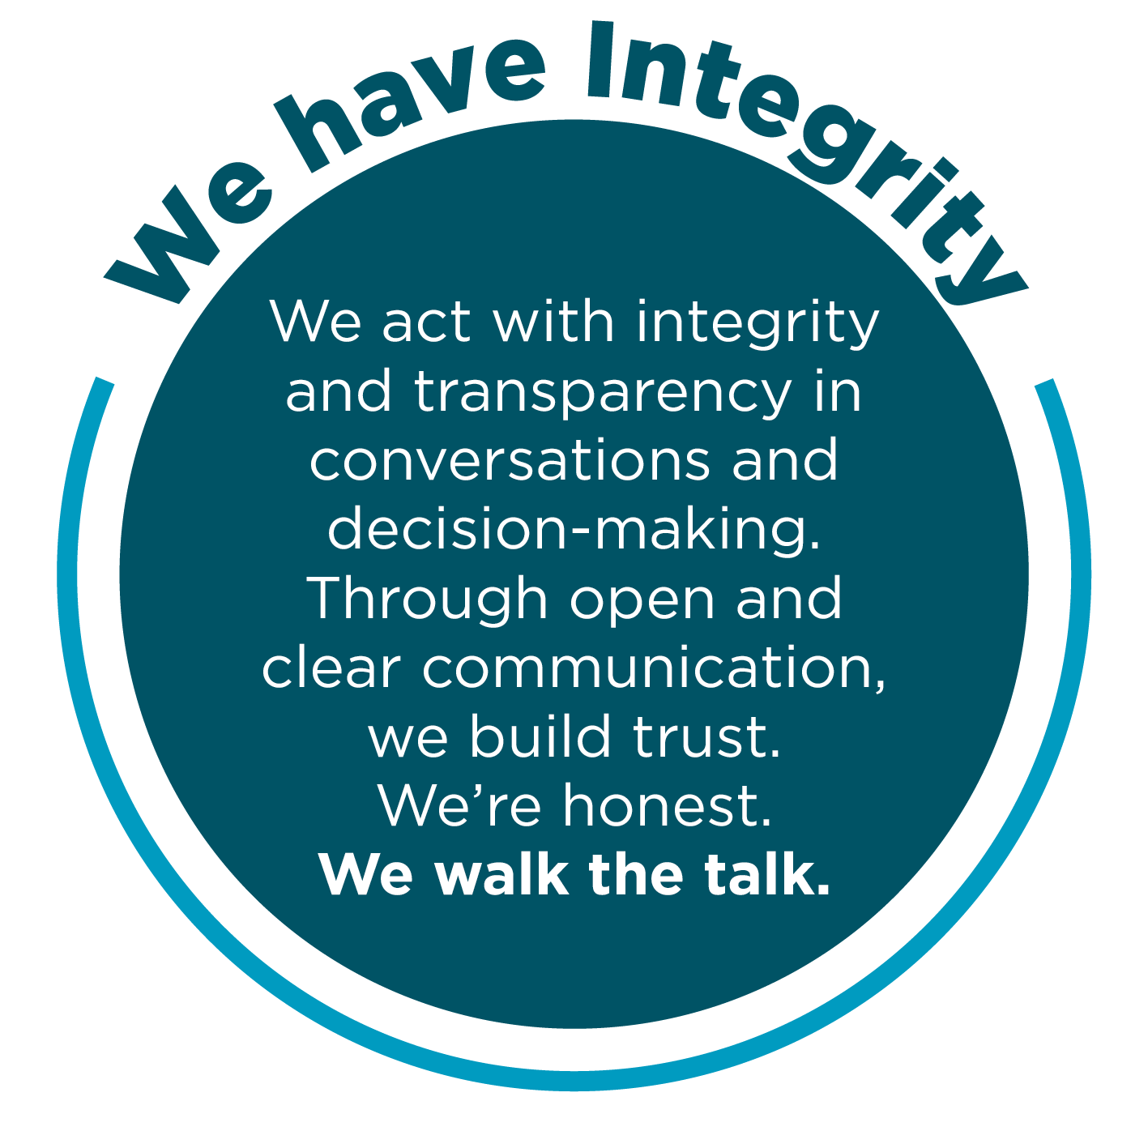
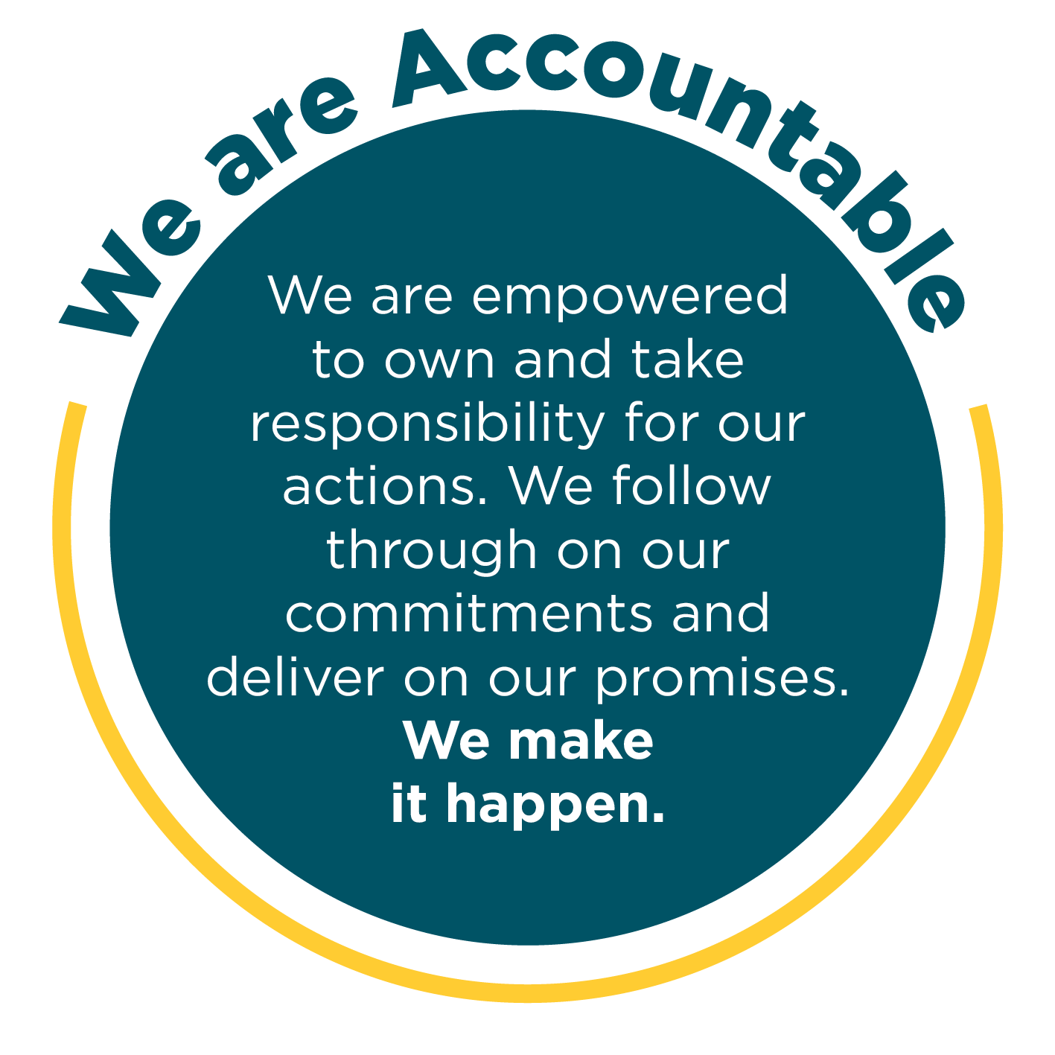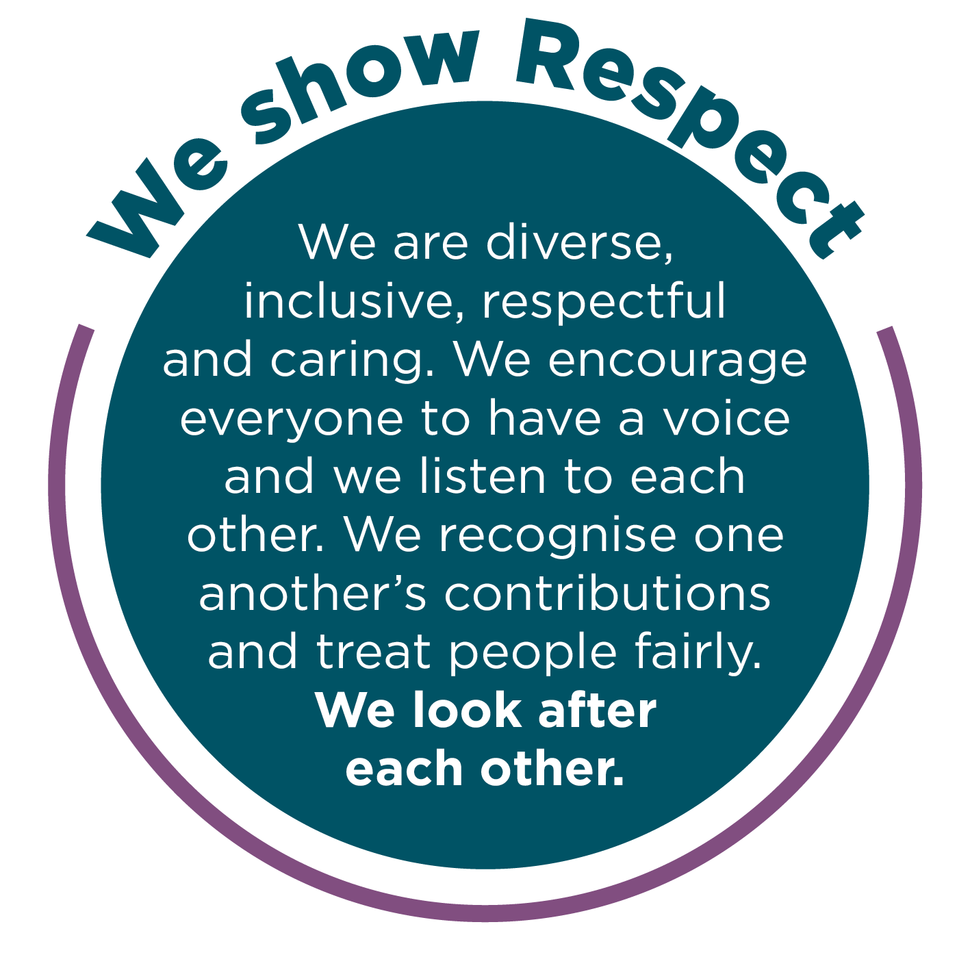
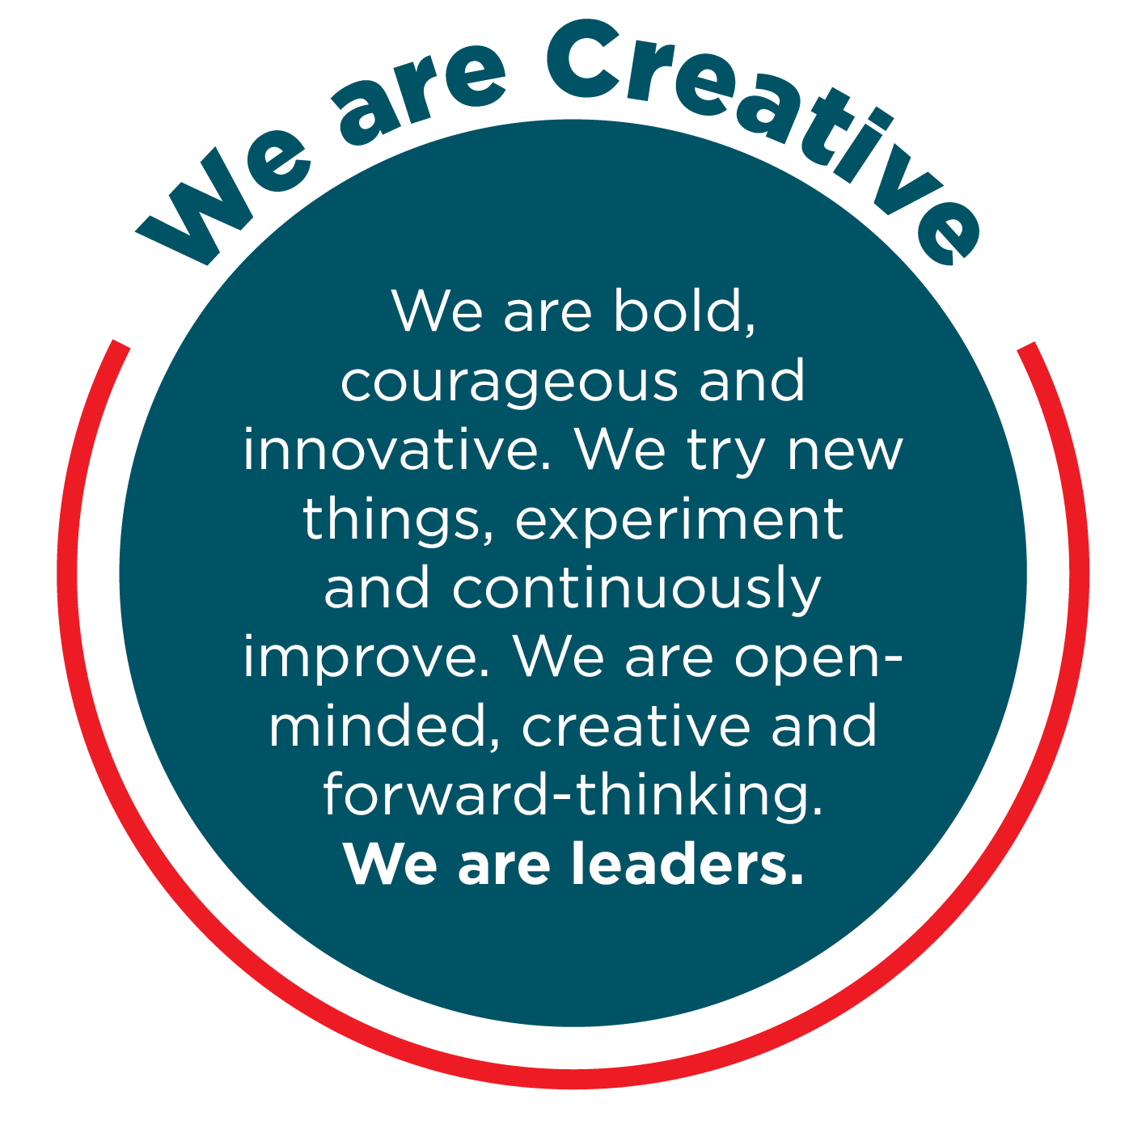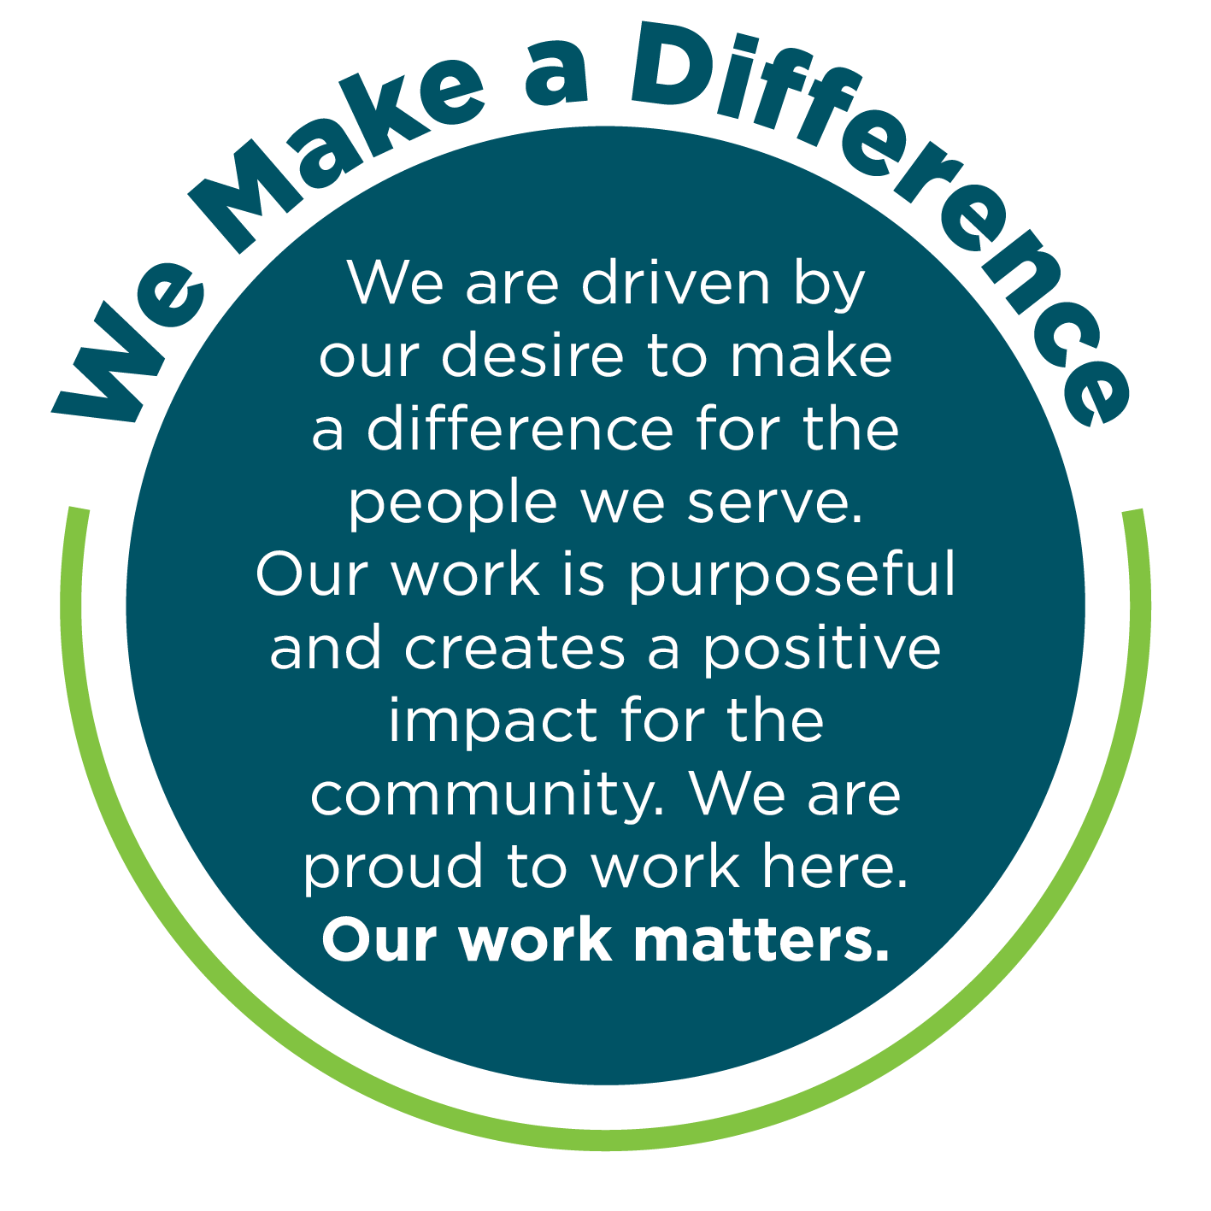
Occupational Health & Safety
To achieve our desired outcome, you will:
- Comply with the Occupational Health and Safety Act, related Regulations and defined OH&S policies, procedures, safety rules and Safe Working Procedures and implement and monitor the organisation’s OH&S policies, procedures, safety rules and programs in the relevant work area to achieve and maintain OH&S standards.
- Monitor health and safety performance and rehabilitation performance within your area of responsibility and initiate actions to improve health and safety, including facilitating rehabilitation of injured workers.
- Review any health and safety related reports and take appropriate action to resolve safety issues.
- Ensure consultation with employee health and safety representatives, particularly on any workplace changes that have health and safety implications.
- Actively monitor the workplace to determine presence of hazards and take appropriate action to rectify any hazards found.
- Ensure all employees understand their legal obligation under the OH&S Act and that they receive regular training to perform jobs safely.

Climate Action and Sustainability
Council plays a crucial and leading role in taking strong action on the climate crisis and in increasing environmental sustainability and awareness to ensure a safe and healthy future for us all.
Darebin’s Climate Emergency Plan outlines the leadership, advocacy and action Council is taking to respond to the climate crisis. Council’s Social and Sustainable Procurement Policy outlines Council’s commitment to supporting local, equitable and sustainable practices and procurement.
Council has committed to carbon neutrality, advocating for climate justice, supporting the community to transition to renewable energy, working towards zero waste to landfill, improving sustainable water use, protecting our unique ecosystems and healthy waterways and ensuring a thriving and connected community. To help us achieve these outcomes, you will:
- Review work practices to identify how you can make a difference in Council and the community to reduce environmental impacts and raise awareness
- Maintain an awareness of the issues associated with the climate crisis and environmental sustainability and how they impact your role, Council and the community
- Carry out your role in line with Council’s Climate Emergency and Environment Policy lens guide, Equity Impact Assessment Guide and the Council’s Social and Sustainable Procurement policy guide
- Reach out to the Climate Emergency and Sustainability team if you ever have any questions or suggestions.

Excellence in Governance
Employees of Darebin City Council (Darebin) are expected to read and understand the Excellence in Governance Policy and to conduct themselves ethically, professionally and in accordance with Darebin's statutory obligations. Employees are also expected to treat others fairly and courteously while being respectful of alternative views and opinions. Darebin is an equal opportunity employer and does not tolerate discrimination, bullying or harassment in any form.
Employees are prohibited from disclosing any confidential information they may acquire during their employment or using such information for any purpose other than for the purposes of Darebin. Further, employees shall not use such information improperly to cause harm or detriment to other staff, people, body or the Council.
Employees shall not engage in any outside employment or activities that impact on their primary employment at Darebin. Employees shall also ensure that any outside employment or activities do not create a conflict of interest and/or duty with their role at Darebin. Where it is unclear whether a conflict of interest may exist, the employee should seek direction from their Direct Manager. Any actual or perceived conflict of interest must be disclosed prior to business dealings or immediately the conflict is apparent. This includes any possible direct or indirect pecuniary interest with a potential external tenderer in respect of goods, services or works tendered by Council.
Employees shall take responsibility for their actions when carrying out duties for Council and protect public resources and assets.
Employees must not make a statement made on behalf of the Council to the media or public unless authorised to do so by the Chief Executive.
Employees shall not discuss departmental business or staff matters with Councillors. If a Councillor requests such information from an employee, the request should be referred to the employee's Manager in the first instance.
As a condition of employment, the successful candidate is expected to sign the Excellence in Governance at Darebin Declaration confirming that they have read and understood and agree to act in accordance with the Excellence in Governance at Darebin Policy.

Child Safe - Statement of Commitment
Darebin City Council prides itself on being a child safe organisation with zero tolerance for child abuse. We recognise our legal and moral responsibilities to keep children and young people safe from harm; we promote their health and well-being and support their best interests.
We have policies, procedures, and training in place that support our leadership team, employees and volunteers to achieve these commitments.
We create environments where all children, including children with a disability, Aboriginal children, and children from cultural and linguistically diverse backgrounds, have a voice - they are listened to, their views are respected and they contribute to how we plan for, design and implement our services and activities.
As a condition of employment, the successful candidate is expected to sign the Safeguarding Children Code of Conduct confirming that they have read and understood and agree to act in accordance.

Position Objectives:

- The primary objective is to be an active participant in the youth service team and to support the enhancement of the status and wellbeing of young people within the City of Darebin.

- To collaborate with community and service providers to develop best practice approaches and strategies to engage and meet the needs of young people

- Support the development, implementation and evaluation of a range of programs aimed at engaging young people in education and employment, enhancing health and wellbeing and community participation

- Ability to collaboratively design and implement programs and interventions to meet a range of diverse and complex needs

Reporting Relationships:

This Position Reports To:

Team Leader Programs

Position Reporting To This Position:

Casual employees

Internal Relationships:

All employees across Council

External Relationships:

Local youth service agencies and providers, young people and their families, schools, government organisations and state government departments

Key Responsibilities and Duties:

People Support and Engagement
- Inspire, coach, empower and motivate young people
- Work with other service providers including education, employment and other specialised providers to ensure a holistic suite of services is available
- Provide information, short term support and referral to young people and their families
- Promote service and programs to young people and their families

Programs and Service Delivery
- Plan, develop, implement and evaluate programs and initiatives that address the health, wellbeing, education and employment of young people
- Support and oversee the daily operation of The Hub youth facility at Northland
- Support the development of strategies to identify and address the needs of young people
- Other duties as directed within the skills and capabilities of a position at this level.

Accountability and Extent of Authority:

- The position is directly responsible for the design, delivery, promotion and evaluation of a program that supports the service aims along with overseeing the safe operation of The Hub.
- The incumbent has the freedom to develop and deliver programs within the boundaries of the service aims and exercise best judgement where required, in line with current risk management strategies, child safe code of conduct and staff code of conduct.
- The position can give direction to casual staff within the team, student placements, program participants and patrons of The Hub.
- The position will report directly to the Team Leader of Youth Programs and will be held accountable through bi-annual performance reviews and KPI’s as outlined in a mutually agreed workplan.

Judgement and Decision Making:
- Apply high levels of judgement and ethical standards of practice to deliver service and programs to young people
- Incumbent required to act and make decision within the organisation’s values and behaviour framework at all times
- The incumbent has the responsibility of making decisions on most aspects of youth programs, however guidance is usually available
- Apply problem solving methods in relation to issues as they arise within your area of responsibility
- Under the guidance of the Team Leader submit recommendations in the form of reports and or discussion paper

Specialist Skills and Knowledge:

- Demonstrated ability to work within a youth participation framework to meet diverse needs
- Demonstrated ability to develop, deliver and evaluate youth-based programs
- Sound knowledge of youth and community development theories and practice
- Demonstrated ability to interpret and communicate legislation, policies and precedents that affect young people

Management Skills:

- Proven ability to set goals and implement strategies, work methods and practices to achieve department goals
- Ability to manage time, plan and organise work priories to achieve specific objectives within negotiated timeframe
- When required, plan and organise tasks of supervised employees within available resources and timetables

Other Relevant Information:

In accordance with the Australian Fair Work Act 2009, protection from unfair dismissal is subject to a minimum six-month period of employment.

The successful candidate will be required to provide proof of Australian Citizenship or residency status, (including at least a birth certificate or passport), and proof of identity, (Medicare card and/or current driver’s licence).

This position requires a Health Declaration and/or Functional Capacity Assessment prior to an offer of employment being made.

This position requires a satisfactory Police Check result prior to an offer of employment being made.

This position requires an employee Working with Children Card.

Council requires all employees to be fully vaccinated against COVID-19 as outlined in the Staff Covid-19 Vaccination Policy.

A Zero Blood Alcohol Level is required at all times.

The successful applicant will be provided with all relevant tools and equipment to undertake the inherent requirements of the role. All tools and equipment must be returned to the direct Manager upon cessation of the role.

Darebin City Council is an equal opportunity employer committed to providing a safe working environment that embraces and values child safety, diversity, and inclusion. We encourage applications from Aboriginal or Torres Strait Island people, people with disabilities and culturally and linguistically diverse backgrounds. If you require support or advice with your application, contact the People and Culture team on 8470 8204. Reasonable adjustments can be negotiated.

Canvassing of Councillors and Council Officers:

Canvassing of Councillors and Council Officers, either directly or indirectly that may influence the outcomes of this application may be deemed a disqualification.
Enquiries regarding the position, however, can be directed to the nominated contact officer named in this Position Description.

Qualifications, Certificates, Licences, and/or Experience:

A tertiary qualification in youth work (or related discipline) and/or relevant experience in the youth environment.
A current Victorian Driver’s Licence.
Current First Aid Level 2 Certificate

Key Selection Criteria:

- Ability to achieve objectives and implement programs and projects within specific timelines and budgetary constraints relative to their accountabilities within the role.

- Ability to deal with a variety of complex issues and behaviours.

- Broad understanding of youth trends and issues impacting young people.

- Demonstrated experience in supporting the development, implementation and evaluation of youth programs and projects.

- Demonstrated experience engaging with young people using a youth participation model and/or community development framework.

Interpersonal Skills/ Personal Attributes:

- Integrity - Demonstrated ability to support communication and consultation regarding complex and confidential matters

- Excellent Communication and Relationship Building Skills - Demonstrated ability to communicate effectively with a diverse range of clients and stakeholders

- Excellent negotiation and conflict resolution skills

- Team Work – Demonstrated ability to contribute positively to a team

- Empathy and cultural awareness


Inherent Physical Requirement

Position Number & Title: F67015 Program Development Officer
Work Area: Youth Services, The Hub, Northland
Summary Tasks: Program development and delivery, active supervision of youth facility
Physical demands of the task and % of time allocated | Rarely  1-10% | Occasional  11-33% | Frequent  34-66% | Constant  67-100%
Sitting |  |  | X
Standing |  |  | X
Walking |  |  | X
Steps/ stairs | X
Squatting | X
Kneeling | X
Looking Up | X
Looking Down | X
Bending spine forwards | X
Twisting spine to side e.g. during meetings to view team members |  | X
Bending spine backwards | X
Working with one or both hands above shoulder height | X
Reaching forwards or sideways > 30cm from the body |  | X
Gripping or grabbing |  | X
Fine hand coordination e.g. for computer keying |  |  | X
Lifting floor-waist | X
Lifting at waist height | X
Lifting waist overhead | X
Carrying | X
Pushing e.g. of trolleys | X
Pulling e.g. of trolleys | X
Exerting force with one hand or one side of body e.g. when hole punching / stapling | X
Exerting force in an awkward posture | X
Holding, supporting or straining | X
Other | X

