
Position Description
Title: Senior Officer, Solar Saver Program
Position No: S12014
Classification: Band 7
Status: Maximum Term, Full-time until September 2022
Hours: 38 hours per week
Division: City Sustainability and Strategy
Department: Climate Emergency and Sustainable Transport
Location: 274 Gower Street, Preston

About Darebin

Located in the northern suburbs of Melbourne, covering an area of around 53 square kilometres of land and encompassing the areas of Bundoora, Kingsbury and Macleod, Fairfield and Alphington, Northcote, Preston, Reservoir, Coburg and Thornbury, the City of Darebin has a population of 161,609 (2018 ERP). The city has one of the largest populations of Aboriginal and Torres Strait Islander residents in metropolitan Melbourne and is home to one of the largest, most diverse communities anywhere in the State in terms of cultures (close to 33 per cent were born overseas), language (138 languages are spoken), religions, gender, age, abilities, socio-economic background, employment status, occupation, and housing needs. One in five Darebin residents is affected by a disability, and almost one-third of these residents require assistance with daily living. About 6 per cent of the population 16 years and over, identify as bisexual, gay or lesbian.

Council has a clear commitment to equity, diversity and inclusion in all that it does. We acknowledge the role that a workforce reflective of the community plays in delivering services and programs; we recognise that in order to meet the needs of the diverse community we serve; we need a diverse workforce with special knowledge and skills. This means that a high-quality workforce, skilled in diversity, equity and inclusion principles and practice, is central for Council to deliver responsive, accessible, equitable and inclusive services across the municipality.

We are an Equal Opportunity Employer and do not discriminate in our selection and employment practices on the basis of race, colour, religion, sex, national origin, political affiliation, sexual orientation, gender identity, marital status, disability, genetic information, age, membership in an employee organisation, or other non-merit factors. We are committed to providing a safe working environment that embraces and values child safety, and thorough ‘Safety Screening’ processes apply. For all other information regarding the City of Darebin, including our Profile, our Diverse Community, our Values, the Council Plan 2017-2021, Equal Opportunity Employment, Disability Access and Inclusion, the Victorian Charter of Human Rights, and Risk Management, visit our website: www.darebin.vic.gov.au

Our Values

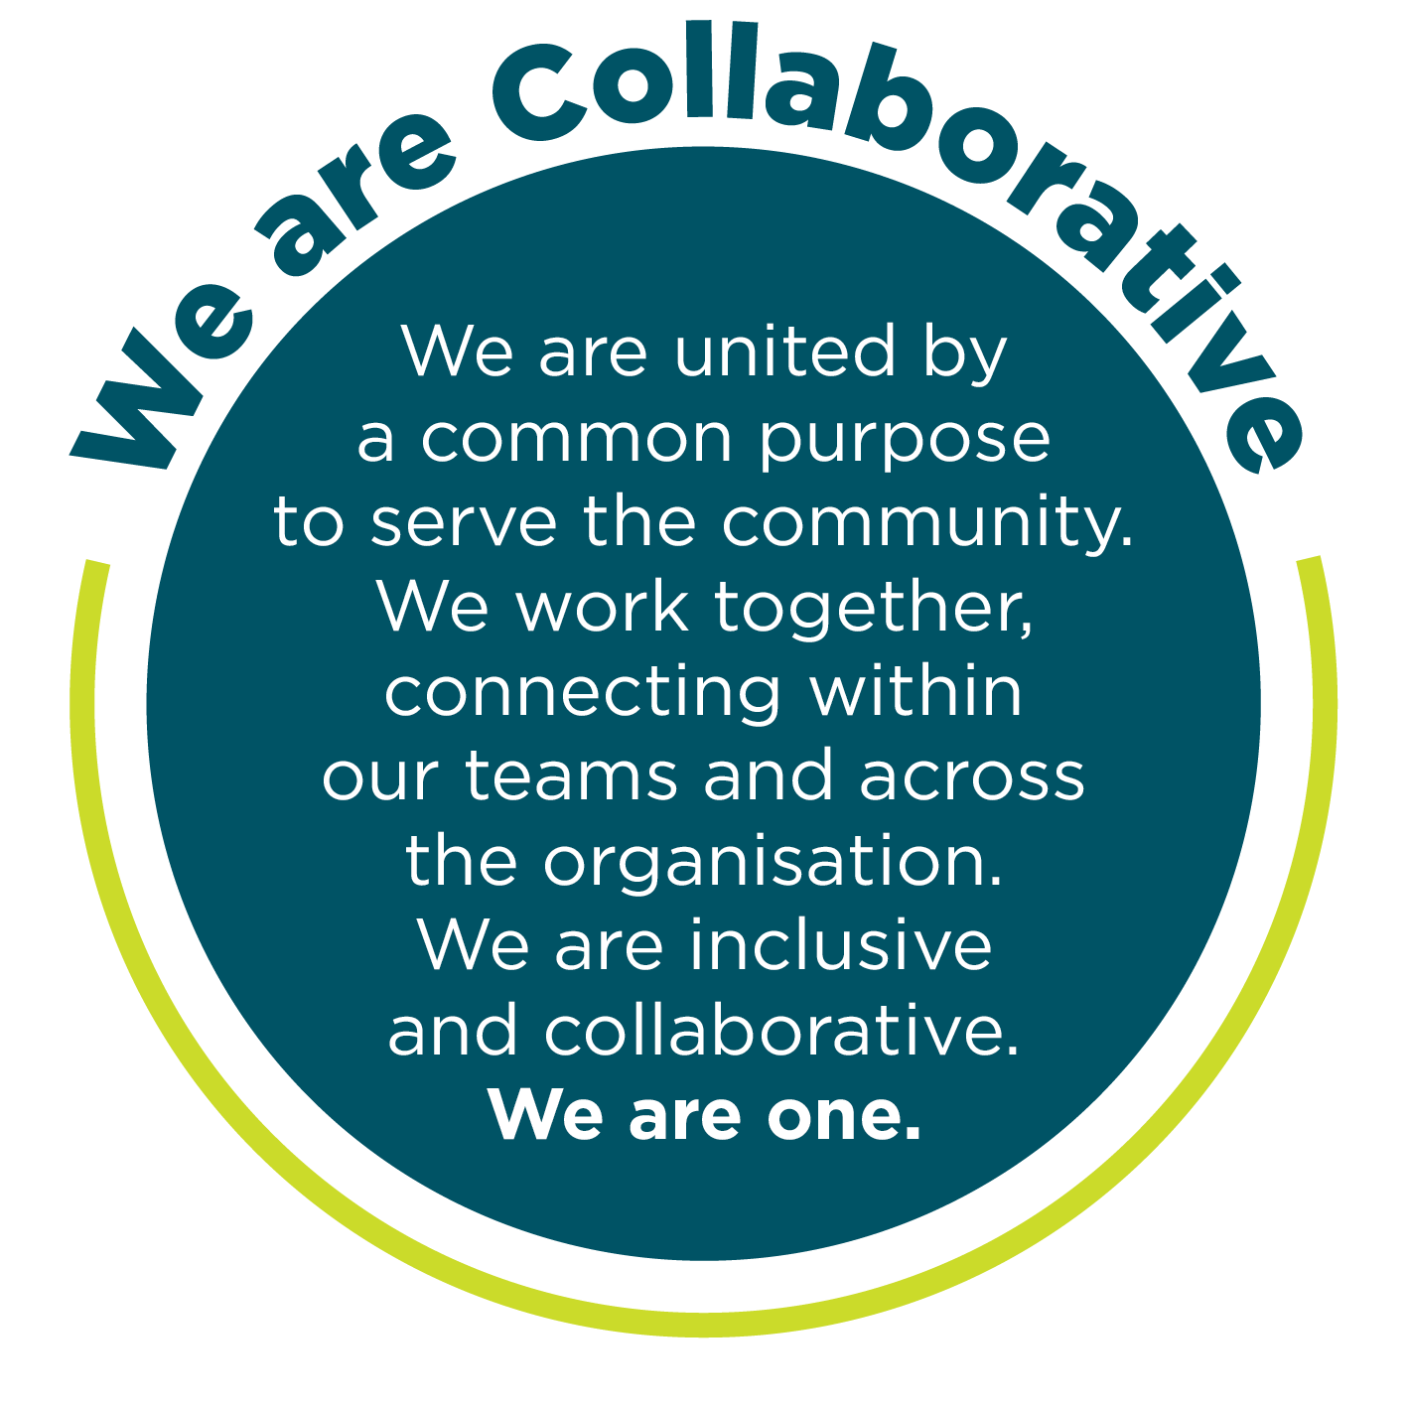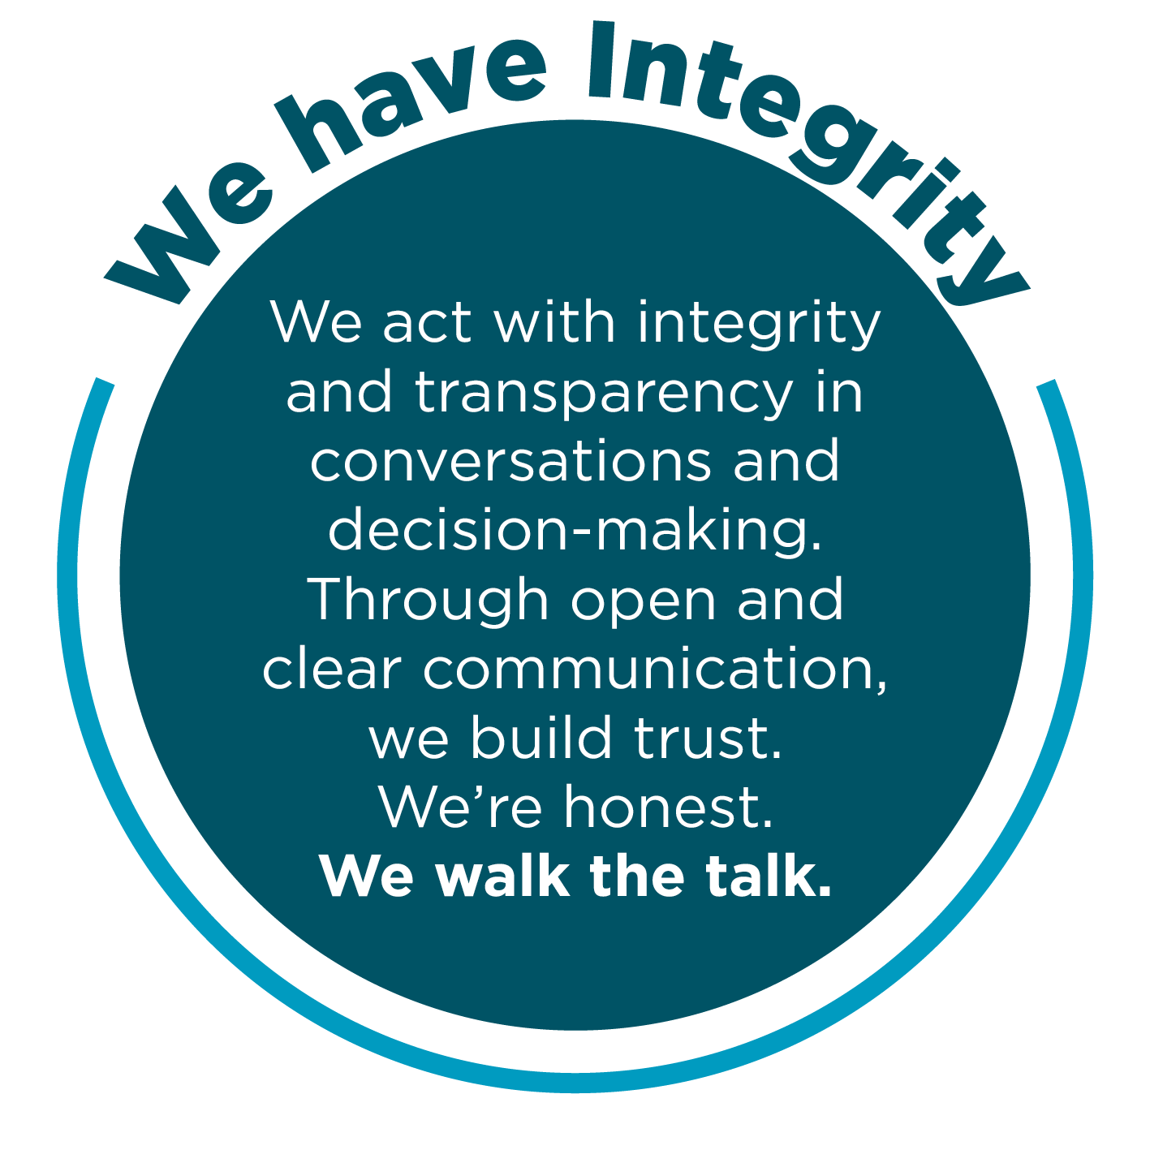
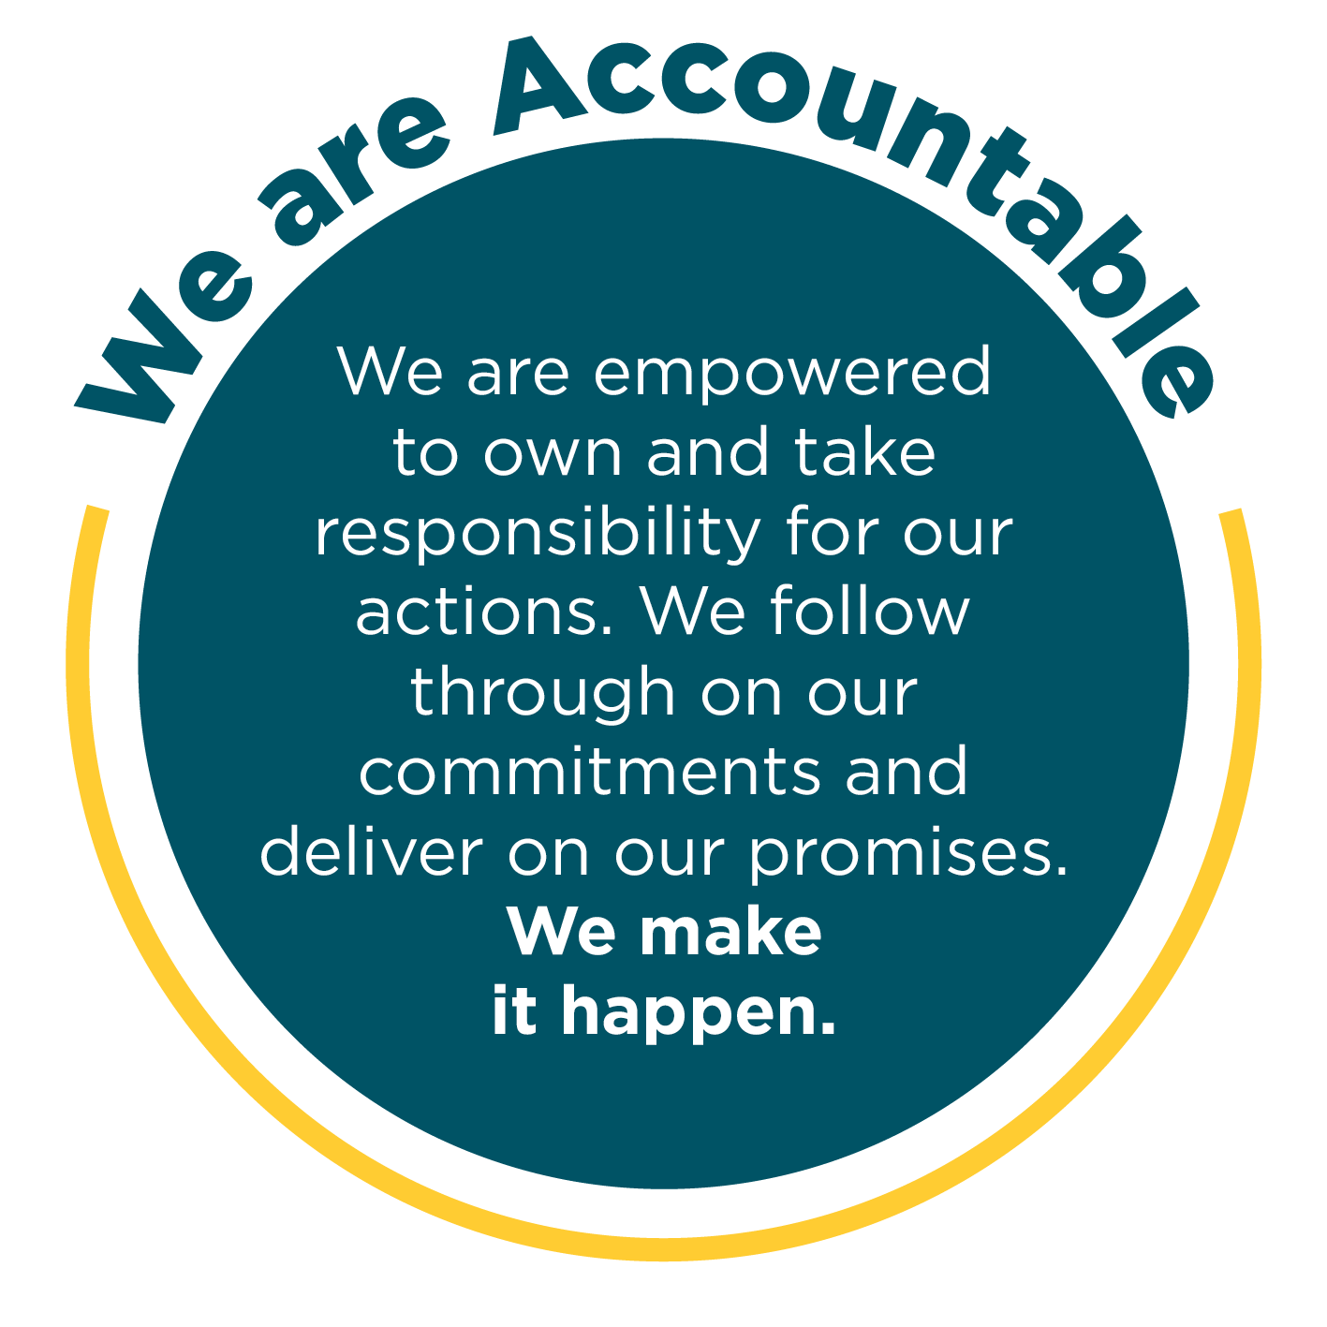
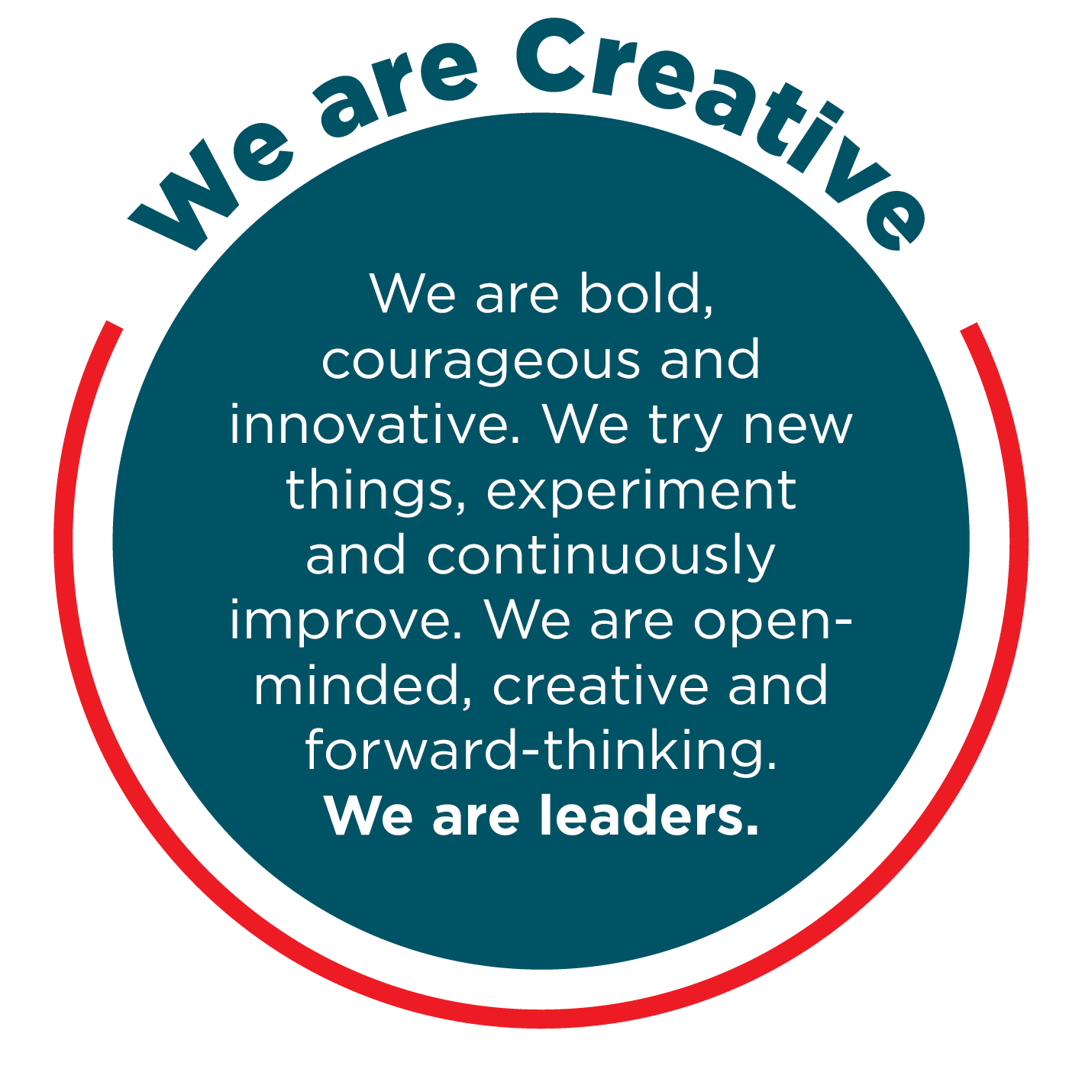
Occupational Health & Safety
To achieve our desired outcome, you will:
- Comply with the Occupational Health and Safety Act, related Regulations and defined OH&S policies, procedures, safety rules and Safe Working Procedures and implement and monitor the organisation’s OH&S policies, procedures, safety rules and programs in the relevant work area to achieve and maintain OH&S standards.
- Monitor health and safety performance and rehabilitation performance within your area of responsibility and initiate actions to improve health and safety, including facilitating rehabilitation of injured workers.
- Review any health and safety related reports and take appropriate action to resolve safety issues.
- Ensure consultation with employee health and safety representatives, particularly on any workplace changes that have health and safety implications.
- Actively monitor the workplace to determine presence of hazards and take appropriate action to rectify any hazards found.
- Ensure all employees understand their legal obligation under the OH&S Act and that they receive regular training to perform jobs safely.

Climate Action and Sustainability
Council plays a crucial and leading role in taking strong action on the climate crisis and in increasing environmental sustainability and awareness to ensure a safe and healthy future for us all.
Darebin’s Climate Emergency Plan outlines the leadership, advocacy and action Council is taking to respond to the climate crisis. Council’s Social and Sustainable Procurement Policy outlines Council’s commitment to supporting local, equitable and sustainable practices and procurement.
Council has committed to carbon neutrality, advocating for climate justice, supporting the community to transition to renewable energy, working towards zero waste to landfill, improving sustainable water use, protecting our unique ecosystems and healthy waterways and ensuring a thriving and connected community. To help us achieve these outcomes, you will:
- Review work practices to identify how you can make a difference in Council and the community to reduce environmental impacts and raise awareness
- Maintain an awareness of the issues associated with the climate crisis and environmental sustainability and how they impact your role, Council and the community
- Carry out your role in line with Council’s Climate Emergency and Environment Policy lens guide, Equity Impact Assessment Guide and the Council’s Social and Sustainable Procurement policy guide
- Reach out to the Climate Emergency and Sustainability team if you ever have any questions or suggestions.

Excellence in Governance
Employees of Darebin City Council (Darebin) are expected to read and understand the Code of Conduct and to conduct themselves ethically, professionally and in accordance with Darebin's statutory obligations. Employees are also expected to treat others fairly and courteously while being respectful of alternative views and opinions. Darebin is an equal opportunity employer and does not tolerate discrimination, bullying or harassment in any form.
Employees are prohibited from disclosing any confidential information they may acquire during their employment or using such information for any purpose other than for the purposes of Darebin. Further, employees shall not use such information improperly to cause harm or detriment to other staff, people, body or the Council.
Employees shall not engage in any outside employment or activities that impact on their primary employment at Darebin. Employees shall also ensure that any outside employment or activities do not create a conflict of interest and/or duty with their role at Darebin. Where it is unclear whether a conflict of interest may exist, the employee should seek direction from their Direct Manager. Any actual or perceived conflict of interest must be disclosed prior to business dealings or immediately the conflict is apparent. This includes any possible direct or indirect pecuniary interest with a potential external tenderer in respect of goods, services or works tendered by Council.
Employees shall take responsibility for their actions when carrying out duties for Council and protect public resources and assets.
Employees must not make a statement made on behalf of the Council to the media or public unless authorised to do so by the Chief Executive.
Employees shall not discuss departmental business or staff matters with Councillors. If a Councillor requests such information from an employee, the request should be referred to the employee's Manager in the first instance.
As a condition of employment, the successful candidate is expected to sign the Code of Conduct Declaration confirming that they have read and understood and agree to act in accordance.

Child Safe - Statement of Commitment
Darebin City Council prides itself on being a child safe organisation with zero tolerance for child abuse. We recognise our legal and moral responsibilities to keep children and young people safe from harm; we promote their health and well-being and support their best interests.
We have policies, procedures, and training in place that support our leadership team, employees and volunteers to achieve these commitments.
We create environments where all children, including children with a disability, Aboriginal children, and children from cultural and linguistically diverse backgrounds, have a voice - they are listened to, their views are respected and they contribute to how we plan for, design and implement our services and activities.
As a condition of employment, the successful candidate is expected to sign the Safeguarding Children Code of Conduct confirming that they have read and understood and agree to act in accordance.

Position Objectives:

This role leads a small team of highly skilled professionals and is responsible for the delivery of Council’s Solar Saver program.

Reporting Relationships:

This Position Reports To: Coordinator Climate Emergency and Environment Programs

Positions reporting to this position:

Two Solar Saver Project Officers

Solar Saver Support Officer

Internal Relationships:

All employees across Council

External Relationships:

Residents and ratepayers, business representatives and trader groups, partner organisations, solar industry organisations and representatives, energy efficiency service providers, local and state government and other public authority representatives

Key Responsibilities and Duties:
- Manage the development and delivery of Council’s Solar Saver program.
- Lead the Solar Saver team. Engage, empower and motivate staff, develop capability and potential in others
- Oversee the forward planning of the Solar Saver program with support from colleagues and supervisors.
- Organise and manage procurements and contracts that underpin the delivery of this program.
- Monitor, review and evaluate to ensure appropriate progress, financial management, risk management, addressing of complex issues, and reporting.
- Ensure a positive customer experience and develop internal and external stakeholder relationships to ensure program has maximum impact
- Project planning, delivery, and oversight as required. Plan and organise work in line with organisational goals and adjust to changing priorities.
- Be responsible for program budgets and apply processes in line with legislation and policy. Other duties as directed within the skills and capabilities of a position at this level.

Accountability and Extent of Authority:
Under general supervision, the successful applicant will be directly responsible for the delivery of Council’s residential renewable and energy efficiency projects within the Solar Saver program. Whilst having responsibility for the management of a team, the successful applicant will also:
- Ensure that projects and programs are delivered in accordance with organisational goals, project specifications, customer experience strategy, environmental sustainability and OH&S requirements, agreed budget and timelines, and accepted project management best practice while at the same time, providing the highest quality outcomes.
- Provide contract management services for the suite of contracts which underpin the delivery of these projects and programs, ensuring adherence to project management best practice and procurement compliance.
- Manage small team.

Judgement and Decision Making:
The successful applicant will be required to identify and resolve complex issues, promptly and positively respond to changing circumstances, and make decisions which ensure the best outcomes for Council. The successful applicant will also be required to:
- Work with the Coordinator Climate Emergency Programs to make positive decisions on strategic issues and day-to-day operations under direction from the Manager, Climate Emergency and Sustainable Transport.
- Research and interpret regulations, standards and statutory requirements, and apply these to Council’s Solar Saver program, including in relation to project scope, stakeholder management, resolving issues and communications.
- Adopt an unprejudiced and pragmatic approach in managing complex issues or negotiations, conflicting perspectives or challenging stakeholders, while at the same time prioritising best outcomes for Council and the community
- Responsible for planning and / or coordinating appropriate development for the team.

Specialist Skills and Knowledge:
- Demonstrated knowledge of renewable energy, energy efficiency and energy management technology, government policy and legislation, markets and issues and capacity to research and apply strategic solutions to issues.
- Demonstrated expertise and experience in providing program planning, management and contract management services, including tender and other procurement processes, contract execution and review.
- An ability to seek input from and achieve cooperation with a range of stakeholders and interest groups
- An ability to manage budgets including budget forecasting and acquittal.
- Excellent problem solving and negotiation skills.
- Outstanding communication, reporting, and presentation skills and the ability to represent Council at a variety of external forums.
- Proficiency in the use of computers and software including the usual suite of Microsoft products.

Management Skills:
- Demonstrated ability to lead a team of professional people.
- Demonstrated ability to manage consultants and contractors in a construction or similar environment.
- Proven contract administration.
- Demonstrated ability to plan, prioritise and organise work, both on an individual and team basis within set timelines and budget, and in an environment of change and conflicting demands.
- Understanding of, and ability to implement personnel practices including equal opportunity, health and safety, and training and development.
- Demonstrated ability develop and maintain collaborative relationships with all project and program stakeholders in order to achieve the best outcomes for Council.

Other Relevant Information:

In accordance with the Australian Fair Work Act 2009, protection from unfair dismissal is subject to a minimum six-month period of employment.

The successful candidate will be required to provide proof of Australian Citizenship or residency status, (including at least a birth certificate or passport), and proof of identity, (Medicare card and/or current driver’s licence).

This position requires a satisfactory Police Check result prior to an offer of employment being made.

This position requires an employee Working with Children Card.

Council requires all employees to be fully vaccinated against COVID-19 as outlined in the Staff Covid-19 Vaccination Policy.

The successful applicant will be provided with all relevant tools and equipment to undertake the inherent requirements of the role. All tools and equipment must be returned to the direct Manager upon cessation of the role.

Darebin City Council is an equal opportunity employer committed to providing a safe working environment that embraces and values child safety, diversity, and inclusion. We encourage applications from Aboriginal or Torres Strait Island people, people with disabilities and culturally and linguistically diverse backgrounds. If you require support or advice with your application, contact the People and Development team on 8470 8204. Reasonable adjustments can be negotiated.

Canvassing of Councillors and Council Officers:

Canvassing of Councillors and Council Officers, either directly or indirectly that may influence the outcomes of this application may be deemed a disqualification.
Enquiries regarding the position, however, can be directed to the nominated contact officer named in this Position Description.

Qualifications, Certificates, Licences, and/or Experience:

A tertiary qualification in environmental science, renewable energy, energy management, and/or extensive relevant experience.

Key Selection Criteria:

- Demonstrated experience and expertise in managing large-scale renewable energy programs, or other comparable projects or programs, ensuring delivery is on time, within budget and quality expectations.
- Proven ability and experience in providing contract management services; including development of tenders and requests for quote; contract drafting, execution and delivery; seeking legal advice; as well as experience in managing complex financial modelling and reporting.
- Excellent engagement skills including demonstrated ability to communicate, negotiate, influence and engage with a wide range of key stakeholders both internal and external to the organisation.
- Understanding of good customer service and the ability to work with a wide range of people.
- Outstanding written and verbal communication including expertise in communicating technical concepts in clear, accessible language and writing reports for different audiences.
- Demonstrated understanding of the energy sector including energy policy, markets and programs and understanding of renewable infrastructure such as Solar PVs and energy efficiency equipment.
- Excellent organisational skills with the ability to work flexibly and independently in a dynamic and changing environment.

Interpersonal Skills/ Personal Attributes:
- Demonstrated ability to lead and motivate a team of highly skilled professional officers.
- Excellent organisational and time management skills, with the ability to manage workloads and set priorities and competing demands.


Inherent Physical Requirement

Position Number & Title: Senior Officer, Solar Saver Program
Work Area: Climate Emergency and Sustainable Transport
Summary Tasks:
Physical demands of the task and % of time allocated | Rarely  1-10% | Occasional  11-33% | Frequent  34-66% | Constant  67-100%
Sitting |  |  |  | x
Standing |  |  | x
Walking |  |  | x
Steps/ stairs |  | x
Squatting |  | x
Kneeling |  | x
Looking Up |  | x
Looking Down |  |  | x
Bending spine forwards |  |  | x
Twisting spine to side e.g. during meetings to view team members |  | x
Bending spine backwards | x
Working with one or both hands above shoulder height |  | x
Reaching forwards or sideways > 30cm from the body |  | x
Gripping or grabbing |  | x
Fine hand coordination e.g. for computer keying |  |  |  | x
Lifting floor-waist |  | x
Lifting at waist height |  | x
Lifting waist overhead |  | x
Carrying |  | x
Pushing e.g of trolleys |  | x
Pulling e.g. of trolleys |  | x
Exerting force with one hand or one side of body e.g. when hole punching / stapling |  | x
Exerting force in an awkward posture |  | x
Holding, supporting or straining |  | x
Other

