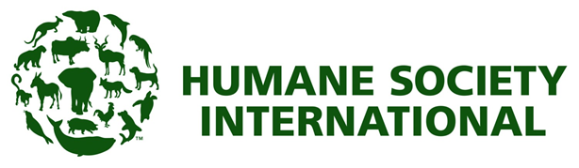

JOB DESCRIPTION
Position Title | Marketing and Social Media Coordinator
Job Type: | Full-time
Location: | Avalon office and/or from home on a hybrid basis
Reports to: | Fundraising Manager and Head of Campaigns
Humane Society International is the largest and most effective international charity working to create a world where people treat animals with respect and compassion.
The Marketing and Social Media Coordinator supports the campaigns and fundraising teams, manages community engagement and leads the development of the strategy and content for HSI’s social media channels.
This position will help us engage and retain supporters and donors through outstanding, best-practice digital communications. The Marketing and Social Media Coordinator will excel in engaging digital audiences and love using analytics to drive results.
The successful candidate will create and manage social media content and engagement (Facebook, Twitter, LinkedIn and Instagram) assist in executing email marketing and help to keep the website up to date. This position reports to both the Fundraising Manager and the Head of Campaigns.

Main Duties and Responsibilities
- Work with CEO, Head of Campaigns and campaigns and program staff to assist and advise on digital marketing and social media strategy to help reach campaign goals, build HSI’s brand and attract new supporters.
- Work with Fundraising Manager to execute digital fundraising campaigns.
- Create and publish content on HSI’s social media channels and manage online communities following approvals guidelines.
- Prepare and publish emails, e-newsletters and social media posts.
- Publish new content on HSI’s website.
- Set up email marketing automations.
- Conduct A/B testing to keep HSI’s digital communications current within the changing digital landscape and performing well.
- Monitor key online marketing metrics to track success.
- Ensure that the brand message and tone are consistent and appropriate across platforms.
- Boost supporter and donor engagement across platforms.
- Conduct regular data hygiene processes to ensure CRM records are kept up-to-date.
- Support fundraising administration staff as required to manage integration of digital and donor CRM records.
- Adhere to HSI policy and procedures.
- Maintain a safe workplace.

Skills and Experience

Qualifications
- Bachelor's degree in marketing or business or similar

Experience
- Experience in digital marketing and social media management
- Experience in digital fundraising preferred
- Experience with Google Analytics, digital engagement platforms (Engaging Networks preferred) social media platforms (Sprout Social preferred) and a keen interest in online marketing communications
- Knowledge of content management systems (Wordpress preferred)
- Experience executing digital acquisition and retention campaigns for excellent results
- Knowledge of video and picture editing software such as Canva or Photoshop and Premiere Pro
- Experience activating online communities for social change campaigns will be looked upon favourably

Skills
- High-level communication skills
- Problem-solving skills and good initiative to find solutions
- Creative flair and understanding of how to communicate across different channels
- Digital best-practice for audience engagement and fundraising
- Excellent analytic skills and demonstrated ability in using data to drive results
- Must be able to juggle multiple projects at the same time
- Incredible attention to detail
- Full understanding of all social media platforms
- Great team player
- Passion for animal welfare and conservation!

