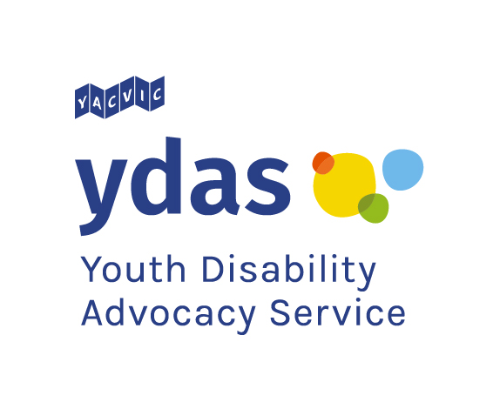
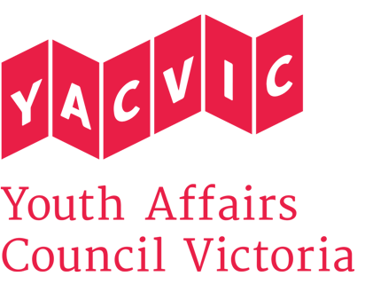

Title: | 2x YDAS Young Leaders Program Facilitator
Reporting to: | YDAS Young Leaders Program Officer
Remuneration: | $33.20 per hour. Classified as SCHADS Award Level 3.1 (YACVic pays above award rates, with generous T&C.)
Status: | Part time (0.5 FTE / 19 hours per week, negotiable). Fixed term contract until 30 June 2022.
Location: | Based in Melbourne CBD (Queen Street) with some state-wide travel. Working from home arrangements during COVID-19.

Youth Disability Advocacy Service (YDAS)
YDAS is a core YACVic agency, funded by the Victorian Government. YDAS has a service model which places the human rights and interests of disabled young people at the centre of its work. YDAS undertakes individual and policy advocacy, working with disabled young people to ensure that their human rights are upheld so they can access services and participate as valued and respected members of their community.

(In this document YDAS uses identity first language (disabled young people), as per the advice of the YDAS Steering Committee, which is comprised of disabled young people. However, we recognise that language and identity are personal choices, and that some people may prefer to use other terms including person first language (young people with disability).

About Youth Affairs Council Victoria (YACVic)
Youth Affairs Council Victoria (YACVic) is the peak body and leading policy advocate on young people’s issues in Victoria. YACVic’s vision is that the rights of young people in Victoria are respected, and they are active, visible and valued in their communities. YACVic is an independent, for-purpose, member-driven organisation that represents young people (aged 12–25 years) and the sector that works with them.

YACVic provides additional targeted advocacy and services through our key services, YACVic Rural and the Youth Disability Advocacy Service, and our auspice partner, the Koorie Youth Council.

About the YDAS Young Leaders Program
The goal of the YDAS Young Leaders Program (YLP) is for disabled young people to be in influential leadership roles in a diverse range of organisations and communities.

YLP is a 4-workshop series for young Victorians who identify as having a disability. This can include having a health condition or chronic illness, being neurodiverse or autistic, Deaf, deaf or hard of hearing, blind or vision impaired, or having lived experience of mental health issues.

The half-day YLP workshops bring together groups of young people to grow their skills, knowledge, confidence and motivation to become better leaders. Participants build their knowledge of who they are, their confidence in teamwork and communication, and their advocacy and goal setting skills.

Each group has 15 disabled young people coming together on Zoom and/or face-to-face, in an accessible and inclusive space. The workshops include young people from Melbourne and regional Victoria aged from 14 – 25. Workshops are a mix of practical activities and discussions. Each workshop features a guest speaker who is an established disabled leader in their field.

The program also includes six months of direct support from YDAS staff, who share opportunities for jobs, volunteering, and other ways to continue a leadership journey.

This is a link to the main page of the program.
This is a link to the Frequently Asked Questions page for the program.

About the YDAS Young Leaders Program Facilitator role
There are two Program Facilitator roles available. Each Facilitator will deliver the workshops of the Young Leaders Program, supported by YDAS staff. You will co-facilitate with another Program Facilitator, and help the young leaders learn through discussion and activities. You will also be involved in design, planning and preparation for the YLP workshops.

Prior to each workshop series, you and your co-facilitator will recruit, plan and prepare for the participants, including understanding goals and access needs for each individual in the group. You will also rehearse with your co-facilitator and prepare materials.

You and your co-facilitator will set up, run and wrap up each session; manage materials; and complete the necessary debriefing and follow up processes. You will also track each participant's journey throughout the program and adjust workshop materials and delivery as needed.

Other responsibilities include communicating with young people, parents and carers, and organisations and support staff that support the program; providing short-term mentoring and advice to participants; and responding to any new tasks the workshops may have produced.

One Program Facilitator will be responsible for running post-workshop support for graduates of the program. They will organise check-ins with graduates, keep track of their successes, and develop ideas for supporting the graduates to reach their goals.

The other Program Facilitator will be responsible for ensuring the program content is accessible, up to date, easy to understand, and is updated to accurately reflect what happens in the workshops.

Using your lived experience as a disabled young person to support and develop program participants will be core to the role. This position is only available for those who identify as a disabled person under the special measure of the EOA.

Key Responsibilities: What you’ll be doing
- Facilitate YDAS Young Leaders workshops for disabled young people. This includes providing support and mentorship to disabled young people to understand leadership and how it can be applied in their lives.
- Review program materials to ensure they are relevant and engaging for disabled young participants. This includes working with the Programs Coordinator and YLP Officer to update the program design and materials when necessary.
- Coordinate recruitment of program participants, including reviewing applications, communicating with applicants, signing them up, completing their paperwork.
- Plan and prepare for each group of participants, gathering information about individual goals and access needs, and preparing the workshop materials in advance.
- Monitor program participants for child safety concerns and ensure the workshops are a safe and inclusive space for diverse young people (training will be provided to you about how to do this).
- Provide post-workshop support for program graduates.
- Maintain appropriate notes to document workshop outcomes.
- Work with the Programs Coordinator and YLP Officer to evaluate the program.
- Carry out any other duties senior managers may assign to you, having regard to your skills, training and experience.

KEY SELECTION CRITERIA: What you’ll need to respond to in your application. Please respond to each one. Use stories from your life or work.
- Demonstrated commitment to the rights and interests of disabled young people.
- Proven ability to build rapport and work effectively with others, especially disabled young people.
- Demonstrated skills in leading or assisting with groups or workshops.
- Demonstrated understanding of appropriate behaviours when engaging with children and young people, including those with diverse needs and/or backgrounds, and commitment to the Code of Ethical Practice for the Victorian Youth Sector.
- Willingness and capacity to travel throughout Victoria and work occasional evenings.
- Demonstrated organisation skills, including using tools in the MS 365 Office Suite.
DESIRABLE CRITERIA: What would be good to respond to if relevant to you. You don’t have to respond to these, but it helps.
- Experience writing and editing content, for example, articles, blog posts, newsletters, documents.
- An interest or desire to lead within your community or social setting.
- Experience coaching, facilitating, tutoring, or mentoring.
REPORTING
The Young Leaders Program Facilitators report to the Young Leaders Program Officer.
EMPLOYMENT CONDITIONS
This position is only available for those who identify as a disabled person under the special measure of the EOA.
YACVic promotes the safety, wellbeing and inclusion of all children and young people, including those with a disability, those who are Aboriginal or those from refugee or migrant backgrounds. We take child protection very seriously. All employees are subject to screening and assessment against child safety standards, including rigorous background, identity and reference checks. The successful applicant will require a current Working with Children Check and Police Check (costs reimbursed) and must agree to adhere to our Child Safe Policy and Code of Conduct.
You must include:
- A cover letter (1 page or less, or video/audio recording 5 minutes or less).
- Your resumé or CV (they are the same thing).
- Your reply to the Key Selection Criteria and Desirable Criteria above as a separate document or video/audio 15 minutes or less. Explain how you have the traits, skills and experience needed for the role. Give examples or tell a story from your past to illustrate your response. If you choose to send a video/audio recording, include the link to the file.
- Contact details for two people who can talk about your skills and experience. For example, a manager, teacher, or youth worker. You need to include your most recent manager if you have had a manager before. We will not contact these people without your permission.
- Tell us the best way we can contact you. For example, email, text, phone call.

Only applications that include all the information above will be accepted.

Please tell us if you have any access needs that we can support you with during the application process. We can support you if you would like to apply in a different format or you need support to apply or access the Code of Ethical Practice for the Victorian Youth Sector.

Applications close at 11:30pm 17th December.

If you have any questions about the role, please contact Simon Green by emailing sgreen@ydas.org.au or by calling 0447 678 653.

