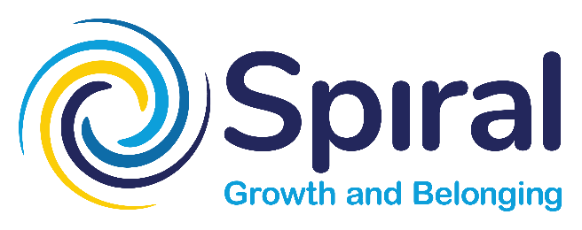

Experienced Development Workers
Empowering potential and equality for people with disabilities.
About Us
Supporting People in Respite and Lifestyle (Spiral) is a not-for-profit disability service based in Nambour.
Spiral supports individuals who are eligible for Government funded services in the Sunshine Coast Council region. We provide:
- Individual support in community
- In home assistance
- Facilitated workshops
Spiral is a person-centred organisation which works collaboratively with the individual, their families, advocates and other service providers to be part of an innovative and creative support circle.

Why join Spiral?
- Our staff are valued, and we value the work they do
- You will make a daily difference in people’s lives
- We are a not-for-profit organisation with a value driven culture
- The friendly team environment

Benefits of working at Spiral
- A rewarding role and competitive salary
- Professional development
- Opportunities for on-the-job training and learning
- Access to employee benefits and assistance program
- Support from your colleagues
About the Role
The role of Development Worker is to provide direct support to Individuals to meet their needs and achieve their goals.
The Development Worker is responsible for supporting individuals to link into their community, foster social relationships, develop natural networks, as well as pursue valued roles in vocational, learning and leisure pursuits.
Other functions may include support with shopping, appointments, meals, mobility, personal care, exercise, hygiene, health, and emotional well-being.
The role requires a strong developmental focus in line with a person-centred framework. Whether working autonomously or as part of a team, the Development Worker will work in collaboration with the supervising Co-ordinators to support self-directed services within a flexible service delivery mode.
The Successful Candidate is reliable, flexible, of high integrity and able to work both independently and as part of a team. You will have well developed written and oral communication skills. You will be proactive and have an ability to think outside of the box to achieve positive outcomes for the people you support.
Must haves:
- Extensive experience in direct support of adults with disabilities including some of the following:
  - Positive Behaviour Support
  - High level support needs
  - People Handling and Manual Handling equipment
  - An understanding of alternative communication methods
  - Mental Health awareness
  - Epilepsy
  - Other specialisations to meet the needs of a diverse range of Participant support requirements
- Certificate 3 Individual Support or equivalent or a willingness to obtain
- Australian Drivers Licence
- Current First Aid and CPR Certificates
- Hold a certificate evidencing COVID19 double vaccination status or authorised exemption notification.
Please note: The successful candidate will be required to participate in NDIS Quality and Safeguards Worker Screening and hold National NDIS Worker Screening Clearance prior to commencement of position.
The successful candidate will be required to successfully complete the NDIS Worker Induction Module.
For further information, please contact Gavin Burkhardt, Corporate Services Manager on 5476 2711 or gavinb@spiralinc.org.au by email.

