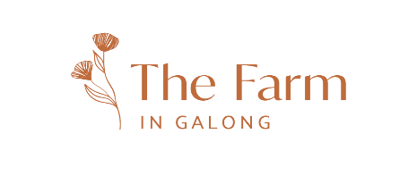
CASE MANAGER REQUIRED
Exciting opportunity to be part of a not-for-profit charitable residential program that aims to provide long-term stabilisation for women with drug and alcohol problems.
As a member of our team, you will provide case management to our residents. This includes helping them to access legal and financial assistance, housing, educational/ vocational qualifications, advocating on their behalf with other bodies (parole office, courts, Dept. of Justice in relation to children in Out of Home Care etc) and help them to access medical/ health services (doctors, dentists, dietician, psychologist etc). In summary, you will be instrumental in helping our vulnerable residents to achieve self-efficacy and gain skills to prepare them to be fully productive members of the community.
Due to the vulnerable and often complex background of our residents, we require case managers with experience and qualifications in the areas of psychology, criminology, social work or a related discipline.
Contract rate: Negotiable subject to qualifications and experience – contract role
Please email resume to kate.cleary@galongfarm.org
Time fraction: 1.0 (fulltime)
For more information on the Farm visit www.thefarmingalong.com.au
Enquiries 02 6386 7275
The Farm in Galong is a Therapeutic Community situated in country NSW.

