Position Description
Title: Executive Assistant Community (Aboriginal and/or
Torres Strait Islander Identified Position)
Position No: F60001
Classification: Band 6
Status: Permanent, Full-time
Hours: 38 hours per week
Division: Community
Department: Community Division
Location: 274 Gower Street, Preston

About Darebin

Located in the northern suburbs of Melbourne, covering an area of around 53 square kilometres of land and encompassing the areas of Bundoora, Kingsbury and Macleod, Fairfield and Alphington, Northcote, Preston, Reservoir, Coburg and Thornbury, the City of Darebin has a population of 161,609 (2018 ERP). The city has one of the largest populations of Aboriginal and Torres Strait Islander residents in metropolitan Melbourne and is home to one of the largest, most diverse communities anywhere in the State in terms of cultures (close to 33 per cent were born overseas), language (138 languages are spoken), religions, gender, age, abilities, socio-economic background, employment status, occupation, and housing needs. One in five Darebin residents is affected by a disability, and almost one-third of these residents require assistance with daily living. About 6 per cent of the population 16 years and over, identify as bisexual, gay or lesbian.

Council has a clear commitment to equity, diversity and inclusion in all that it does. We acknowledge the role that a workforce reflective of the community plays in delivering services and programs; we recognise that in order to meet the needs of the diverse community we serve; we need a diverse workforce with special knowledge and skills. This means that a high-quality workforce, skilled in diversity, equity and inclusion principles and practice, is central for Council to deliver responsive, accessible, equitable and inclusive services across the municipality.

We are an Equal Opportunity Employer and do not discriminate in our selection and employment practices on the basis of race, colour, religion, sex, national origin, political affiliation, sexual orientation, gender identity, marital status, disability, genetic information, age, membership in an employee organisation, or other non-merit factors. We are committed to providing a safe working environment that embraces and values child safety, and thorough ‘Safety Screening’ processes apply. For all other information regarding the City of Darebin, including our Profile, our Diverse Community, our Values, the Council Plan 2017-2021, Equal Opportunity Employment, Disability Access and Inclusion, the Victorian Charter of Human Rights, and Risk Management, visit our website: www.darebin.vic.gov.au

Our Values

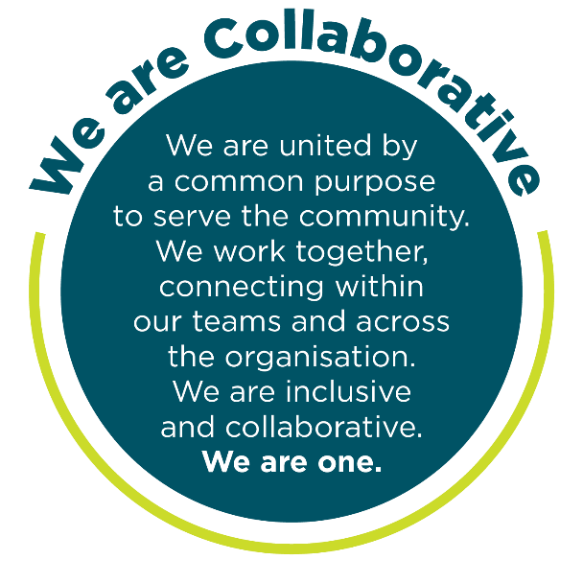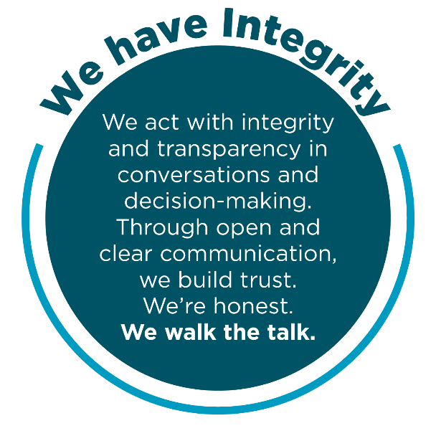
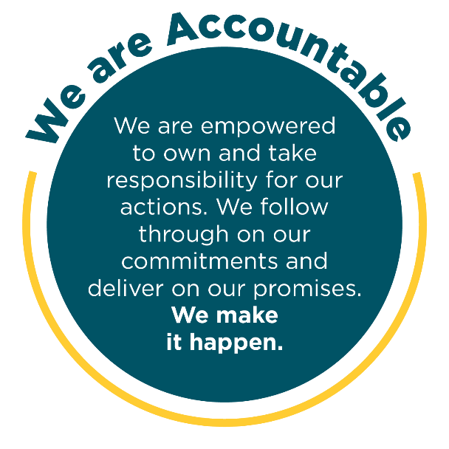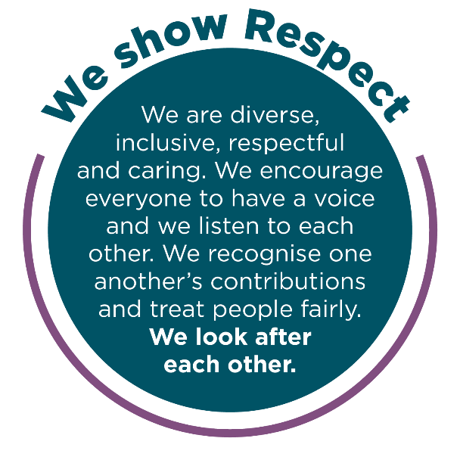
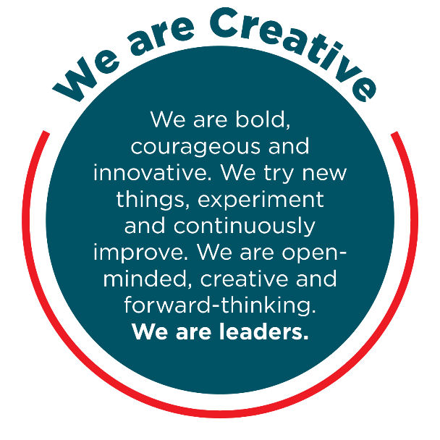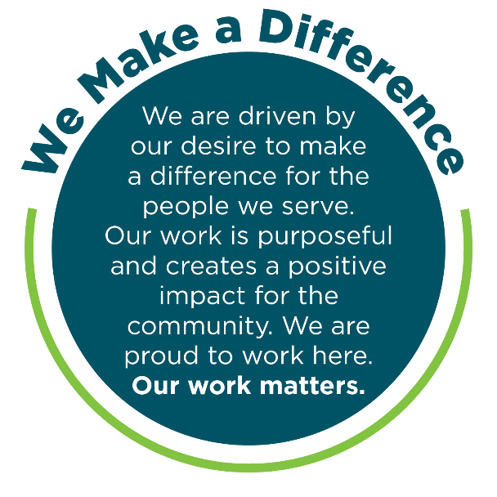
Occupational Health & Safety
To achieve our desired outcome, you will:
- Comply with the Occupational Health and Safety Act, related Regulations and defined OH&S policies, procedures, safety rules and Safe Working Procedures and implement and monitor the organisation’s OH&S policies, procedures, safety rules and programs in the relevant work area to achieve and maintain OH&S standards.
- Monitor health and safety performance and rehabilitation performance within your area of responsibility and initiate actions to improve health and safety, including facilitating rehabilitation of injured workers.
- Review any health and safety related reports and take appropriate action to resolve safety issues.
- Ensure consultation with employee health and safety representatives, particularly on any workplace changes that have health and safety implications.
- Actively monitor the workplace to determine presence of hazards and take appropriate action to rectify any hazards found.
- Ensure all employees understand their legal obligation under the OH&S Act and that they receive regular training to perform jobs safely.

Climate Action and Sustainability
Council plays a crucial and leading role in taking strong action on the climate crisis and in increasing environmental sustainability and awareness to ensure a safe and healthy future for us all.
Darebin’s Climate Emergency Plan outlines the leadership, advocacy and action Council is taking to respond to the climate crisis. Council’s Social and Sustainable Procurement Policy outlines Council’s commitment to supporting local, equitable and sustainable practices and procurement.
Council has committed to carbon neutrality, advocating for climate justice, supporting the community to transition to renewable energy, working towards zero waste to landfill, improving sustainable water use, protecting our unique ecosystems and healthy waterways and ensuring a thriving and connected community. To help us achieve these outcomes, you will:
- Review work practices to identify how you can make a difference in Council and the community to reduce environmental impacts and raise awareness
- Maintain an awareness of the issues associated with the climate crisis and environmental sustainability and how they impact your role, Council and the community
- Carry out your role in line with Council’s Climate Emergency and Environment Policy lens guide, Equity Impact Assessment Guide and the Council’s Social and Sustainable Procurement policy guide
- Reach out to the Climate Emergency and Sustainability team if you ever have any questions or suggestions.

Excellence in Governance
Employees of Darebin City Council (Darebin) are expected to read and understand the Code of Conduct and to conduct themselves ethically, professionally and in accordance with Darebin's statutory obligations. Employees are also expected to treat others fairly and courteously while being respectful of alternative views and opinions. Darebin is an equal opportunity employer and does not tolerate discrimination, bullying or harassment in any form.
Employees are prohibited from disclosing any confidential information they may acquire during their employment or using such information for any purpose other than for the purposes of Darebin. Further, employees shall not use such information improperly to cause harm or detriment to other staff, people, body or the Council.
Employees shall not engage in any outside employment or activities that impact on their primary employment at Darebin. Employees shall also ensure that any outside employment or activities do not create a conflict of interest and/or duty with their role at Darebin. Where it is unclear whether a conflict of interest may exist, the employee should seek direction from their Direct Manager. Any actual or perceived conflict of interest must be disclosed prior to business dealings or immediately the conflict is apparent. This includes any possible direct or indirect pecuniary interest with a potential external tenderer in respect of goods, services or works tendered by Council.
Employees shall take responsibility for their actions when carrying out duties for Council and protect public resources and assets.
Employees must not make a statement made on behalf of the Council to the media or public unless authorised to do so by the Chief Executive.
Employees shall not discuss departmental business or staff matters with Councillors. If a Councillor requests such information from an employee, the request should be referred to the employee's Manager in the first instance.
As a condition of employment, the successful candidate is expected to sign the Code of Conduct Declaration confirming that they have read and understood and agree to act in accordance.

Child Safe - Statement of Commitment
Darebin City Council prides itself on being a child safe organisation with zero tolerance for child abuse. We recognise our legal and moral responsibilities to keep children and young people safe from harm; we promote their health and well-being and support their best interests.
We have policies, procedures, and training in place that support our leadership team, employees and volunteers to achieve these commitments.
We create environments where all children, including children with a disability, Aboriginal children, and children from cultural and linguistically diverse backgrounds, have a voice - they are listened to, their views are respected and they contribute to how we plan for, design and implement our services and activities.
As a condition of employment, the successful candidate is expected to sign the Safeguarding Children Code of Conduct confirming that they have read and understood and agree to act in accordance.

Position Objectives:

The Executive Assistant Community provides strategic executive and administrative support services to the Community Division General Manager and across the division. The Community Division is responsible for the provision of services in Age and Disability, Creative Culture and Events, Economic Resilience and Recovery, Equity and Wellbeing, Families Youth and Children, and Recreation and Libraries to the Darebin community.

The Executive Assistant Community is responsible for providing a high level of administrative and systems support in the coordination of the day to day activities of the division and the General Manager Community. The role coordinates the workflow within the Departmental Administration area as outlined in the Key Responsibilities and Duties.

The Executive Assistant Community will be creative and curious with the ability to work independently. Time management skills and an ability to connect and collaborate with others will be required for success.

Reporting Relationships:

This Position Reports To: General Manager Community

Position Reporting To This Position: Nil

Internal Relationships: Executive Management Team, Managers,

Coordinators and Community Division staff

Department Managers

People and Culture Team

Council Advisory Committee members

External Relationships: General public, residents, local business leaders, local Members of Parliament and Government Department staff, agencies

Key Responsibilities and Duties:

The Executive Assistant Community is directly responsible and accountable for producing and/or servicing the functions of the Community Division and the General Manager Community (General Manager) including;

Administrative Support
- A broad variety of administrative tasks and governance processes
- Support calendar management for the General Manager
- Preparation, collation and distribution of business papers, agendas and other documents
- Research, prioritise and follow up on incoming correspondence, issues and concerns for the General Manager including those of a sensitive or confidential nature and determine an appropriate course of action, referral, or response.
- Representation of the General Manager on cross organisational working groups and project teams (as required)
- Record, or transcribe reports, agendas, minutes and correspondence
- Review and monitor current administration procedures, documenting processes, and develop improved processes

Executive Coordination
- Schedule and coordinate meetings, arranging appropriate venues, meeting rooms, invites and virtual gatherings for the General Manager
- Coordinate workflow for to ensure deadlines are met and tasks are completed on time
- Maintain files and correspondence for the General Manager, including the maintenance of files, schedules, reports and manuals and compile information efficiently ensuring deadlines are met
- Assist with budget monitoring
- Liaise with Coordinators, Team Leaders and administrative staff to ensure administration functions are being performed to a high standard
- Encourage and enhance the department’s approach to internal and external customers

Fostering Relationships
- Build and maintain effective working relationships characterised by mutual respect and integrity with other Council departments, professional bodies and all external stakeholders.
- Anticipating and understanding the different needs and concerns of Managers, peers and clients and dealing with difficult issues
- Demonstrate ability to equitably and effectively manage and work with staff with diversity of ethnicity, gender, abilities, skills, age, etc.

Accountability and Extent of Authority:
- Provide a bridge for smooth communication between the General Manager, CEO and internal departments; demonstrating leadership to maintain credibility, trust and support with senior management staff.
- Coordinate office equipment and supplies purchase, maintenance of equipment
- Ability to make decisions independently and take an innovative approach
- Ability to provide professional customer service and to respond to customer needs in a political environment
- Enhance the reputation of City of Darebin by building and maintaining professional, collaborative relationships based on mutual trust and respect.
- Exercise judgment and discretion regarding confidential issues

Judgement and Decision Making:

The Executive Assistant Community works under broad guidance and advice from the General Manager and is responsible for making decisions on how to undertake work activities within their key responsibilities.
- Make judgements, decisions and solve problems to meet the objective and key responsibilities of the position.
- Communicate directly on behalf of the General Manager, with Councillors, EMT and external stakeholders
- Ability to exercise judgment and make decisions and communicate directly on behalf of the General Manager.
- Exercise integrity, accountability, respect, judgment and discretion regarding confidential issues.
- Experience in the operations and services of an organisation of similar functions and size.
- Demonstrated high level administrative, clerical and customer service skills.

Specialist Skills and Knowledge:

- Established proficiency in Microsoft Word, Excel, Teams, OneDrive, PowerPoint and Outlook
- A sound understanding of administrative procedures and the level of customer service required
- Problem solving, interpersonal, customer service & time management skills
- Understanding and appreciation for the role of General Manager Community
- General understanding of State, Federal and Local Government structures
- Ability to conduct research and prepare briefing papers, and formal correspondence
- Demonstrated ability to use discretion and to maintain confidentiality on sensitive issues.
- Bi-lingual skills an advantage

Management Skills:

- Skills in managing time, setting priorities, planning and organising one’s own work
- Creative and innovative thinking to be flexible and adaptable, alert to changes which require different responses.
- Make a positive contribution to the performance and culture of the City of Darebin by role modelling collaborative, constructive behaviours to build trust and support high standards of performance.
- Demonstrated experience at effectively prioritising tasks within competing demands and timeframes

Other Relevant Information:

In accordance with the Australian Fair Work Act 2009, protection from unfair dismissal is subject to a minimum six-month period of employment.

The successful candidate will be required to provide proof of Australian Citizenship or residency status, (including at least a birth certificate or passport), and proof of identity, (Medicare card and/or current driver’s licence).

This position requires a Health Declaration and/or Functional Capacity Assessment prior to an offer of employment being made.

This position requires a Psychometric Assessment prior to an offer of employment being made. (delete if not applicable)

This position requires a satisfactory Police Check result prior to an offer of employment being made.

This position requires a satisfactory Disability Worker Exclusion Scheme (DWES) check against the Department of Health and Human Services disability worker register, prior to an offer of employment being made. (delete if not applicable)

This position requires an employee Working with Children Card.

A Zero Blood Alcohol Level is required at all times. (delete if not applicable)

The Council issued uniform and protective clothing must be worn in this position. (delete if not applicable)

The successful applicant will be provided with all relevant tools and equipment to undertake the inherent requirements of the role. All tools and equipment must be returned to the direct Manager upon cessation of the role.

Darebin City Council is an equal opportunity employer committed to providing a safe working environment that embraces and values child safety, diversity, and inclusion. We encourage applications from Aboriginal or Torres Strait Island people, people with disabilities and culturally and linguistically diverse backgrounds. If you require support or advice with your application, contact the People and Culture team on 8470 8204. Reasonable adjustments can be negotiated.

Canvassing of Councillors and Council Officers:

Canvassing of Councillors and Council Officers, either directly or indirectly that may influence the outcomes of this application may be deemed a disqualification.
Enquiries regarding the position, however, can be directed to the nominated contact officer named in this Position Description.

Qualifications, Certificates, Licences, and/or Experience:

The Executive Assistant Community will have:
- Tertiary qualifications in Business Administration and demonstrated relevant experience; or
- Considerable experience and management expertise; or an equivalent combination of relevant experience and/or education/training
- Understanding of information systems and database development will be considered advantageous
- A Working with Children Check will be required to perform in the role

Key Selection Criteria:

- Knowledge of and experience in providing dedicated high-level professional advisory, research and executive administrative support to an executive level position within a complex organisation
- Highly developed communication and problem-solving skills with the ability to effectively manage complex and sensitive situations and provide excellent customer service both within and outside the organisation.
- Demonstrated ability to prepare correspondence, respond to emails and manage an inbox etc.
- Proven ability to manage a dynamic workload with competing priorities and operate effectively under pressure.
- Demonstrated commitment to effective, and efficient administration, sensitivity to community needs, encouraging pride and belonging and promoting a positive image of Council

Interpersonal Skills/ Personal Attributes:
- Outstanding communication and interpersonal skills including a proven ability and genuine interest in working with others.
- High self-awareness and capacity to build trust and confidence with others.
- A personal style that models integrity, equity, fairness and transparency.
- A high level of political acumen and judgement, the ability to read situations and act to support and enhance the reputation and effectiveness of the General Manager.

Inherent Physical Requirement

Position Number & Title: 400001 Executive Assistant Community
Work Area: Community Division
Summary Tasks: Strategic and Executive Administration
Physical demands of the task and % of time allocated | Rarely  1-10% | Occasional  11-33% | Frequent  34-66% | Constant  67-100%
Sitting |  |  |  | X
Standing |  |  | X
Walking |  | X
Steps/ stairs |  | X
Squatting | X
Kneeling | X
Looking Up | X
Looking Down |  | X
Bending spine forwards |  | X
Twisting spine to side e.g. during meetings to view team members |  | X
Bending spine backwards | X
Working with one or both hands above shoulder height | X
Reaching forwards or sideways > 30cm from the body | X
Gripping or grabbing |  | X
Fine hand coordination e.g. for computer keying |  |  |  | X
Lifting floor-waist |  | X
Lifting at waist height |  | X
Lifting waist overhead | X
Carrying |  | X
Pushing e.g. of trolleys | X
Pulling e.g. of trolleys | X
Exerting force with one hand or one side of body e.g. when hole punching / stapling | X
Exerting force in an awkward posture | X
Holding, supporting or straining | X
Other

