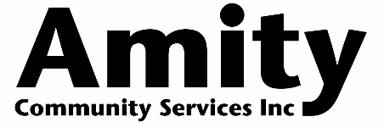
Our Values: Respect | Diversity | Professionalism | Curiosity

Illicit Drug Referral Officer
Amity is a for-purpose community organisation based in Darwin. Amity delivers a range of professional evidence-informed services and programs that encourage healthier habits and lifestyles. Amity specialises in the areas of alcohol, other drugs, gambling and associated areas of mental health.

Amity works with people to understand their needs, and aims to work collaboratively to encourage healthier habits and lifestyles by providing information and educational strategies for harm minimisation, building upon current skills and/or developing new skills that may assist people. Amity works in a manner that is non-judgemental, supportive and encouraging. We are recognised for our commitment, connection and contribution to our community.

Responsibilities:

As the Illicit Drug Referral Officer, you are directly responsible to the manager of the Counselling service. The key functions of this role are:

- Develop health promotion material with key messages and information about illicit drugs;
- Build and maintain effective relationships with key stakeholders;
- Promote referral pathways into treatment relating to illicit drug use;
- Disseminate health promotion materials;
- Work in collaboration with the Counselling team to compile reports as required;
- Develop and deliver training and information sessions for community organisations;
- Participate in the review, evaluation, analysis and continuous improvement of the organisation within the internal quality management system.

Selection Criteria
Essential:
- Certificate IV in Alcohol and Other Drugs, or the commitment to undertake this study;
- Demonstrated ability to establish and maintain networks and relationships with key stakeholders and community organisations.
- High level of communication skills, with the capacity to relate to various members of the public, including business and industry, support agencies, welfare groups and government;
- Strong project management and report writing skills;
- Ability to work and communicate effectively in a team environment;
- Capacity for self-motivation related to work practice and learning;
- A Northern Territory Driver’s License;
- A Working with Children’s Card; and
- A National Police Check

Desirable:
- Qualifications in health or social sciences field;
- Knowledge and/or experience of alcohol and drug issues and harm minimisation principles;
- Relevant computer skills, especially with Microsoft Office software; and
- Knowledge of the local Darwin Community and the community sector.

What Amity Offers:
- A workplace that values and actively supports career development and continual learning;
- 6 weeks annual leave;
- the option of salary sacrificing;

Applicants are welcome to contact habitwise@amity.org.au using the subject line:
Illicit Drugs Referral Officer Application. Closing Date 12/11/2021

