Supporting Information
Paving the Way Forward – North Melbourne Community Partner
North Melbourne Language and Learning – Drummond Street Services – Mission Australia

Paving the Way Forward (PTWF) Background Information
Paving the Way Forward (PTWF) is a program funded through the Department of Families Fairness and Housing (DFFH) to support communities residing in North Melbourne and Flemington public housing estates to recover and rebuild from the COVID-19 health emergency and deliver housing services that better meet the needs of residents.
This pilot program tests a new way of working with residents, local government and delivery partners, where residents are involved in the decisions that impact them.
The following information applies to the PTWF program based at the North Melbourne public housing estate and is to provide context for applicants of the Community Development Officer (CDO) roles.
PTWF aims to improve outcomes for residents in public housing across three domains:
- My Home – improving property and tenancy responses to meet the needs of residents with complex needs
- My Neighbourhood – addressing safety and security in public housing, education and employment outcomes, liveability and diversity, and community connectedness to address the drivers of socioeconomic disadvantage
- My Services – establishing tailored services and connecting residents to the support services they need to live a healthy and well life.
The Program aims to deliver on five key outcomes:
- Residents are involved in the key decisions that impact their home, neighbourhood and services.
- Housing services are fundamentally reformed to better meet the needs of residents
- There are real employment, education and training pathways tailored to communities’ needs ensuring more residents have jobs
- Residents are safe and equipped to manage their health and wellbeing needs now and into the future
- Barriers to access including cultural bias are acknowledged, and tailored responses and services developed
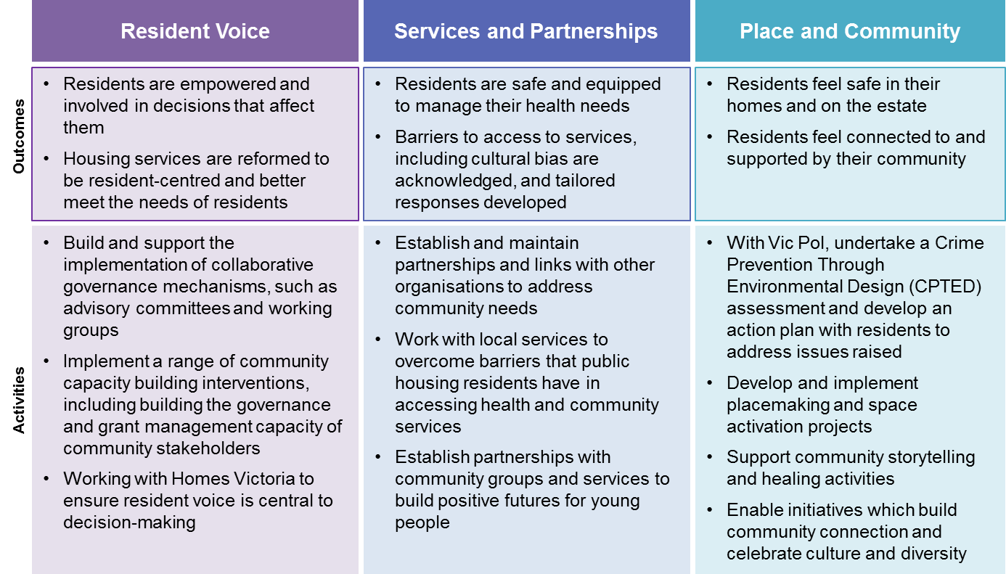
Table 1 - extracted from PTWF tender document 2021
Background information
The North Melbourne Public Housing Estate (NMPHE) area consists of four high rise towers in Alfred, Sutton, Melrose and Canning Streets, medium density public housing in Pampas Street and other single-unit and low-rise housing scattered within close proximity. The demographics of the residents living in these public housing dwellings is diverse. There is considerable cultural diversity – the largest language groups include Somali, Arabic, Tigrigna, Amharic, Oromo, Chinese (including Cantonese and Mandarin) and Vietnamese. Residents from various life stages are also represented: elderly residents, single households and large families. During 2020, the public housing residents of the North Melbourne Public Housing Towers (along with the residents of the Flemington Public Housing Towers) were subjected to the harshest lockdowns in Victoria. Many of the experiences of residents have been documented through the Victorian Ombudsman Investigation (see end note for link to the report), through the media and at community forums.

The North Melbourne PTWF Community Partner
The Consortium, comprised of NMLL (North Melbourne Language & Learning) – lead agency; Drummond Street Services (DSS) and Mission Australia (MA), successfully tendered to be the North Melbourne Community Partner for the PTWF program. As the Community Partner for North Melbourne PTWF program, the NMLL consortium will work in partnership with DFFH to deliver community engagement activities, capacity building and co-designed initiatives with the residents of the North Melbourne public housing estates.
Collectively the Consortium organisations provide support across a range of services spanning youth transitions, education and employment, child and family services, intercultural exchange and cultural support, community development, group and individual advocacy and social enterprise. The Consortium has more than 32 years of experience and expertise in delivering community development initiatives within a public housing place-based context.
As part of this initiative three Community Development Officers (CDOs) will be employed by the North Melbourne Community Partner organisations.

North Melbourne Community Partner Co-Production Model
The North Melbourne Community Partner intend that the work of the North Melbourne Community Partner be closely aligned (where resources allow) to the Co-Production Model outlined below. The CDOs will work with residents in line with the Co-Production Model and Principles in developing and delivering the Community Engagement and Consultation Plan and other Community Partner activities and responsibilities.
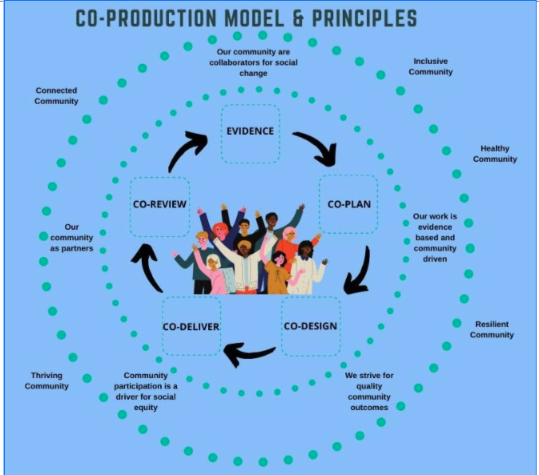
Figure 1 - North Melbourne PTWF Partner – Co-production Model

North Melbourne PTWF Community Partner Governance Structure
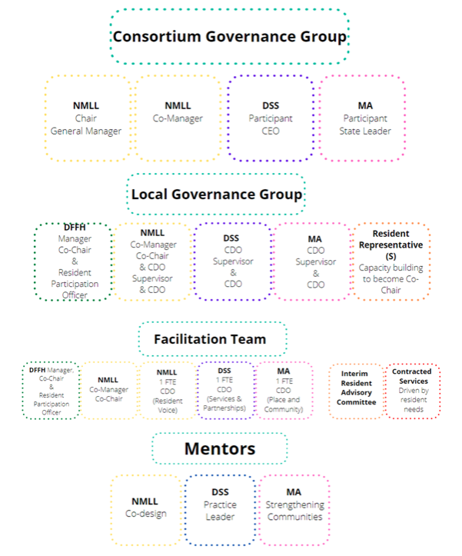
Figure 2 – Proposed Consortium Project Governance Structures (to be confirmed)

Community Development Officers’ (CDO) Position Purpose:
Each CDO will be employed by one of the three organisations that form North Melbourne Community Partner Consortium, as outlined below.
The CDOs will work as a team within the Consortium to implement the work and goals of the PTWF Program. This will include working with residents and other community groups, organisations, local council and service providers to develop and deliver a Local Action Plan (LAP) for the estate.
The CDOs will also have a working relationship with the Community Partner staff and the DFFH PTWF Manager and Resident Participation Officers (RPO).
CDOs report to their employing organisation.
Operational Supervision: The position has day to day reporting partnership responsibilities to their employer and the DFFH PTWF Manager
A management matrix has been developed to support this arrangement.

The key focus area for each CDO role is as follows:
1 - Resident Voice CDO (employed by NMLL) will take the lead the following activities:
- Build and support the implementation of collaborative governance mechanisms, such as advisory committees and working groups
- Implement a range of community capacity building interventions, including building the governance and grant management capacity of community stakeholders
- Work with Homes Victoria to ensure resident voice is central to decision-making.
2 - Services and Partnerships CDO (employed by DSS) will take the lead the following activities:
- Undertake system and service mapping (inreach and outreach) against local data and consultation with the diverse communities and groups
- Expand existing linkages and partnerships for coordinated planning and service navigation-pathways to address community needs and reduce barriers
- Support the establishment of service navigation and advocacy mechanisms across mapped health and wellbeing services of local services to overcome barriers that public housing residents have in accessing health and community services
- Establish partnerships with community groups and services to build positive futures including employment opportunities for young people, women, and other residents.
3 - Place and Community CDO (employed by MA) will take the lead on the following activities:
- With Vic Pol*, undertake a Crime Prevention Through Environmental Design (CPTED) assessment and develop an action plan with residents to address issues raised
- Develop and implement place making and space activation projects
- Support community storytelling and healing activities
- Enable initiatives which build community connection and celebrate culture and diversity
Although each CDO will lead and be responsible for a key focus area they will work as a team to implement the work and goals of the PTWF Program
*Subject to further discussion: alternative frameworks may be adopted.

For more information about the PTWF North Melbourne Community Partner Activities contact:
Loretta Asquini - Paving the Way Forward (PTWF) North Melbourne Community Partner on
Email – lasquini@nmll.org.au
Ph – 9326 7446

More PTWF North Melbourne Community Partner contact details include:
North Melbourne Language and Learning Community Voice Focus Lead

Loretta Asquini – Community Development Coordinator
Email – lasquini@nmll.org.au
Ph – 9326 7446

Drummond Street Services – Services and Partnerships Focus Lead

Amuna Abdella – Family Services Program Manager, Northern Region
Email - Amuna.abdella@ds.org.au
Ph - 9633 6733

Mission Australia – Place and Community Focus Lead

Aileen Lacey - Area Manager, Victoria
Email – LaceyA@missionaustralia.com.au
Ph – 03 9213 2513

https://assets.ombudsman.vic.gov.au/assets/Reports/Parliamentary-Reports/Public-housing-tower-lockdown/Victorian-Ombudsman-report-Investigation-into-the-detention-and-treatment-of-public-housing-residents-arising-from-a-COVID-19-hard-lockdown-in-July-2020.pdf

