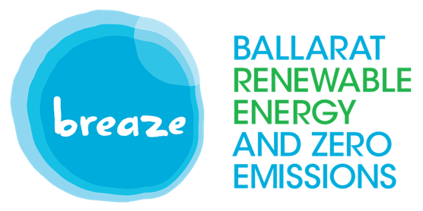
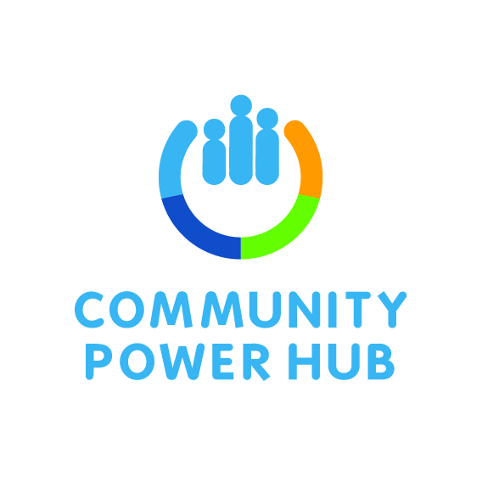

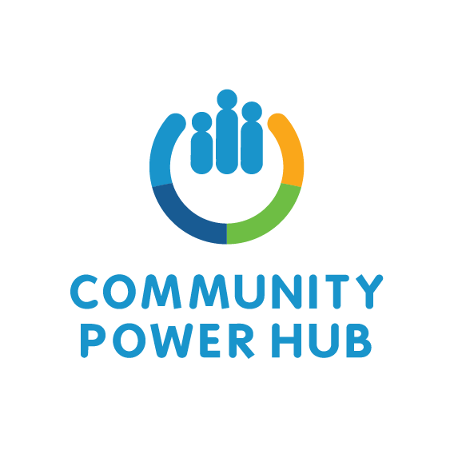

POSITION DESCRIPTION
JOB TITLE: Project Manager

JOB TYPE: Full time 12 months fixed term

LOCATION: Ballarat region | Work from Home

SUPERVISOR: BREAZE Inc.

Position Summary
The Grampians Community Power Hub (CPH) is led by Ballarat Renewable Energy and Zero Emissions Incorporated (BREAZE Inc.). BREAZE Inc. is a voluntary not-for-profit organisation that formed in 2007 because of community concern about the impacts of climate change. The BREAZE vision is for the Ballarat community to achieve zero net GHG emissions by 2030. BREAZE aims to enable individuals, communities, commercial entities and governments to reduce emissions through provision of information, behaviour change programs and demonstration projects. With BREAZE Inc. membership including residents from across the Central Highlands Region, the activities undertaken by BREAZE Inc.are delivered with a regional focus.
The 2021 Community Power Hub program is being delivered by Sustainability Victoria with the objectives of reducing carbon emissions and energy costs, as well as bolstering local support and understanding of renewable energy across Victoria.
Expanding on the success of the Ballarat Community Power Hub Pilot of 2017-2020, the 2021 -2022 program ecompasses the entire Grampians region to take in all 11 local government areas.

The aim of this program is to increase access to and involvement in community renewable energy by partnering with local community energy groups, Councils, key stakeholders and their local communities. The CPH operates under a collaborative governance structure.
This expansion of the Community Power Hub Program is an important aspect of the broader rollout of renewables across the Grampians region, to ensure communities are involved in and benefit from local energy projects as the state transitions to 50% renewable energy by 2030.
The focus of the Project Officer is ensuring that The Grampians Community Power Hub reaches its desired audience and supports a pipeline of community energy projects across the region. The position will add technical and project management expertise to the BREAZE Inc. led Community Power Hub team as we improve access to community energy and deliver local benefits.
The Project Manager will oversee all operations of the Grampians Community Power Hub and ensure activites are on budget and progress according to the CPH Project Plan along with managing compliance with reporting protocols agreed in the contract with Sustainability Victoria. The Project manager will work with the team of BREAZE volunteers and the Hepburn Branch partner: identifying potential community energy projects across the region; undertaking feasibilty studies/business cases as appropriate; liaising with the Hub’s Roundtable Advisory Group in selecting projects for development; liaising/facilitating implementation of community projects as appropriate; and ultimately expediting a pipeline of community energy projects across the region. The position will add project management expertise to the BREAZE Inc. led Community Power Hub team as we improve access to community energy and deliver local benefits.
This position will suit someone who is commited to sustainable renewable energy solutions, has wide-ranging relevant technical skills, is keen to connect with communities across the Region, and is interested in extending their networks across government agencies, the renewable energy sector and community energy groups.
The Project Manager will be assisted by a part time Communications/Administrative Officer in the day to day operations of the Community Power Hub.
The position will be a full time appointment initially for a fixed term of 12 months.
While BREAZE Inc. is primarily located in Ballarat, flexible work and travel arrangements can be negotiated with the successful applicant.

The key deliverables/responsibilities of the position are:
- Work with the Project Control Group to develop, implement and manage a project delivery plan and community engagement plan, and provide progress reports to the PCG as required.
- Advise regional communities and groups on clean energy solutions as appropriate to their needs
- Assist regional groups and organisations to develop and deliver community energy projects
- Ensure an equitable spread of community energy groups and projects across the region.
- Select/assess community energy projects identified across the region on the basis of social llicence, financial feasibility and technical viability.
- Develop and commission at least two of these projects by the end of June 2022.
- Ensure the Grampians Community Power Hub runs on time and on budget.

Essential skills/attributes
- Demonstrable knowledge of the renewable energy industry, policy and regulations
- Good understanding of the development process including constraints analysis, grid connection and permitting process
- Work with the PCG to develop, implement and manage a project delivery plan and community engagement plan, and provide reports on progress to the PCG as required.
- Comprehensive knowledge of clean energy solutions and ability to articulate these clearly to community groups
- Able to work both one- to-one and with community groups, to develop and deliver community energy projects across the Grampians Region.
- Ability to monitor/ensure projects are spread equitably across community energy groups and across the region.
- Ability to identify community energy projects across the region that are socially acceptable, financially feasible and technically viable.
- Develop and oversee commission of at least two of these projects by June 2022.
- Keeping the program running on time and on budget.
- Strong organizational and planning skills

Desirable skills/attributes
  - Commitment to sustainability and the renewable energy tranistion
  - Some familiarity with and/or understanding of regional community life
  - Formal tertiary qualifications in electrical engineering or other relevant discipline
  - Ability to use the Sunulator tool
  - Familiarity with a variety of renewable energy project business models
  - Commercial and technical risk management knowledge
  - Ability and willingness to work effectively independently and in a team environment

Key Performance Goals
- Compliance with the Grampians Community Power Hub project plan, budget and reporting protocols
- Implementation of at least two projects before the end of the program
- Completion of scheduled tasks independently without supervision
- Completion of the Hub’s contractual obligations on time

SUMMARY

- JOB TYPE: Full time for 12 months fixed term
- REMUNERATION: A salary of $76,000 - $90,000 p.a. commensurate with skills and experience plus 10% superannuation and holiday entitlements.
- LOCATION: Working from home in the Ballarat region or elsewhere as negotiated
- SUPERVISOR: BREAZE Inc.

If you require further information, please contact: Talent Nation
Applicants should submit a current CV and cover letter citing 2 referees by COB 13 August 2021.

