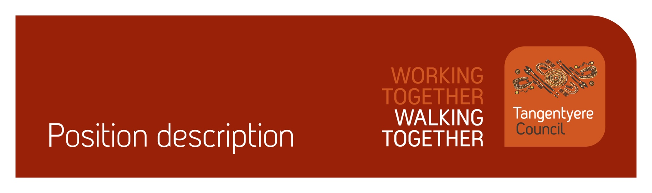

Position title | A2E After Hours Youth Services Team Leader
Division | Access to Education
Classification | Level 5
Prepared by
Date
Staff reporting to position | 0

Position summary
Tangentyere Council Aboriginal Corporation (TCAC) is a community controlled
Public Benevolent Institution delivering human services and social enterprise activities for
the benefit of Aboriginal people from the Alice Springs Town Camps, Urban Alice Springs
and Central Australia.
Access to Education (A2E) is an innovative and unique program that supports Aboriginal children and youth to achieve positive outcomes in education, safety and wellbeing in the Alice Springs Greater Region.

Working closely with the A2E Youth Co-ordinator, the Team Leader will provide leadership and day to day support to the Youth Services team at 3 Brown Street, working to ensure effective delivery of Tangentyere Council’s Integrated Model of Service Delivery at 3 Brown Street. Drawing on significant knowledge of trauma informed practice and using strengths based framework, the Team Leader will support the Youth Co-ordinator in the delivery of a range of culturally appropriate, diverse and meaningful after hours support services and activities for at risk youth.

This position will be responsible for facilitating membership and regular meetings of the A2E Youth Reference Group, ensuring that youth services and programming are tailored to the needs and wishes of young people. The position requires strong leadership skills, and a commitment to cultural safety, quality service provision, risk assessment, staff support and development. Recognising the rights of young people, responding to feedback and ensuring that young people participate in planning their own pathways to success are essential. This position involves out of hours work including evenings and weekends.

Responsibilities
Support A2E Youth Co-ordinator in developing 3 Brown Street as a Youth Drop In Space through the implementation of Tangentyere Council’s Integrated Model of Service Delivery for young people in collaboration with ASYASS.
Provide leadership to youth team in delivery of a range of After Hours support services and youth activities at 3 Brown Street that are culturally appropriate, solutions based, trauma informed and tailored to individual need through assessment.
Ensure the voices of young people are heard through Youth Reference Group, and that feedback provided is actioned
Ensure collaborative and integrated approach to planning, resourcing of service delivery.
Promotion of youth and community education, health, safety and wellbeing.
Ensure data collection and reporting requirements are met in timely fashion.
Ensure compliance with statutory requirements and A2E policies/procedures and operational objectives.
Other duties as required
- Assist with achieving quality management objectives across the organisation.

Major Accountabilities
Accountabilities | Performance indicators
Support Co-ordinator to develop 3 Brown Street as a Youth Drop In Space  - Implementation of Tangentyere Council’s Integrated Model of Service Delivery for young people  - In collaboration with ASYASS  - Work with A2E staff, youth and their families, and a range of key stakeholders to implement and develop Integrated Model of Service Delivery | Co-ordinator is supported in role  Clear understanding and comprehensive knowledge of the Tangentyere Council’s Integrated Model of Service Delivery for 3 Brown Street including theoretical underpinning  Work in close collaboration with ASYASS staff in implementation  Model is effectively implemented
Provide leadership to youth team to deliver safe operation of a range of After Hours support services and youth activities at 3 Brown Street  - Culturally appropriate programming supported  - Solutions based, trauma informed and tailored to individual need through assessment | Program is delivered in line with Integrated model including solution based and trauma informed practice  3 Brown Street developed as an inclusive and well accessed culturally safe space for young people  Staff are supported in their role and practice guidelines are adhered to
Ensure the voices of young people are heard and listened to, and that feedback provided is actioned | Youth Reference Group (YRG) developed and regular meetings held  Feedback from YRG and other youth fed back to Youth Co-ordinator for actioning
Ensure collaborative and integrated approach to planning, resourcing and co-ordination in service delivery. | Working in partnership with ASYASS staff  High levels of collaboration with range of providers  Service delivery is informed by Integrated Model of Service Delivery  Service gaps identified
Promotion of youth and community education, health, safety and wellbeing. | Services and activities are delivered in line with Tangentyere’s Integrated Model of Service Delivery  Activities are safe and subject to rigorous risk assessments  Trauma based framework  Advocacy to A2E Youth Co-ordinator on youth issues
Ensure data collection and all reporting requirements are met in timely fashion. | Data collated for progress reports  All information as requested by Co-ordinator provided in timely fashion
Ensure compliance with statutory requirements and A2E policies/procedures and operational objectives. | Mandatory reporting requirements met  Youth policies and procedures strictly adhered to by all staff
Other duties as required | Other duties met as required
Assist with achieving quality management objectives across the organisation. | Commitment to the Tangentyere Council Quality Management Objectives.

Relationships
Internal
Access to Education Manager
Access to Education Youth Co-ordinator
Access to Education Youth Workers
Access to Education Casual Youth Workers
Access to Education Youth Mentors
A2E Community Centre Co-ordinators
Tangentyere Employment Services
All Access to Education Staff
Social Services, e.g. Night Patrol
CAYLUS
Human Resources
Finance
External
ASYASS
Schools
Youth sector including other Youth Service providers
NT Gov. YORET
Employment Services
Business Sector
NTPOL

Competencies
Tangentyere core competencies
Commitment
Teamwork
Communication
WHS
Cultural Awareness

Qualifications and Selection Criteria
Required
- Qualification in Social Work, Youth Work, Education or relevant experience
- Excellent leadership, interpersonal, supervisory and operational skills regarding program development, planning and implementation across multiple sites/locations
- High level understanding of trauma informed practice
- Demonstrated experience in developing and delivering youth/social services and programs in a cross cultural context – preferably with Aboriginal people and communities.
- Ability to develop rapport and support mechanisms with young people, often building and maintaining professional relationships with family members and key stakeholders (internal and external)
- Computer literacy
- Current NT driver’s licence, Police Check, Ochre Card and First Aid Certificate

Verification
This section verifies that the position holder and the manager have read the attached position description and are satisfied that it accurately describes the position.
Position holder
Name
Date effective
Signature
Manager
Name
Date effective
Signature

