ROLE PURPOSE: Reporting & Analytics Lead
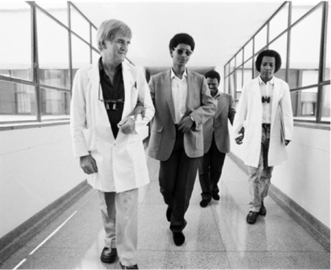  Image of Fred Hollows | How we value your contribution:
Remuneration package
We aim to provide an overall remuneration package that is attractive and fair. Our global remuneration framework ensures we align to local pay, employment conditions and laws, and we benchmark against the local market to ensure we offer competitive employment conditions that are appropriate to our sector.
Salary packaging
We qualify as a health promotion charity so the Australian Taxation Office (ATO) allows us to reimburse you for personal expenses without having to pay any income or fringe benefits tax that would normally be payable. These tax concessions are in addition to the income Tax Free Threshold.
Leave
You will have access to 20 days of paid annual leave each year (pro-rated for part-time employees) and receive 17.5% leave loading when you take annual leave. You will also receive 5 days paid leave between the Christmas and New Year period and other types of leave such as personal (sick or carers’) leave, paid parental leave, long service leave and compassionate leave. In addition, we provide culturally significant leave for employees with commitments under Indigenous and other cultural customs, traditional laws or religions.
Paid parental leave
We provide 8 weeks paid parental leave for primary carers at full pay and 4 weeks paid parental leave for non-primary carers, In addition, upon receipt of notification from the Family Assistance Office, primary carers may access 18 weeks paid parental leave at the statutory rate.
Performance & development
Our performance and development framework enables you to work closely with your manager to plan, manage, and review your performance throughout the year. This approach also enables you to discuss development opportunities and areas for growth.
Learning & development
Our approach to learning and development will enable you to have the information, skills and knowledge needed to do your job. We build the capacity of our people and support you with on-the-job experience, coaching and formal learning.
Leadership
Leadership is a key priority for us. We have customized leadership programs for leaders at all levels that are focused on supporting our people to be inspired, empowered and to make an impact in their work so that together we can achieve our vision.
Study support
We are proud that so many of our people are tertiary educated and we are committed to supporting tertiary education that is relevant to your work through our global study assistance program. Relevant applications for study support are considered annually, providing financial assistance and study days.
Recognition
Our recognition program has been designed to recognize and acknowledge our people who live our values of Integrity, Collaboration, Empowerment and Action, in everyday activities. We recognize our people in three ways: Peer-to-peer, manager recognition, as well as length of service.
Flexible work arrangement
You will have access to flexible work arrangements. We encourage a spirit of mutual flexibility, enabling discussions between you and your manager about maintaining work-life balance.
Health & safety
We are committed to supporting your health, safety and wellbeing. We have worker Health & Safety Representatives in each of our offices to assist in making your workplace safe.
Employee Assistance Program
You and your family will have access to free external, professional and confidential counselling assistance if you need help with personal, family or employment related matters.
Our Vision
We see a world in which no person is needlessly blind and Indigenous Australia’s exercise their right to good health.
Our Purpose
To end avoidable blindness and improve Indigenous Australian’s health.
At The Fred Hollows Foundation we offer a career where your talent and energy will help many see tomorrow.

 | To work in The Foundation you will: | Role purpose defines the broad accountabilities of the positions, which may change based on organisational need.  Please refer to divisional, team and individual work plans for more specific details
- Be eligible to work in Australia and other regions where you will be based
- Undergo background check including criminal records and qualifications check
- Undergo working with children check for positions which are identified as working with children.

ROLE PURPOSE
Role Title:  Reporting & Analytics Lead | Division:  Business Operations |  |  | Location:  Sydney | Date:  May 2021
Employment type:  Permanent, full-time | Reports to:  Global Lead – Business Systems & Integration |  |  | Number of direct reports: 0 | Leadership Band:  Leads Self

Purpose of the role:
The Reporting & Analytics Lead is responsible for the development, support and implementation of the reporting and analytics tools used by The Fred Hollows Foundation to provide information, insight and analysis of financial and other business data. This includes designing new reporting, data management and training of business users in all aspects of the reporting and analytics environment including forecasting and budgeting processes.
The Finance Business Intelligence Specialist will own the outcomes of:
- Designing, building and maintaining a suite of agreed financial and business dashboards, reports and analytical data sets across multiple systems.
- Lead the rollout of agreed dashboards, reports and analytical data sets by educating, supporting and engaging with the key business stakeholders
- Reconcile, review and repair data across all data sources to ensure its accuracy, reliability and timeliness for all stakeholders.
- Conduct regular review and feedback sessions to identify gaps and future business needs to support ongoing improvements and developments in reporting and analytics, processes and integrations.
- Collaborate with the business and IT teams to support new business systems, integrations and process changes in order to continually improve organisation data and analysis to facilitate improved business decision making
- Support and drive a business partnership approach by ensuring a culture of data literacy, accountability, responsiveness, engagement and collaboration within The Foundation to ensure assurance actions are shared and undertaken to improve our risk, compliance and safeguarding culture
- Other tasks as requested by your manager

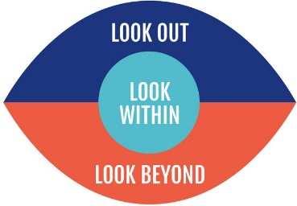  Our Capabilities:  - Look out  - Look within  - Look Beyond  As a member of the Foundation Family you will:  - Live by the values of The Foundation and support The Foundations culture, performance and brand.  - Adhere to all The Foundation policies & Procedures.  - Strengthen the health, safety and well-being of all.  - Lead, collaborate and contribute in all interactions. |  | Essential Experience:  - Strong experience working with financial and business reporting across international business environments  - Strong experience designing, building and implementing reporting and analytics systems.  - Strong experience in educating, supporting and engaging with business users in the rollout of reporting systems.  - Demonstrated ability to design, build and implement data cubes, reports and dashboards using contemporary reporting and analytics software.  - Demonstrated ability to guide and evangelise the organisation on appropriate data management practices and executing them through strong collaboration and leveraging positive relationships with stakeholders.  - Demonstrated ability to coach and mentor staff in data and reporting literacy matters.
Skills:  - Outstanding organisational skills, attention to detail and a demonstrated ability to meet deadlines.  - Demonstrated capacity to work productively and respectfully in a team.  - Strong data analytical skills and experience managing data  - Strong experience with data visualisation and business intelligence tools (PowerBI or equivalent)  - Experience using the Microsoft Power Platform  - Strong background in SQL and other data analysis tools |  | Desirable Experience:  - Experience in an International NGO  - Accounting systems and reporting  - Technical expertise in Dynamics
Qualifications:  Degree in Computer Science, IT or similar degree qualifications  Useful: Chartered or Certified Practising Accountant, Data science and AI |  |  | The position involves:  This position is not recognised as having “Contact with Children” either direct or indirect  This position does not involve “Working with Children” either direct or indirect.
Travel:  Infrequent international travel may be required |  |  | Additional Responsibility:  Ensure that the work for which they are responsible is carried out in ways, which safeguard the health and safety of workers.

