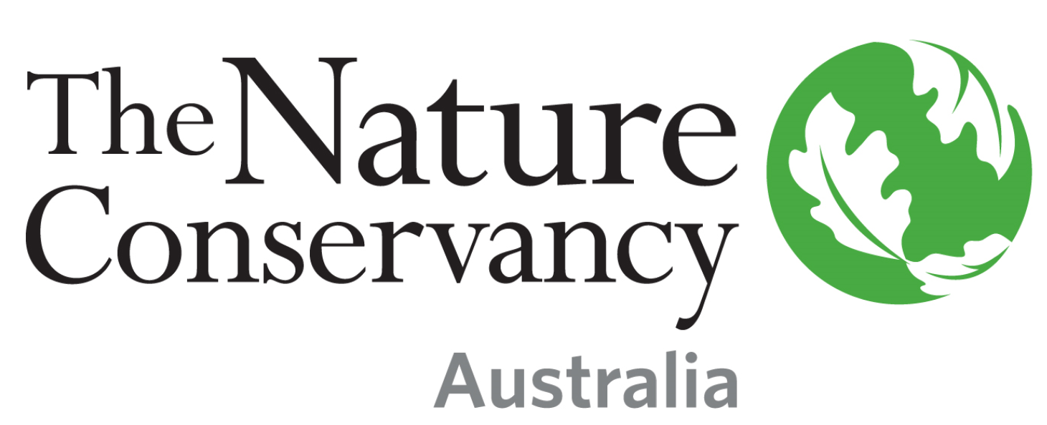

Position: Monitoring, Evaluation and Learning Specialist, Asia Pacific Region

Location: Location is flexible within Asia Pacific. We are open to location for the right candidate.

Status Permanent full-time, Monday to Friday

Salary Range: AUD $ 105,600 per annum to AUD $ 137,200 per annum (commensurate with skills and experience), plus 9.5% superannuation, plus benefits.

A LITTLE ABOUT US
Since 1951, The Nature Conservancy has been doing work you can believe in protecting the lands and waters that all life depends on. As a science-based organization, we create innovative, on-the-ground solutions to our world’s toughest challenges so that we can create a world in which people and nature thrive.

We’re grounded in our Mission and guided by our Values, which includes a Commitment to Diversity and Respect for People, Communities, and Cultures. We know we’ll only achieve our Mission by hiring and engaging a diverse workforce that reflects the communities in which we work. Whether it’s career development, work/life balance, or a rewarding mission, there’s lots of reasons to love life #insideTNC. Our goal is to cultivate an inclusive work environment so that all of our colleagues around the globe feel a sense of belonging, and that their unique contributions to our mission are valued.

The Nature Conservancy offers competitive remuneration, 9.5% superannuation, excellent benefits, flexible work policies and a collaborative work environment. We also provide professional development opportunities and promote from within. As a result, you will find a culture that supports and inspires conservation achievement and personal development, both within the workplace and beyond.

THE ROLE
Science staff at The Nature Conservancy help ensure that the organization’s actions are evidence-based. The Monitoring, Evaluation and Learning Specialist will work closely with staff within the Asia Pacific Region’s Business Units (country programs) to conduct research and publish findings that advance the evidence base for existing and emerging conservation strategies in support of TNC’s organizational goals. Research responsibilities include quantitative data analysis, sampling design, and leading peer-reviewed publications that present the findings from TNC’s monitoring and evaluation work. They will build capacity within TNC through doing these tasks in partnership with staff based in AP Business Units. Publishing the results of our monitoring and evaluation work increases its credibility, makes the learning accessible to the broader conservation community outside of TNC, and provides important products that can be shared to highlight our work.

This is a 2-year fixed-term position that reports to the Lead Scientist, Asia Pacific, and is a member of the Asia Pacific Regional team.

The location for this position is flexible within the Asia-Pacific region. We are open to location for the right candidate.
The Monitoring, Evaluation and Learning (MEL) Specialist supports rigorous design and analysis of monitoring and evaluation work within the Asia Pacific. To do this they require strong quantitative analytical skills that can be applied to analyses across many different environments (e.g. grasslands, forests, oceans) and conservation strategies. The essential functions are to advance TNC’s overall Monitoring, Evaluation and Learning systems, standards, and capacity; support the assessment and measurement of conservation project impacts; and contribute to the body of knowledge about measuring conservation outcomes and the impacts of project interventions.

In fulfilling these functions, they will support the design of conservation projects and specific research and data collection activities designed to determine the impact and effectiveness of the conservation work of TNC and partners in the region. They also advise on and help with appropriate analysis of existing data already collected by TNC teams and partners. They support, and in some cases lead, the timely development of peer reviewed publications that report on these analyses. They support global MEL related processes and build TNC staff capacity by doing these activities in close partnership with TNC staff in country Business Units across the Asia-Pacific. They help connect TNC teams to external expertise (e.g. collaborators at universities) as necessary and beneficial. They support the inclusion of monitoring and evaluation plans within project and fundraising proposals.

Responsibilities & Scope
- Support business units in the Asia Pacific to apply the regional MEL system.
- Supports and builds the capacity of project implementors to contribute lessons to the evidence base.
- Confronts questions of conservation impact and effectiveness with quantitative analysis of empirical data.
- Timely development of manuscripts for submission to peer reviewed publications.
- Documents and publishes lessons to add to the global body of knowledge about nature conservation.
- Mentors staff.
- Supports the Asia Pacific Project Review Committee in evaluating project proposals.
- Fosters internal and external collaborations including with TNC business units and universities.
- Acts as the AP focal point to coordinate with the global MEL team.
- Works in a complex matrix organization environment.
- Participate and/or lead a cross functional team.
- Self-motivated training so that skills remain current.
- May manage a grant, contract, or write a request for proposal.

A LITTLE ABOUT YOU
To be successful in the role you will have:
- Master's Degree in relevant discipline and 2 years of experience.
- Fluency in English.
- Experience manipulating, analyzing, and interpreting data using a variety of statistical methods.
- Record of peer reviewed publications in scientific journals.
- Experience working across different cultures.

Desired Qualifications
- PhD in relevant discipline.
- Proficiency with other languages used in the AP region.
- Familiarity with R programming language.
- Training experience.
- An interest in capacity building and diversity and equity in science.
- Demonstrated ability to successfully develop and implement complex projects in an unstructured environment.
- Independent and self-motivated with the ability to participate effectively in a remote team environment.

HOW TO APPLY
To apply to position number 49849, submit resume (required) and cover letter separately using the upload buttons. Applications will be reviewed in the order they’re received, and the position will remain open until filled.

Click “submit” to apply for the position or “save for later” to create a draft application for future submission. Once submitted, applications cannot be revised or edited. Failure to complete required fields may result in your application being disqualified from consideration.

If you experience technical issues, please refer to our applicant user guide or contact applyhelp@tnc.org.

The Nature Conservancy is an Equal Opportunity Employer
Our commitment to diversity includes the recognition that our conservation mission is best advanced by the leadership and contributions of people of diverse backgrounds, beliefs and culture. Recruiting and mentoring staff to create an inclusive organization that reflects our global character is a priority and we encourage applicants from all cultures, races, colors, religions, sexes, national or regional origins, ages, disability status, sexual orientation, gender identity, military, protected veteran status or other status protected by law.

The successful applicant must meet the requirements of The Nature Conservancy’s background screening process.

