Illicit Drug Referral Project Officer Duty Statement 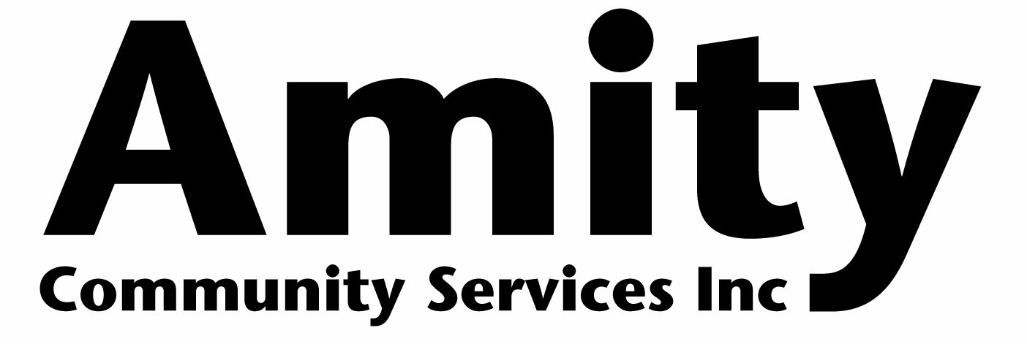

As the Illicit Drug Referral Project Officer you are directly responsible to the Program Manager. The aim of this role is to work in consultation and collaboration with the Health Promotion Officer and Counselling Service team to contribute to the overall program development, delivery and sustainability.

FUNCTION
The purpose of the Illicit Drug Referral Project Officer is to work with a small, dynamic health promotions and counselling team with the aim of developing and disseminating health promotion material and referral information for pathways into Amity’s treatment service.

ORGANISATION
Our Values: Respect | Diversity | Professionalism | Curiosity

RESPONSIBILITIES
- Develop health promotion material with key messages and information about illicit drugs;
- Build and maintain effective relationships with key stakeholders;
- Disseminate health promotion materials throughout the greater Darwin community;
- Promote referral options into treatment relating to illicit drug use;
- Oversee a day-to-day outputs of the Illicit Drug Referral Project as per the project plan;
- Work in collaboration to write reports as required; and
- Develop and deliver training and information sessions for community organisations.
QUALITY MANAGEMENT SYSTEM
- Actively participating in all aspects of quality management; and
- Participate in the review, evaluation, analysis and continuous improvement of products, services and the quality management system.

WHAT AMITY OFFERS
- 6 weeks annual leave, plus a ‘Gifted’ period between Christmas and New Year;
- The option of salary packaging; and
- Up to $2,500 per year support for approved professional development.

Illicit Drug Referral Project Officer Duty Statement

SELECTION CRITERIA
ESSENTIAL
- Knowledge and/or experience of alcohol and drug issues and harm minimisation principles;
- High level of communication skills, with the capacity to relate to various members of the public, including business and industry, support agencies, welfare groups and government;
- Strong project management and report writing skills;
- Ability to work and communicate effectively in a team environment;
- Capacity for self-motivation related to work practice and learning;
- Demonstrated ability to establish and maintain networks and relationships with key stakeholders and community organisations;
- A Northern Territory Driver’s License; and
- A Working with Children’s Card.

DESIRABLE
- Certificate IV in Training and Assessment with a demonstrated ability to develop and deliver training;
- Qualifications in education / health or social sciences field;
- Relevant computer skills, especially with Microsoft Office software; and
- Knowledge of the local Darwin Community and the community sector.

Application Information
- Applicants are required to submit a cover letter of no more than two A4 pages stating why they are suited to this position and the organisation, plus a current resume with at least two work related referees.
- Applications are to be forwarded to habitwise@amity.org.au and received no later than close of business on 14 May 2021.

