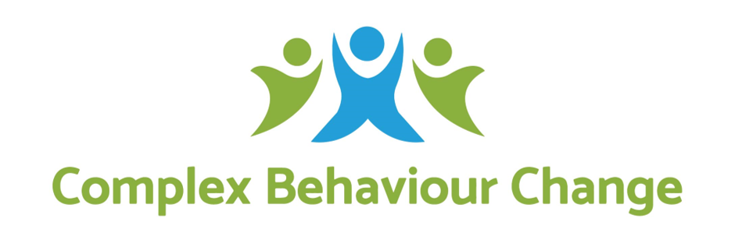

Position Description

Therapeutic Behaviour Support Practitioner

Our Specialist Services Practitioners are inspiring people! They work to understand participant needs and goals and provide person centred support to meet these. They ensure our organisational purpose and values are demonstrated to our participants and others in their approach to day to day practice and support.

Division-Program | Specialist Services
Reports To | Team Leader, Specialist Services
Direct Reports | Nil
Level | NDISC Positive Behaviour Support Capability Framework Core, Proficient or Above
Location | Metropolitan Melbourne
Date Prepared | 12/04/2021

We are guided by our Purpose and Values
Our Purpose is the reason we exist, and at Complex Behaviour Change that is:
Understanding People, Transforming Lives, Cocreating an Inclusive World

Our Values guide all that we do:
- At CBC we hold others in mind with Compassion and understanding.
- We act with Courage, challenging the status quo and advocating for the needs of vulnerable people.
- It’s all about Connection, we seek to relate with transparency, dignity and respect.
- We show our Character by doing our best in all that we do, holding ourselves accountable for results and striving for always do better.
- Most of all we value Cocreation, working with others to achieve lasting and meaningful change.

We provide valued services to people of all ages and all abilities and to do this we need employees to join our team who are skilled professionals, guided by our purpose and values in all that that they do, able to put our participants first, working with passion, commitment, and innovation to help others to realise their hopes and dreams.

About Specialist Services…
Specialist Services is a division of CBC dedicated to providing safe and high-quality behaviour support and therapeutic support to participants who engage in complex concerning behaviour. Comprising of a network of partially distributed teams, Specialist Services provides behavioural and therapeutic services for a broad range of participants including children, young people, and adults across a range of sectors including disability, out of home care, and schools.

What it takes to inspire positive change…
- Assist participants, their families and support teams to identify their needs through assessment and individual planning, to develop meaningful goals and practical strategies to support participants to meet their goals in their home and community
- Collaborate as part of a multi/inter-disciplinary model with a range of allied health professionals to provide a holistic and integrated approach to supports
- Facilitate specialist services utilising the CBC’s BASIC System™ approach to Therapeutic Behaviour Support
- Provide clinical knowledge, expertise and support to individuals, families, and support staff
- Effectively use our client management system, including maintaining client records and ensuring the required daily/weekly billable hours are completed and recorded.

A day in the life of a Therapeutic Behaviour Support Practitioner…
- Participate in morning bumps, team meetings and supervision
- Manage a varied and diverse caseload
- Assess, plan, deliver and evaluate behaviour supports relating to the individual’s needs in line with relevant legislative and ethical requirements
- Plan implement and review training and support plans for participants, support staff, families and carers in positive behaviour support and specialist topics as required.
- Utilise therapeutic skills, knowledge and training to foster positive change
- Apply advanced clinical reasoning skills with support from your line manager
- Use principals of evidence-based practice as part of all service delivery
- Provide support which reflects the Disability Services Standards, Child Safety, NDIS and other relevant legislative requirements and to report any potential breaches to CBC’s management
- Actively promote CBC’s Purpose and Values in everyday work and in the community
- Follow and implement Work Health & Safety (WHS) guidelines and instructions
- Follow, contribute, and work in a culture committed to continuous improvement within CBC’s online and in person work environments
- Undertake administrative tasks necessary for the role including recording billable hours and maintaining appropriate documentation and systems to safeguard the wellbeing of the participants supported
- Work positively and collaboratively as a member of a multi/inter-disciplinary team and respect team values and participate in learning and development opportunities

What you need to be successful in this role…

Key Selection Criteria
- A commitment to CBC code of conduct
- Demonstrated skills and experience of at least basic/core Behaviour Support Practitioner with proficient or above preferred, as outlined in the National Disability Insurance Scheme Quality and Safeguards Commission – Positive Behaviour Support Capability Framework 2019 and to maintain suitability to deliver Specialist Behaviour Support under the NDIS
- Have a minimum 2 years’ experience in the delivery supports to people with complex therapeutic and/or behaviour support needs, including working with their families and/or other supports
- Relevant Tertiary Qualification in Psychology, Social Work, Occupational Therapy, Psychotherapy, Disability, Education, or Social Sciences
- Understand Positive Behaviour Support principals in theory and in practice
- Willingness to gain knowledge, understanding and to commit to the policies, procedures, and delegations of CBC, together with relevant legislation
- Willingness to engage in our Practitioner Development Program (PDP), including training in CBC’s BASIC System Therapeutic Behaviour Support framework and work towards registration or eligibility for registration with the BASIC System Certification Board (BSCB)
- Willingness to gain knowledge of or understand relevant policy and legislation relating to provision of Specialist Behaviour Support and Restrictive Practices at a National and State/Territory jurisdictional level
- Willingness to learn how to deliver and evaluate relevant training for support staff and/or hold a Certificate in Workplace Training and Assessing.
- Advanced writing skills with demonstrated ability or a willingness to learn to utilise data collection tools, collate information, analyse, and prepare reports and plans for relevant stakeholders
- Demonstrated capacity to quickly engage different groups of people, in a variety of contexts, and with differing levels of engagement
- Ability to work effectively with a range of stakeholders including individuals, families, Local Area Coordinators, NDIA, the Office of the Public Guardian, ADHC, other government agencies and specialist support services
- Good time management and case load management skills,
- Ability to complete and record the ratio of billable hours each day/week as required at your specific role level
- Confidence using information technology, including navigating online working platforms such as Microsoft Teams, and ability to use Microsoft Office 365 programs
- An ability to work autonomously as well as part of a team
- Working with Children Check and National Police Check clearance
- Current driver’s licence and a willingness to drive as per role requirements
- A motor vehicle, computer, internet, office space, and a lockable cabinet for the safe storage of hard copy client information.

Please note this role includes a 6-month probation period for all new employees to CBC.

Signed: Date:

Print Name: ____________________________________

