Position Description
Position Title | Senior Practitioner
Program | Family violence crisis accommodation and case management
Employment Status | 0.8/0.9 EFT – includes some (minimal) on-call hours
Tenure | Permanent/ongoing
Classification | Social, Community, Home Care and Disability Services Industry Award (SCHADS) – level commensurate with requirement of role, qualifications, and experience
Position reports to | Team Leader
Location | North East/North West

About Georgina Martina Inc.
Georgina Martina Inc. is a community-based organisation which operates a state-wide family violence support and accommodation service including two high security refuges – Georgina and Martina. The organisation is committed to a feminist strength-based approach to service delivery that views women as the experts in their own lives. Our practice at GMI is also child focused, trauma informed, and strength based/client focused.
Both Martina and Georgina refuges provide high security crisis accommodations, ensuring women and children experiencing family violence can feel safe. The organisation operates an outreach support service for women and children who have moved on from high security accommodation. We maintain several properties for longer-term support and work closely with mainstream housing services to ensure appropriate exit points from the service.
Georgina Martina Inc. is overseen by a community-based Board of Management involving professionals with relevant expertise and is accredited against: DHHS (Department of Health Human Services) and QIC (Quality Improvement Council) standards on a 3-year cycle by & QIP (Quality Improvement Performance)

Our Vision
To Enable and empower women and children in our care to create and access opportunities to lead a life free from violence.

Our Philosophy
- Georgina Martina Inc. believes women and children should enjoy the fundamental human right to live free of threat or presence of violence regardless of race, age, class, sexual preference, religion or culture. We believe women have the strength and courage to survive and grow through their experiences.
- Our feminist approach strives to preserve and strengthen women’s capacity for self-determination and mutual support and challenge the power imbalances inherent in patriarchy.
- We recognise that children suffer the trauma of family violence equally, separately and differently from their mothers and that children are the least powerful in this regard.
- Georgina Martina Inc. acknowledges and supports the rights of Aboriginal and Torres Strait Islander people to be recognised and compensated as the original inhabitants of this country.

Our Values
All staff and Board members value and adhere to the following set of core values:
- Empowerment
- Collaboration
- Ethical
- Feminist
- Enabling

Context of Position
GMI are in the process of an exciting transition from a communal model to newly developed Core and Cluster model (one of the recommendations from the Royal Commission into Family Violence), with new purpose-built facilities.
We will be experiencing considerable growth in client and staff capacity, staged over a couple of months. We require an enthusiastic leader with significant experience within the family violence sector who can mentor, support and develop staff practice, as well as contribute to the review and implementation of the organisations policies and procedures.
A Senior Practitioner will be based at each of our two new sites, one in the North East and one in the North West. However, the roles will be required to work across both sites to support a cohesive and connected organisational culture.
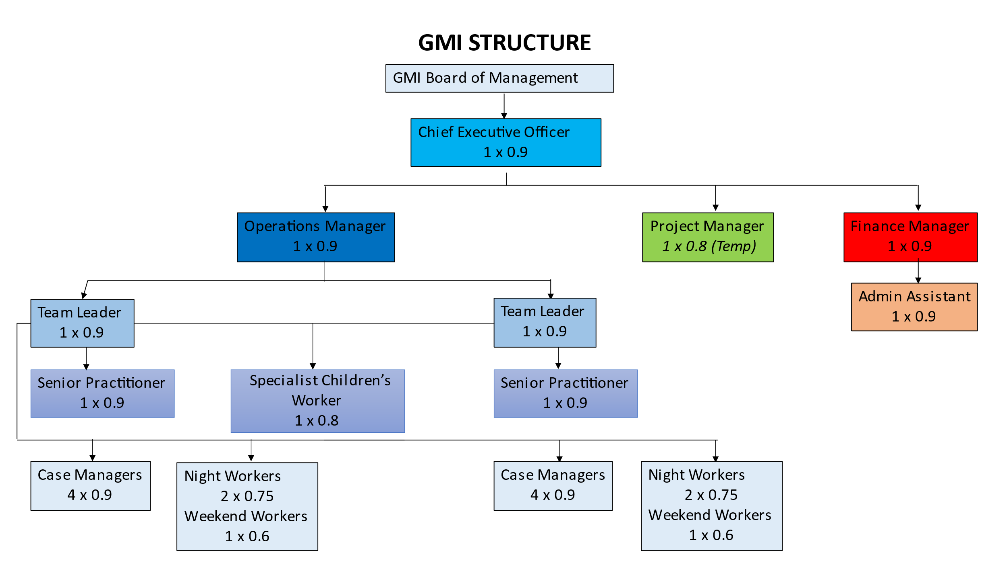

Internal relationships
- Report directly to Team Leader
- Accountable to Operations Manager
- Provide supervision to Case Manager’s, as required by Team Leader
- Provide mentoring and coaching to Case Managers.
- Work closely with Specialist Children’s Practitioner and Team Leaders to develop workforce capacity in trauma informed and child centred practice
External Relationships
- Family violence crisis specialists and case managers
- Referral pathways such as Safe Steps and Orange Door
- Participate in relevant networks & forums
- Develop and maintain external networks of benefit to GMI clients
- Provide secondary consultation to external services
- Liaison with external services to advocate for clients

Key Responsibilities
- Work closely with the Team Leader to facilitate a high performing team.
- Manage a caseload of clients with complex needs. This includes high quality assessments and case planning underpinned by relevant family violence frameworks and legislation.
- Work with a high level of initiative and autonomy
- Support the Team Leaders and Operations Manager with the development and review of refuge procedures and working instructions.
- Ensure compliance with current legislation (MARAM, FVISS, CISM, CISS, DVVIC code of Conduct for FV Case Management)
- Make recommendations for improvements to practice and procedures
- Under the direction and supervision of the Team Leader, lead the team in reflecting on best practice and continuous improvement standards.
- Support the Team Leader with induction and orientation of new staff.
- Provide direct support and supervision to Case Manager’s, as required by Team Leader
- In conjunction with the Team Leader and Operations Manager, ensure performance appraisals are conducted yearly for direct reports.
- Assist Team Leader, Operations Manager, CEO and Finance Manager in the accreditation process.
- Model best practice when engaging in direct service delivery and generously share learnings to build capacity of team members.
- At all times show initiative and enthusiasm that fosters a positive and professional culture
- Provide consultation to staff, as directed by the Team Leader.
- Ensure GMI values are reflected in practice and culture.
- Ensure child safe practices are embedded, including the reporting of any children and young people at risk of harm to Child Protection and follow best practice in managing risk
- Attend and contribute appropriately in a range of meetings
- Foster exceptional working relationships with internal and external stakeholders
- Actively engage and prepare for formal internal supervision with the Team Leader at least fortnightly.
- The incumbent is required to participate in an annual formal performance appraisal and any other appraisal systems as directed by the Operations Manager
- All other tasks as directed by the Team Leader and Operations Manager

Key Selection Criteria
Formal Qualifications and Prerequisite | - A relevant tertiary qualification in Social Work, Psychology, and/or related discipline  - Minimum 3 years experience working in family violence support service  - Current Australian Driving License
Essential Skills and Experience | - Advanced understanding of feminist theory and contemporary family violence practice including the gendered nature of family violence.  - Extensive experience and refined skills in the provision of family violence case management and crisis response services  - Experience in leading/coaching others and providing reflective and operational supervision.  - Extensive experience in undertaking comprehensive risks and needs assessments and risk management responses (safety planning).  - An understand of the key findings and recommendations of the Royal Commission into Family Violence  - An excellent demonstrated understanding of theoretical frameworks and legislation relevant to family violence intervention and ability to apply these to practice.  - A demonstrated understanding of intersectionality as it relates to diverse and marginalised populations and their experience of family violence.  - Demonstrated ability to work in a challenging and demanding environment, managing competing demands and maintain composure in times of stress – employing effective engagement strategies with colleagues and clients in times of crisis.  - Demonstrated understanding of the principles of continuous quality improvement and the ability to apply these to the organisation.  - High level interpersonal and communication skills, advocacy, negotiation, and conflict resolution skills  - Demonstrated high levels of resilience and professional conduct during periods of significant organisational change
Equal Opportunity Exemption
Georgina Martina Inc. is exempt from the provisions of the Equal Opportunity Act 2010. Applications for this position will be considered from women only.
We strongly encourage women from Culturally diverse, LGBTIQ, Mature Age or Aboriginal and Torres Strait Islander backgrounds to apply

