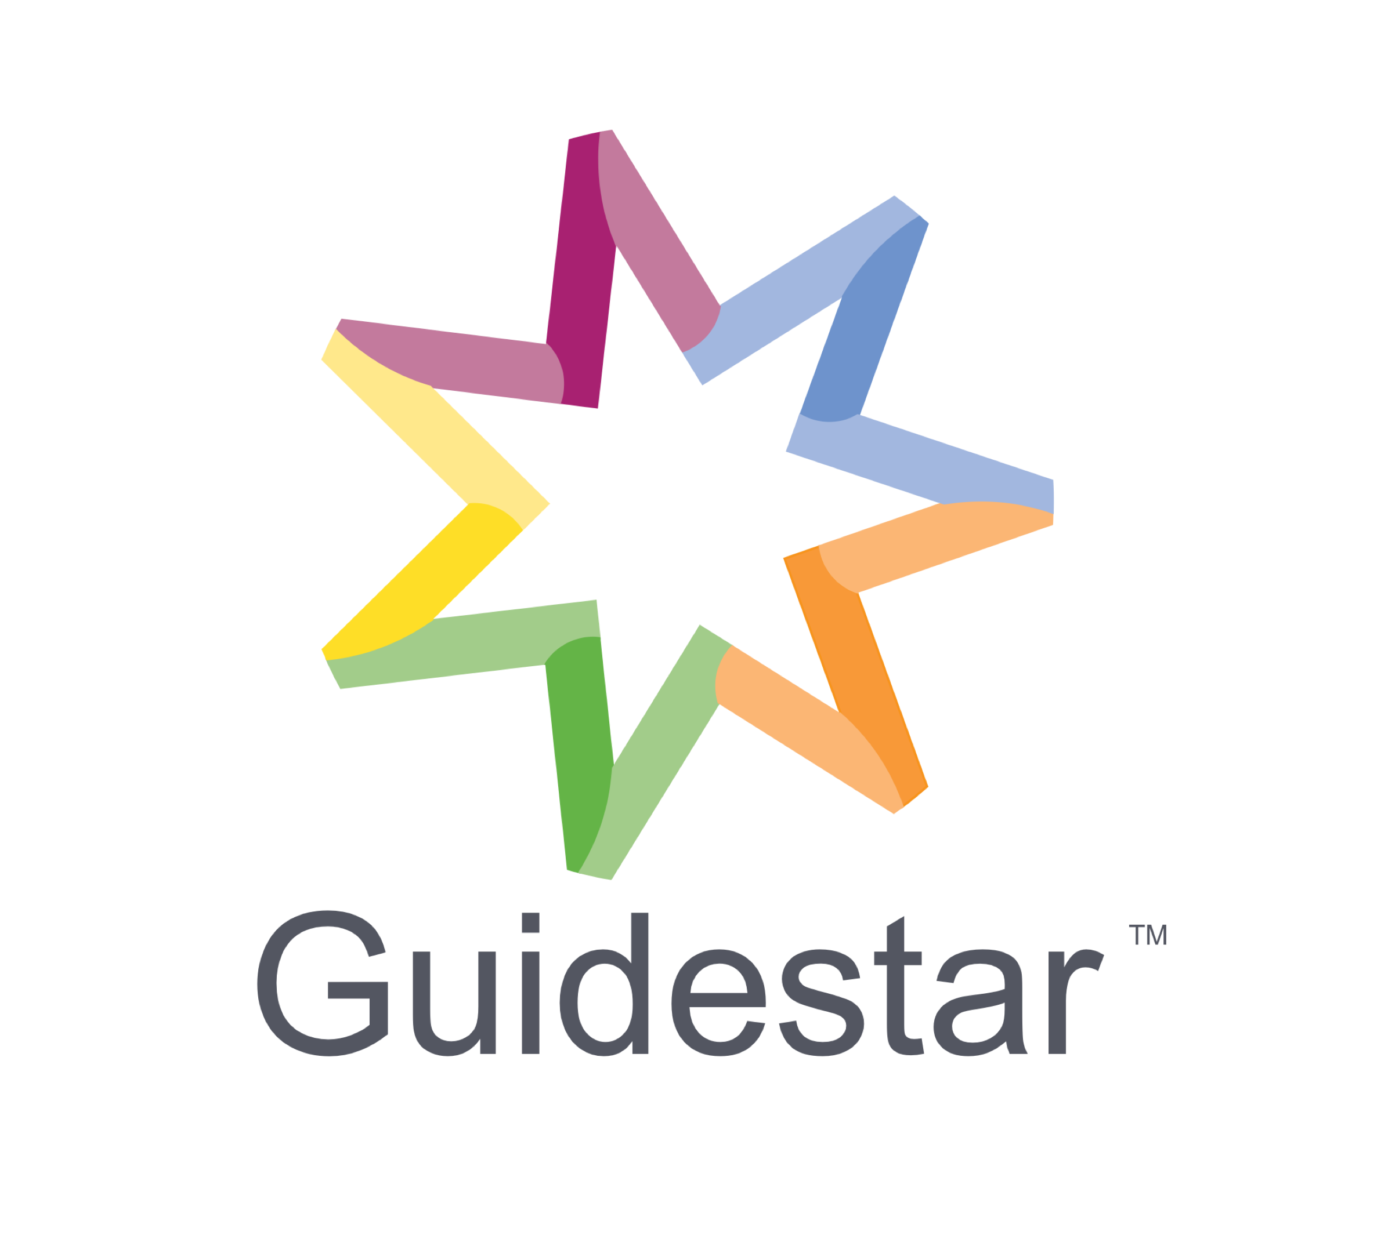

Position Description

Consultant Behaviour Support
Reports to | Team Leader Behaviour Support
Award | Health Professionals & Support Services award
Award Classification | Level 4
Date of Review | July 2023

Guidestar focuses on providing support and professional services to individuals across the lifespan with multiple and complex needs.
As part of our person-centered approach, services are provided both from our Alphington Head Office and within the individuals' environment/s therefore travel around Melbourne, Geelong and, occasionally, regional Victoria is expected for clinicians.
Key Program Areas:
- Services for Individuals and Families
- NDIS services
  - Therapy
  - Positive Behaviour Support
  - Support & Specialist Support Coordination
- Psychology/Counselling Clinic Medicare
- Fee Paying
- Training
- Professional Development/Supervision
- Organisational Development

Our work is informed by human rights-based principles including participation, accountability, non-discrimination, empowerment and the practice of human rights standards. We require all employees to perform in a way that is in line with these principles and our organisational values. We celebrate difference and welcome people of all cultural backgrounds, faiths, genders, sexualities and abilities.
Guidestar is also committed to managing corporate social responsibility as an employer, prospective employer and professional service provider to its clients. In alignment with our Corporate Governance Policy, we will ensure that all matters of corporate social responsibility are considered and supported in our operations and administrative matters and are consistent with our stakeholders’ expectations.

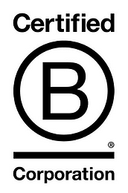
Guidestar is a Certified B-Corporation
Certified B Corporations are a new kind of business that balance purpose and profit.
Certified B Corporations are businesses that meet the highest standards of verified social and environmental performance, public transparency, and legal accountability to balance profit and purpose. B Corps are accelerating a global culture shift to redefine success in business and build a more inclusive and sustainable economy.
B Corp Certification doesn’t just evaluate a product or service; it assesses the overall positive impact of the company that stands behind it. And increasingly that’s what people care most about.
Certified B Corporations achieve a minimum verified score on the B Impact Assessment—a rigorous assessment of a company’s impact on its workers, customers, community, and environment—and make their B Impact Report transparent on bcorporation.net. Certified B Corporations also amend their legal governing documents to require their board of directors to balance profit and purpose.

About the Position
The purpose of this position is to form an alliance with our clients and their families, to develop Functional Behaviour Assessments and Behaviour Support Plans and oversee the use and reduction of restrictive interventions with clients in the community who present with complex needs. Tasks will include report writing and treatment plan development, as well as face to face work with clients. This includes establishing goals that target their assessed needs, then providing guidance, intervention and support to the client in their pursuit and achievement of these goals.
This role may over time be modified and amended to ensure it is meeting business needs.
Organisational Environment

Our Purpose
To provide quality, sustainable, and responsive services that uphold human rights, create opportunities, promote health, and empower people to make their own choices.
We do this through:
- Striving to be the change that we seek;
- Supporting people to work with vulnerability, complexity, and trauma;
- Working alongside individuals, families, and carers;
- Partnering with organisations to achieve best possible outcomes that benefit their customers;
- Demonstrating best possible practice in relation to service planning, psychological and therapeutic service delivery, and behaviour intervention; and
- Addressing and overcoming barriers to community inclusion for children, young people and people with disabilities and / or mental health support needs.

Our Vision
Working together to realise potential, attain optimal wellbeing and enable a meaningful and engaged life.

Our Values

Relationships
We value relationships first and foremost. Establishing ethical and professional relationships is central to our work and practice.
Respect
We are respectful and caring in all our dealings.

Diversity
We celebrate uniqueness and promote diversity. We respect and acknowledge the skills and perspectives that people may bring through gender, race, culture, ethnicity, disability, age, sexual orientation, gender identity, intersex status or other difference.

Innovation
We are bold and imaginative. We thrive on opportunities to work collectively on complex issues and deliver breakthrough results. We apply our creativity across all aspects of our business and in the way we interact with our clients and stakeholders.

Thought Leadership
We share knowledge and ideas. Our directions are guided by contemporary theory and thinking, research and evidence-informed practice.
General Responsibilities
Contribute to the  Vision, Purpose and Ethos of Guidestar | - Act in accordance with the Ethos of the organisation at all times  - Maintain a high standard of professional conduct when dealing with internal and external stakeholders  - Contribute to the achievement of the strategic direction and goals of the organisation
Workplace  Health Safety | - Adopt a risk management approach to problem solving to assist in identifying issues which may have ramifications for the client, family or wider community  - Lead and participate in all workplace health safety policies and procedures as required
Clinical Services | - Develop comprehensive functional behaviour assessments that are centred on a person’s goals and aspirations.  - Conduct observations, collect data and work directly with an individual to understand why they are displaying behaviour that others find challenging.  - Develop visual aides that are reflective of the support needs of the individual and the targeted audience  - Use your knowledge and skills to ensure that the persons goals are being achieved through advocacy and support  - Work closely with a person’s family and support network  - Undertake specific adaptive functioning, risk and behaviour-related assessments.  - Prepare, write, deliver and implement psychosocial and behaviour assessment reports as well as quality behaviour support plans.  - Prepare, write, deliver and implement psychosocial and behaviour assessment reports as well as quality behaviour support plans.  - Provide training to staff and families around positive behaviour support and assist in the implementation of this practice  - Maintain documented evidence that demonstrates your process of support  - Ensure that communication is effective and responsive in complex care teams  - Able to work independently in remote settings but maintain contact  - Have strong administration skills and record keeping, ensuring adherence to privacy and confidentially legislation  - Deliver agreed billable hours.
Maintain high service quality & continuing professional development | - Evaluate your work and seek feedback from those who you provide a service to. Adapt and update your work to incorporate outcomes and feedback  - Respond to complaints in accordance with Guidestar policy  - Collaborate and co-work with your colleagues and seek constructive feedback.  - Reflect on the evidence base for your practice by participating in team reflective practice. Incorporate new information into everyday practice.  - Develop a Continuing Professional Development Plan to plan and monitor professional development.  - Reflect on challenges and successes in your work via group, peer and 1:1 supervision.  - Access professional development and training outside of Guidestar as appropriate.  - Monitor and audit key service aims and outcomes regularly
Participate in  Projects as Required | - Participate within a project team and assume responsibility for shared leadership as required.  - Undertake Project Management as required.

Key Selection Criteria
Experience & Knowledge | - Strong report writing skills that match the intended audience.  - Demonstrated knowledge, experience and understanding of the support needs of people with disability across home and community settings  - Well-developed communication and interpersonal skills including the ability to work and communicate effectively with participants, their families, community agencies and other professionals  - Focused on supporting someone to increase their quality of life through self-determination and person-centred thinking  - Able to adapt to changing needs and prioritise tasks in an efficient manner  - Ability to work independently and collaborate in a team  - Ability to provide support to clients with high and complex needs (including the experience of mental ill health and trauma).  - Highly developed communication and interpersonal skills including the ability to provide clinical advice and consultancy services and produce high quality written reports.  - Working knowledge and understanding of the Disability Act 2006, and NDIS  - Understanding of individual clients’ cultural and diversity requirements including Aboriginal Torres Strait Islander people (ABTSI); Cultural and Linguistically Diverse (CALD) clients; and Gay Lesbian Bisexual Transgender Intersex (GLBTI+) clients.  Candidates who do not meet this criteria but can demonstrate similar appropriate experience and values may be considered.
Qualities | Commitment to diversity & inclusion  Diversity and inclusion objectives align with personal values and there is strong belief in the business case.  Courage  Ability to speak up and challenge the status quo, humility about strengths and weaknesses.  Cognisance of bias  Mindfulness of personal and organisational blind spots, and ability to self-regulate to help ensure ‘fairness’.  Curiosity  An open mindset, a desire to understand how others view and experience the world, and a tolerance for ambiguity.  Culturally intelligent  Confident and effective in cross-cultural interactions.  Collaborative  Empower individuals as well as create and leverage the thinking of diverse groups.
Qualifications | - Minimum tertiary qualification in a relevant discipline (Social Work, Psychology, Occupational Therapy, Disability).  - Registered psychologist, occupational therapist, speech pathologist, social worker or other allied health practitioner or a developmental educator (with current membership with Developmental Educators Australia Inc) with experience supporting people with a disability who may display behaviours that challenge others.  - Current and full registration with AHPRA or other professional body (as appropriate).
Relevant Checks | - Consent to undertake employee checks processes.  - Current registration with Australian Health Practitioner Regulation Agency or other relevant body.  - Working with Children Check.  - Cleared NDIS Worker Screening Check.  - A current Driver’s License.  - International Police Check (where applicable) - if individual has a period of residence of 12 months or more in an overseas country during the last 10 years.  - Right to Work in Australia.
Confidentiality
- Any information obtained during employment is confidential and should not used for any purpose other than the performance of the duties for which the person was employed. Please refer to Guidestar Conditions of Employment and Guidestar policies governing the areas of confidentiality and disclosure of information, particularly the Privacy Policy.

Occupational Health and Safety

Related legislation: OHS Act (2004) and associated Regulations and Australian Standards
- Guidestar recognises its moral and legal responsibility to provide a safe and healthy work environment. Guidestar will maintain, as far as practicable, a working environment that is safe and minimises risk to the health and wellbeing of all staff, clients, contractors and visitors. Staff will at all times conduct themselves in a safe and responsible manner, with due regard to minimising potential risks within the workplace.
- Guidestar encourages staff to take a constructive role in promoting improvements in occupational health and safety, and to assist Guidestar in achieving a healthy and minimal risk work environment. It is a condition of employment that staff comply with all health and safety related policy and procedures and take part in activities designed to improve the health and safety of the workplace.

Training and Development
- All staff will be required to participate in the annual performance development review process which will be conducted by their designated Manager.
- Staff will be expected to take part in any training or courses relevant to their area of work as may be deemed appropriate.

Other Relevant Information and Conditions
- Guidestar is an EEO Employer
- Aboriginal and Torres Strait Islander people, and those who speak languages other than English are encouraged to apply
- Guidestar is a totally smoke free workplace
- Some out of hours work may be required
- It is a condition of employment that all staff take part in Guidestar’s Quality Improvement Process, and that they take part in and assist in any evaluations of the whole or any part of Guidestar or its programs or projects as required.
- The position is subject to the terms set out in the Guidestar Human Resources Policy, Staff Code of Ethics, and any future addition or variations to them. Tenure of the position is conditional upon ongoing observance of the Guidestar Staff Code of Ethics

Authorisation
I have read, understood and accepted this position description as the basis of this role.

Employee Signature Authorised Manager’s Signature

