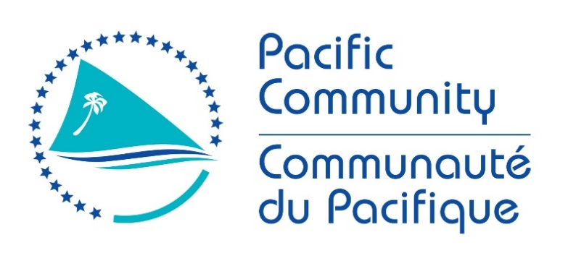

JOB DESCRIPTION

Job Title: | Monitoring, Evaluation and Learning Adviser (PacMEL)
Division /Programme; | Director General’s Office; Strategy, Performance and Learning Unit
Location: | Suva or Noumea
Reporting to: | Team Leader Monitoring, Evaluation and Learning
Number of Direct Reports: | 0
Purpose: | To develop and strengthen relationships between the partners and stakeholders for Pacific MEL, including high level government officials from member countries, MEL professionals in the region, donor and implementing partners, civil society and NGOs.  To lead engagement, partnership development, and socialization of the Pacific Monitoring, Evaluation and Learning Capacity strengthening Rebbilib roadmap with stakeholders.
Date: | November 2020

Organizational Context and Organization Chart
The Pacific Community has been providing scientific and technical services to the Pacific region, since 1947. We are an international development organisation owned and governed by our 26 country and territory members. In pursuit of sustainable development to benefit Pacific people, our organisation works across more than 20 sectors. We are known for our knowledge and innovation in such areas as fisheries science, public health surveillance, geoscience, and conservation of plant genetic resources for food and agriculture. The Pacific Community Transition Plan 2021 sets out our strategic intent and plans for action to respond to, and support recovery from the shocks of 2020. We remain committed to our long-term goals for the Pacific and the goal of One SPC:
- Goal 1: Pacific people benefit from sustainable economic development
- Goal 2: Pacific Communities are empowered and resilient
- Goal 3: Pacific people reach their potential and live long and healthy lives
- Goal 4: One SPC delivering integrated programmes through streamlined services.
The Strategy, Performance & Learning (SPL) is a specialised unit within the Office of the Director-General, with responsibilities for developing methodology, capability and practice for monitoring and reporting against the SPC Strategic Plan. SPL has staff based at our headquarters in Noumea, as well as our regional office in Suva. We provide whole of organisation service (Secretariat and member) through: i) Strategy and Planning; ii) Monitoring, Evaluation & Learning; iii) Programming and Design. Our work is focussed on creating the conditions for change, grounded in contextually relevant and culturally responsive practice.
Pacific MEL
In 2018, SPC began to explore partnerships to look at strengthening monitoring, evaluation and learning (MEL) capacity in the Pacific in order to supply and increase the demand for evidence to support decision-making. In 2019, a partnership was formed with the New Zealand Government Ministry of Foreign Affairs and Trade, SPC and BetterEvaluation to co-design a participatory process to assess and understand the current MEL system and opportunities for capacity strengthening. Over the next 12 months the partnership extended to Pacific stakeholders from national governments, civil society, academic institutions, development partners and donors.
This participatory process led to the Pacific Monitoring, Evaluation and Learning Capacity Strengthening Rebbilib, which acts as a roadmap for the Pacific region and commits the Pacific Community (SPC), Pacific Island countries and territories (PICTs), and development partners to strengthen capacity in the Pacific region for contextually and culturally appropriate monitoring, evaluation, research and learning to support improved governance and decision making. The Pacific MEL team within SPL will continue to support the voyage ahead for Pacific MEL.

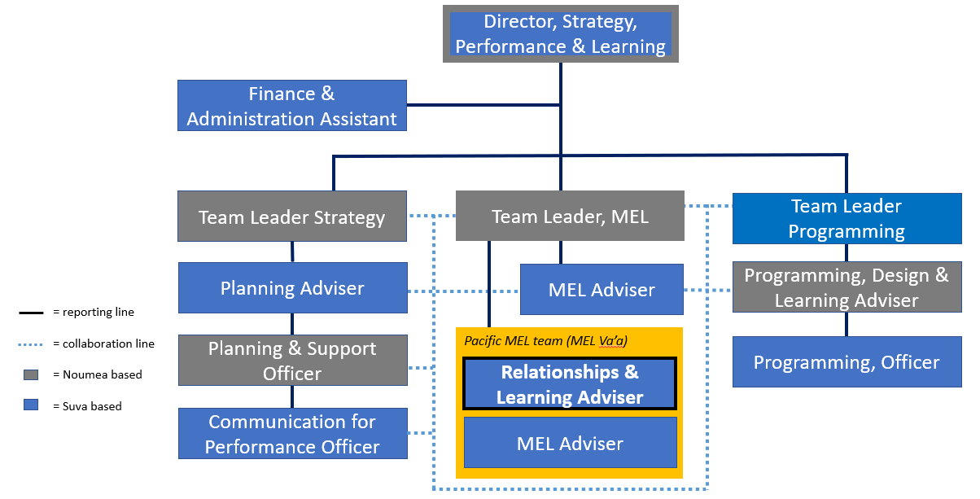

Key Result Areas (KRAs):

The Monitoring, Evaluation and Learning Adviser is a specialist position within the SPL team and is critical to furthering the regional dialogue, needs analysis and design for Pacific MEL development across the region. The following KRA’s have been designed based on “the voyage ahead” outlined for Pacific MEL in rebbilib (pp.29-32):

The functions and Key Result Areas are below.
- KRA 1 - Pacific-led va’a for co-ordination
- KRA 2 - MEL capacity
- KRA 3 - MEL implementation
- KRA 4 - Evidence for resilient development

The performance requirements of the Key Result Areas are broadly described below

Jobholder is accountable for | Jobholder is successful when
KRA 1 - Pacific-led va’a for co-ordination  Strengthening the ownership, coordination and cohesion of MEL in the Pacific region through solesolevaki (reciprocity, social capital, kinship and community relationships).  Key elements include:  - The establishment of Pacific MEL governance arrangements, bringing together national governments, development partners, donors, civil society and academic institutions  - Provide secretariat support to Pacific MEL, along with the Pacific MEL adviser  - Facilitate consultative processes to co-ordinate and manage specific initiatives, relationships and collaborations, including negotiating priorities and arranging annual MEL convenings  - Support the Relationships and Learning Adviser on two other components of the voyage ahead, “MEL culture” and “MEL collaboration”, as well as other recommended strategies and actions in the voyage ahead as required. | - Pacific MEL governance arrangements are developed, bringing together a wide range of partners and stakeholders  - Support is provided to a Pacific MEL consortium of organisations connected by agreed principles and vision  - Pacific MEL governance arrangements help ensure that Pacific MEL stakeholders have a regular forum through which to provide direct inputs into MEL governance in the Pacific region, and to better coordinate their actions and resources in support of MEL development.
KRA 2 - MEL capacity  Develop MEL capacity (where basic MEL capacity is currently lacking), as well as ensuring efforts are dedicated to continuously maintaining MEL knowledge and skills.  Key elements include:  - Develop and/or enable access to on the job training, short courses, micro-qualifications, graduate programmes, along with follow up technical assistance, coaching, mentoring, peer learning  - Develop and/or enable access to some short courses on specific topics, which include Pacific examples and presenters, run online and in-person  - Work with partners to develop formal qualifications, such as regional micro qualifications and a graduate programme at USP, as well as other accredited training providers from across the Pacific region. | - Contextually relevant and culturally responsive MEL capacity development is developed or available at the individual and institutional level  - MEL capacity involves not only knowledge and skills, but also the ability to apply these, including enabling organisational structures and culture.  - Partners emphasise that skills development is not only about trainer-led learning, but also peer learning, coaching, mentoring and self-directed learning that fit in with cultural ways of learning in the Pacific region.  - Different entry points are available, including on the job, short courses, micro-qualifications, graduate programmes  - Capacity development is directed at different users – MEL specialists, those with MEL responsibilities, senior leaders, etc.
KRA 3 - MEL implementation  Support provided to organisations to strengthen systems, processes and tools for MEL planning, and monitoring, evaluation and learning, and knowledge management, including data access and management.  Key elements include:  - Utilise Pacific approaches to research and data collection methods, such as the framing of questions, who should come to the table, etc.  - Extend indigenous evaluation and capitalise on and nurture local, national, regional MEL expertise  - Undertake more in-depth country-level assessments of existing MEL capacity to inform planning for country-level and regional level MEL capacity strengthening  - Provide advice to support the development of M&E systems, tools, baseline studies, evaluations as required  - Improve MEL data communication. | - Emerging or progressing individuals and organisations are supported to develop or strengthen systems, processes and tools for MEL planning, and monitoring, evaluation and learning, and knowledge management, including data access and management  - More established partners are supported to enable the alignment MEL implementation efforts across government or organisational plans and strategies  - Attention to robust MEL planning (including appropriate resourcing, and the development of capacity, systems, processes and tools) has a positive knock-on effect on monitoring, evaluation and knowledge management practice.
KRA 4 - Evidence for resilient development  Improve knowledge management and sharing, and the development of tailored knowledge products, to support evidence-based decision making for resilient development.  Key elements include:  - Link MEL with integrated programming and transdisciplinary themes (e.g. climate change, pandemic crisis)  - Utilise national diagnostics and assessments to triangulate national needs for regional support  - Aligning country needs with regional MEL support plans and actions across implementing and donor partners  - Consciously apply Pacific ways of being, ways of communicating, ways of learning and ways of knowing into regional MEL practice  - Create and produce communications and knowledge products  - Contributing to the global transformative evaluation agenda and the local efforts  - Support improved utility of evaluation reports and recommendations for sectoral reporting, monitoring national sustainable development plans, and global commitments, including the SDGs. | - Support provided improves systematic use of MEL evidence for improving MEL systems and strategies, programming and decision-making  - Knowledge management and sharing is improved, with the evidence needs of different users identified  - Tailored knowledge products are improved and/or developed, and support evidence-based decision making for resilient development.

The above performance requirements are provided as a guide only. The precise performance measures for this job will need further discussion between the jobholder and supervisor as part of the performance development process.

Most Challenging Duties Typically Undertaken (Complexity):

- Leading intra and cross-organisational change processes to identify MERL capacity needs at the regional level
- Supporting member countries with the engagement in the needs analysis, event and post event engagement – balancing trust, engagement and mutual reciprocity. Understanding of the socio-political contexts of member countries
- Supporting divisions to build their capacity to engage with performance management processes that are outside of their comfort zones and areas of expertise to strengthen the foundation for business planning

Functional Relationships & Relationship Skills:

Key internal and/or external contacts | Nature of the contact most typical
External  Key external contacts are:  CRGA and CRGA Subcommittee  Pacific MEL partners and practitioners  Pacific organisations and governments  Consultants | - Partnership building and network development  - Presenting information and facilitating engagement on Pacific MEL governance, management and participatory processes  - Facilitating effective information exchange  - Liaising  - Influencing and persuading.
Internal  Key internal contacts are:  Deputy Directors General  Divisional Directors  SPL Team  MELnet  Programme staff | - Providing specialist advice, facilitation and feedback  - Planning, facilitation, coordination  - Giving/receiving and informing  - Facilitating information exchange  - Explaining and mediating  - Leading and supervising development of MEL systems  - Gaining cooperation, influencing, and negotiating.

Level of Delegation:

Routine Expenditure Budget: N/A

Budget Sign off Authority without requiring approval from direct supervisor: N/A

Personal Specification:

This section is designed to capture the expertise required for the role at the 100% fully effective level. (This does not necessarily reflect what the current position holder has.) This may be a combination of knowledge / experience, qualifications or equivalent level of learning through experience or key skills, attributes or job specific competencies.

Qualifications

Essential: | Desirable:
- Post-graduate master’s degree in relevant field such as international development, evaluation, public sector policy, economics | - Post-graduate qualifications in project design or monitoring and evaluation.

Knowledge/Experience

Essential: | Desirable:
- At least 7 years of relevant experience in:  - Understanding on Pacific ways of learning, engagement, and/or partnership building  - Monitoring, evaluation and learning in the Pacific  - MEL for programmes and projects, and  - good understanding of best practices in development effectiveness.  - Demonstrated experience in building or supporting communities of practice / professional networks  - Experience in international development, including design and implementation of MEL Frameworks  - Capacity development skills  - Excellent interpersonal and organisational skills  - Excellent communication skills in English (both oral and writing skills) and experience in communicating PMEL products for development effectiveness  - Ability to work in a multi-cultural and gender-sensitive environment. | - Broad ranging experience in monitoring and evaluation in various sectors such as organisational development, natural resource management, health, climate change, gender and social inclusion etc.  - Skilled in quantitative and qualitative research methods and data analysis  - Understanding of Pacific development challenges  - Understanding of the concepts of Thinking and Working Politically, Adaptive Development and Doing Development Differently  - Broad ranging experience in monitoring and evaluation in various sectors.  - Working knowledge of French.

Key Skills/Attributes/Job Specific Competencies

The following levels would typically be expected for the 100% fully effective level:

Expert level | - Monitoring, evaluation and reporting on donor/grant-funded projects or programmes  - Good understanding of international best practices in development effectiveness  - Leadership  - Project management, planning and coordination  - Strategic thinking skills  - Innovation and analytical skills  - Change management  - Oral and written communication skills in English  - Skilled user of databases for entering, processing, cleaning and extracting data  - Strong influencing and relationship-building skills
Advanced level | - Capacity development  - Facilitation skills  - Presentation skills  - Results orientated problem solving  - High attention to detail  - Familiarity with SPC Corporate policies and strategies
Working knowledge | - Financial management  - Development effectiveness  - SPC programme activities  - Understanding of development issues in the Pacific region
Awareness | - French language

Key behaviours

All employees are measured against the following key behaviours as part of Performance Development:

  - Change and Innovation
  - Interpersonal Skills
  - Teamwork
  - Promotion of Equity and Equality
  - Judgement
  - Building Individual Capacity

Personal Attributes

  - High level of professional integrity and ethics
  - Friendly demeanor
  - Demonstrated high level commitment to customer service

Change to Job Description:

From time to time it may be necessary to consider changes in the job description in response to the changing nature of the work environment - including technological requirements or statutory changes. Such change may be initiated as necessary by SPC. This Job Description may also be reviewed as part of the preparation for performance planning for the annual performance cycle.

Approved:

Manager/Supervisor Date

Employee

https://www.spc.int/updates/blog/2020/08/pacific-mel-rebbilib-report-on-mel-capacity-available-for-download
https://www.spc.int/updates/blog/2020/08/pacific-mel-rebbilib-report-on-mel-capacity-available-for-download

