Position: Case Manager: Moorabool Outreach, based in Bacchus Marsh
Program: Family Violence Outreach Program
Reports to: Team Leader
Hours: 0.8
Classification: as per SCHADS Award
ORGANISATION VISION, MISSION & VALUES: | 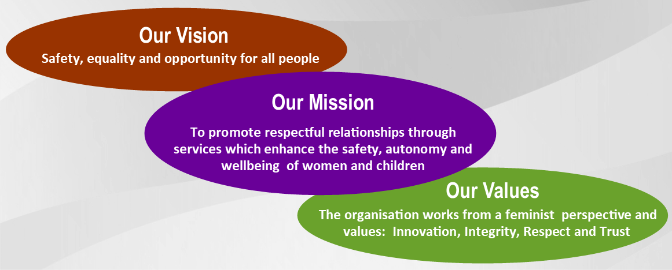
TURNING POINT:  our collective spirit 2015 | Respective, Supportive, Inclusive, Culturally Safe, Stimulating, Flexible  More of: Directness, Forgiveness, Trust, Tolerance, Acceptance  Less of: Negativity, Taking things personally, Assumptions, Undermining
BUILDING BETTER ORGANISATIONS | Making our culture visible  The 4 pillars: Empathy, Clarity, Engagement & Learning  Understanding and use of all processes and tools relating to the BBO Quality Improvement Project.  Participating in the BBO processes to ensure client needs are met with a healthy and sustainable workforce.
Position Context:
The Central Highlands Women’s Collective (CHWC) began in 1983 with the premise that women have the strength to change the world. At the outset the Collective identified the need to name women’s experience of family violence as essential in challenging community attitudes condoning violence against women. They sought to shine a light on the gendered nature of family violence.
Funding was received in 1988 for ‘The Women’s Resource Information & Support Centre’ (WRISC). In the 1990’s funding was specific to provide family violence outreach support (agencies historically supporting the work of women’s refuges). The Collective, comprising personnel and non-personnel community members, managed WRISC under a flat structure until 2006. A new hierarchal staffing structure was then adopted. An Executive Officer and Business Manager were appointed. A new constitution was drafted to reflect the changed organisational structure and passed by members in October 2007. A board of governance was elected in November 2007.
WRISC Family Violence Support is a non-profit organisation funded in the main by the Department of Human Services. WRISC provides a range of services for women and children living in or escaping from situations of family violence. Services include information, referral, advocacy, support, women’s and children’s support groups and children’s counselling. The WRISC office is located in Ballarat and services are offered across the Central Highlands region of Victoria including the shires of Ballarat, Hepburn, Moorabool, Pyrenees and Golden Plains. Services are provided on an outreach basis (including outreach offices and home visits) and at the WRISC office. WRISC is a member of the Grampians Integrated Family Violence Committee and our services are delivered within an integrated service system working closely with police, courts and other agencies.
Position Background
The Family Violence Outreach Program aims to assist women and children who are experiencing, or have experienced, family violence to receive the most appropriate and timely service.
This WRISC Moorabool Outreach Case management role involves providing a range of supports including safety planning, ongoing risk assessment using the MARAM (Multi Agency Risk Assessment and Management) framework, case management, intensive case management and outreach services to women and children in the Moorabool Shire. The position will be based in Bacchus Marsh.
Position Objectives:
- To provide case management support for women and children, working with them to achieve their identified goals.
- Ongoing assessment and response to the diverse needs of service users
- Promote women and children’s safety, self-determination and well-being within the community and wider population
- Liaise with relevant local government bodies, community based services and private services to advocate for women and children, and to promote WRISC values and vision.

MAIN DUTIES AND RESPONSIBILITIES
- Service Delivery
Deliver client directed family violence services in a case management framework including intensive case management:
Case Management:
- Provide women with information about their rights and responsibilities as a client of the organisation, and the services available at WRISC, and supply with a client information pack where safe and appropriate to do so.
- Provide specialist information and advice for women and children regarding family violence and its associated harms. Support them to explore the range of options, services and resources available to promote their rights and safety, and to redress the harm and disadvantage associated with gendered violence and abuse.
- Provide holistic case management, and negotiate and implement a support plan in collaboration with women and their children centred on their goals, and supporting safety and stability.
- Where possible and appropriate provide the client with a copy of any written plans (e.g. safety plan, preliminary case plan)
- Understand and use SHIP (data management and client information software) in accordance with case – management guidelines.
- Provide crisis intervention when required and prioritise safety for all concerned in the response.
- Undertake ongoing Risk Assessment and Safety Planning using the MARAM (Multi Agency Risk Assessment and Management) framework and case management guidelines.
- Report serious and imminent concerns for safety of clients, staff, their children or others to a Team Leader or Executive Officer and implement response as required. Report critical incidents to a Team Leader or the Executive Officer and implement responses as required.
- Work closely and effectively with relevant services including Court, Police, child protection and other services as part of an integrated response to family violence. Attend client related meetings and case conferences as required.
- When and if appropriate facilitate referrals and consultations with other specialist services.
- Identify existing service supports and determine whether WRISC has a role in liaising with these supports (e.g. advocacy, support and other case management tasks). If so, gain appropriate consent.
- Advocate for women and children to negotiate the service system effectively and redress the harm caused by family violence.
- Advocate for and support women through Court processes at regional Magistrates Courts including preparation for Court, facilitating access to Court resources and supports, provision of information about Court process and procedures and supporting women to access legal advice.
- Advocate for and assist women with housing options as appropriate, including private rental, Office of Housing.
- If and when appropriate develop working relationships with other agencies providing direct or indirect support to women and children who have experienced family violence to ensure an integrated response to women and children affected by family violence.
- Maintain client and workplace confidentiality at all times while adhering to Duty of Care responsibilities and other legal requirements.
- Perform all service delivery duties in accordance with professional practice standards and professional code of ethics.
- Demonstrate cultural sensitivity and professional approach to client diversity. Provide sensitive and informed support through secondary consultation and co-case management with culturally specific services.
- Community education and/or co-facilitation of women’s and children’s therapeutic support groups may be negotiated as part of duties.
- Administration and Documentation
- Maintain accurate client records completed in a professional and timely manner adhering to privacy principles and relevant procedures and work instructions.
- Collect and maintain client data for monthly reporting, adhering to the privacy principles, SHIP guidelines and organisational work instructions.
- Assist in the maintenance and accurate upkeep of resource files, brokerage spread sheets and databases.
- Set priorities, plan and organise own work.
- Teamwork and Communication
- Maintain a professional manner in all aspects of communication with clients, colleagues, stakeholders and the broader community.
- Work cooperatively and harmoniously with others to achieve team and organisational goals.
- Prepare for and positively participate in team, staff and organisational meetings as required.
- Promote a positive image of WRISC to members of the community through professional standards of personal presentation, behaviour and accountability.
- Represent WRISC on external networks and committees as negotiated.
- Continuous Improvement and Risk Management
- Be aware of, and apply to practice the organisations strategic vision, values and directions and abide by the code of conduct.
- Perform all organizational duties in accordance with organisational policies, procedures and work instructions.
- Undertake quality improvement activities as appropriate to the position and ensure own work practices comply with relevant legislation and quality standards.
- Contribute to team work plans and ensure own work outcomes are achieved.
- Identify occupational health risks and hazards, and contribute to a safe work environment.
- Actively participate in the risk management process appropriate to the position. For all types of risk, a comprehensive risk management process will be followed. This involves:
  - Identifying potential risks
  - Assessing the likelihood of risks and consequences of losses
  - Choosing how to control, avoid, eliminate or minimise risk through strategies, processes and policies.
- Personal and Professional Development
- Demonstrate reflective and evidence based practice to support improved outcomes for women and children through positive participation in supervision, case discussions, evaluation and feedback processes, and training.
- Actively participate in regular individual and group supervision and debriefing as required.
- Develop self-care strategies and monitor the effects of the work in supervision accessing available organisational support as required.
- Negotiate in supervision annual work and training plans to achieve organisational goals and undertake performance appraisal processes in line with WRISC’s performance management program.
- Attend training, conferences and forums provided by the organisation.
KEY SELECTION CRITERIA
Essential
- Tertiary qualifications in social work, community services or related discipline; with relevant work experience (including volunteer &/or work experience placements) in the family violence and/or community services sector.
- High level of knowledge of the causes and context of family violence (theory), its impact on women and children; and skills to respond (practice) to address same.
- Demonstrated ability to use initiative and judgement providing quality client services within a case management framework – supporting clients to achieve their goals. Experience within a family violence work context is preferable.
- Demonstrated ability to provide culturally sensitive practice, inclusive of the needs and context of Indigenous and CALD communities.
- High level of interpersonal skills to work respectfully and effectively within a team and in collaboration with other professionals and organisations.
- Highly developed administrative skills to create and maintain client records including sound computer skills - proficient in Microsoft Office Suite. Experience in report writing desirable.
- Considerable experience in the development of effective and collaborative working relationships with other agencies in a service network
Conditions of Employment
- The successful applicant will be required to undergo satisfactory pre-employment checks, including three referees, a criminal records check (entails proof of identity), working with children check and proof of qualifications.
- The successful applicant will be expected to have a current Victorian driver’s licence.
- Employment is subject to a three month probationary period.
- A pre-employment health declaration is required.
- Terms and conditions of employment are based on the Social, Community, Home Care and Disability Service Industry Award 2010.
Description of Work Activities /Environment
Element | Key Activity | Frequency
Work Environment | Manage demanding and changing workloads and competing priorities. | Daily
 | Work in a team environment. | Daily
 | Work in different geographical and office locations and other settings (e.g. schools). | Regular
 | Work in unstructured environments (e.g. home visit). | Regular
 | Work office hours with the possibility of extended hours. | Regular
 | Work in an open plan or shared office space. | Daily
 | Sit at a computer or in meetings for extended periods. | Daily
 | Interact with members of the public who may display the full range of emotional expressions, including parents, partners, significant others, family members, advocates, doctors, police. | Regular
 | Interact with clients and members of the public who could display verbal or physically challenging behaviour. | Occasionally
 | Support and participate with clients in recreational activities (e.g. camping, gardening). | Occasionally
 | Participate in team development/building activities. | Regular
 | Fluorescent lighting. | Daily
Manual Handling | Undertake minimal manual handling such as lifting of equipment which would be of varying weight and size (e.g. child car seats, books and resources). | Regular
Administrative tasks | Computer work, filing, writing reports, case notes/plans and client records, participate in meetings, concentrating for long periods of time, managing resources and budgets and researching and analysing information and data. | Daily
Technology | Use technology including photocopier, telephones, mobiles, fax, laptop, projectors, televisions, video, electronic whiteboards, security and duress alarm systems. | Daily
Transport | Drive vehicles possibly over long distances and in all traffic and weather conditions. | Regular
 | Use public transport including trains, buses, trams and taxis. | Occasionally

Exemption No A75/2013 has been granted under the Equal opportunity Act 1983 to enable women only to be employed by WRISC Family Violence Support Inc
Full name:
Signature: |  | Date:

Line Manager: _______________________________________ Date: ____________________

Return a copy to the Business Manager

