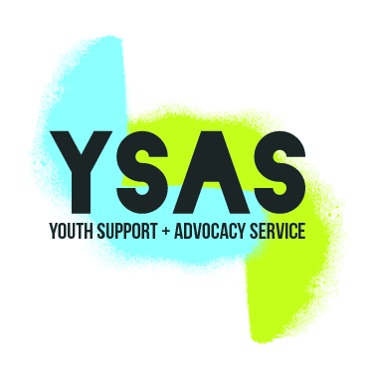
APPLICATION FORM
Please email completed application form to careers@ysas.org.au
Name:
Email address:
Name of role you are applying for: | Youth and Family Worker (North)
What website did you find this job?

I’ve attached my recent CV in Word or PDF form ☐
I am an Australian Citizen or Permanent Resident ☐

Key Selection Criteria
For us to understand your skills and capability, we have introduced a Key Selection Criteria (KSC) assessment. This information will be used to assess your skills and experience against the key components of the role you are applying for.

As a guide, you can use the STAR technique to answer the KSC. For your reference, the STAR acronym has been provided for you.
Situation – Tell us about the situation
Task – Tell us what was involved
Action – Tell us what actions you undertook
Result – Tell us what happened as a result of your actions
Try to use a different scenario for each KSC as this will provide a broader insight into your background and increase your chances to progress to the interview stage.

KEY SELECTION CRITERIA
- Understanding of and experience in working with young people at risk of entering the Criminal Justice System, especially those who have had recent contact with Victoria Police.
- Skills in engaging and working with young people, ranging from advocacy, conducting street based outreach, case management, group work and intensive individual casework.
- Ability to assess (young people’s health and well-being, risk situations) and to formulate and implement case plans based in evidence and aligned to the practice standards and values of YSAS.
- Understanding of adolescent development and specific circumstances which impact on consent and family involvement. Inherent in this is the ability to communicate effectively with family members and involve family members in assessment and support plans.
- Demonstrated ability to work collaboratively with stakeholders particularly Courts, family services, mental health providers, schools, etc.

Answer to Key Selection Criteria

