**Job Description**

|  |  |  |  |  |  |
| --- | --- | --- | --- | --- | --- |
| **Section** | Nyangirru Piliyi-ngara Kurantta – Corporate Services Section | | | **Work Unit** | Programs |
| **Job Title** | Grants Officer | | | **Level** | 6.1 – 7.4 |
| **Job Type** | Full Time | | | **Duration** | Reliant on ongoing funding |
| **Salary** | $67,597 - $83,385 | | | **Location** | Tennant Creek |
| **Position Number** | CSS 16 | **Budget** | CSS | **Closing** |  |
|  |  |  |  |  |  |
| **Contact** | **Anastasia Power (HR Officer) 08 89 6252 633** | | | | |
| **Position reports to** | Grants Coordinator then the Corporate Services Section Manager | | | | |
| **Information for Applicants** | **Applications must be limited to a one-page summary sheet, an attached detailed resume/cv and response to the Selection Criteria. All applications to be sent to** [**hr@anyinginyi.com.au**](mailto:hr@anyinginyi.com.au)  **Confirmation of employment is dependent on the outcome of a Criminal History Check and successful application for an Ochre Card** | | | | |
| **Hours of Work** | Monday – Friday, excluding public holidays. 8.00am – 5.00pm Accrued Day Off (ADO) access. 8.24 – 5.00pm – no ADO’s access. Weekend work may occur | | | | |
| **Special Measures** | Not applicable to this vacancy. | | | | |
| **About Benefits** | Salary packaging up to $15,899.94pa, Subsidised accommodation for candidates from outside of the Barkly region,6 weeks annual leave, Free employee gym membership; Free employee General Dentistry (Laboratory work to be paid by employee) Free prescriptions. | | | | |

**OUTLINE OF POSITION OBJECTIVES**

The Grants Officer is part of the team responsible for providing holistic support and advice to Anyinginyi program staff and Section Managers to enable sections and the organisation to consistently meet the funding terms and conditions of grant submissions, grant monitoring and reporting compliance processes. The position will also be proactive in seeking out and following up funding opportunities and support for Anyinginyi programs in collaboration with Section Managers, and to manage and acquit current grant funding agreements. The position reports to the Grants Coordinator and has significant requirements in relation to professional conduct, understanding of culturally responsive service delivery and the ethos of comprehensive primary health care.

**DUTIES**

**Duties**

1. Liaise with Section Managers, agency subscriptions and contacts to proactively monitor online grant sites to identify grant funding opportunities which coincide with Anyinginyi Health’s projected programs, planning goals and strategies.
2. Develop approved draft proposals and concepts into grant funding applications in collaboration with the Grants Coordinator and the responsible Section manager,
3. Assist in the development and maintenance of internal monitoring and reporting compliance tools used by Sections for the collection of evidence-based funding Agreement performance indicator outcomes for grant funding purposes, including all organisational contracts and service agreements i.e. Compliance Register, reporting templates and electronic KPI data reports.
4. Provide Grants induction to new Section Managers and ongoing assistance in the development and reporting of financial and narrative documentation as required by respective funding Agreements.
5. Ensure effective administrative links with all relevant parties are established and consistent reporting is maintained.
6. Set and provide reminders with the Grants Coordinator supporting information collation and timely submission of organisational financial or narrative performance reporting in collaboration with responsible Section manager as required by respective funding Agreements.
7. Liaise with Anyinginyi’s financial department as and when required for remittance tracking and invoicing, or other financial reporting matters of grant funds as required by respective funding Agreement.
8. Assist the Grants Coordinator to monitor National, Territory or local funding influences and/or program changes in the Aboriginal primary health care sector and related programs relevant to the Anyinginyi service environment.
9. Provide annual educative and information sharing sessions to respective Anyinginyi managers and employees in grants development, compliance and reporting requirements.
10. Comply with all Anyinginyi policy and procedures, including use of approved IT programs for electronic data management, including the sharing and advocacy of this information to fellow colleagues.
11. Liaise and contribute to Continuous Quality Improvement (CQI) mechanisms related to grant policy and procedures that promotes efficient and effective grant management systems and records
12. Liaise and maintain productive relationships with Funding Providers by electronic, phone or face to face communications, and internally with Section Managers on grant enquiries, needs and appropriate responses as and when due by the respective funding terms and conditions of grant.
13. Fulfil other functions as deemed associated to the position and acceptable to the band of employment.

**SELECTION CRITERIA**

***Essential***

1. Respect for traditional Aboriginal Culture and cultural diversity and the ability to communicate effectively and sensitively with Aboriginal/culturally diverse people.
2. Understanding of Workplace Health and Safety (WHS) individual responsibilities and in the workplace, including demonstrated awareness of conditions for remote living and travel safety.
3. Demonstrated ability to seek both government and non-government funding opportunities.
4. Experience in writing and applying for government and non-government grants
5. Experience managing complex and multiple grant terms and conditions of grants for various funding bodies for both government and non-government grants.
6. Experience in financial and narrative reporting and the acquitting of grants for various funding bodies for both government and non-government grants
7. Demonstrated ability to communicate at a high level using both written and verbal communication skills to a wide range of internal and external stakeholders and agencies relevant to primary health care and related services.
8. Demonstrate effective time management skills, including ability to monitor and maintain reminder tools for timely completion of reporting requirements, delivery of Anyinginyi grant performance indicators and other compliance requirements relevant to Anyinginyi Health
9. Demonstrated ability to contribute to effective data collection tools leading to effective representation of services and service delivery of Anyinginyi and the status of grants performance indicators
10. Current NT Driver’s License.
11. Obtain or be in possession of an OCHRE Card.

**Desirable**

1. Previous experience working with Aboriginal and Torres Strait Islander Health
2. Knowledge of social and health issues confronting Aboriginal people in the Northern Territory
3. Previous experience working in a remote area

**Organisational Overview**

**Governance Model**

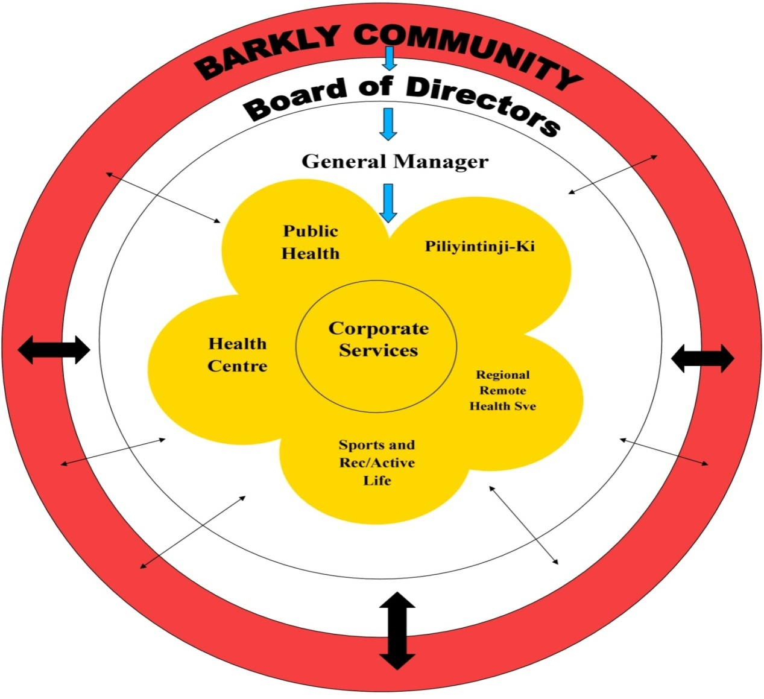

In line with the Pathways to Community Control *“…Community Control requires communities and their organization to possess both the understanding of and the ability to apply the knowledge and competence on which sound engagement is built. It also depends on the capability of government organizations and structures to understand and find new ways of working that responds to community’s calls for greater levels of engagement.”* (Page 9, Pathways to Community Control)

The Anyinginyi Governance Model illustrates how the Barkly community, Anyinginyi Board of Directors, the General Manager and the Anyinginyi Sections are integrated and work collaboratively serving the needs of their clients.

The border of the Model represents the Barkly region. The Barkly community representatives are elected to the Anyinginyi Board of Directors situated in the Model’s inner rim. The business of the corporation is managed by or under the direction of the Board of Directors. The Directors may exercise all the powers of the corporation except any that the CATSI Act or the Anyinginyi Rule Book requires the corporation to exercise in general meetings.

The General Manager over sees the everyday operations of Anyinginyi as an entity. Each highlighted Section is managed by individual Section Manager to guide and direct the programs of each section and oversee the management of employees.

The arrows within the Governance Model represent how services are utilised. There are various ways that clients or individuals can access Anyinginyi Services for example:

* Community people accessing our services – on a need’s basis
* Anyinginyi representatives from their individual sections going out and providing an outreach service to the community/communities or promotion of programs

**Primary Health Care Delivery Model**



Anyinginyi Health adopts a social community development approach to delivering primary health care ensuring Aboriginal people have the right to affordable, accessible and appropriate health care. Primary Health care has a broad focus on the social conditions and environment rather than just health care service. Anyinginyi Health holistic approach is based on social justice, equity, community inclusion and social acceptability broadly linked with the social determinants of health.

The integration of preventative measures through public health awareness, education, health promotion and community development are key to community capacity build and to empowering Aboriginal individuals, families and community accepting self-responsibility for health and wellbeing. When managing Aboriginal client care the three components of family, community and culture are intrinsic to good health outcomes.

The model recognizes the strong role Culture and Cultural Authority plays in a holistic approach to good health and well - being. The model respects the diverse cultural leadership structures and cultural identities of Aboriginal people, families and clients. Culture sets the foundation for Anyinginyi to strive to be compliant with maintaining cultural respect and ensures the principles of cultural responsiveness are considered in the design & implementation of health care.

***Our model integrates Primary Health Care best practice and Cultural best practice – this is how we do business.***