Operations Manager - Position Description

Period of Employment: Permanent Part-time
Permanent: 9-day fortnight (67.5 hours per fortnight)
Some on-call, and after hours may be required
Report to CEO
Renumeration: SCHCADS (confidential negotiation, dependant on Qualifications, skills, and experience).
_________________________________________________________________________________
Internal relationships:
- Direct liaison with and accountability to CEO
- Management of Georgina Martina Inc. daily operations (including staff)
- Provide leadership & supervision to Team Leaders, Senior Practitioners
- Oversight of case work via Team Leaders
- Provide Secondary Consultation (to Team Leaders), and Team
- Facilitate in -house training and staff development opportunities
- Provide Operational Management report to CEO & Board
- Attend Board meetings
- Facilitate team and Senior Staff meetings
- Participate in internal committees
- Manage internal relationships and alert CEO of any HR risks
_________________________________________________________________________________
External relationships:
- Participate in relevant networks & forums
- Develop external networks of benefit to GMI clients
- Keep abreast and comply with all relevant legislation
- Source training & development opportunities
__________________________________________________________________________________Conditions:
- Must have qualification in Social Work, Psychology or equivalent
- Management experience, preferably within the community sector
- Current: Working with Children Check, Australian NPC, Victorian Drivers licence
- Expertise in the provision of Case Management
- Experience with accreditation processes
- Willingness to sign & abide by GMI code of Conduct
- Adherence to GMI policies & procedures
- Participate in pre-employment safety screening process and full disclosure (of any health or disciplinary actions)
- Adhere to Child Safety Standards, GMI have zero tolerance to child abuse
- Observe the rights of people of diversity, LGBTQI+ and Aboriginal and Torres Strait Islander people, we are an equal opportunity employer

Context of Position:
This is a newly created position, a rare opportunity to be at the forefront of change. GMI are moving from two Communal High security refuges, to 2 new Core and Cluster facilities within the next 4 -8 months. We require a dynamic, professional, and mature person, who can initially assist with the transition and lead the ongoing daily operations. We require someone with established Management skills who can work independently: induct, train, manage facilities, manage staff, and assist with accreditation and review of documentation. An ability to lead, be flexible, adapt to change and then consolidate.
The Operations Manager will report directly to the CEO (and liaise with the Finance Manager on Financial matters), directly responsible to lead and mentor Team Leaders, Senior Practitioners, Child Support Worker and Case Managers.

Structure
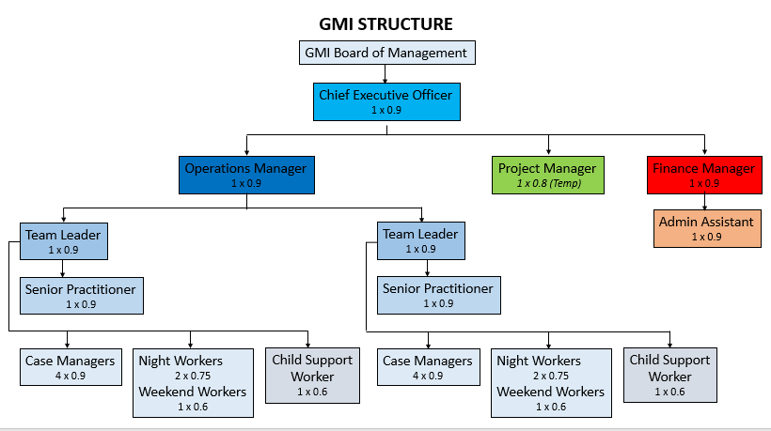

Organisational Context
Georgina Martina Inc. currently operates as a community-based organisation with a state-wide family violence support and accommodation service including two high security refuges – Georgina and Martina. The organisation is committed to a feminist strength-based approach to service delivery that views women as the experts in their own lives.
________________________________________________________________________________
Delegation of Authority
- The Operations Manager is responsible for the operations of Georgina Martina Inc. in consultation with the CEO (see Delegations of Authority Policy)
- Liaise with CEO in all matters pertinent to HR that provide a risk to the organisation
- Liaise with FM (and CEO) on all matters Financial (including any increases to staff hours), to ensure we adhere to budget constraints.
- The Operations Manager will:
- Manage day to day staff via Team Leaders and/or Senior practitioner
- Collect Statistics, provide Refuge Report, Client feedback, Complaints (can delegate)
- Ensure: timely refuge reports, file audits, PA’s, staff supervision (as delegated to Team Leader, Senior Practitioner)
- Assist in developing and reviewing policies and procedures
- Ensure compliance with current legislation (MARAM, FVISS, CISM, CISS, DVVIC code of Conduct for FV Case Management and other relevant legislation)
- Develop review systems: processes, and procedures of Case Management (in consultation with Team Leaders)
- Make recommendations and develop improvements to practice and procedures
- Lead the Team in reflecting on best practice and continuous improvement standards, including through regular staff development and training sessions.
- Develop a training and induction package for training new staff
- Ensure all Performance Appraisals are conducted at least yearly. In concert with annual review of PA templates and PD’s.
- Ensure all facilities are well maintained (via delegated responsibility, document all activities/maintenance)
- Ensure GMI are compliant with OH&S
- Lead the team in the accreditation process by ensuring all case management documentation (minutes, supervision notes, file audits, fire drills, first aid and OH&S checks) are up to date and available.
- Ensure all HR documentation is retained and stored confidentially.
- Role model, best practice, professional and emotionally mature leadership
- At all times show initiative and enthusiasm
- Provide a positive, approachable Management style that nurtures a positive culture and encourages collaboration amongst team members
___________________________________________________________________________________

Supervision
The incumbent is required to engage in formal internal supervision with the CEO, fortnightly

Performance Appraisal
The incumbent is required to participate in an annual formal performance appraisal and any other appraisal systems as directed by the CEO

The Position will become permanent after the successful completion of a 6 months probationary period

Mandatory Qualifications
- Tertiary Qualifications in Social Work, Management, Psychology and/or equivalent
- Substantial relevant experience, Management, and an understanding of Case Management processes
- Management experience in community sector setting
- Experience and expertise in Management within a not for profit environment
- Current Level 2 First Aid Certificate (or willingness to gain one).
- Current Australian Driving License
- Professional membership with a relevant professional association (such as AASW) an advantage

Key Selection Criteria
- Empathy and understanding of the issues facing women and children experiencing family violence and/or experience working within social and community services.
- Extensive experience in management within a community-based organisation including the ability to manage human and physical resources.
- Extensive knowledge of the community services sector, FV, housing or youth and families.
- An excellent understanding of feminist frameworks and perspectives and the ability to apply these to the practices within the organisation.
- Demonstrated ability to effectively supervise, manage and support staff using principles of equal opportunity, health and safety and in a manner that reflects the principles and philosophies of the service.
- Demonstrated ability to exercise initiative, judgement, sensitivity, and discretion when recommending and consulting on appropriate courses of action in relation to Human Resource Management
- Demonstrated understanding of the principles of continuous quality improvement and the ability to apply these to the organisation.
- High level interpersonal and communication skills: advocacy, negotiation, and conflict resolution skills.
- Preparedness to provide afterhours secondary consultation and on-call as required.
- Experience in change management would be an advantage.

Reviewing Position Description
PD will be reviewed annually as Part of the Performance Appraisal Process, in keeping with HR policy

Equal Opportunity Exemption
Georgina Martina Inc. is exempt from the provisions of the Equal Opportunity Act 2010. Applications for this position will be considered from women only.

We encourage women from Culturally diverse, LGBTIQ+, Mature Age or Aboriginal or Torres Strait Islander backgrounds to apply

Conditions of Employment
Salary | As negotiated (SCHCADS Award)  Salary packing available  Dependant on Qualifications & experience
Health and Safety | All Employees must comply with the organisation's Health and Safety guidelines.
Pre-employment safety screening process and disclosure | Including: police check, WWCC, Driver’s License and qualification verification, disclosure; of previous criminal history and/or employment history and disciplinary action
Notice of pre-existing injuries / sickness | Under the Accident Compensation Act 1985 (dealing with pre-existing injuries / sickness / injuries/ mental health diagnosis) new employees are required to disclose in writing any pre-existing injury, illness or condition that may be exacerbated by the duties of this position. Further, any pre-existing illness/condition that would preclude you from fulfilling the duties required. If these disclosures are not made and the existing injury, illness or condition worsens, entitlement to WorkCover compensation for that injury, illness or condition may not apply.
Right to Work in Australia | New employees must show proof of their right to work in Australia by providing either proof of their Australian citizenship or a relevant visa. If an employee has worked or lived Overseas for more than 12 months in the last 10 years, they must provide an international police check.
Leave | Any leave such as annual leave, personal leave, compassionate leave etc. will be granted pro rata in accordance with the relevant award and any internal agreements.

Application close: COB Tuesday, 3rd November,
email applications, addressing the selection criteria, mandatory requirements, Resume to Tracey Edwards (Interim Manager) and Lisa Dunbar (CEO):
tracey.e@gmi.org.au & lisa@gmi.org.au

