Easy Read job description and application form
Peer Worker
Day | To be decided
  Time | 10 am to 2 pm
Job type | Part time  4 hours a week
Pay   | $ 31.02 an hour
How long for? | November 2020 to June 2021
Where?  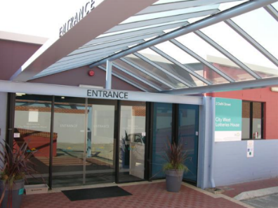 | City West Lotteries House  2 Delhi Street  West Perth

Things you will do in the job
 | Work on a project called Make Decisions Real.
 | Test workbooks, videos and other things that help people make decisions.
 | Help make training about making decisions.  Help run training for people with intellectual disability, their families and paid workers.
 | Help with other goals in the Make Decisions Real project.
 | Give advice to the Make Decisions Real project team.

What you must be able to do
 | Work well with other people.
 | Be interested in the rights of people with intellectual disability to make their own decisions.
 | Speak in front of other people.
 | Follow instructions.
 | Ask for help if you need it.
 | You might travel to other states.  You might need to stay in a hotel overnight.  Inclusion Australia will pay for the travel.
Job Application
You can answer these questions on your own or with a supporter

What is your name?

What is your address?

How can we contact you?
Phone:
Email:

Why do you want to be a Peer Worker?
What jobs have you done before?

What education or training courses have you done?

Can you tell a story about a time you needed to make a decision for yourself?

What do you like about working with other people?

What do you like about public speaking?

Do you have time to do this job?
☐ Yes
☐ No

Are you able to travel to other states if you need to?
☐ Yes
☐ No

Write the names of two people who can tell us about you and your work
1 | Name:  Phone:  Email:
2 | Name:  Phone:  Email:

Do you have a support person you would like us to contact?
☐ Yes
☐ No

If you said yes then write their details here
Name:
Phone:
Email:

