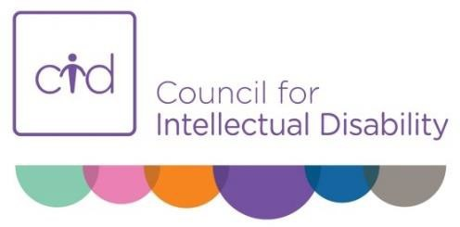

Position Description

Position Title: Inclusion Projects Officer
Position Aim: To empower and improve the lives of people with disability
through facilitating a range of projects and inclusion activities.
Reports to: Manager, Inclusion Projects
Direct Reports: Nil
Key Relationships: Internal – Chief Executive Officer, Senior Managers and Managers, Members and other staff.
External – People with disability and families/carers and supporters, community service providers, government and non-government organisations; project partners as identified and any other key stakeholders
Award Placement: Level 5 - Social, Community, Home Care and Disability Services (SCHADS) Award.
Position Status: | Full Time or Part Time or Casual
Hours of Work: | Flexible, between office hours 8am-6pm
Position Location: | Greater Sydney Region  Possible intrastate travel
Conditions of  Employment | Salary packaging available.  Employer superannuation contribution is 9.50%.  Appointment is contingent on a satisfactory Police Record Check and Working with Children Check.

About Council for Intellectual Disability (CID)
CID is a peak body representing the rights and interests of people with intellectual disability in NSW.
CID undertakes advocacy, information provision and projects that advance the rights of people with intellectual disability.

Role Responsibilities
- Facilitate engaging and inclusive workshops and sessions for various participant groups (people with disability, family members, staff of government agencies, and staff of disability services) including some logistics.
- Develop resources, content and activities which are appropriate for people with disability, including those with high support needs.
- Develop, implement and evaluate project plans in coordination with the Manager, Inclusion Projects and other relevant stakeholders.
- Flexibility to work both one-on-one and in large group setting with people with disability and their families as the situation requires.
- Where required undertake community engagement activities at expos, local community networks, events.
- Develop and maintain effective communication networks with internal and external stakeholders to ensure the efficient and timely exchange of information and the achievement of project outcomes.
- Ongoing monitoring, recording and evaluation of data and processes to allow for continuous improvement.
- Support the participation of people with intellectual disability in CID's work.

Essential Selection Criteria – Skills & Experience
- Demonstrated commitment to the human rights of people with disability and the principles of participation and inclusion.
- Demonstrated experience in facilitation and/or training environments, with people with disability.
- Well-developed interpersonal, communication, facilitation and negotiation skills.
- Demonstrated understanding of the importance of supporting people to speak for themselves
- Demonstrated experience in productive working relationships with colleagues to achieve required outcomes.
- Willingness and ability to travel.
- Excellent computer literacy including in Microsoft Office.
Aboriginal and Torres Strait Islander people and people with disability or living with mental illness are strongly encouraged to apply.
Signed by CID Representative | Signed by Employee
Signature: | Signature:
Date: | Date:

