Policy Research Officer | Position Description

Employment Type: Part Time (0.6 FTE negotiable)
Term: Permanent
Location: Melbourne or Australia wide.
Reports to: Policy Manager
Works with: Policy and Government Relations

The purpose of this role is to provide research support to the Summer Foundation’s Policy and Government Relations Team in order to develop high quality evidence-based policy reports and submissions.

You will be part of a dynamic team which is at the forefront of providing strategic advice to ensure government policy and programs meets the needs of young people in, or at risk of entering, Residential Aged Care. Your work will also inform the Summer Foundation’s broader agenda of building the capacity of all mainstream and specialist disability services to assist young people with complex support needs.

Position Summary

The Policy Research Officer will support the Policy & Strategy Team to develop high quality evidence-based policy briefs, reports and submissions.

Your strong research background in public policy will provide the team with up-to-date and relevant evidence to support the development of robust public policy analysis.

Reporting to the Summer Foundation Policy Manager, you will:

- Research and analyse qualitative and quantitative data, policy reports and case studies related to disability, health and housing;
- Consult with stakeholders and gather and collect data to inform policy, including with people with disabilities and service providers;
- Draft policy submissions, briefing papers, presentations and other publications;
- Contribute to the identification of emerging policy issues and opportunities to contribute to policy influence and solutions.
- Interpret government policy changes in health, housing and disability; and
- Support and participate in policy team meetings and other relevant Summer Foundation activities and events.

You will need to display a ‘can-do’ attitude and actively contribute to developing a culture of excellence, responsiveness and flexibility. Excellent communication, organisational and report writing skills are essential.

Essential Criteria

- Experience writing policy briefs, submissions to inquiries and policy reports.
- Excellent written communication skills
- Understanding of a rights-based approach to disability support
- An understanding of the NDIS and on policy issues impacting on people with disabilities who have high and complex support needs
- A commitment to reflective practice and a demonstrated ability to work collaboratively in a team environment
- Willingness and capacity to travel interstate with overnight stays as needed

Desirable criteria

- An undergraduate degree in policy, law or social sciences
- Lived experience of disability

Core Competencies
The Job Holder’s values will match those of the Summer Foundation. The Summer Foundation’s values include:
Vision: We are creative, innovative and resourceful. We continually strive to be the best
Integrity: We act with integrity and honesty in everything we do
Communication: We communicate openly by exchanging information and actively listening to all stakeholders
Team Spirit: We value and recognize the contribution of our colleagues, both locally and globally. We enjoy working together to achieve outstanding results and total job satisfaction
Corporate Responsibility: We act responsibly within our community and care for the environment

Work related Competencies
Communication develops business plans, policy framework, project development proposals and briefs on highly complex issues for consideration by the Executive management team, demonstrating a high level of knowledge and expertise in the project area and providing expert analysis
Influence and Negotiation ~ Gains agreement to proposals and ideas; Builds behind-the- scenes support for ideas to ensure buy-in and ownership; Uses chains of indirect influence to achieve outcomes.
Stakeholders and relationship focus ~ Establishes and maintains relationships with people at all levels; Forges useful partnerships with people across government and industry; Builds trust through consistent actions, values and communication;
Planning and organizing ~ Establishes systems and procedures to guide work and track progress; Recognises actual and potential barriers and finds effective ways to deal with them.

Other Relevant Information
The position description is indicative of the initial expectation of the role and subject to changes to Summer Foundation goals and priorities, activities or focus of the job.

Application process
should be addressed to XXX and include a current CV and a cover letter which includes responses to the position responsibilities, experience and attributes. People with disabilities are strongly encouraged to apply.

About the Summer Foundation

Established in 2006, the key aim of the Summer Foundation is to change human service policy and practice related to young people in nursing homes. The Summer Foundation utilises a range of strategies to influence health, housing, aged care and disability service policy and practice related to this target group.
The Summer Foundation’s four key strategies to preventing young people being forced to live in nursing homes are:
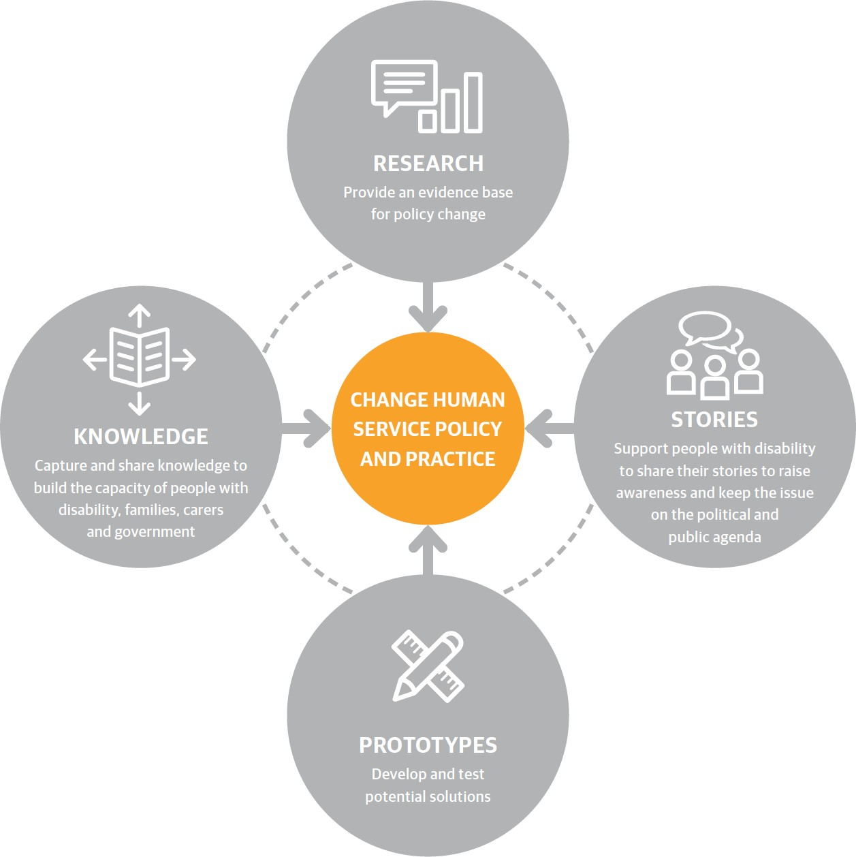
Research ~ Our research underpins our work and provides an evidence base for policy and practice change.
Stories ~ Enabling young people with disability and their families to tell their stories and disseminating these stories is a powerful and effective tool for influencing the general public, decision makers and politicians.
Prototypes ~ We design and pilot potential solutions and then evaluate them through action research. This is an iterative process which involves: designing, building, evaluation and learning.
Knowledge ~ We capture, document and disseminate the knowledge generated from
our research and prototypes in order to encourage others to replicate and scale our work.

What policy change do we want?
There are four key areas that must be addressed to resolve the issue of young people in nursing homes in Australia.
- NDIS – Ensure young people in RAC (or at risk of entering RAC) have effective NDIS plans
- Housing – Increase the range and scale of housing
- Pathways home – Improve the interface between the NDIS, health and aged care gateway
- Community and primary health – Increase access to proactive health services

