Housing Options Program Manager
Position Description
Employment Type: Full Time (0.8-0.9 FTE is negotiable)
Term: 12 month fixed term contract
Location: Melbourne, Sydney or Brisbane (with regular interstate travel)
Reports To: General Manager
Direct Reports: 3 x Housing Options Facilitators, Housing Options Coordinator, Individual Living Options Coordinator
Works With: Housing Matching Team, People with disability, Coordinators of Support, Families, Allied Health Professionals, community organisations and stakeholders
Housing Matching Team has been established to create a social enterprise within the Summer Foundation. Our vision is to create a place where people with disability can see the possibilities for a home for themself, have options to choose from and find the home that is right for them. The housing matching team will play a key role in ensuring the effectiveness of the disability housing market by:
- increasing awareness of and access to housing options for people with disability
- providing a means for people with disability to find appropriate housing and connect with providers of housing in order to exercise choice over where they live, who they live with and to promote their independence
- providing an efficient way for housing providers to connect with people with disability to promote their properties so they are tenanted
We have the privilege of supporting people to find the home that is right for them, which is often a truly life changing experience.
Purpose:
The Housing Options Program Manager will lead a new team to undertake a community engagement campaign to identify people across Australia who are eligible for Specialist Disability Accommodation Funding and support them to articulate their housing needs and preferences. Your team will identify at least 1,000 people and their preferences within the next 12 months. Your team will develop resources, stories and deliver workshops to engage with people with disabilities and their supporters.

Responsibilities & Duties
Strategic planning
- Development of a strategy to access people in various settings with various barriers
- Development of a detailed work plan for the Housing Options Team
- Campaign to deliver information to people in various settings
- Develop relationships with key organisations to build profiles on the Housing Hub
- Implementation plan and ongoing monitoring and tweaking where required
Workshops
- Develop a series of workshops to be delivered across Australia both online and offline over 12 months that aim to raise awareness, build capacity and gather housing preferences in order to support people to acquire SDA funding
- Undertake co-design of the workshops with people with lived experience of disability
- Workshop marketing plans developed and implemented
- Regular review of workshop activities to ensure they are meeting objectives
- Monitor conversion rates of marketing to attendance and attendance to housing preferences profiles
- Facilitation at some of the workshops
Housing Resources
- Understand barriers from the development of the strategy and work to date to determine topics for video stories
- Undertake co-design of the resources with people with lived experience of disability
- Oversee video story production, promotion of stories with appropriate calls to action, monitoring of performance
- Understand barriers from strategy development and work to date to determine resource topics, oversee the development of resources with promotion of resources with appropriate calls to action
- Establish an SDA phone support line to provide advice and support on what SDA is, how to get it and how to find a new home, oversee the performance of the phone line once established and monitor conversion rates from calls to profiles
Team Leadership
- Manage Human Resources effectively across the Housing Options Team including providing training, coaching and supervision to team members in line with our culture and operational priorities
- Develop KPIs for the team and report back on these regularly using data and take action as required to manage any areas lagging behind target performance
- Foster a positive culture where all team members can contribute and feel valued
- Participate in the Housing Matching Leadership Team meetings and lead across the team in line with our values and culture

Other
- Project management of grants and funding agreement requirements, communications and reporting
- Management of cost centre budget and associated reporting
- Participation in regular meetings as required
- Other duties as required
Skills & Experience
Qualifications
- Degree in Business or Marketing and relevant experience in leading campaigns delivering messaging to target groups of consumers
- Employment is subject to National Police History Check
Experience
Required
- Demonstrated experience in developing and executing community engagement campaigns with success
- Experience in developing, implementing and monitoring marketing strategy
- People leadership and team management
- Project management
- Events management
- Workshop design and delivery
- Communication with people with disability
- Understanding of the disability sector, barriers, players
Desired
- Lived experience of disability and housing search
- Evaluation and reporting
- Video storytelling production
- Design and Development of resources
Skills
- Commercial acumen
- Operational planning and delivery
- Project Management
- Monitoring performance
- Risk management
- Financial Management
- For purpose sector knowledge
- Understanding of our customers and stakeholder's needs
- Stress testing of tactics and pivoting as required
- Public relations
- General IT proficiency
- People Leadership
- Marketing strategy
- Organised - meets deadlines and has strong accountability
- Strong communication verbally and written to audiences internally and externally and for various levels of experience and knowledge

Core Competencies
The successful applicant’s values will match those of the Summer Foundation. The Summer Foundation’s values include:
- Vision: We are creative, innovative and resourceful. We continually strive to be the best
- Integrity: We act with integrity and honesty in everything we do
- Communication: We communicate openly by exchanging information and actively listening to all stakeholders
- Team Spirit: We value and recognize the contribution of our colleagues, both locally and globally. We enjoy working together to achieve outstanding results and total job satisfaction
- Corporate Responsibility: We act responsibly within our community and care for the environment
Other Relevant Information
The position description is indicative of the initial expectation of the role and subject to changes to Summer Foundation goals and priorities, activities or focus of the job.
People with disability are encouraged to apply. Lived experience is valued by the organisation and looked upon favourably.
We offer
- Salary Packaging
- Flexible working hours
- Supportive and collaborative team environment
About the Summer Foundation
Established in 2006, the key aim of the Summer Foundation is to change human service policy and practice related to young people in nursing homes. The Summer Foundation utilises a range of strategies to influence health, housing, aged care and disability service policy and practice related to this target group.
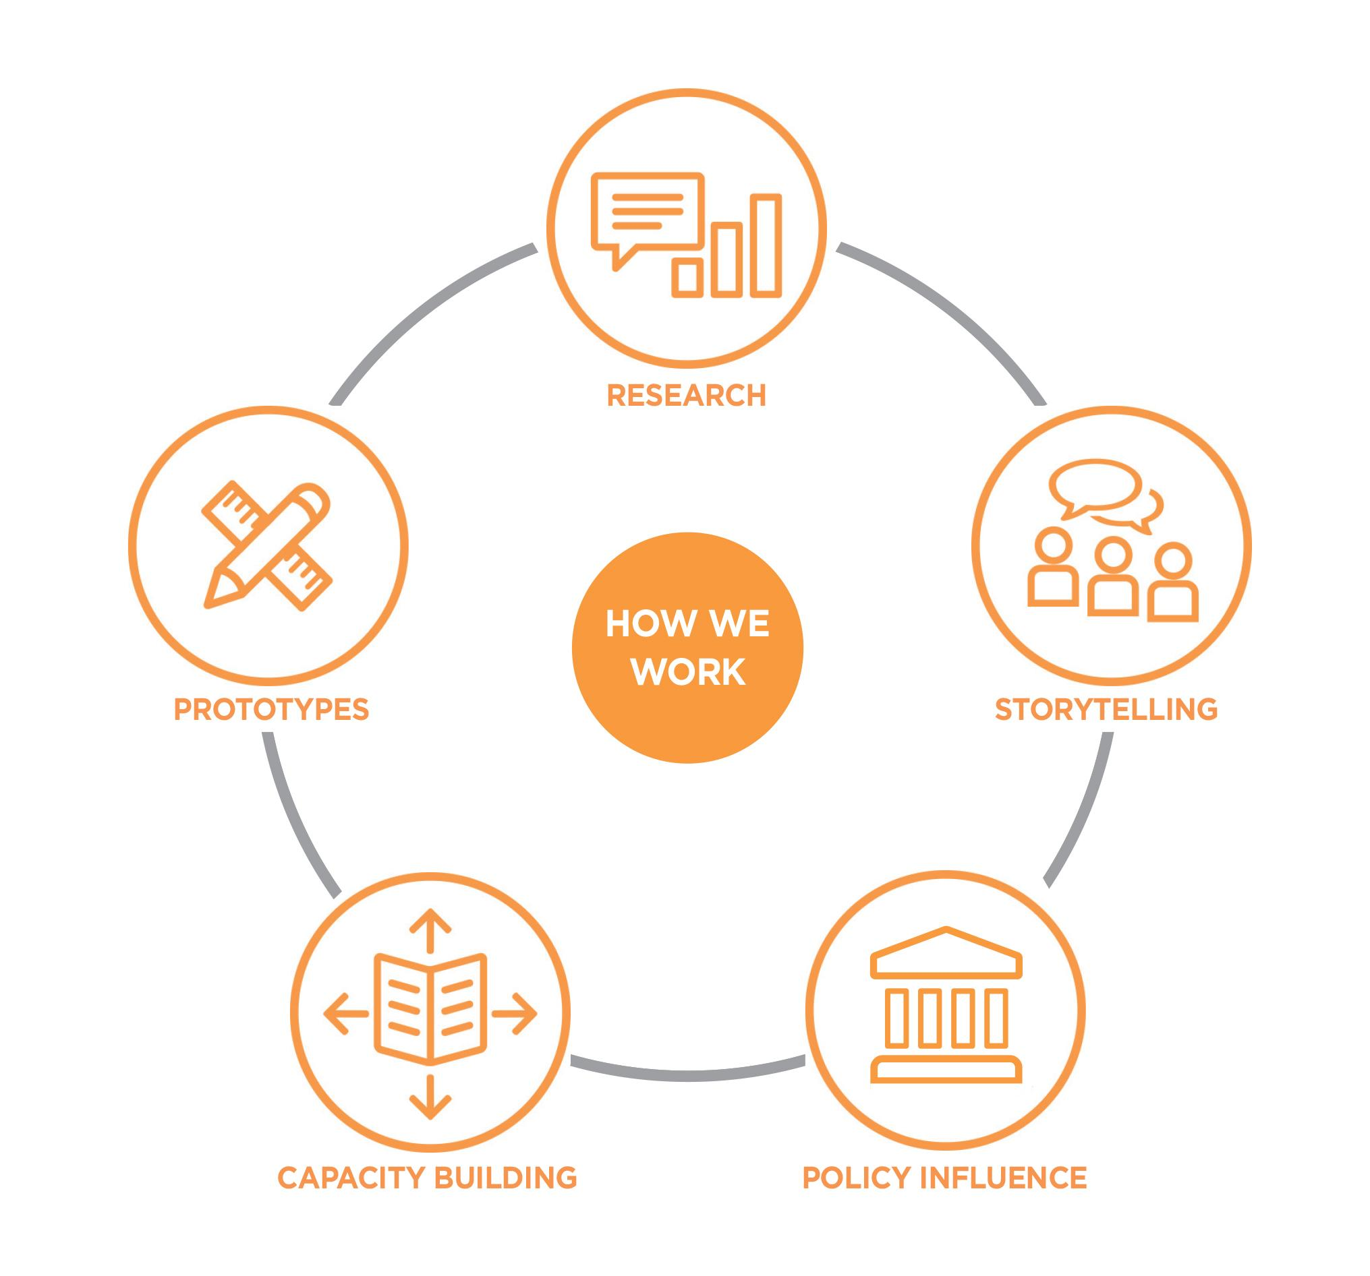
The Summer Foundation’s five key strategies to preventing young people being forced to live in nursing homes are:

Research – Data collection and analysis to provide an evidence base for problem solving
Storytelling – Support people with lived experience to share their journeys and perspectives
Prototypes – Designing, testing and evaluating new solutions
Capacity Building – Share information and best practice with stakeholders
Policy Influence – Shape thinking and change decisions of governments

What policy change do we want?
There are four key areas that must be addressed to resolve the issue of young people in nursing homes in Australia.
- Those in RAC or at risk of RAC entry have NDIS plans which support and reflect their goals
- Significantly increase the volume and range of high quality, accessible and affordable housing
- Health, disability and other systems communicating and collaborating to support discharge to community living
- Define the challenges and explore solutions to barriers that limit access to primary and community health services

